# Race: AQU | 2025-02-21 | Race #1 | Track: AQUEDUCT

Track: AQUEDUCT

|  |  |  |  |  |
| --- | --- | --- | --- | --- |
| Saddle Cloth # | Horse Name | Global Speed | Composite | Win Prob (%) |
| ['', 1, ''] | Shop Lifting | 89.2 | 4.29 | 0.65 |
| ['', 2, ''] | Shirl's Delight | 89.2 | 6.77 | 4.73 |
| ['', 3, ''] | Wimberly | 111.3 | 3.28 | 24.39 |
| ['', 4, ''] | Wake Up Lauren | 104.0 | -3.08 | 0.03 |
| ['', 5, ''] | MUTUALLY EXCLUSIVE * | 98.3 | 7.85 | 70.19 |

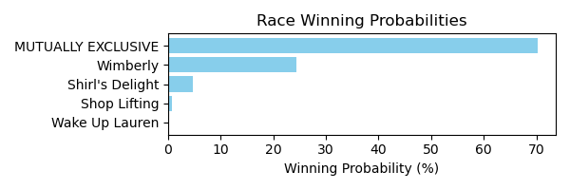

Figure: Winning Probability Distribution

NOTE: THIS RACE HAS HORSES THAT ARE MISSING CRITICAL DATA ELEMENTS

# Race: AQU | 2025-02-21 | Race #2 | Track: AQUEDUCT

Track: AQUEDUCT

|  |  |  |  |  |
| --- | --- | --- | --- | --- |
| Saddle Cloth # | Horse Name | Global Speed | Composite | Win Prob (%) |
| ['', 1, ''] | Whistler's Style | 104.1 | 0.64 | 0.31 |
| ['', 2, ''] | Pistol Liz Ablazen | 104.1 | 7.85 | 99.55 |
| ['', 3, ''] | Adeleke | 82.5 | 1.34 | 0.01 |
| ['', 4, ''] | Willful Desire | 76.4 | 5.98 | 0.09 |
| ['', 5, ''] | Floge | 76.4 | 4.55 | 0.03 |
| ['', 6, ''] | Goldcrest | 82.5 | 1.70 | 0.01 |

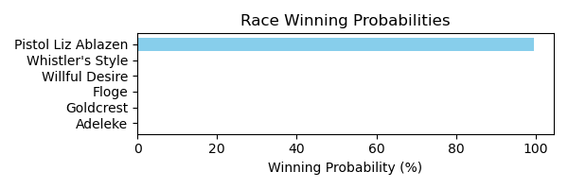

Figure: Winning Probability Distribution

NOTE: THIS RACE HAS HORSES THAT ARE MISSING CRITICAL DATA ELEMENTS

# Race: AQU | 2025-02-21 | Race #3 | Track: AQUEDUCT

Track: AQUEDUCT

|  |  |  |  |  |
| --- | --- | --- | --- | --- |
| Saddle Cloth # | Horse Name | Global Speed | Composite | Win Prob (%) |
| ['', 1, ''] | SMOKEY PLACES * | 92.0 | 3.29 | 99.28 |
| ['', 2, ''] | America's Honor | 103.9 | -7.28 | 0.23 |
| ['', 3, ''] | Laird of Magnolia | 103.9 | -8.94 | 0.06 |
| ['', 4, ''] | Nico's Derby Run | 103.9 | -7.87 | 0.14 |
| ['', 5, ''] | Broderick | 76.3 | -0.23 | 0.26 |
| ['', 6, ''] | King's Spirit | 76.3 | -3.17 | 0.02 |

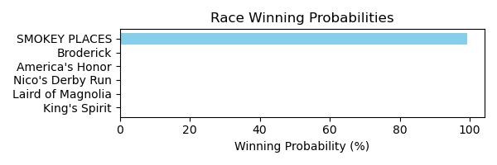

Figure: Winning Probability Distribution

NOTE: THIS RACE HAS HORSES THAT ARE MISSING CRITICAL DATA ELEMENTS

# Race: AQU | 2025-02-21 | Race #4 | Track: AQUEDUCT

Track: AQUEDUCT

|  |  |  |  |  |
| --- | --- | --- | --- | --- |
| Saddle Cloth # | Horse Name | Global Speed | Composite | Win Prob (%) |
| ['', 1, ''] | Taparino | 103.9 | 6.76 | 67.70 |
| ['', 2, ''] | Solo Empire | 89.1 | -6.86 | 0.00 |
| ['', 3, ''] | Brown Don't Stop | 118.1 | 1.51 | 17.46 |
| ['', 4, ''] | D Day Sky | 118.1 | 1.31 | 14.82 |
| ['', 5, ''] | Big Rich | 76.3 | -2.41 | 0.00 |
| ['', 6, ''] | Neptune Beach | 103.9 | -7.99 | 0.00 |
| ['', 7, ''] | Ollie Can Dance | 103.9 | -3.36 | 0.02 |

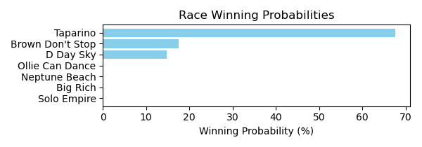

Figure: Winning Probability Distribution

NOTE: THIS RACE HAS HORSES THAT ARE MISSING CRITICAL DATA ELEMENTS

# Race: AQU | 2025-02-21 | Race #5 | Track: AQUEDUCT

Track: AQUEDUCT

|  |  |  |  |  |
| --- | --- | --- | --- | --- |
| Saddle Cloth # | Horse Name | Global Speed | Composite | Win Prob (%) |
| ['', 1, ''] | I See You Lookin | 89.1 | 3.07 | 22.26 |
| ['', 2, ''] | Zeebear | 76.3 | 2.42 | 1.02 |
| ['', 3, ''] | Perfect Flight | 76.3 | 6.04 | 18.46 |
| ['', 4, ''] | Whenlovetakesover | 76.3 | 3.08 | 1.74 |
| ['', 5, ''] | Aleah Aleah | 89.1 | 4.22 | 55.93 |
| ['', 6, ''] | Pineapple Man | 76.3 | 1.51 | 0.49 |
| ['', 7, ''] | King Moonracer | 89.1 | -3.68 | 0.10 |

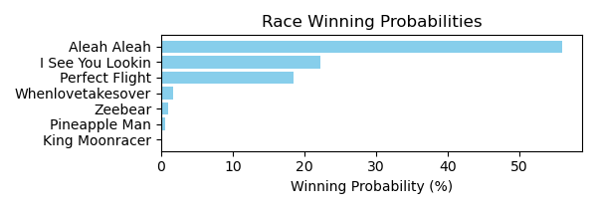

Figure: Winning Probability Distribution

NOTE: THIS RACE HAS HORSES THAT ARE MISSING CRITICAL DATA ELEMENTS

# Race: AQU | 2025-02-21 | Race #6 | Track: AQUEDUCT

Track: AQUEDUCT

|  |  |  |  |  |
| --- | --- | --- | --- | --- |
| Saddle Cloth # | Horse Name | Global Speed | Composite | Win Prob (%) |
| ['', 1, ''] | Stewie | 76.4 | -7.29 | 0.00 |
| ['', 2, ''] | Abadin | 89.3 | 3.67 | 0.37 |
| ['', 3, ''] | Courageoous Oh La | 76.4 | -1.17 | 0.00 |
| ['', 4, ''] | Amundson | 89.3 | 8.97 | 25.35 |
| ['', 5, ''] | Tetsu | 104.1 | 6.61 | 74.27 |
| ['', 6, ''] | Mister J T | 76.4 | -4.30 | 0.00 |
| ['', 7, ''] | Dot's Dollar | 76.4 | 2.11 | 0.01 |

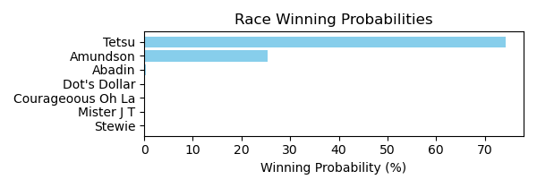

Figure: Winning Probability Distribution

NOTE: THIS RACE HAS HORSES THAT ARE MISSING CRITICAL DATA ELEMENTS

# Race: AQU | 2025-02-21 | Race #7 | Track: AQUEDUCT

Track: AQUEDUCT

|  |  |  |  |  |
| --- | --- | --- | --- | --- |
| Saddle Cloth # | Horse Name | Global Speed | Composite | Win Prob (%) |
| ['', 1, ''] | Scoot Daddy | 76.6 | -1.13 | 0.00 |
| ['', 2, ''] | Dangerous Ride | 76.6 | 0.65 | 0.01 |
| ['', 3, ''] | Crazy Mason | 82.7 | 6.75 | 5.67 |
| ['', 4, ''] | Spun and Won | 76.6 | -3.35 | 0.00 |
| ['', 5, ''] | Toxic Gray | 76.6 | 0.95 | 0.02 |
| ['', 6, ''] | Victory Way | 104.4 | 4.85 | 94.30 |

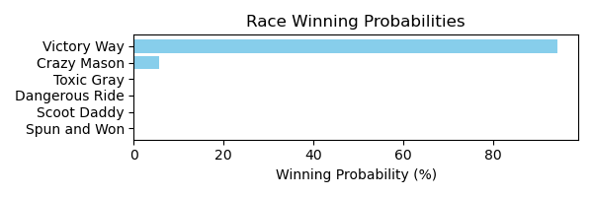

Figure: Winning Probability Distribution

NOTE: THIS RACE HAS HORSES THAT ARE MISSING CRITICAL DATA ELEMENTS

# Race: AQU | 2025-02-21 | Race #8 | Track: AQUEDUCT

Track: AQUEDUCT

|  |  |  |  |  |
| --- | --- | --- | --- | --- |
| Saddle Cloth # | Horse Name | Global Speed | Composite | Win Prob (%) |
| ['', 1, ''] | Have a Cigar | 103.9 | -3.34 | 0.61 |
| ['', 2, ''] | Total Silence | 82.4 | 2.71 | 1.05 |
| ['', 3, ''] | Kismeholdmethrlme * | 76.3 | -5.94 | 0.00 |
| ['', 4, ''] | TIOTE * | 83.5 | 3.02 | 1.68 |
| ['', 5, ''] | ALZERO * | 83.5 | 3.27 | 2.04 |
| ['', 6, ''] | MO FOR THE KING * | 83.5 | 3.34 | 2.15 |
| ['', 7, ''] | RECURRING REVENUE * | 83.5 | 2.91 | 1.54 |
| ['', 8, ''] | First Pitch * | 76.3 | -9.66 | 0.00 |
| ['', 9, ''] | Grand Cash * | 89.1 | 6.60 | 90.93 |
| ['', 10, ''] | State Park * | 76.3 | -8.37 | 0.00 |

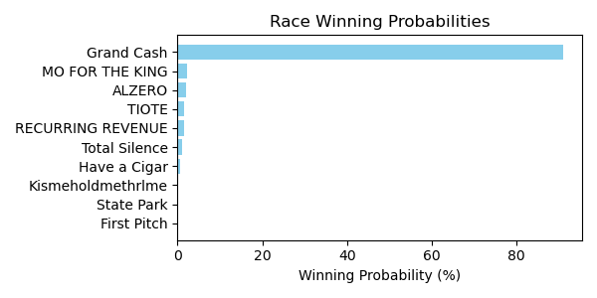

Figure: Winning Probability Distribution

NOTE: THIS RACE HAS HORSES THAT ARE MISSING CRITICAL DATA ELEMENTS

# Race: DED | 2025-02-21 | Race #1 | Track: DELTA DOWNS

Track: DELTA DOWNS

|  |  |  |  |  |
| --- | --- | --- | --- | --- |
| Saddle Cloth # | Horse Name | Global Speed | Composite | Win Prob (%) |
| ['', 1, ''] | Flying I | 66.5 | -8.33 | 0.00 |
| ['', 2, ''] | Tarkington Girl * | 66.5 | -5.48 | 0.00 |
| ['', 3, ''] | Destiny's Grace * | 66.5 | -3.97 | 0.01 |
| ['', 4, ''] | Long Shot Louise * | 66.5 | -9.94 | 0.00 |
| ['', 5, ''] | Nownowdancer * | 66.5 | 0.23 | 0.26 |
| ['', 6, ''] | Customerunhappy * | 66.5 | -6.23 | 0.00 |
| ['', 7, ''] | Mydealoftheday * | 66.5 | -4.44 | 0.01 |
| ['', 8, ''] | Saberfight * | 66.5 | 5.47 | 17.49 |
| ['', 9, ''] | La Deal * | 66.5 | 7.41 | 82.13 |
| ['', 10, ''] | Hopeshecanrun * | 66.5 | -3.83 | 0.01 |
| ['', 11, ''] | Moion * | 66.5 | -1.10 | 0.09 |

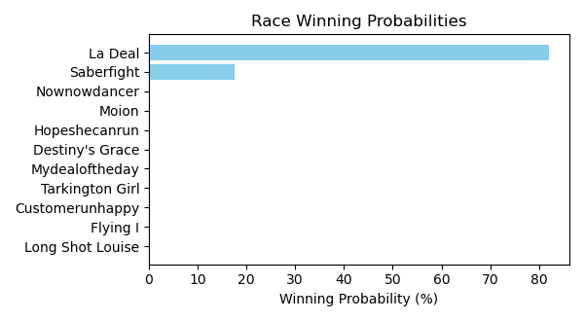

Figure: Winning Probability Distribution

NOTE: THIS RACE HAS HORSES THAT ARE MISSING CRITICAL DATA ELEMENTS

# Race: DED | 2025-02-21 | Race #2 | Track: DELTA DOWNS

Track: DELTA DOWNS

|  |  |  |  |  |
| --- | --- | --- | --- | --- |
| Saddle Cloth # | Horse Name | Global Speed | Composite | Win Prob (%) |
| ['', 1, ''] | So Jordan | 66.5 | 6.28 | 3.11 |
| ['', 2, ''] | Ocean Jet * | 66.5 | 3.46 | 0.33 |
| ['', 3, ''] | Go Ishla | 66.5 | 1.43 | 0.06 |
| ['', 4, ''] | Who's Madie * | 66.5 | 4.35 | 0.66 |
| ['', 5, ''] | Kip the Distance | 66.5 | -3.60 | 0.00 |
| ['', 6, ''] | Lagunera * | 66.5 | 3.75 | 0.41 |
| ['', 7, ''] | Lady Cheryl's Song * | 66.5 | 10.56 | 95.43 |

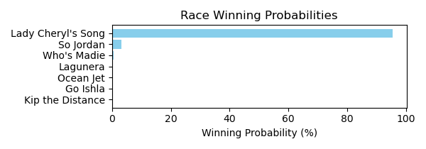

Figure: Winning Probability Distribution

NOTE: THIS RACE HAS HORSES THAT ARE MISSING CRITICAL DATA ELEMENTS

# Race: DED | 2025-02-21 | Race #3 | Track: DELTA DOWNS

Track: DELTA DOWNS

|  |  |  |  |  |
| --- | --- | --- | --- | --- |
| Saddle Cloth # | Horse Name | Global Speed | Composite | Win Prob (%) |
| ['', 1, ''] | Tommie's True * | 89.0 | -4.26 | 0.01 |
| ['', 2, ''] | SAILOR DE ACES * | 89.0 | 5.16 | 26.04 |
| ['', 3, ''] | Real Thrill * | 89.0 | 4.20 | 12.05 |
| ['', 4, ''] | COOL GUITAR * | 89.0 | 5.08 | 24.47 |
| ['', 5, ''] | Ayden's Edge * | 89.0 | -7.74 | 0.00 |
| ['', 6, ''] | My Special Star * | 89.0 | -5.67 | 0.00 |
| ['', 7, ''] | Hold My Hat * | 89.0 | 3.36 | 6.15 |
| ['', 8, ''] | Bella's Boss * | 89.0 | -4.59 | 0.01 |
| ['', 9, ''] | My First Deal * | 89.0 | -1.37 | 0.14 |
| ['', 10, ''] | PISTOL RIDGE KID * | 89.0 | 5.10 | 24.88 |
| ['', 11, ''] | Deelitesandimsum * | 89.0 | 3.38 | 6.24 |
| ['', 12, ''] | Yankeestrolgy * | 89.0 | -5.97 | 0.00 |

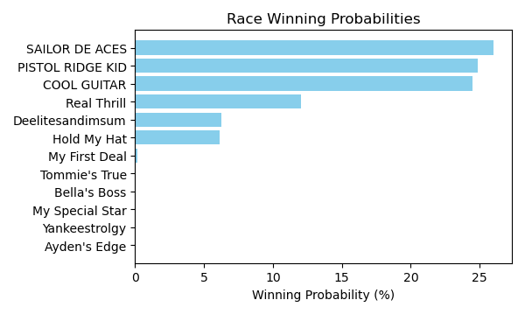

Figure: Winning Probability Distribution

NOTE: THIS RACE HAS HORSES THAT ARE MISSING CRITICAL DATA ELEMENTS

# Race: DED | 2025-02-21 | Race #4 | Track: DELTA DOWNS

Track: DELTA DOWNS

|  |  |  |  |  |
| --- | --- | --- | --- | --- |
| Saddle Cloth # | Horse Name | Global Speed | Composite | Win Prob (%) |
| ['', 1, ''] | Maximus Freedom * | 66.7 | -0.11 | 0.08 |
| ['', 2, ''] | Sharp Charlie * | 66.7 | 5.27 | 5.83 |
| ['', 3, ''] | Alterana | 66.7 | 3.62 | 1.55 |
| ['', 4, ''] | Guitar Doctor | 66.7 | -0.92 | 0.04 |
| ['', 5, ''] | Bind Faith * | 66.7 | 2.24 | 0.52 |
| ['', 6, ''] | Prado's Priority * | 66.7 | 8.71 | 91.42 |
| ['', 7, ''] | Matzoh Ball * | 66.7 | -6.84 | 0.00 |
| ['', 8, ''] | Speightful One * | 66.7 | 2.36 | 0.57 |

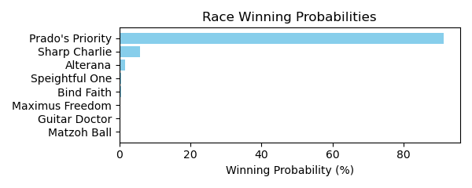

Figure: Winning Probability Distribution

NOTE: THIS RACE HAS HORSES THAT ARE MISSING CRITICAL DATA ELEMENTS

# Race: DED | 2025-02-21 | Race #5 | Track: DELTA DOWNS

Track: DELTA DOWNS

|  |  |  |  |  |
| --- | --- | --- | --- | --- |
| Saddle Cloth # | Horse Name | Global Speed | Composite | Win Prob (%) |
| ['', 1, ''] | Sheer Luck * | 82.0 | 4.50 | 11.67 |
| ['', 2, ''] | SHE'S WILD AGAIN * | 82.0 | 3.29 | 4.43 |
| ['', 3, ''] | Laryslittleracer | 82.0 | 6.02 | 39.48 |
| ['', 4, ''] | SAYYOULOVEMEBABY * | 82.0 | 3.22 | 4.20 |
| ['', 5, ''] | Back Nine * | 82.0 | -7.97 | 0.00 |
| ['', 6, ''] | Acadiana * | 82.0 | -8.88 | 0.00 |
| ['', 7, ''] | Desired Fantasies * | 82.0 | -9.94 | 0.00 |
| ['', 8, ''] | Laoban's Carat * | 82.0 | -6.18 | 0.00 |
| ['', 9, ''] | Whodoyoulikehere | 82.0 | -7.05 | 0.00 |
| ['', 10, ''] | Meeting Jenny * | 82.0 | 5.98 | 38.05 |
| ['', 11, ''] | Imperial Assault * | 82.0 | -9.18 | 0.00 |
| ['', 12, ''] | Mopac Traffic | 82.0 | 2.39 | 2.16 |

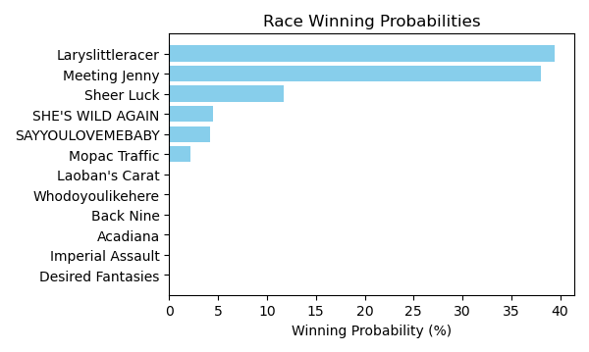

Figure: Winning Probability Distribution

NOTE: THIS RACE HAS HORSES THAT ARE MISSING CRITICAL DATA ELEMENTS

# Race: DED | 2025-02-21 | Race #6 | Track: DELTA DOWNS

Track: DELTA DOWNS

|  |  |  |  |  |
| --- | --- | --- | --- | --- |
| Saddle Cloth # | Horse Name | Global Speed | Composite | Win Prob (%) |
| ['', 1, ''] | The Rage of Art * | 82.5 | -3.93 | 0.07 |
| ['', 2, ''] | Gee Gee * | 82.5 | 1.52 | 5.69 |
| ['', 3, ''] | Jess's Rainbow | 82.5 | -5.79 | 0.02 |
| ['', 4, ''] | Eli's Girl * | 82.5 | -4.26 | 0.06 |
| ['', 5, ''] | Czar's Ballerina | 82.5 | 0.98 | 3.70 |
| ['', 6, ''] | Bold Exaggeration * | 82.5 | -1.29 | 0.60 |
| ['', 7, ''] | Legal Deceiver | 82.5 | -0.26 | 1.37 |
| ['', 8, ''] | Dr Stricklands Ace * | 82.5 | 3.53 | 28.37 |
| ['', 9, ''] | Be Bo * | 82.5 | 2.45 | 11.99 |
| ['', 10, ''] | Black Ace | 82.5 | -1.87 | 0.38 |
| ['', 11, ''] | Berlaine | 82.5 | 2.32 | 10.79 |
| ['', 12, ''] | Blueberry Eyes | 82.5 | 3.86 | 36.96 |

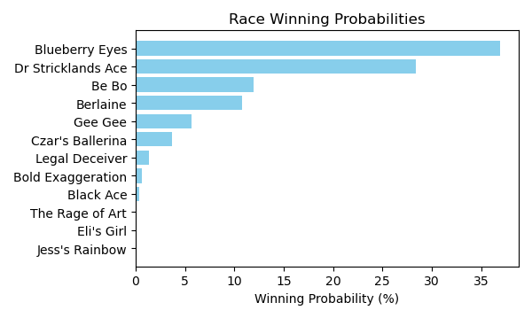

Figure: Winning Probability Distribution

NOTE: THIS RACE HAS HORSES THAT ARE MISSING CRITICAL DATA ELEMENTS

# Race: DED | 2025-02-21 | Race #7 | Track: DELTA DOWNS

Track: DELTA DOWNS

|  |  |  |  |  |
| --- | --- | --- | --- | --- |
| Saddle Cloth # | Horse Name | Global Speed | Composite | Win Prob (%) |
| ['', 1, ''] | Adios Carlos | 66.6 | -2.13 | 0.01 |
| ['', 2, ''] | Donna's Court | 66.6 | -9.03 | 0.00 |
| ['', 3, ''] | Whatta Life * | 66.6 | 8.88 | 89.93 |
| ['', 4, ''] | Oceola | 66.6 | -4.03 | 0.00 |
| ['', 5, ''] | Skippa | 66.6 | 3.22 | 0.97 |
| ['', 6, ''] | Slither * | 66.6 | 5.96 | 8.71 |
| ['', 7, ''] | Goldenlute | 66.6 | -8.40 | 0.00 |
| ['', 8, ''] | Empire Kid * | 66.6 | 1.42 | 0.23 |
| ['', 9, ''] | Half Full * | 66.6 | 0.17 | 0.08 |
| ['', 10, ''] | Bobby Boy * | 66.6 | -4.55 | 0.00 |
| ['', 11, ''] | Hostile Afleet | 66.6 | -0.37 | 0.06 |

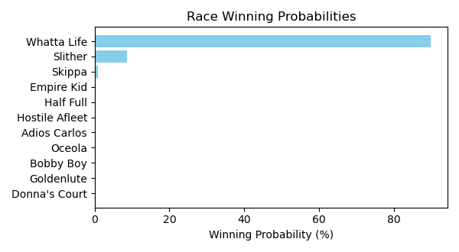

Figure: Winning Probability Distribution

NOTE: THIS RACE HAS HORSES THAT ARE MISSING CRITICAL DATA ELEMENTS

# Race: DED | 2025-02-21 | Race #8 | Track: DELTA DOWNS

Track: DELTA DOWNS

|  |  |  |  |  |
| --- | --- | --- | --- | --- |
| Saddle Cloth # | Horse Name | Global Speed | Composite | Win Prob (%) |
| ['', 1, ''] | Beat the Double * | 88.9 | -3.64 | 0.03 |
| ['', 2, ''] | Sparkle City | 88.9 | -8.54 | 0.00 |
| ['', 3, ''] | Holiday Double * | 88.9 | -0.17 | 0.42 |
| ['', 4, ''] | Dylan's Dream | 88.9 | -1.73 | 0.12 |
| ['', 5, ''] | Surrey * | 88.9 | -6.13 | 0.00 |
| ['', 6, ''] | Leucadia | 88.9 | 6.33 | 76.20 |
| ['', 7, ''] | She's Extra | 88.9 | 4.76 | 21.61 |
| ['', 8, ''] | Mda Senorita Run | 88.9 | -5.78 | 0.00 |
| ['', 9, ''] | Merrily Rush | 88.9 | 1.40 | 1.47 |
| ['', 10, ''] | Awesome Becca * | 88.9 | -1.61 | 0.13 |
| ['', 11, ''] | My Idea | 88.9 | -6.62 | 0.00 |
| ['', 12, ''] | Gypsy Jackpot * | 88.9 | -8.55 | 0.00 |

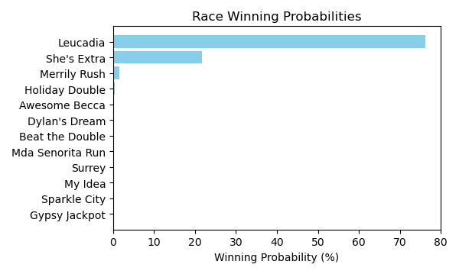

Figure: Winning Probability Distribution

NOTE: THIS RACE HAS HORSES THAT ARE MISSING CRITICAL DATA ELEMENTS

# Race: DED | 2025-02-21 | Race #9 | Track: DELTA DOWNS

Track: DELTA DOWNS

|  |  |  |  |  |
| --- | --- | --- | --- | --- |
| Saddle Cloth # | Horse Name | Global Speed | Composite | Win Prob (%) |
| ['', 1, ''] | Prettywell Stacked * | 82.4 | 2.06 | 0.89 |
| ['', 2, ''] | Good N Sassy * | 82.4 | -7.56 | 0.00 |
| ['', 3, ''] | Overcast | 82.4 | -1.55 | 0.05 |
| ['', 4, ''] | Get Ready Gal | 82.4 | 7.86 | 91.94 |
| ['', 5, ''] | Lord Harmony * | 82.4 | 3.27 | 2.33 |
| ['', 6, ''] | Double Cute * | 82.4 | 1.60 | 0.61 |
| ['', 7, ''] | La Palabra * | 82.4 | 1.10 | 0.41 |
| ['', 8, ''] | Bayou Chick * | 82.4 | 3.85 | 3.72 |
| ['', 9, ''] | Congratulera * | 82.4 | -1.76 | 0.04 |

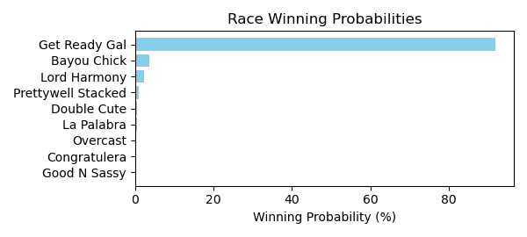

Figure: Winning Probability Distribution

NOTE: THIS RACE HAS HORSES THAT ARE MISSING CRITICAL DATA ELEMENTS

# Race: DED | 2025-02-21 | Race #10 | Track: DELTA DOWNS

Track: DELTA DOWNS

|  |  |  |  |  |
| --- | --- | --- | --- | --- |
| Saddle Cloth # | Horse Name | Global Speed | Composite | Win Prob (%) |
| ['', 1, ''] | Cat County * | 82.2 | 7.95 | 63.00 |
| ['', 2, ''] | Texoma * | 82.2 | 7.27 | 36.72 |
| ['', 3, ''] | Kah Nigh | 82.2 | -6.07 | 0.00 |
| ['', 4, ''] | Hay Lover Boy * | 82.2 | -8.45 | 0.00 |
| ['', 5, ''] | Beaudean * | 82.2 | -2.23 | 0.02 |
| ['', 6, ''] | Baby Zong * | 82.2 | 0.88 | 0.22 |
| ['', 7, ''] | Scallywag | 82.2 | -2.18 | 0.02 |
| ['', 8, ''] | Island Cabana | 82.2 | -2.03 | 0.02 |
| ['', 9, ''] | Embrace My Heart * | 82.2 | -9.72 | 0.00 |
| ['', 10, ''] | Wicked Punches * | 82.2 | -5.36 | 0.00 |
| ['', 11, ''] | C F Cantgoforthat * | 82.2 | -9.35 | 0.00 |
| ['', 12, ''] | Zestiny * | 82.2 | -5.77 | 0.00 |

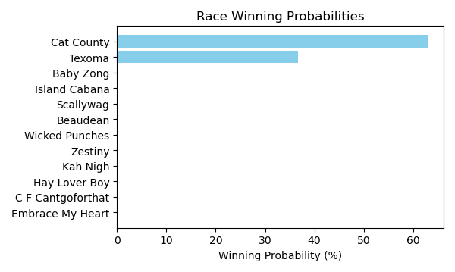

Figure: Winning Probability Distribution

NOTE: THIS RACE HAS HORSES THAT ARE MISSING CRITICAL DATA ELEMENTS

# Race: DED | 2025-02-22 | Race #1 | Track: DELTA DOWNS

Track: DELTA DOWNS

|  |  |  |  |  |
| --- | --- | --- | --- | --- |
| Saddle Cloth # | Horse Name | Global Speed | Composite | Win Prob (%) |
| ['', 1, ''] | Baby Jane * | 88.8 | -0.14 | 0.32 |
| ['', 2, ''] | Dr. Boo * | 88.8 | -7.66 | 0.00 |
| ['', 3, ''] | World of Hurt * | 88.8 | -2.75 | 0.04 |
| ['', 4, ''] | Gypsy Jackpot * | 88.8 | -7.43 | 0.00 |
| ['', 5, ''] | She's the Sheriff | 88.8 | -9.69 | 0.00 |
| ['', 6, ''] | Charged Up Rose * | 88.8 | -9.48 | 0.00 |
| ['', 7, ''] | Beulah K * | 88.8 | -5.42 | 0.00 |
| ['', 8, ''] | High Donna * | 88.8 | 4.86 | 17.40 |
| ['', 9, ''] | Coal Dancer * | 88.8 | 2.28 | 2.20 |
| ['', 10, ''] | My Idea | 88.8 | -4.95 | 0.01 |
| ['', 11, ''] | Wings Like Eagles * | 88.8 | 6.77 | 80.01 |
| ['', 12, ''] | Costa Lady * | 88.8 | -3.38 | 0.02 |

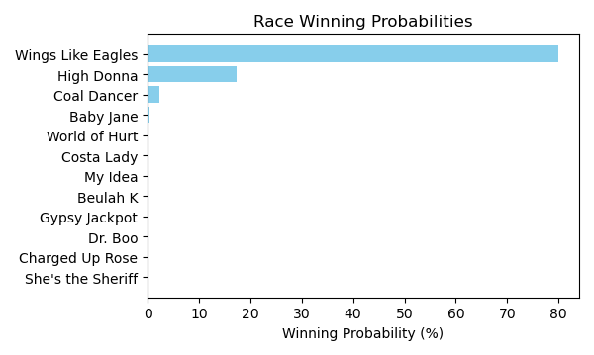

Figure: Winning Probability Distribution

NOTE: THIS RACE HAS HORSES THAT ARE MISSING CRITICAL DATA ELEMENTS

# Race: DED | 2025-02-22 | Race #2 | Track: DELTA DOWNS

Track: DELTA DOWNS

|  |  |  |  |  |
| --- | --- | --- | --- | --- |
| Saddle Cloth # | Horse Name | Global Speed | Composite | Win Prob (%) |
| ['', 1, ''] | Moor to Conquer * | 82.0 | -1.11 | 0.01 |
| ['', 2, ''] | Unaffiliated | 82.0 | 8.50 | 24.33 |
| ['', 3, ''] | UNION CARD * | 82.0 | 9.08 | 38.83 |
| ['', 4, ''] | Wabash * | 82.0 | 4.71 | 1.17 |
| ['', 5, ''] | Olympia Harbor * | 82.0 | -5.43 | 0.00 |
| ['', 6, ''] | LEMON FIZZ * | 82.0 | 8.93 | 34.38 |
| ['', 7, ''] | Simplicated | 82.0 | 4.81 | 1.27 |

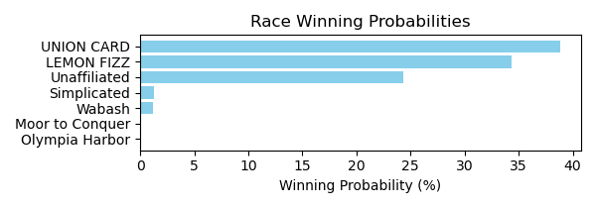

Figure: Winning Probability Distribution

NOTE: THIS RACE HAS HORSES THAT ARE MISSING CRITICAL DATA ELEMENTS

# Race: DED | 2025-02-22 | Race #3 | Track: DELTA DOWNS

Track: DELTA DOWNS

|  |  |  |  |  |
| --- | --- | --- | --- | --- |
| Saddle Cloth # | Horse Name | Global Speed | Composite | Win Prob (%) |
| ['', 1, ''] | ZANTERIA * | 88.9 | 4.01 | 8.30 |
| ['', 2, ''] | Mopac Traffic | 88.9 | -2.69 | 0.04 |
| ['', 3, ''] | Dreamchaser Jewels * | 88.9 | -3.66 | 0.02 |
| ['', 4, ''] | Kalil * | 88.9 | 6.78 | 76.07 |
| ['', 5, ''] | Wicked Sailor * | 88.9 | 0.32 | 0.43 |
| ['', 6, ''] | Platinumus Maximus * | 88.9 | -0.67 | 0.20 |
| ['', 7, ''] | Tizzira * | 88.9 | -8.47 | 0.00 |
| ['', 8, ''] | Frisee * | 88.9 | -7.88 | 0.00 |
| ['', 9, ''] | Cc Cola * | 88.9 | 4.74 | 14.82 |
| ['', 10, ''] | Thats Unbelievable * | 88.9 | -1.28 | 0.12 |

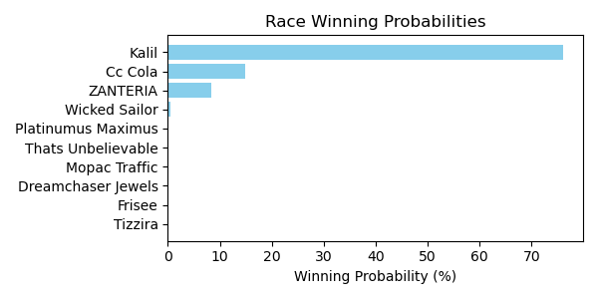

Figure: Winning Probability Distribution

NOTE: THIS RACE HAS HORSES THAT ARE MISSING CRITICAL DATA ELEMENTS

# Race: DED | 2025-02-22 | Race #4 | Track: DELTA DOWNS

Track: DELTA DOWNS

|  |  |  |  |  |
| --- | --- | --- | --- | --- |
| Saddle Cloth # | Horse Name | Global Speed | Composite | Win Prob (%) |
| ['', 1, ''] | The Donegal Clan | 104.5 | 1.49 | 0.20 |
| ['', 2, ''] | Without a Trace | 104.5 | 2.62 | 0.50 |
| ['', 3, ''] | Iron in the Fire * | 104.5 | 7.74 | 30.10 |
| ['', 4, ''] | Uxmal * | 104.5 | 5.50 | 5.00 |
| ['', 5, ''] | All About Croge * | 104.5 | -7.23 | 0.00 |
| ['', 6, ''] | Brite Outlook * | 104.5 | 7.29 | 20.98 |
| ['', 7, ''] | Special Stormy | 104.5 | 6.88 | 15.12 |
| ['', 8, ''] | Unified Dreams | 104.5 | 7.66 | 28.09 |

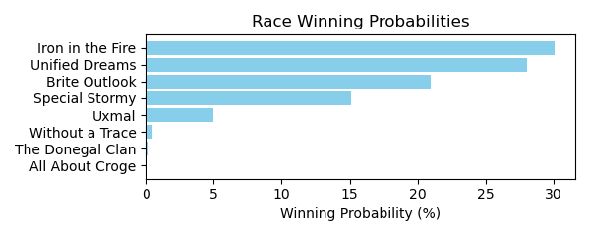

Figure: Winning Probability Distribution

NOTE: THIS RACE HAS HORSES THAT ARE MISSING CRITICAL DATA ELEMENTS

# Race: DED | 2025-02-22 | Race #5 | Track: DELTA DOWNS

Track: DELTA DOWNS

|  |  |  |  |  |
| --- | --- | --- | --- | --- |
| Saddle Cloth # | Horse Name | Global Speed | Composite | Win Prob (%) |
| ['', 1, ''] | G E H Giants Way * | 66.5 | -6.09 | 0.00 |
| ['', 2, ''] | Love a Fighter * | 66.5 | -8.96 | 0.00 |
| ['', 3, ''] | Vobiscum | 66.5 | 7.57 | 92.51 |
| ['', 4, ''] | Baby's Last Dance * | 66.5 | -9.66 | 0.00 |
| ['', 5, ''] | Quick Zong * | 66.5 | -7.56 | 0.00 |
| ['', 6, ''] | True and Ready | 66.5 | 2.33 | 1.40 |
| ['', 7, ''] | Tiz Fabulous | 66.5 | 1.34 | 0.63 |
| ['', 8, ''] | Top Priority * | 66.5 | 2.26 | 1.32 |
| ['', 9, ''] | Relic Hunter * | 66.5 | 3.68 | 4.12 |
| ['', 10, ''] | Catalina Day * | 66.5 | -3.97 | 0.01 |

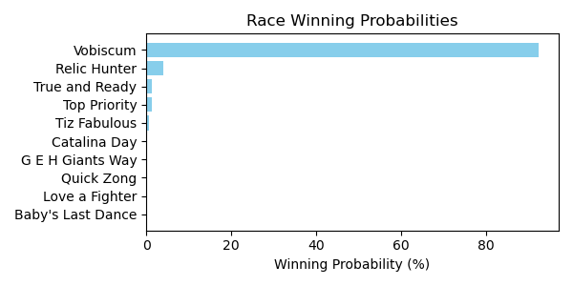

Figure: Winning Probability Distribution

NOTE: THIS RACE HAS HORSES THAT ARE MISSING CRITICAL DATA ELEMENTS

# Race: DED | 2025-02-22 | Race #6 | Track: DELTA DOWNS

Track: DELTA DOWNS

|  |  |  |  |  |
| --- | --- | --- | --- | --- |
| Saddle Cloth # | Horse Name | Global Speed | Composite | Win Prob (%) |
| ['', 1, ''] | New Destiny * | 111.6 | -5.78 | 0.00 |
| ['', 2, ''] | Butler Cabin * | 111.6 | 4.63 | 1.27 |
| ['', 3, ''] | My Uncle Leon | 111.6 | 10.02 | 94.79 |
| ['', 4, ''] | Confucius | 111.6 | -0.25 | 0.03 |
| ['', 5, ''] | Cajun Mischief * | 111.6 | -2.06 | 0.01 |
| ['', 6, ''] | Sonneman | 111.6 | 1.96 | 0.15 |
| ['', 7, ''] | Into Wishing | 111.6 | -2.71 | 0.00 |
| ['', 8, ''] | Bayou Jam * | 111.6 | 0.47 | 0.05 |
| ['', 9, ''] | Dare to Fail | 111.6 | -7.18 | 0.00 |
| ['', 10, ''] | Northernreflection * | 111.6 | 5.01 | 1.72 |
| ['', 11, ''] | Guitar Boy | 111.6 | 5.00 | 1.71 |
| ['', 12, ''] | Rockall | 111.6 | 2.77 | 0.29 |

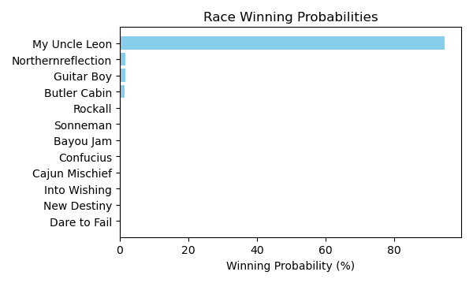

Figure: Winning Probability Distribution

NOTE: THIS RACE HAS HORSES THAT ARE MISSING CRITICAL DATA ELEMENTS

# Race: DED | 2025-02-22 | Race #7 | Track: DELTA DOWNS

Track: DELTA DOWNS

|  |  |  |  |  |
| --- | --- | --- | --- | --- |
| Saddle Cloth # | Horse Name | Global Speed | Composite | Win Prob (%) |
| ['', 1, ''] | Tap to Connect | 88.9 | 8.15 | 50.32 |
| ['', 2, ''] | Aller Vite | 88.9 | -0.11 | 0.07 |
| ['', 3, ''] | Out Making Treble * | 88.9 | -5.30 | 0.00 |
| ['', 4, ''] | Roulette | 88.9 | 1.65 | 0.28 |
| ['', 5, ''] | Cowboy Cause | 88.9 | 7.54 | 30.92 |
| ['', 6, ''] | Classy Shipman | 88.9 | -2.62 | 0.01 |
| ['', 7, ''] | All Saints * | 88.9 | 6.79 | 16.93 |
| ['', 8, ''] | Saucy Argument * | 88.9 | -5.53 | 0.00 |
| ['', 9, ''] | Gloria's Boy * | 88.9 | -7.64 | 0.00 |
| ['', 10, ''] | Nephi * | 88.9 | 3.06 | 0.86 |
| ['', 11, ''] | F J's Flaco * | 88.9 | 2.63 | 0.61 |
| ['', 12, ''] | Bobby Merlot * | 88.9 | -2.31 | 0.01 |

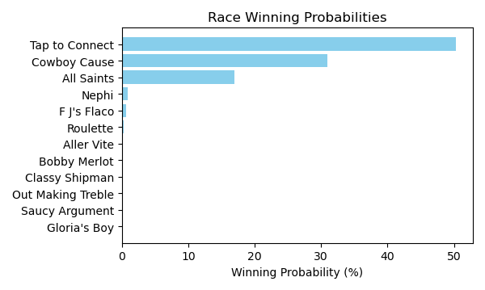

Figure: Winning Probability Distribution

NOTE: THIS RACE HAS HORSES THAT ARE MISSING CRITICAL DATA ELEMENTS

# Race: DED | 2025-02-22 | Race #8 | Track: DELTA DOWNS

Track: DELTA DOWNS

|  |  |  |  |  |
| --- | --- | --- | --- | --- |
| Saddle Cloth # | Horse Name | Global Speed | Composite | Win Prob (%) |
| ['', 1, ''] | Eagle Point * | 96.1 | -2.97 | 0.01 |
| ['', 2, ''] | Mischievous Smile * | 96.1 | 1.29 | 0.21 |
| ['', 3, ''] | North of Bali | 96.1 | 7.45 | 29.51 |
| ['', 4, ''] | After the Game | 96.1 | 0.32 | 0.10 |
| ['', 5, ''] | M L Brody's Gem * | 96.1 | 3.41 | 1.16 |
| ['', 6, ''] | BARR'S BAY * | 96.1 | 5.82 | 8.01 |
| ['', 7, ''] | Steen | 96.1 | -7.39 | 0.00 |
| ['', 8, ''] | Mariachi Man * | 96.1 | 8.04 | 47.23 |
| ['', 9, ''] | Zestiny * | 96.1 | -4.40 | 0.00 |
| ['', 10, ''] | FLINT'S SPARKY * | 96.1 | 5.84 | 8.13 |
| ['', 11, ''] | C F Jimmy Ray * | 96.1 | -1.23 | 0.03 |
| ['', 12, ''] | Prince Perfecta | 96.1 | 5.38 | 5.62 |

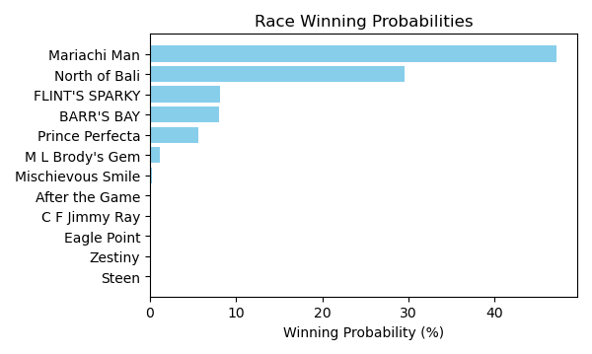

Figure: Winning Probability Distribution

NOTE: THIS RACE HAS HORSES THAT ARE MISSING CRITICAL DATA ELEMENTS

# Race: DED | 2025-02-22 | Race #9 | Track: DELTA DOWNS

Track: DELTA DOWNS

|  |  |  |  |  |
| --- | --- | --- | --- | --- |
| Saddle Cloth # | Horse Name | Global Speed | Composite | Win Prob (%) |
| ['', 1, ''] | Chad's Flashy Ways * | 82.4 | 8.19 | 5.96 |
| ['', 2, ''] | El Dan * | 82.4 | 7.64 | 3.84 |
| ['', 3, ''] | Connectique * | 82.4 | 1.62 | 0.03 |
| ['', 4, ''] | Majestic Palace * | 82.4 | 1.47 | 0.03 |
| ['', 5, ''] | Same Play * | 82.4 | -1.96 | 0.00 |
| ['', 6, ''] | Pennys Deal * | 82.4 | -3.95 | 0.00 |
| ['', 7, ''] | Tincan Cat * | 82.4 | -0.53 | 0.01 |
| ['', 8, ''] | Majority Opinion | 82.4 | 6.02 | 1.05 |
| ['', 9, ''] | Country Hit * | 82.4 | 11.57 | 89.07 |
| ['', 10, ''] | Koodie * | 82.4 | -0.96 | 0.00 |
| ['', 11, ''] | Gabbys Bling * | 82.4 | -2.42 | 0.00 |
| ['', 12, ''] | Gray Dane * | 82.4 | 0.48 | 0.01 |

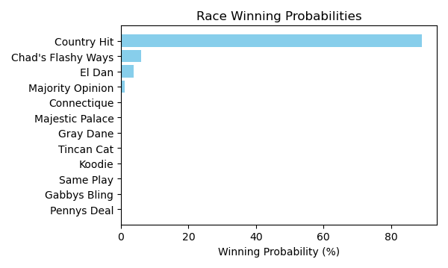

Figure: Winning Probability Distribution

NOTE: THIS RACE HAS HORSES THAT ARE MISSING CRITICAL DATA ELEMENTS

# Race: DED | 2025-02-22 | Race #10 | Track: DELTA DOWNS

Track: DELTA DOWNS

|  |  |  |  |  |
| --- | --- | --- | --- | --- |
| Saddle Cloth # | Horse Name | Global Speed | Composite | Win Prob (%) |
| ['', 1, ''] | Crusin Like a Cat * | 66.6 | 2.10 | 0.98 |
| ['', 2, ''] | Cajun Catalina * | 66.6 | 4.96 | 9.64 |
| ['', 3, ''] | Ironit | 66.6 | -9.75 | 0.00 |
| ['', 4, ''] | Usain d'Oro * | 66.6 | 7.44 | 69.80 |
| ['', 5, ''] | Fitzy * | 66.6 | 5.13 | 11.02 |
| ['', 6, ''] | Myfriendsawinner | 66.6 | 2.72 | 1.60 |
| ['', 7, ''] | Country Lady | 66.6 | -2.09 | 0.03 |
| ['', 8, ''] | Custom Sunshine * | 66.6 | 4.16 | 5.08 |
| ['', 9, ''] | Miss Dealority * | 66.6 | 2.89 | 1.84 |

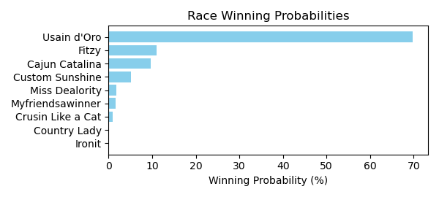

Figure: Winning Probability Distribution

NOTE: THIS RACE HAS HORSES THAT ARE MISSING CRITICAL DATA ELEMENTS

# Race: DED | 2025-02-22 | Race #11 | Track: DELTA DOWNS

Track: DELTA DOWNS

|  |  |  |  |  |
| --- | --- | --- | --- | --- |
| Saddle Cloth # | Horse Name | Global Speed | Composite | Win Prob (%) |
| ['', 1, ''] | Hard Candy Kisses * | 82.1 | 3.80 | 9.16 |
| ['', 2, ''] | Surprise Sunrise * | 82.1 | -2.32 | 0.07 |
| ['', 3, ''] | Cat Ate the Canary | 82.1 | -2.38 | 0.06 |
| ['', 4, ''] | Break Out Sister * | 82.1 | -8.03 | 0.00 |
| ['', 5, ''] | Tiz a Breakup * | 82.1 | 1.98 | 2.12 |
| ['', 6, ''] | Brand Bois * | 82.1 | -7.09 | 0.00 |
| ['', 7, ''] | Taka | 82.1 | 6.61 | 86.37 |
| ['', 8, ''] | Round in Circles | 82.1 | 2.00 | 2.17 |
| ['', 9, ''] | Abbey Cakes | 82.1 | -8.91 | 0.00 |
| ['', 10, ''] | Miss Gypsy * | 82.1 | -3.13 | 0.04 |
| ['', 11, ''] | Chimes Lake * | 82.1 | -10.29 | 0.00 |

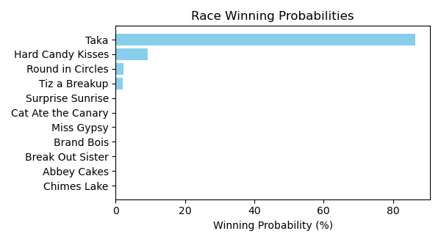

Figure: Winning Probability Distribution

NOTE: THIS RACE HAS HORSES THAT ARE MISSING CRITICAL DATA ELEMENTS

# Race: TFG | 2025-02-21 | Race #1 | Track: FAIR GROUNDS

Track: FAIR GROUNDS

|  |  |  |  |  |
| --- | --- | --- | --- | --- |
| Saddle Cloth # | Horse Name | Global Speed | Composite | Win Prob (%) |
| ['', 1, ''] | Kinsman Redeemer | 76.2 | 8.56 | 73.09 |
| ['', 2, ''] | Metronome | 76.2 | -1.67 | 0.02 |
| ['', 3, ''] | Knock'em Out Jerry | 76.2 | 7.29 | 26.41 |
| ['', 4, ''] | C F Cantgoforthat * | 76.2 | -9.66 | 0.00 |
| ['', 5, ''] | Wholeheartedly | 76.2 | 2.02 | 0.39 |
| ['', 6, ''] | Tamashi | 76.2 | -7.88 | 0.00 |
| ['', 7, ''] | Ragnow | 76.2 | 0.14 | 0.09 |

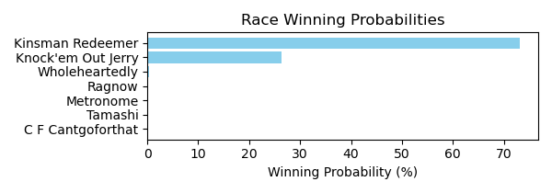

Figure: Winning Probability Distribution

NOTE: THIS RACE HAS HORSES THAT ARE MISSING CRITICAL DATA ELEMENTS

# Race: TFG | 2025-02-21 | Race #2 | Track: FAIR GROUNDS

Track: FAIR GROUNDS

|  |  |  |  |  |
| --- | --- | --- | --- | --- |
| Saddle Cloth # | Horse Name | Global Speed | Composite | Win Prob (%) |
| ['', 1, ''] | Call My Banker * | 76.5 | 10.35 | 68.83 |
| ['', 2, ''] | Peso in My Pocket | 76.5 | 7.38 | 6.40 |
| ['', 3, ''] | Notion | 76.5 | 4.32 | 0.55 |
| ['', 4, ''] | Scooteranddabigman * | 76.5 | 5.55 | 1.49 |
| ['', 5, ''] | Oncoming Train | 76.5 | -5.89 | 0.00 |
| ['', 6, ''] | Global Pride * | 76.5 | 8.95 | 22.52 |
| ['', 7, ''] | Cryptozonic | 76.5 | 3.06 | 0.20 |
| ['', 8, ''] | Twirling Roses * | 76.5 | -1.27 | 0.01 |

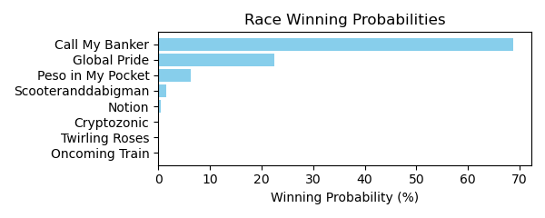

Figure: Winning Probability Distribution

NOTE: THIS RACE HAS HORSES THAT ARE MISSING CRITICAL DATA ELEMENTS

# Race: TFG | 2025-02-21 | Race #3 | Track: FAIR GROUNDS

Track: FAIR GROUNDS

|  |  |  |  |  |
| --- | --- | --- | --- | --- |
| Saddle Cloth # | Horse Name | Global Speed | Composite | Win Prob (%) |
| ['', 1, ''] | Kazillion * | 96.4 | -5.32 | 0.11 |
| ['', 2, ''] | Cheval B | 96.4 | 0.49 | 11.15 |
| ['', 3, ''] | Star Anise * | 96.4 | 1.84 | 32.83 |
| ['', 4, ''] | Lynna | 96.4 | -7.75 | 0.02 |
| ['', 5, ''] | Ash Wednesday | 96.4 | 2.49 | 55.45 |
| ['', 6, ''] | Wayzata | 96.4 | -5.51 | 0.09 |
| ['', 7, ''] | Daring Hope | 96.4 | -6.46 | 0.04 |
| ['', 8, ''] | Mischief Lily | 96.4 | -7.41 | 0.02 |
| ['', 9, ''] | Trust Fund Baby | 96.4 | -10.17 | 0.00 |
| ['', 10, ''] | Promdatebonnie | 96.4 | -4.08 | 0.29 |

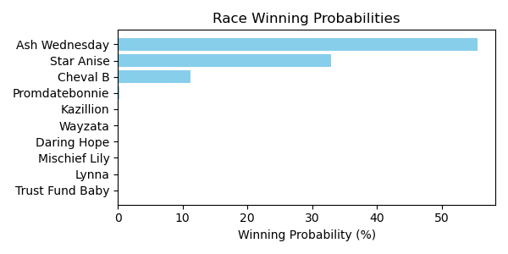

Figure: Winning Probability Distribution

NOTE: THIS RACE HAS HORSES THAT ARE MISSING CRITICAL DATA ELEMENTS

# Race: TFG | 2025-02-21 | Race #4 | Track: FAIR GROUNDS

Track: FAIR GROUNDS

|  |  |  |  |  |
| --- | --- | --- | --- | --- |
| Saddle Cloth # | Horse Name | Global Speed | Composite | Win Prob (%) |
| ['', 1, ''] | Cairo Charm * | 76.2 | -9.87 | 0.00 |
| ['', 2, ''] | Wannawholelottaluv | 76.2 | -6.13 | 0.00 |
| ['', 3, ''] | Copper Crush | 76.2 | -7.11 | 0.00 |
| ['', 4, ''] | Aspen Link | 76.2 | -3.32 | 0.01 |
| ['', 5, ''] | Honor His Half * | 76.2 | -3.27 | 0.01 |
| ['', 6, ''] | Runtolive * | 76.2 | -4.55 | 0.00 |
| ['', 7, ''] | Dreamy Deal | 76.2 | -5.26 | 0.00 |
| ['', 8, ''] | Sassy Spry * | 76.2 | 7.68 | 61.11 |
| ['', 9, ''] | Mika Ella Pika * | 76.2 | 5.79 | 13.49 |
| ['', 10, ''] | Radiant Rebel | 76.2 | 6.49 | 23.58 |
| ['', 11, ''] | Mia Antonia | 76.2 | 3.27 | 1.79 |

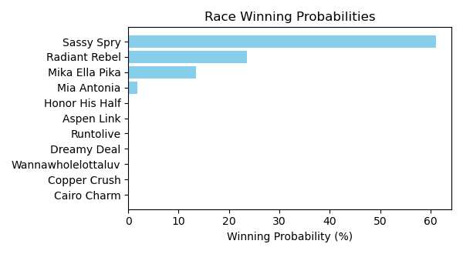

Figure: Winning Probability Distribution

NOTE: THIS RACE HAS HORSES THAT ARE MISSING CRITICAL DATA ELEMENTS

# Race: TFG | 2025-02-21 | Race #5 | Track: FAIR GROUNDS

Track: FAIR GROUNDS

|  |  |  |  |  |
| --- | --- | --- | --- | --- |
| Saddle Cloth # | Horse Name | Global Speed | Composite | Win Prob (%) |
| ['', 1, ''] | Just Jimmy | 104.3 | -1.63 | 0.03 |
| ['', 2, ''] | Bourbon Life | 104.3 | -1.80 | 0.03 |
| ['', 3, ''] | Battle Scars * | 104.3 | 2.17 | 0.72 |
| ['', 4, ''] | Sivako | 104.3 | 5.06 | 7.24 |
| ['', 5, ''] | Optimus Kat | 104.3 | 7.55 | 53.01 |
| ['', 6, ''] | Rowdy Jess | 104.3 | -8.89 | 0.00 |
| ['', 7, ''] | South Side * | 104.3 | 5.34 | 9.09 |
| ['', 8, ''] | Clarestown | 104.3 | 2.97 | 1.36 |
| ['', 9, ''] | Prowling Tiger | 104.3 | -3.68 | 0.01 |
| ['', 10, ''] | Gentle Soul | 104.3 | 6.77 | 28.51 |

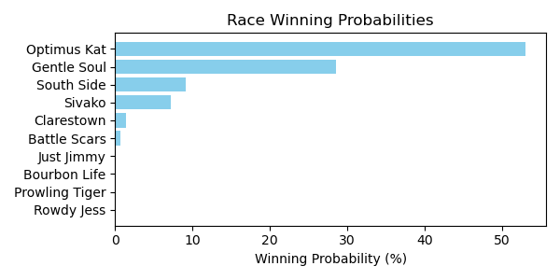

Figure: Winning Probability Distribution

NOTE: THIS RACE HAS HORSES THAT ARE MISSING CRITICAL DATA ELEMENTS

# Race: TFG | 2025-02-21 | Race #6 | Track: FAIR GROUNDS

Track: FAIR GROUNDS

|  |  |  |  |  |
| --- | --- | --- | --- | --- |
| Saddle Cloth # | Horse Name | Global Speed | Composite | Win Prob (%) |
| ['', 1, ''] | Hesper * | 71.2 | 4.18 | 2.54 |
| ['', 2, ''] | Hawija | 71.2 | 8.60 | 86.79 |
| ['', 3, ''] | Classic Time | 71.2 | -1.19 | 0.03 |
| ['', 4, ''] | Gabbys Bling * | 71.2 | -3.63 | 0.00 |
| ['', 5, ''] | Pair of Socks | 71.2 | 5.17 | 5.62 |
| ['', 6, ''] | Voila Magic * | 71.2 | 4.95 | 4.71 |
| ['', 7, ''] | Distinctly Golden * | 71.2 | 1.51 | 0.30 |

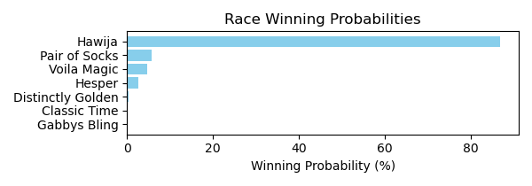

Figure: Winning Probability Distribution

NOTE: THIS RACE HAS HORSES THAT ARE MISSING CRITICAL DATA ELEMENTS

# Race: TFG | 2025-02-21 | Race #7 | Track: FAIR GROUNDS

Track: FAIR GROUNDS

|  |  |  |  |  |
| --- | --- | --- | --- | --- |
| Saddle Cloth # | Horse Name | Global Speed | Composite | Win Prob (%) |
| ['', 1, ''] | Rampagius | 111.5 | 2.97 | 0.92 |
| ['', 2, ''] | King Rosso | 111.5 | 6.92 | 21.69 |
| ['', 3, ''] | Seaville * | 111.5 | -4.16 | 0.00 |
| ['', 4, ''] | Elko County | 111.5 | -0.18 | 0.07 |
| ['', 5, ''] | El Magnifico | 111.5 | 7.58 | 36.64 |
| ['', 6, ''] | English Chunnel | 111.5 | 5.76 | 8.60 |
| ['', 7, ''] | Hard Par | 111.5 | -5.78 | 0.00 |
| ['', 8, ''] | Finn McSorley | 111.5 | -4.82 | 0.00 |
| ['', 9, ''] | Initialize | 111.5 | 1.72 | 0.34 |
| ['', 10, ''] | Tickled Quist | 111.5 | -1.10 | 0.04 |
| ['', 11, ''] | THE COMMACK KID * | 111.5 | 6.93 | 21.92 |
| ['', 12, ''] | Pretty Capable * | 111.5 | 5.92 | 9.77 |
| ['', 13, ''] | Global Quote | 111.5 | -3.52 | 0.01 |

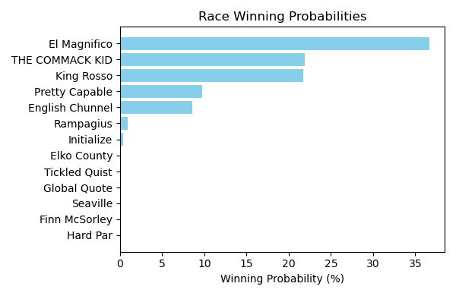

Figure: Winning Probability Distribution

NOTE: THIS RACE HAS HORSES THAT ARE MISSING CRITICAL DATA ELEMENTS

# Race: TFG | 2025-02-21 | Race #8 | Track: FAIR GROUNDS

Track: FAIR GROUNDS

|  |  |  |  |  |
| --- | --- | --- | --- | --- |
| Saddle Cloth # | Horse Name | Global Speed | Composite | Win Prob (%) |
| ['', 1, ''] | Razz * | 70.9 | -4.26 | 0.00 |
| ['', 2, ''] | Rebind | 70.9 | -7.65 | 0.00 |
| ['', 3, ''] | Bobby Two Shot's * | 70.9 | 6.75 | 29.27 |
| ['', 4, ''] | Puppeteer * | 70.9 | -0.40 | 0.10 |
| ['', 5, ''] | Its Wild Again | 70.9 | 2.30 | 0.83 |
| ['', 6, ''] | Colt's Brim | 70.9 | 1.89 | 0.60 |
| ['', 7, ''] | Sophie's Painter * | 70.9 | -3.58 | 0.01 |
| ['', 8, ''] | Maximum Grace | 70.9 | -3.91 | 0.01 |
| ['', 9, ''] | Lost My Bag | 70.9 | 7.42 | 50.02 |
| ['', 10, ''] | Righteous Freedom * | 70.9 | 6.22 | 19.15 |
| ['', 11, ''] | Josan * | 70.9 | -3.15 | 0.01 |

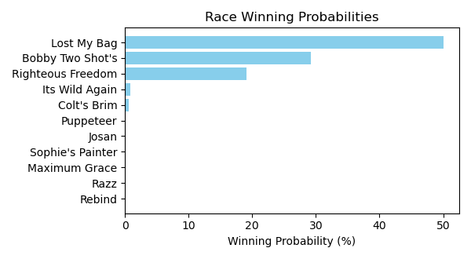

Figure: Winning Probability Distribution

NOTE: THIS RACE HAS HORSES THAT ARE MISSING CRITICAL DATA ELEMENTS

# Race: FON | 2025-02-22 | Race #1 | Track: FONNER PARK

Track: FONNER PARK

|  |  |  |  |  |
| --- | --- | --- | --- | --- |
| Saddle Cloth # | Horse Name | Global Speed | Composite | Win Prob (%) |
| ['', 1, ''] | Legend of Gold * | 103.9 | 0.11 | 14.37 |
| ['', 2, ''] | Joey's Valentine * | 76.3 | 5.00 | 2.89 |
| ['', 3, ''] | Caleb On the Go * | 76.3 | -7.24 | 0.00 |
| ['', 4, ''] | Ships Log * | 82.4 | 5.33 | 12.71 |
| ['', 5, ''] | Firespitten Kitten * | 103.9 | 1.87 | 58.65 |
| ['', 6, ''] | Phlash Drive * | 76.3 | 6.71 | 11.38 |

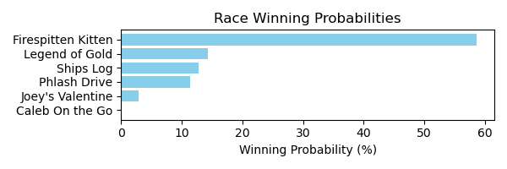

Figure: Winning Probability Distribution

NOTE: THIS RACE HAS HORSES THAT ARE MISSING CRITICAL DATA ELEMENTS

# Race: FON | 2025-02-22 | Race #2 | Track: FONNER PARK

Track: FONNER PARK

|  |  |  |  |  |
| --- | --- | --- | --- | --- |
| Saddle Cloth # | Horse Name | Global Speed | Composite | Win Prob (%) |
| ['', 1, ''] | Youngdumbandbroke * | 71.1 | 1.84 | 0.00 |
| ['', 2, ''] | Big Boss Ben * | 59.7 | -2.61 | 0.00 |
| ['', 3, ''] | Reginald Aurelius * | 66.5 | -3.66 | 0.00 |
| ['', 4, ''] | Palace Attained | 71.1 | -2.22 | 0.00 |
| ['', 5, ''] | dh-Steel Link | 76.4 | 8.46 | 2.13 |
| ['', 6, ''] | Willet Kinda Night * | 59.7 | -8.09 | 0.00 |
| ['', 7, ''] | Lt. Norm | 96.5 | 8.22 | 97.87 |

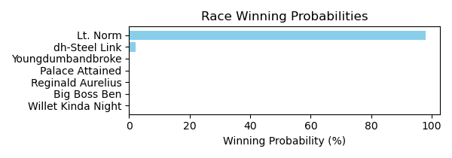

Figure: Winning Probability Distribution

NOTE: THIS RACE HAS HORSES THAT ARE MISSING CRITICAL DATA ELEMENTS

# Race: FON | 2025-02-22 | Race #3 | Track: FONNER PARK

Track: FONNER PARK

|  |  |  |  |  |
| --- | --- | --- | --- | --- |
| Saddle Cloth # | Horse Name | Global Speed | Composite | Win Prob (%) |
| ['', 1, ''] | My Buddy Mel * | 66.6 | 6.57 | 5.51 |
| ['', 2, ''] | Forced Ranking * | 104.3 | -3.44 | 3.39 |
| ['', 3, ''] | Exacting | 76.5 | 7.23 | 66.90 |
| ['', 4, ''] | dh-Drivehappy * | 66.6 | 7.05 | 8.04 |
| ['', 5, ''] | Mister Chairman | 76.5 | -0.36 | 0.15 |
| ['', 6, ''] | Absolute Chaos * | 76.5 | -2.83 | 0.02 |
| ['', 7, ''] | Falsely Accused * | 104.3 | -1.50 | 15.99 |

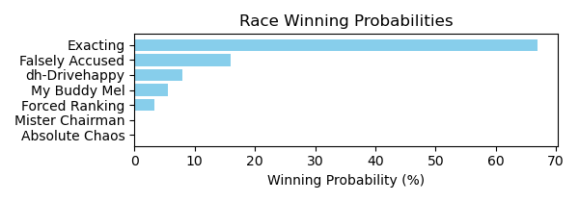

Figure: Winning Probability Distribution

NOTE: THIS RACE HAS HORSES THAT ARE MISSING CRITICAL DATA ELEMENTS

# Race: FON | 2025-02-22 | Race #4 | Track: FONNER PARK

Track: FONNER PARK

|  |  |  |  |  |
| --- | --- | --- | --- | --- |
| Saddle Cloth # | Horse Name | Global Speed | Composite | Win Prob (%) |
| ['', 1, ''] | Ferociously * | 66.6 | 2.99 | 0.08 |
| ['', 2, ''] | Time Machine * | 66.6 | -0.78 | 0.00 |
| ['', 3, ''] | Creative Miracle | 71.1 | 8.64 | 17.12 |
| ['', 4, ''] | Mucho Gifted * | 71.1 | -1.56 | 0.00 |
| ['', 5, ''] | Kaely's Brother * | 89.3 | 5.98 | 77.12 |
| ['', 6, ''] | Magnet and Steel | 76.4 | 5.76 | 4.94 |
| ['', 7, ''] | Daddy's Finest * | 66.6 | 5.85 | 0.74 |
| ['', 8, ''] | Jamming Eddy | 59.7 | -4.70 | 0.00 |

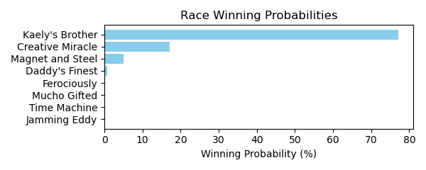

Figure: Winning Probability Distribution

NOTE: THIS RACE HAS HORSES THAT ARE MISSING CRITICAL DATA ELEMENTS

# Race: FON | 2025-02-22 | Race #5 | Track: FONNER PARK

Track: FONNER PARK

|  |  |  |  |  |
| --- | --- | --- | --- | --- |
| Saddle Cloth # | Horse Name | Global Speed | Composite | Win Prob (%) |
| ['', 1, ''] | J's Little Man | 82.3 | -3.13 | 0.08 |
| ['', 2, ''] | The Greatest Eagle * | 108.5 | -5.21 | 2.97 |
| ['', 3, ''] | Schleicher | 76.2 | 6.20 | 42.90 |
| ['', 4, ''] | Northwind * | 103.8 | -0.46 | 51.09 |
| ['', 5, ''] | Tap Dance Tango | 71.0 | -3.17 | 0.01 |
| ['', 6, ''] | Hangin' Tuff | 59.7 | 5.30 | 0.75 |
| ['', 7, ''] | Ring Tailed Tooter * | 76.2 | 2.26 | 1.83 |
| ['', 8, ''] | Prince Is My Boy | 108.5 | -7.85 | 0.36 |
| ['', 9, ''] | Hard Luck Henry * | 82.3 | -5.43 | 0.01 |

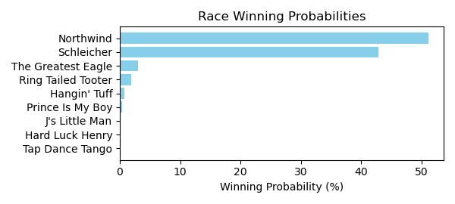

Figure: Winning Probability Distribution

NOTE: THIS RACE HAS HORSES THAT ARE MISSING CRITICAL DATA ELEMENTS

# Race: FON | 2025-02-22 | Race #6 | Track: FONNER PARK

Track: FONNER PARK

|  |  |  |  |  |
| --- | --- | --- | --- | --- |
| Saddle Cloth # | Horse Name | Global Speed | Composite | Win Prob (%) |
| ['', 1, ''] | Go Lilly Go * | 76.0 | 1.06 | 4.00 |
| ['', 2, ''] | The Bigger Bear * | 70.8 | -0.01 | 0.60 |
| ['', 3, ''] | Beautiful Judge * | 103.3 | -4.95 | 7.72 |
| ['', 4, ''] | Thatta Peppa * | 103.3 | -9.85 | 0.15 |
| ['', 5, ''] | Goldies Claim * | 66.3 | -4.24 | 0.01 |
| ['', 6, ''] | May B Better * | 76.0 | 2.02 | 8.65 |
| ['', 7, ''] | Judge Jennings * | 66.3 | -1.64 | 0.07 |
| ['', 8, ''] | Lady Mazatlan * | 76.0 | 4.78 | 78.80 |

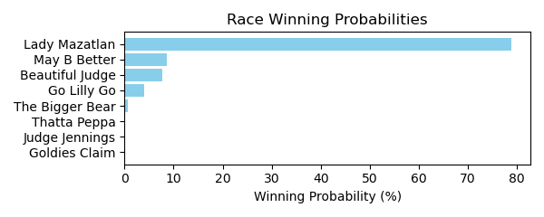

Figure: Winning Probability Distribution

NOTE: THIS RACE HAS HORSES THAT ARE MISSING CRITICAL DATA ELEMENTS

# Race: FON | 2025-02-22 | Race #7 | Track: FONNER PARK

Track: FONNER PARK

|  |  |  |  |  |
| --- | --- | --- | --- | --- |
| Saddle Cloth # | Horse Name | Global Speed | Composite | Win Prob (%) |
| ['', 1, ''] | Braybray * | 66.5 | -6.56 | 0.00 |
| ['', 2, ''] | Toska's Ruler * | 71.0 | 4.36 | 11.20 |
| ['', 3, ''] | Wilbert * | 89.1 | -9.42 | 0.01 |
| ['', 4, ''] | Robert Who * | 82.4 | -3.26 | 0.25 |
| ['', 5, ''] | Serendip Ruler | 66.5 | -3.85 | 0.01 |
| ['', 6, ''] | Rahm * | 59.7 | -0.20 | 0.03 |
| ['', 7, ''] | Captain Don * | 71.0 | 6.94 | 88.51 |
| ['', 8, ''] | Prince of Luck * | 71.0 | -9.61 | 0.00 |
| ['', 9, ''] | Kahaal * | 76.3 | -8.37 | 0.00 |

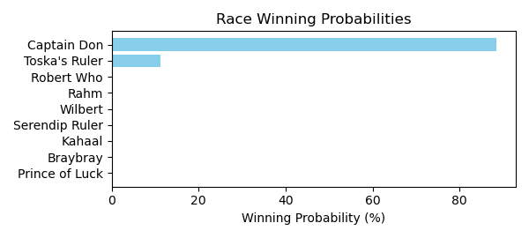

Figure: Winning Probability Distribution

NOTE: THIS RACE HAS HORSES THAT ARE MISSING CRITICAL DATA ELEMENTS

# Race: FON | 2025-02-22 | Race #8 | Track: FONNER PARK

Track: FONNER PARK

|  |  |  |  |  |
| --- | --- | --- | --- | --- |
| Saddle Cloth # | Horse Name | Global Speed | Composite | Win Prob (%) |
| ['', 1, ''] | Timehascome | 76.4 | -7.68 | 0.00 |
| ['', 2, ''] | Party Foul * | 66.6 | 5.08 | 2.02 |
| ['', 3, ''] | Prizeless | 66.6 | -1.41 | 0.01 |
| ['', 4, ''] | Fayette Warrior * | 66.6 | -3.00 | 0.00 |
| ['', 5, ''] | Rivzonaroll | 76.4 | -0.62 | 0.15 |
| ['', 6, ''] | Full Authority | 76.4 | 7.46 | 97.20 |
| ['', 7, ''] | Hurts So Good | 62.8 | 3.85 | 0.36 |
| ['', 8, ''] | Storm Catcher | 76.4 | 0.05 | 0.26 |
| ['', 9, ''] | Gold Punch * | 76.4 | -9.20 | 0.00 |

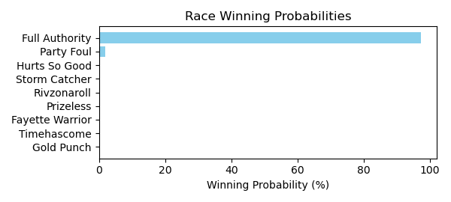

Figure: Winning Probability Distribution

NOTE: THIS RACE HAS HORSES THAT ARE MISSING CRITICAL DATA ELEMENTS

# Race: FON | 2025-02-22 | Race #9 | Track: FONNER PARK

Track: FONNER PARK

|  |  |  |  |  |
| --- | --- | --- | --- | --- |
| Saddle Cloth # | Horse Name | Global Speed | Composite | Win Prob (%) |
| ['', 1, ''] | Bluegrass Breeze * | 89.5 | -3.31 | 0.00 |
| ['', 2, ''] | Toomanynames | 111.7 | 3.71 | 98.31 |
| ['', 3, ''] | Axel Steel | 66.7 | 9.56 | 1.31 |
| ['', 4, ''] | Hacker * | 71.2 | -1.02 | 0.00 |
| ['', 5, ''] | Spirit's Mischief | 71.2 | 6.81 | 0.36 |
| ['', 6, ''] | Mysterious Tale * | 66.7 | 3.70 | 0.01 |
| ['', 7, ''] | Diamond City * | 82.7 | -3.72 | 0.00 |
| ['', 8, ''] | Under Oath | 62.9 | 3.90 | 0.01 |
| ['', 9, ''] | Adios Gary | 76.6 | -1.35 | 0.00 |

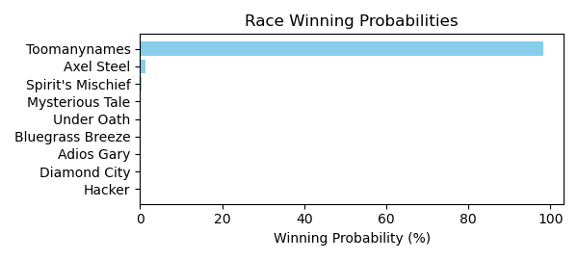

Figure: Winning Probability Distribution

NOTE: THIS RACE HAS HORSES THAT ARE MISSING CRITICAL DATA ELEMENTS

# Race: FON | 2025-02-22 | Race #10 | Track: FONNER PARK

Track: FONNER PARK

|  |  |  |  |  |
| --- | --- | --- | --- | --- |
| Saddle Cloth # | Horse Name | Global Speed | Composite | Win Prob (%) |
| ['', 1, ''] | Notacry * | 76.2 | -3.41 | 0.00 |
| ['', 2, ''] | Mongolian Moon * | 59.7 | -2.27 | 0.00 |
| ['', 3, ''] | Zultan * | 103.8 | 1.23 | 9.65 |
| ['', 4, ''] | Sol Del Sur * | 76.2 | 0.63 | 0.02 |
| ['', 5, ''] | Brilliant Colors * | 76.2 | 5.29 | 1.01 |
| ['', 6, ''] | Jahez | 103.8 | 2.39 | 24.26 |
| ['', 7, ''] | Broadway Pete * | 66.5 | 7.77 | 1.04 |
| ['', 8, ''] | Rosie's Boy * | 103.8 | 2.93 | 37.35 |
| ['', 9, ''] | Leaoflittlefaith | 76.2 | 9.39 | 26.68 |

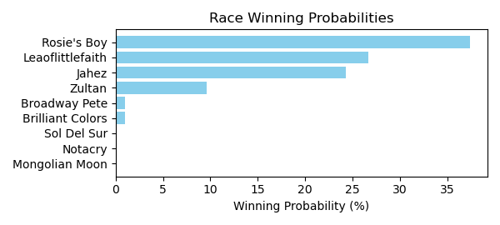

Figure: Winning Probability Distribution

NOTE: THIS RACE HAS HORSES THAT ARE MISSING CRITICAL DATA ELEMENTS

# Race: TGP | 2025-02-21 | Race #1 | Track: GULFSTREAM PARK

Track: GULFSTREAM PARK

|  |  |  |  |  |
| --- | --- | --- | --- | --- |
| Saddle Cloth # | Horse Name | Global Speed | Composite | Win Prob (%) |
| ['', 1, ''] | Pharoahs Baby Gyal | 76.3 | -6.96 | 0.00 |
| ['', 2, ''] | Gratia | 71.0 | -9.50 | 0.00 |
| ['', 3, ''] | Go Big Green | 111.2 | 0.76 | 72.64 |
| ['', 4, ''] | Dubstep | 108.6 | -8.21 | 0.03 |
| ['', 5, ''] | Motown Mika | 82.3 | 3.44 | 1.94 |
| ['', 6, ''] | Current Situation | 108.6 | 0.08 | 25.01 |
| ['', 7, ''] | Red Hot Spark | 71.0 | 4.25 | 0.38 |

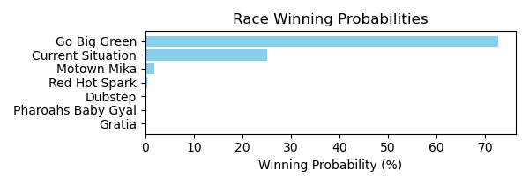

Figure: Winning Probability Distribution

NOTE: THIS RACE HAS HORSES THAT ARE MISSING CRITICAL DATA ELEMENTS

# Race: TGP | 2025-02-21 | Race #2 | Track: GULFSTREAM PARK

Track: GULFSTREAM PARK

|  |  |  |  |  |
| --- | --- | --- | --- | --- |
| Saddle Cloth # | Horse Name | Global Speed | Composite | Win Prob (%) |
| ['', 1, ''] | Sarah's Dream | 111.6 | 8.05 | 91.95 |
| ['', 2, ''] | My Blessing | 104.2 | -4.99 | 0.00 |
| ['', 3, ''] | Fantasy Performer | 104.2 | -1.30 | 0.01 |
| ['', 4, ''] | Goodbetterbest | 104.2 | 5.25 | 2.24 |
| ['', 5, ''] | Surprenant Cocca | 111.6 | 4.52 | 5.44 |
| ['', 6, ''] | Tinki Abarrio | 104.2 | -3.62 | 0.00 |
| ['', 7, ''] | On the Nile | 104.2 | -6.10 | 0.00 |
| ['', 8, ''] | Escape Room | 104.2 | 2.17 | 0.19 |
| ['', 9, ''] | Boston Rose (IRE) | 111.6 | 0.17 | 0.17 |

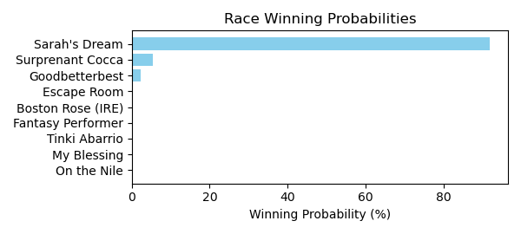

Figure: Winning Probability Distribution

NOTE: THIS RACE HAS HORSES THAT ARE MISSING CRITICAL DATA ELEMENTS

# Race: TGP | 2025-02-21 | Race #3 | Track: GULFSTREAM PARK

Track: GULFSTREAM PARK

|  |  |  |  |  |
| --- | --- | --- | --- | --- |
| Saddle Cloth # | Horse Name | Global Speed | Composite | Win Prob (%) |
| ['', 1, ''] | Secret Revenge | 66.5 | 0.52 | 0.05 |
| ['', 2, ''] | Lunetta Jak | 103.8 | -6.20 | 0.36 |
| ['', 3, ''] | BASHFUL DAISY * | 82.3 | 5.08 | 40.79 |
| ['', 4, ''] | La Girvina | 66.5 | -4.21 | 0.00 |
| ['', 5, ''] | WIFFLETREE SERRY * | 82.3 | 5.33 | 50.09 |
| ['', 6, ''] | Speranzosa * | 103.8 | -2.23 | 8.71 |

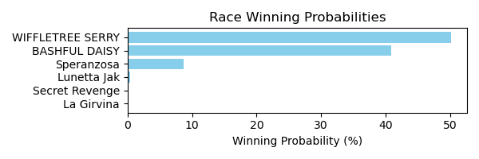

Figure: Winning Probability Distribution

NOTE: THIS RACE HAS HORSES THAT ARE MISSING CRITICAL DATA ELEMENTS

# Race: TGP | 2025-02-21 | Race #4 | Track: GULFSTREAM PARK

Track: GULFSTREAM PARK

|  |  |  |  |  |
| --- | --- | --- | --- | --- |
| Saddle Cloth # | Horse Name | Global Speed | Composite | Win Prob (%) |
| ['', 1, ''] | Come Dream With Me | 89.1 | 6.02 | 55.93 |
| ['', 2, ''] | Mohay Please | 103.9 | 1.72 | 34.40 |
| ['', 3, ''] | Otto | 76.3 | 3.70 | 0.67 |
| ['', 4, ''] | Southern Dream | 76.3 | -3.38 | 0.00 |
| ['', 5, ''] | Amazing Woo | 76.3 | -2.54 | 0.00 |
| ['', 6, ''] | Performante | 103.9 | -3.49 | 0.53 |
| ['', 7, ''] | Golden Sombrero | 76.3 | 2.57 | 0.27 |
| ['', 8, ''] | Go Billy Go | 76.3 | 6.82 | 8.19 |

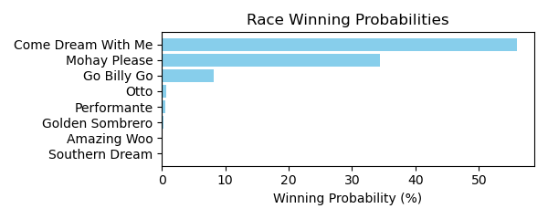

Figure: Winning Probability Distribution

NOTE: THIS RACE HAS HORSES THAT ARE MISSING CRITICAL DATA ELEMENTS

# Race: TGP | 2025-02-21 | Race #5 | Track: GULFSTREAM PARK

Track: GULFSTREAM PARK

|  |  |  |  |  |
| --- | --- | --- | --- | --- |
| Saddle Cloth # | Horse Name | Global Speed | Composite | Win Prob (%) |
| ['', 1, ''] | Lou the Body | 111.3 | 5.36 | 6.15 |
| ['', 2, ''] | Kuwait Towers | 111.3 | -0.56 | 0.05 |
| ['', 3, ''] | Dixie Preach | 111.3 | -0.61 | 0.05 |
| ['', 4, ''] | Take Your Seats (IRE) | 118.2 | 5.84 | 35.32 |
| ['', 5, ''] | Racket | 103.9 | 6.23 | 2.82 |
| ['', 6, ''] | Last U Turn | 111.3 | 1.61 | 0.31 |
| ['', 7, ''] | Franks Mimi | 111.3 | 7.41 | 31.80 |
| ['', 8, ''] | Star of the Beast | 108.7 | 7.69 | 23.49 |
| ['', 9, ''] | Split Strike | 71.0 | 3.17 | 0.00 |

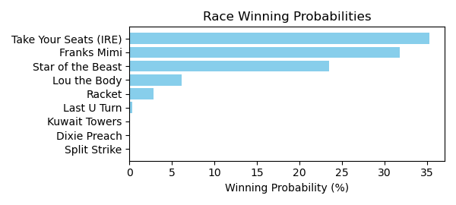

Figure: Winning Probability Distribution

NOTE: THIS RACE HAS HORSES THAT ARE MISSING CRITICAL DATA ELEMENTS

# Race: TGP | 2025-02-21 | Race #6 | Track: GULFSTREAM PARK

Track: GULFSTREAM PARK

|  |  |  |  |  |
| --- | --- | --- | --- | --- |
| Saddle Cloth # | Horse Name | Global Speed | Composite | Win Prob (%) |
| ['', 1, ''] | Right Angle | 71.0 | 7.54 | 0.19 |
| ['', 2, ''] | Spirited Boss | 71.0 | 8.29 | 0.35 |
| ['', 3, ''] | Designer Bag | 103.9 | 0.52 | 0.50 |
| ['', 4, ''] | Money Bouquet | 111.3 | 4.78 | 66.41 |
| ['', 5, ''] | Miss Mary Nell | 111.3 | 3.66 | 27.01 |
| ['', 6, ''] | La Gioconda | 111.3 | 1.64 | 5.39 |
| ['', 7, ''] | Mojo Rising * | 76.3 | 5.88 | 0.15 |

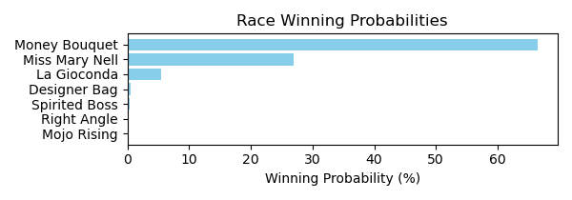

Figure: Winning Probability Distribution

NOTE: THIS RACE HAS HORSES THAT ARE MISSING CRITICAL DATA ELEMENTS

# Race: TGP | 2025-02-21 | Race #7 | Track: GULFSTREAM PARK

Track: GULFSTREAM PARK

|  |  |  |  |  |
| --- | --- | --- | --- | --- |
| Saddle Cloth # | Horse Name | Global Speed | Composite | Win Prob (%) |
| ['', 1, ''] | Waittilmidnitehour | 66.6 | 8.11 | 22.00 |
| ['', 2, ''] | One of One | 66.6 | 7.24 | 10.91 |
| ['', 3, ''] | Warda | 66.6 | 6.16 | 4.63 |
| ['', 4, ''] | Chloe's Toy | 71.1 | 6.63 | 16.60 |
| ['', 5, ''] | Kikitsa | 66.6 | -4.08 | 0.00 |
| ['', 6, ''] | Mywifeknowsitall | 66.6 | 8.80 | 37.98 |
| ['', 7, ''] | Party Shaker | 71.1 | 0.99 | 0.18 |
| ['', 8, ''] | Fortuna Belle | 66.6 | 6.80 | 7.70 |

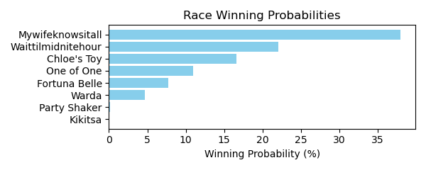

Figure: Winning Probability Distribution

NOTE: THIS RACE HAS HORSES THAT ARE MISSING CRITICAL DATA ELEMENTS

# Race: TGP | 2025-02-21 | Race #8 | Track: GULFSTREAM PARK

Track: GULFSTREAM PARK

|  |  |  |  |  |
| --- | --- | --- | --- | --- |
| Saddle Cloth # | Horse Name | Global Speed | Composite | Win Prob (%) |
| ['', 1, ''] | Into You | 104.2 | 4.48 | 47.25 |
| ['', 2, ''] | Jack Kerouac | 66.6 | 5.80 | 0.07 |
| ['', 3, ''] | Titan | 109.0 | 0.07 | 3.62 |
| ['', 4, ''] | Awesome Beast | 89.4 | 6.68 | 14.24 |
| ['', 5, ''] | Manhattan Boy | 111.6 | 2.20 | 33.55 |
| ['', 6, ''] | Grande Soiree | 111.6 | -2.21 | 0.98 |
| ['', 7, ''] | Themanupfront | 104.2 | -1.90 | 0.29 |

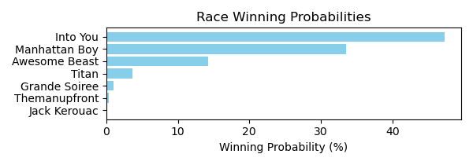

Figure: Winning Probability Distribution

NOTE: THIS RACE HAS HORSES THAT ARE MISSING CRITICAL DATA ELEMENTS

# Race: TGP | 2025-02-21 | Race #9 | Track: GULFSTREAM PARK

Track: GULFSTREAM PARK

|  |  |  |  |  |
| --- | --- | --- | --- | --- |
| Saddle Cloth # | Horse Name | Global Speed | Composite | Win Prob (%) |
| ['', 1, ''] | Royal Poppy | 82.5 | 5.43 | 0.64 |
| ['', 2, ''] | Stormy Mitole | 89.3 | 4.29 | 1.01 |
| ['', 3, ''] | Miles of Smiles | 82.5 | 5.80 | 0.87 |
| ['', 4, ''] | Olga | 82.5 | 4.89 | 0.42 |
| ['', 5, ''] | I'm Into Mischief | 111.4 | -2.63 | 0.33 |
| ['', 6, ''] | Pemberley | 111.4 | 4.42 | 93.68 |
| ['', 7, ''] | Both Sides | 82.5 | 7.32 | 2.94 |
| ['', 8, ''] | Major Pryce | 82.5 | 2.53 | 0.06 |
| ['', 9, ''] | Gallop d'Hermes | 82.5 | 2.05 | 0.04 |

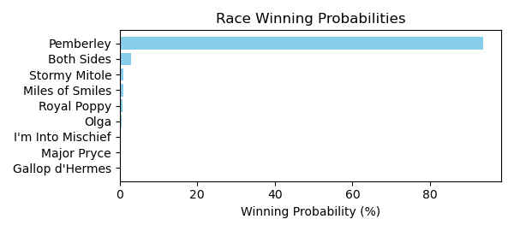

Figure: Winning Probability Distribution

NOTE: THIS RACE HAS HORSES THAT ARE MISSING CRITICAL DATA ELEMENTS

# Race: TGP | 2025-02-21 | Race #10 | Track: GULFSTREAM PARK

Track: GULFSTREAM PARK

|  |  |  |  |  |
| --- | --- | --- | --- | --- |
| Saddle Cloth # | Horse Name | Global Speed | Composite | Win Prob (%) |
| ['', 1, ''] | LA NAYA FACE (CHI) * | 66.4 | 4.51 | 2.98 |
| ['', 2, ''] | ACHAPLINA (CHI) * | 66.4 | 4.70 | 3.49 |
| ['', 3, ''] | KING NICOLAS (CHI) * | 66.4 | 4.58 | 3.16 |
| ['', 4, ''] | CIOCOLATTA (CHI) * | 76.0 | 4.49 | 20.38 |
| ['', 5, ''] | NIETA DEL MONTY (CHI) * | 66.4 | 4.58 | 3.15 |
| ['', 6, ''] | SECRET DUBAI (CHI) * | 70.8 | 4.57 | 7.60 |
| ['', 7, ''] | MAZINGER Z (CHI) * | 68.7 | 4.55 | 4.87 |
| ['', 8, ''] | ATEX (CHI) * | 66.4 | 4.61 | 3.23 |
| ['', 9, ''] | SORAILA (CHI) * | 66.4 | 4.59 | 3.19 |
| ['', 10, ''] | FIJO DAY (CHI) * | 66.4 | 4.24 | 2.40 |
| ['', 11, ''] | UNO CERO (CHI) * | 66.4 | 4.40 | 2.73 |
| ['', 12, ''] | RUCIA DEL DOC (CHI) * | 76.0 | 4.44 | 19.63 |
| ['', 13, ''] | BENDITA LOCURA (CHI) * | 68.7 | 4.15 | 3.55 |
| ['', 14, ''] | BARBIE DREAMS (CHI) * | 66.4 | 4.41 | 2.75 |
| ['', 15, ''] | PALMAS SORDITAS (ARG) * | 76.0 | 4.25 | 16.89 |

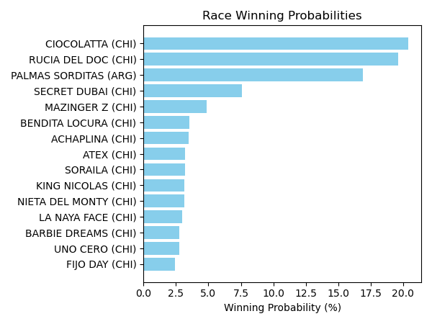

Figure: Winning Probability Distribution

NOTE: THIS RACE HAS HORSES THAT ARE MISSING CRITICAL DATA ELEMENTS

# Race: TGP | 2025-02-21 | Race #11 | Track: GULFSTREAM PARK

Track: GULFSTREAM PARK

|  |  |  |  |  |
| --- | --- | --- | --- | --- |
| Saddle Cloth # | Horse Name | Global Speed | Composite | Win Prob (%) |
| ['', 1, ''] | INTRIGANT (CHI) * | 66.3 | 4.64 | 3.32 |
| ['', 2, ''] | AMAYNA (CHI) * | 70.8 | 4.77 | 8.98 |
| ['', 3, ''] | HUACARNECO (CHI) * | 66.3 | 4.47 | 2.90 |
| ['', 4, ''] | DOMINGO ISLENO (CHI) * | 76.0 | 4.65 | 23.22 |
| ['', 5, ''] | PORTO BELAGGIO (CHI) * | 66.3 | 4.72 | 3.54 |
| ['', 6, ''] | YANE YI (CHI) * | 68.0 | 4.66 | 4.66 |
| ['', 7, ''] | LA PIOLA (CHI) * | 76.0 | 4.75 | 25.10 |
| ['', 8, ''] | AMBROSE (CHI) * | 66.3 | 4.60 | 3.21 |
| ['', 9, ''] | ORAZIA (CHI) * | 66.3 | 4.52 | 3.01 |
| ['', 10, ''] | EL GOLAZO (CHI) * | 66.3 | 4.86 | 3.96 |
| ['', 11, ''] | YO PAGO TODO (CHI) * | 66.3 | 4.63 | 3.30 |
| ['', 12, ''] | JOHANNESBULL (CHI) * | 66.3 | 4.58 | 3.16 |
| ['', 13, ''] | ASTROAZURRO (CHI) * | 66.3 | 4.77 | 3.69 |
| ['', 14, ''] | CIAO JUANITA (CHI) * | 66.3 | 4.83 | 3.87 |
| ['', 15, ''] | PRINCESS MARGARET (CHI) * | 68.0 | 4.49 | 4.07 |

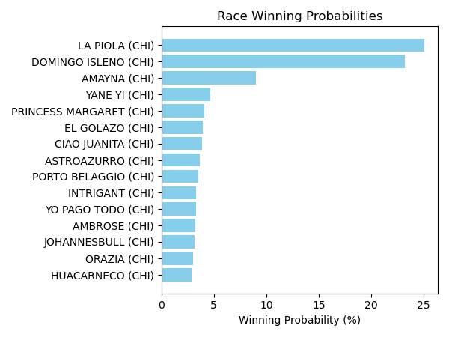

Figure: Winning Probability Distribution

NOTE: THIS RACE HAS HORSES THAT ARE MISSING CRITICAL DATA ELEMENTS

# Race: TGP | 2025-02-21 | Race #12 | Track: GULFSTREAM PARK

Track: GULFSTREAM PARK

|  |  |  |  |  |
| --- | --- | --- | --- | --- |
| Saddle Cloth # | Horse Name | Global Speed | Composite | Win Prob (%) |
| ['', 1, ''] | GEMOLOGA (CHI) * | 66.4 | 4.37 | 0.00 |
| ['', 2, ''] | NEGRITA ANDREA (CHI) * | 66.4 | 4.30 | 0.00 |
| ['', 3, ''] | DESTINO SECRETO (CHI) * | 66.4 | 4.49 | 0.00 |
| ['', 4, ''] | C'EST VRAI (CHI) * | 66.4 | 4.29 | 0.00 |
| ['', 5, ''] | JAIMINI (CHI) * | 66.4 | 4.27 | 0.00 |
| ['', 6, ''] | PEGGY NICE (CHI) * | 66.4 | 4.31 | 0.00 |
| ['', 7, ''] | GOLDEN MIST (CHI) * | 66.4 | 4.42 | 0.00 |
| ['', 8, ''] | CARINOSITO (CHI) * | 66.4 | 4.26 | 0.00 |
| ['', 9, ''] | GRAN RAI (CHI) * | 66.4 | 4.47 | 0.00 |
| ['', 10, ''] | CHIVARO (CHI) * | 123.7 | 4.60 | 99.99 |
| ['', 11, ''] | MAYSAK (CHI) * | 66.4 | 4.46 | 0.00 |
| ['', 12, ''] | GENUINE COMAND (CHI) * | 66.4 | 4.45 | 0.00 |
| ['', 13, ''] | DEAR SISTER (CHI) * | 66.4 | 4.40 | 0.00 |
| ['', 14, ''] | CAMMARATA (CHI) * | 66.4 | 4.23 | 0.00 |
| ['', 15, ''] | MO FARAH (CHI) * | 66.4 | 4.54 | 0.00 |

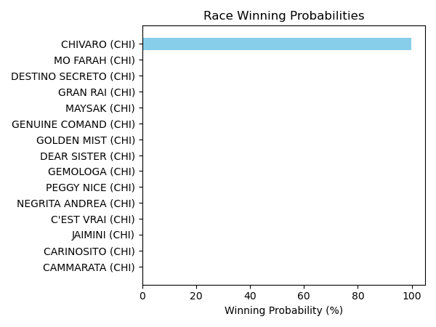

Figure: Winning Probability Distribution

NOTE: THIS RACE HAS HORSES THAT ARE MISSING CRITICAL DATA ELEMENTS

# Race: TGP | 2025-02-21 | Race #13 | Track: GULFSTREAM PARK

Track: GULFSTREAM PARK

|  |  |  |  |  |
| --- | --- | --- | --- | --- |
| Saddle Cloth # | Horse Name | Global Speed | Composite | Win Prob (%) |
| ['', 1, ''] | LATEN GOOD (CHI) * | 66.3 | 4.75 | 3.56 |
| ['', 2, ''] | TREN DE LA QUINTA (CHI) * | 76.0 | 4.68 | 23.49 |
| ['', 3, ''] | IMPERIO BABILONICO (CHI) * | 70.8 | 4.20 | 5.59 |
| ['', 4, ''] | FEELING BLESSED (CHI) * | 66.3 | 4.67 | 3.34 |
| ['', 5, ''] | MAKINEN (CHI) * | 70.8 | 4.45 | 6.81 |
| ['', 6, ''] | PRIMA TOWN (CHI) * | 66.3 | 4.68 | 3.37 |
| ['', 7, ''] | LA CHAMBEKA (CHI) * | 70.8 | 4.47 | 6.95 |
| ['', 8, ''] | AMELITA (CHI) * | 66.3 | 4.49 | 2.91 |
| ['', 9, ''] | TWO FLAGS (CHI) * | 66.3 | 4.67 | 3.36 |
| ['', 10, ''] | DE ORO Y COBRE (CHI) * | 76.0 | 4.49 | 20.07 |
| ['', 11, ''] | ROGER RED (CHI) * | 66.3 | 4.54 | 3.02 |
| ['', 12, ''] | MISS LADY CLASSIC (CHI) * | 70.8 | 4.64 | 7.95 |
| ['', 13, ''] | BLUE KENTUCKY GIRL (CHI) * | 66.3 | 4.60 | 3.16 |
| ['', 14, ''] | CASABLANCA FUNNY (CHI) * | 66.3 | 4.65 | 3.30 |
| ['', 15, ''] | MI MARTUCA (CHI) * | 66.3 | 4.59 | 3.14 |

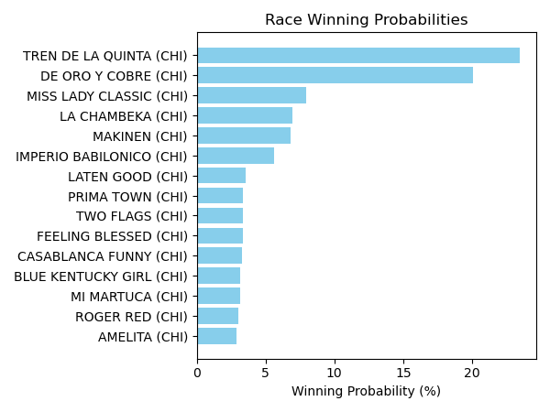

Figure: Winning Probability Distribution

NOTE: THIS RACE HAS HORSES THAT ARE MISSING CRITICAL DATA ELEMENTS

# Race: TGP | 2025-02-21 | Race #14 | Track: GULFSTREAM PARK

Track: GULFSTREAM PARK

|  |  |  |  |  |
| --- | --- | --- | --- | --- |
| Saddle Cloth # | Horse Name | Global Speed | Composite | Win Prob (%) |
| ['', 1, ''] | ELEGANT KATZE (CHI) * | 66.4 | 4.26 | 1.92 |
| ['', 2, ''] | EL SOM CENTAURO (CHI) * | 76.1 | 4.19 | 12.62 |
| ['', 3, ''] | SUN OF ZAZAU (CHI) * | 76.1 | 4.12 | 11.94 |
| ['', 4, ''] | NEGRO DE ORO (CHI) * | 66.4 | 4.00 | 1.56 |
| ['', 5, ''] | RIONA (CHI) * | 76.1 | 4.23 | 13.09 |
| ['', 6, ''] | TEODORA (CHI) * | 70.8 | 4.14 | 4.26 |
| ['', 7, ''] | QUE PASA (CHI) * | 66.4 | 4.28 | 1.96 |
| ['', 8, ''] | NOVAK (CHI) * | 66.4 | 4.28 | 1.96 |
| ['', 9, ''] | TIRABOSCHI (CHI) * | 76.1 | 4.11 | 11.90 |
| ['', 10, ''] | QUIERO TODO (CHI) * | 76.1 | 4.07 | 11.53 |
| ['', 11, ''] | FLACO TITO (CHI) * | 66.4 | 4.01 | 1.57 |
| ['', 12, ''] | SUGAR DADDY (CHI) * | 66.4 | 4.22 | 1.86 |
| ['', 13, ''] | DALIKA (CHI) * | 66.4 | 3.96 | 1.51 |
| ['', 14, ''] | ME HA MIRADO (CHI) * | 76.1 | 3.89 | 9.96 |
| ['', 15, ''] | SENOR TRONCOSO (CHI) * | 76.1 | 4.16 | 12.36 |

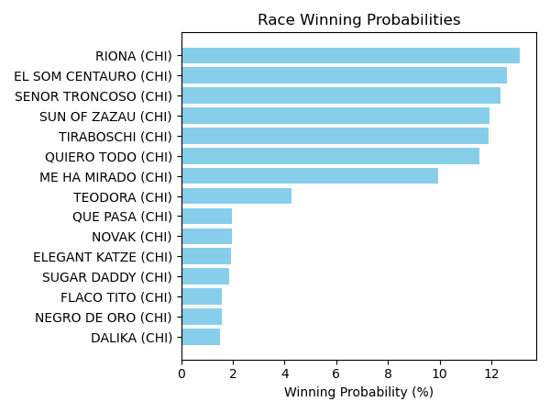

Figure: Winning Probability Distribution

NOTE: THIS RACE HAS HORSES THAT ARE MISSING CRITICAL DATA ELEMENTS

# Race: TCT | 2025-02-21 | Race #1 | Track: HOLLYWOOD CASINO AT CHARLES TOWN RACES

Track: HOLLYWOOD CASINO AT CHARLES TOWN RACES

|  |  |  |  |  |
| --- | --- | --- | --- | --- |
| Saddle Cloth # | Horse Name | Global Speed | Composite | Win Prob (%) |
| ['', 1, ''] | She So Cool * | 88.8 | -1.27 | 0.11 |
| ['', 2, ''] | Sweet Sensation * | 82.1 | 2.60 | 0.65 |
| ['', 3, ''] | Shewearsstilettos * | 88.8 | 7.09 | 91.12 |
| ['', 4, ''] | Shoopthereitis | 88.8 | -6.78 | 0.00 |
| ['', 5, ''] | Somebody Loves Me * | 82.1 | -3.45 | 0.01 |
| ['', 6, ''] | Music Lass * | 82.1 | 5.75 | 8.11 |

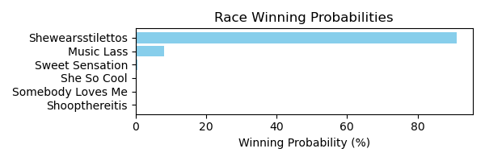

Figure: Winning Probability Distribution

NOTE: THIS RACE HAS HORSES THAT ARE MISSING CRITICAL DATA ELEMENTS

# Race: TCT | 2025-02-21 | Race #2 | Track: HOLLYWOOD CASINO AT CHARLES TOWN RACES

Track: HOLLYWOOD CASINO AT CHARLES TOWN RACES

|  |  |  |  |  |
| --- | --- | --- | --- | --- |
| Saddle Cloth # | Horse Name | Global Speed | Composite | Win Prob (%) |
| ['', 1, ''] | No Time to Boogie * | 89.2 | -1.71 | 0.14 |
| ['', 2, ''] | Radar Alert * | 89.2 | 4.50 | 19.85 |
| ['', 3, ''] | Lawyer Up Riley | 82.5 | 7.91 | 78.87 |
| ['', 4, ''] | In the Chase | 82.5 | 1.53 | 0.48 |
| ['', 5, ''] | Costner | 89.2 | -1.61 | 0.15 |
| ['', 6, ''] | Artwell | 76.4 | 3.15 | 0.52 |

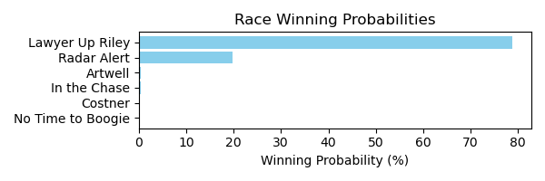

Figure: Winning Probability Distribution

NOTE: THIS RACE HAS HORSES THAT ARE MISSING CRITICAL DATA ELEMENTS

# Race: TCT | 2025-02-21 | Race #3 | Track: HOLLYWOOD CASINO AT CHARLES TOWN RACES

Track: HOLLYWOOD CASINO AT CHARLES TOWN RACES

|  |  |  |  |  |
| --- | --- | --- | --- | --- |
| Saddle Cloth # | Horse Name | Global Speed | Composite | Win Prob (%) |
| ['', 1, ''] | Connect the Dots * | 82.1 | -6.20 | 0.04 |
| ['', 2, ''] | JAZMAN CAN * | 65.3 | 4.74 | 7.73 |
| ['', 3, ''] | Jubacantfixthis * | 62.7 | -7.15 | 0.00 |
| ['', 4, ''] | Bonds Revenge * | 62.7 | 6.33 | 16.26 |
| ['', 5, ''] | Slew the Lion * | 62.7 | -4.39 | 0.00 |
| ['', 6, ''] | Forbidden Spirit * | 62.7 | 5.49 | 8.30 |
| ['', 7, ''] | Rock of Ages * | 82.1 | 2.71 | 44.03 |
| ['', 8, ''] | Just a Wizard * | 62.7 | 0.30 | 0.13 |
| ['', 9, ''] | CHIPPEWA BAY * | 65.3 | 4.74 | 7.74 |
| ['', 10, ''] | MEXICALI MIKE * | 65.3 | 4.67 | 7.32 |
| ['', 11, ''] | Wish On Juba * | 62.7 | 4.74 | 4.57 |
| ['', 12, ''] | A Reason to Party * | 62.7 | -6.43 | 0.00 |
| ['', 13, ''] | Charlienite * | 62.7 | -5.48 | 0.00 |
| ['', 14, ''] | RAY OF SUNSHINE * | 62.7 | 4.54 | 3.89 |

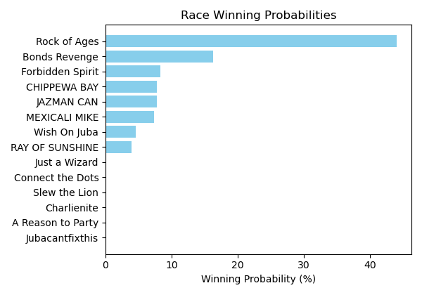

Figure: Winning Probability Distribution

NOTE: THIS RACE HAS HORSES THAT ARE MISSING CRITICAL DATA ELEMENTS

# Race: TCT | 2025-02-21 | Race #4 | Track: HOLLYWOOD CASINO AT CHARLES TOWN RACES

Track: HOLLYWOOD CASINO AT CHARLES TOWN RACES

|  |  |  |  |  |
| --- | --- | --- | --- | --- |
| Saddle Cloth # | Horse Name | Global Speed | Composite | Win Prob (%) |
| ['', 1, ''] | Ms Gloria Jean * | 76.2 | -7.77 | 0.00 |
| ['', 2, ''] | Dixie Rag * | 88.9 | -9.22 | 0.00 |
| ['', 3, ''] | Tangerineginger | 82.2 | 7.38 | 57.23 |
| ['', 4, ''] | Catalina Cruzin * | 88.9 | -1.73 | 0.15 |
| ['', 5, ''] | Red Priestess | 62.7 | -6.89 | 0.00 |
| ['', 6, ''] | Maltese Rose * | 82.2 | 6.98 | 41.54 |
| ['', 7, ''] | Margaret's Lady | 88.9 | -3.95 | 0.03 |
| ['', 8, ''] | Gone With the Wyn * | 82.2 | 2.39 | 1.06 |

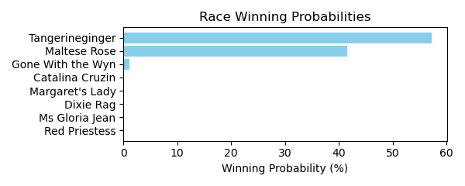

Figure: Winning Probability Distribution

NOTE: THIS RACE HAS HORSES THAT ARE MISSING CRITICAL DATA ELEMENTS

# Race: TCT | 2025-02-21 | Race #5 | Track: HOLLYWOOD CASINO AT CHARLES TOWN RACES

Track: HOLLYWOOD CASINO AT CHARLES TOWN RACES

|  |  |  |  |  |
| --- | --- | --- | --- | --- |
| Saddle Cloth # | Horse Name | Global Speed | Composite | Win Prob (%) |
| ['', 1, ''] | Moonshine Mama * | 62.6 | -8.32 | 0.00 |
| ['', 2, ''] | Ivyleaguedropout * | 88.8 | -6.61 | 1.39 |
| ['', 3, ''] | Unbridled Chopt * | 62.6 | -9.14 | 0.00 |
| ['', 4, ''] | Eyesonthecandy * | 62.6 | -6.42 | 0.01 |
| ['', 5, ''] | Tiger's Candy * | 88.8 | -6.52 | 1.49 |
| ['', 6, ''] | Ruby Bay * | 82.1 | -6.26 | 0.48 |
| ['', 7, ''] | All Aboard * | 88.8 | -7.16 | 0.89 |
| ['', 8, ''] | Alice's Moon | 82.1 | 0.36 | 95.74 |

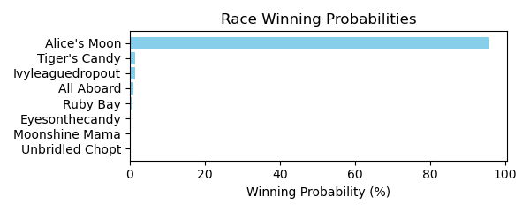

Figure: Winning Probability Distribution

NOTE: THIS RACE HAS HORSES THAT ARE MISSING CRITICAL DATA ELEMENTS

# Race: TCT | 2025-02-21 | Race #6 | Track: HOLLYWOOD CASINO AT CHARLES TOWN RACES

Track: HOLLYWOOD CASINO AT CHARLES TOWN RACES

|  |  |  |  |  |
| --- | --- | --- | --- | --- |
| Saddle Cloth # | Horse Name | Global Speed | Composite | Win Prob (%) |
| ['', 1, ''] | Ozone * | 111.7 | 9.19 | 99.47 |
| ['', 2, ''] | Gran Andrews * | 89.5 | 7.82 | 0.39 |
| ['', 3, ''] | Smooth Rico * | 82.7 | 2.52 | 0.00 |
| ['', 4, ''] | Goodluckchuck | 76.5 | 7.12 | 0.02 |
| ['', 5, ''] | The Khozan One | 89.5 | 5.56 | 0.06 |
| ['', 6, ''] | Al Loves Josie | 89.5 | 5.37 | 0.06 |
| ['', 7, ''] | Jackie A * | 76.5 | -1.85 | 0.00 |

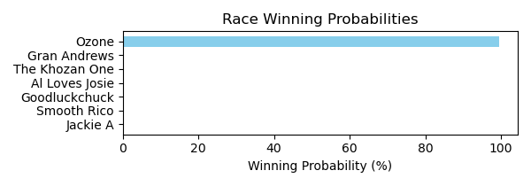

Figure: Winning Probability Distribution

NOTE: THIS RACE HAS HORSES THAT ARE MISSING CRITICAL DATA ELEMENTS

# Race: TCT | 2025-02-21 | Race #7 | Track: HOLLYWOOD CASINO AT CHARLES TOWN RACES

Track: HOLLYWOOD CASINO AT CHARLES TOWN RACES

|  |  |  |  |  |
| --- | --- | --- | --- | --- |
| Saddle Cloth # | Horse Name | Global Speed | Composite | Win Prob (%) |
| ['', 1, ''] | Dorado * | 89.4 | 7.74 | 85.57 |
| ['', 2, ''] | Gabriel Seven | 82.6 | -0.96 | 0.02 |
| ['', 3, ''] | Rol Again Dancer | 89.4 | 3.45 | 2.76 |
| ['', 4, ''] | Besotted * | 82.6 | 0.16 | 0.05 |
| ['', 5, ''] | Nancy Made My Day | 76.5 | 5.59 | 1.15 |
| ['', 6, ''] | Logstradamus * | 89.4 | 5.11 | 10.45 |

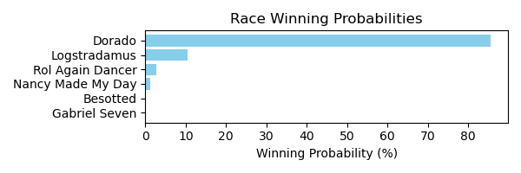

Figure: Winning Probability Distribution

NOTE: THIS RACE HAS HORSES THAT ARE MISSING CRITICAL DATA ELEMENTS

# Race: TCT | 2025-02-21 | Race #8 | Track: HOLLYWOOD CASINO AT CHARLES TOWN RACES

Track: HOLLYWOOD CASINO AT CHARLES TOWN RACES

|  |  |  |  |  |
| --- | --- | --- | --- | --- |
| Saddle Cloth # | Horse Name | Global Speed | Composite | Win Prob (%) |
| ['', 1, ''] | Just Murphy * | 62.7 | -2.93 | 0.02 |
| ['', 2, ''] | Diva's Demon * | 62.7 | 6.45 | 43.75 |
| ['', 3, ''] | Ride the Brand * | 82.1 | -5.68 | 0.13 |
| ['', 4, ''] | Tup's to Take * | 62.7 | -3.58 | 0.01 |
| ['', 5, ''] | Gettin Spicy * | 62.7 | -2.94 | 0.02 |
| ['', 6, ''] | Why Winchill Why * | 62.7 | -4.54 | 0.01 |
| ['', 7, ''] | El Morito * | 62.7 | 6.46 | 44.25 |
| ['', 8, ''] | Salty Starkey * | 62.7 | 4.81 | 11.79 |
| ['', 9, ''] | Shiney Ghost * | 62.7 | -4.80 | 0.01 |

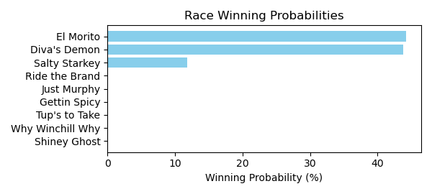

Figure: Winning Probability Distribution

NOTE: THIS RACE HAS HORSES THAT ARE MISSING CRITICAL DATA ELEMENTS

# Race: LRL | 2025-02-21 | Race #1 | Track: LAUREL PARK

Track: LAUREL PARK

|  |  |  |  |  |
| --- | --- | --- | --- | --- |
| Saddle Cloth # | Horse Name | Global Speed | Composite | Win Prob (%) |
| ['', 1, ''] | Fast Talkin Man | 76.1 | 2.21 | 0.39 |
| ['', 2, ''] | Severn Run | 70.8 | 5.53 | 1.94 |
| ['', 3, ''] | Tetched | 88.8 | 3.45 | 13.33 |
| ['', 4, ''] | Real Talented | 88.8 | -5.24 | 0.01 |
| ['', 5, ''] | WHERE'S MY CHEW * | 70.8 | 7.39 | 8.59 |
| ['', 6, ''] | FURIOUS GEORGE * | 78.4 | 7.44 | 40.48 |
| ['', 7, ''] | ZIO LINO * | 78.4 | 7.26 | 35.26 |

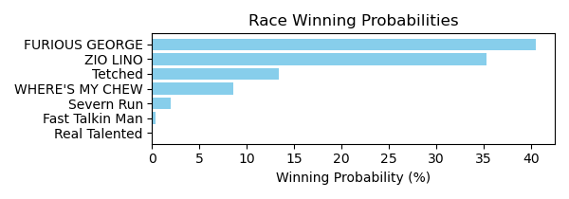

Figure: Winning Probability Distribution

NOTE: THIS RACE HAS HORSES THAT ARE MISSING CRITICAL DATA ELEMENTS

# Race: LRL | 2025-02-21 | Race #2 | Track: LAUREL PARK

Track: LAUREL PARK

|  |  |  |  |  |
| --- | --- | --- | --- | --- |
| Saddle Cloth # | Horse Name | Global Speed | Composite | Win Prob (%) |
| ['', 1, ''] | Square Slice | 76.3 | 5.57 | 7.28 |
| ['', 2, ''] | Maliblue | 71.0 | 9.31 | 50.46 |
| ['', 3, ''] | Twice Gold | 103.9 | 0.51 | 31.67 |
| ['', 4, ''] | Rapidity | 76.3 | 6.02 | 10.44 |
| ['', 5, ''] | Scrappy T Lee | 76.3 | -8.67 | 0.00 |
| ['', 6, ''] | Medagooch | 76.3 | -0.19 | 0.07 |
| ['', 7, ''] | Thedingoateyobaby | 111.3 | -8.82 | 0.08 |

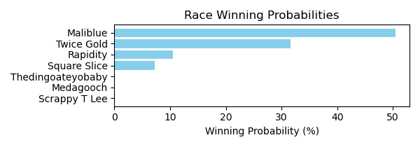

Figure: Winning Probability Distribution

NOTE: THIS RACE HAS HORSES THAT ARE MISSING CRITICAL DATA ELEMENTS

# Race: LRL | 2025-02-21 | Race #3 | Track: LAUREL PARK

Track: LAUREL PARK

|  |  |  |  |  |
| --- | --- | --- | --- | --- |
| Saddle Cloth # | Horse Name | Global Speed | Composite | Win Prob (%) |
| ['', 1, ''] | Tina Tina Tina | 89.1 | -1.59 | 0.04 |
| ['', 2, ''] | Princess Lucia | 111.2 | 1.34 | 36.82 |
| ['', 3, ''] | Voodoo Priestess | 103.8 | 0.22 | 3.43 |
| ['', 4, ''] | Lilly Lightning | 76.3 | -8.02 | 0.00 |
| ['', 5, ''] | Maximo Madness | 89.1 | -0.53 | 0.10 |
| ['', 6, ''] | Looking for Water | 103.8 | 3.79 | 59.61 |
| ['', 7, ''] | Determined Blue | 89.1 | -5.37 | 0.00 |

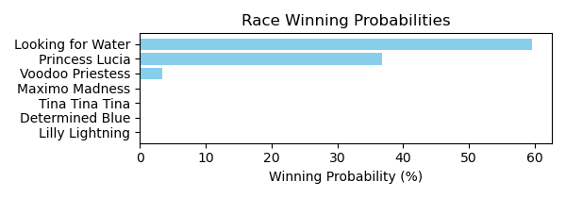

Figure: Winning Probability Distribution

NOTE: THIS RACE HAS HORSES THAT ARE MISSING CRITICAL DATA ELEMENTS

# Race: LRL | 2025-02-21 | Race #4 | Track: LAUREL PARK

Track: LAUREL PARK

|  |  |  |  |  |
| --- | --- | --- | --- | --- |
| Saddle Cloth # | Horse Name | Global Speed | Composite | Win Prob (%) |
| ['', 1, ''] | BRAND NEW DANCE * | 95.7 | 6.43 | 6.03 |
| ['', 2, ''] | BIRDIEJUICE * | 95.7 | 5.94 | 4.07 |
| ['', 3, ''] | Chattolanee Spring | 103.7 | 5.88 | 19.26 |
| ['', 4, ''] | Wikolia Lady | 103.7 | 0.73 | 0.31 |
| ['', 5, ''] | Late Nite Call | 108.4 | 6.31 | 70.25 |
| ['', 6, ''] | Ready for Magic | 89.0 | -1.19 | 0.00 |
| ['', 7, ''] | Passage East | 76.2 | 5.79 | 0.07 |

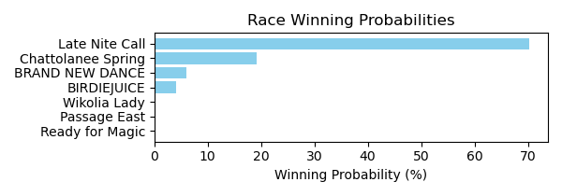

Figure: Winning Probability Distribution

NOTE: THIS RACE HAS HORSES THAT ARE MISSING CRITICAL DATA ELEMENTS

# Race: LRL | 2025-02-21 | Race #5 | Track: LAUREL PARK

Track: LAUREL PARK

|  |  |  |  |  |
| --- | --- | --- | --- | --- |
| Saddle Cloth # | Horse Name | Global Speed | Composite | Win Prob (%) |
| ['', 1, ''] | Irish Warlock | 76.5 | 4.36 | 94.45 |
| ['', 2, ''] | B West | 76.5 | -1.84 | 0.66 |
| ['', 3, ''] | Mister Agent | 76.5 | -0.27 | 2.32 |
| ['', 4, ''] | He's Orientate | 76.5 | -5.06 | 0.05 |
| ['', 5, ''] | The Judge and Jury | 82.7 | -2.36 | 1.48 |
| ['', 6, ''] | Whiskey and You | 76.5 | -3.80 | 0.14 |
| ['', 7, ''] | Shape Note | 76.5 | -2.43 | 0.41 |
| ['', 8, ''] | Magic Spin | 89.5 | -5.44 | 0.49 |

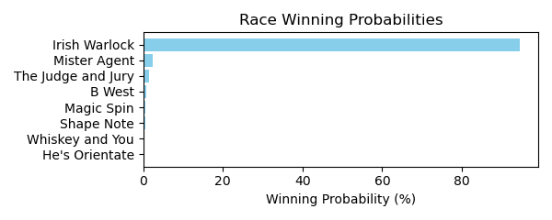

Figure: Winning Probability Distribution

NOTE: THIS RACE HAS HORSES THAT ARE MISSING CRITICAL DATA ELEMENTS

# Race: LRL | 2025-02-21 | Race #6 | Track: LAUREL PARK

Track: LAUREL PARK

|  |  |  |  |  |
| --- | --- | --- | --- | --- |
| Saddle Cloth # | Horse Name | Global Speed | Composite | Win Prob (%) |
| ['', 1, ''] | Gaga's Hamsome | 76.2 | 5.91 | 1.86 |
| ['', 2, ''] | Esroh | 76.2 | 1.36 | 0.05 |
| ['', 3, ''] | Itsamonstamash | 70.9 | 8.22 | 4.12 |
| ['', 4, ''] | Rapido Rosa | 70.9 | -2.85 | 0.00 |
| ['', 5, ''] | Can Do | 76.2 | 4.27 | 0.50 |
| ['', 6, ''] | Green Eyed Monster | 76.2 | 6.73 | 3.58 |
| ['', 7, ''] | Ade | 70.9 | 5.86 | 0.63 |
| ['', 8, ''] | First Pearl | 103.6 | 3.88 | 89.27 |

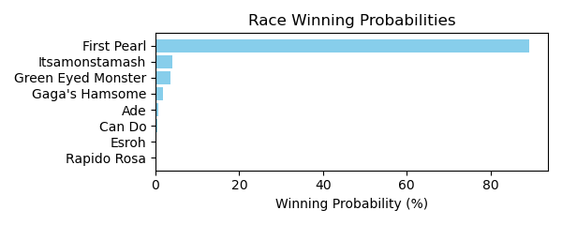

Figure: Winning Probability Distribution

NOTE: THIS RACE HAS HORSES THAT ARE MISSING CRITICAL DATA ELEMENTS

# Race: LRL | 2025-02-21 | Race #7 | Track: LAUREL PARK

Track: LAUREL PARK

|  |  |  |  |  |
| --- | --- | --- | --- | --- |
| Saddle Cloth # | Horse Name | Global Speed | Composite | Win Prob (%) |
| ['', 1, ''] | Mor Mor Mor | 76.4 | 6.57 | 25.15 |
| ['', 2, ''] | Graceful Rose | 82.4 | -9.35 | 0.00 |
| ['', 3, ''] | Dissolute | 89.2 | 4.71 | 74.63 |
| ['', 4, ''] | Dwelling Legacy | 76.4 | -0.71 | 0.07 |
| ['', 5, ''] | Feelin So Lucky | 76.4 | -3.24 | 0.01 |
| ['', 6, ''] | Vicountess | 82.4 | -6.16 | 0.00 |
| ['', 7, ''] | Kilo Road | 76.4 | 0.04 | 0.14 |

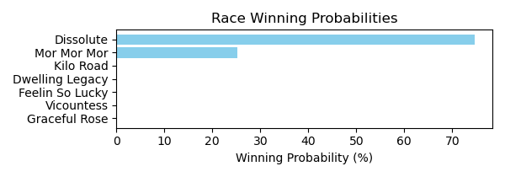

Figure: Winning Probability Distribution

NOTE: THIS RACE HAS HORSES THAT ARE MISSING CRITICAL DATA ELEMENTS

# Race: LRL | 2025-02-21 | Race #8 | Track: LAUREL PARK

Track: LAUREL PARK

|  |  |  |  |  |
| --- | --- | --- | --- | --- |
| Saddle Cloth # | Horse Name | Global Speed | Composite | Win Prob (%) |
| ['', 1, ''] | Magic Michael | 111.8 | 2.63 | 0.55 |
| ['', 1, 'a'] | Just Call Ray | 104.5 | -4.01 | 0.00 |
| ['', 2, ''] | Secret Zipper | 111.8 | 9.02 | 90.47 |
| ['', 3, ''] | Crossland | 104.5 | 7.58 | 6.57 |
| ['', 4, ''] | Curlin's Malibu | 89.6 | 4.43 | 0.03 |
| ['', 5, ''] | Your Analysis | 104.5 | 5.83 | 1.62 |
| ['', 6, ''] | Little Lance | 104.5 | 4.90 | 0.77 |

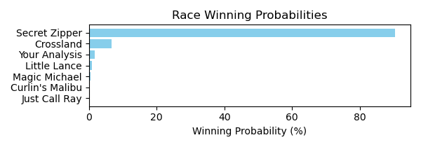

Figure: Winning Probability Distribution

NOTE: THIS RACE HAS HORSES THAT ARE MISSING CRITICAL DATA ELEMENTS

# Race: LRL | 2025-02-21 | Race #9 | Track: LAUREL PARK

Track: LAUREL PARK

|  |  |  |  |  |
| --- | --- | --- | --- | --- |
| Saddle Cloth # | Horse Name | Global Speed | Composite | Win Prob (%) |
| ['', 1, ''] | Autumn in Vermont | 62.6 | -4.03 | 0.00 |
| ['', 2, ''] | Third Tuesday | 75.9 | 2.68 | 0.01 |
| ['', 3, ''] | Storm Creed | 110.5 | -1.48 | 0.41 |
| ['', 4, ''] | Tia Mayin | 110.5 | -5.96 | 0.01 |
| ['', 5, ''] | Cundi | 110.5 | -2.25 | 0.22 |
| ['', 6, ''] | Rascallion | 110.5 | 5.38 | 99.35 |
| ['', 7, ''] | Aunt Margaret | 70.7 | -5.39 | 0.00 |

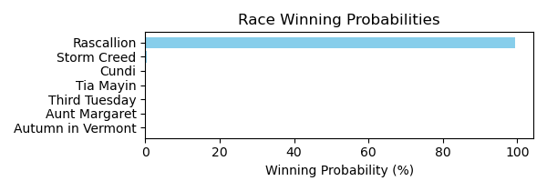

Figure: Winning Probability Distribution

NOTE: THIS RACE HAS HORSES THAT ARE MISSING CRITICAL DATA ELEMENTS

# Race: LRL | 2025-02-21 | Race #10 | Track: LAUREL PARK

Track: LAUREL PARK

|  |  |  |  |  |
| --- | --- | --- | --- | --- |
| Saddle Cloth # | Horse Name | Global Speed | Composite | Win Prob (%) |
| ['', 1, ''] | DONA HOPE (ARG) * | 72.4 | 5.15 | 10.21 |
| ['', 2, ''] | DUDA LUCK (ARG) * | 72.4 | 5.34 | 11.81 |
| ['', 3, ''] | PARTY LAKE (ARG) * | 72.4 | 4.87 | 8.13 |
| ['', 4, ''] | CON RIMOUT (ARG) * | 72.4 | 4.88 | 8.17 |
| ['', 5, ''] | ELLA VENDRA (ARG) * | 72.4 | 4.79 | 7.66 |
| ['', 6, ''] | DONNA STELLA (ARG) * | 75.9 | 5.08 | 19.61 |
| ['', 7, ''] | ESTRELLA DE ROCK (ARG) * | 75.9 | 5.24 | 22.28 |
| ['', 8, ''] | MASK LAND (ARG) * | 72.4 | 4.93 | 8.52 |
| ['', 9, ''] | SI AMOR (ARG) * | 66.3 | 5.37 | 3.61 |

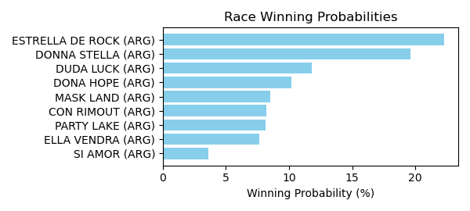

Figure: Winning Probability Distribution

NOTE: THIS RACE HAS HORSES THAT ARE MISSING CRITICAL DATA ELEMENTS

# Race: LRL | 2025-02-21 | Race #11 | Track: LAUREL PARK

Track: LAUREL PARK

|  |  |  |  |  |
| --- | --- | --- | --- | --- |
| Saddle Cloth # | Horse Name | Global Speed | Composite | Win Prob (%) |
| ['', 1, ''] | BLUE DOLLAR (ARG) * | 88.8 | 3.71 | 3.66 |
| ['', 2, ''] | LORD FORTUNE (ARG) * | 88.8 | 4.01 | 4.65 |
| ['', 3, ''] | SIRO'S KING (ARG) * | 88.8 | 4.02 | 4.68 |
| ['', 4, ''] | ATOMIC LEVEL (ARG) * | 88.8 | 4.01 | 4.67 |
| ['', 5, ''] | LOUIS CK (ARG) * | 103.4 | 3.85 | 76.85 |
| ['', 6, ''] | HABLA DE GLORIA (ARG) * | 76.0 | 4.01 | 0.37 |
| ['', 7, ''] | SFORZINI (ARG) * | 88.8 | 4.13 | 5.13 |

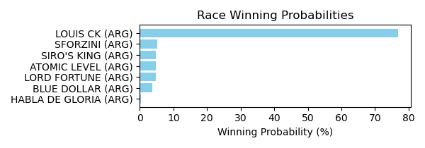

Figure: Winning Probability Distribution

NOTE: THIS RACE HAS HORSES THAT ARE MISSING CRITICAL DATA ELEMENTS

# Race: LRL | 2025-02-21 | Race #12 | Track: LAUREL PARK

Track: LAUREL PARK

|  |  |  |  |  |
| --- | --- | --- | --- | --- |
| Saddle Cloth # | Horse Name | Global Speed | Composite | Win Prob (%) |
| ['', 1, ''] | GIANT RIMOUT (ARG) * | 103.5 | 3.39 | 66.48 |
| ['', 2, ''] | MR BAUTI (ARG) * | 92.4 | 3.86 | 10.49 |
| ['', 3, ''] | TRIGO CANDEAL (ARG) * | 88.8 | 4.15 | 6.49 |
| ['', 4, ''] | FLYING TO THE SKY (ARG) * | 88.8 | 3.68 | 4.44 |
| ['', 5, ''] | SENOR DAN (ARG) * | 88.8 | 3.96 | 5.59 |
| ['', 6, ''] | JARDIN DEL POETA (ARG) * | 92.4 | 3.26 | 6.51 |

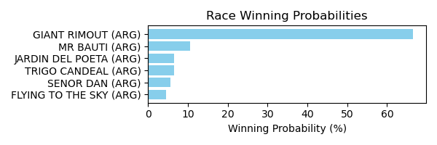

Figure: Winning Probability Distribution

NOTE: THIS RACE HAS HORSES THAT ARE MISSING CRITICAL DATA ELEMENTS

# Race: LRL | 2025-02-21 | Race #13 | Track: LAUREL PARK

Track: LAUREL PARK

|  |  |  |  |  |
| --- | --- | --- | --- | --- |
| Saddle Cloth # | Horse Name | Global Speed | Composite | Win Prob (%) |
| ['', 1, ''] | DENISKA (ARG) * | 88.7 | 4.65 | 43.78 |
| ['', 2, ''] | EXAMINED (ARG) * | 82.0 | 4.96 | 14.70 |
| ['', 3, ''] | PEQUENA MOROCHA (ARG) * | 80.4 | 4.75 | 9.05 |
| ['', 4, ''] | BELLA PATRICIA (ARG) * | 80.4 | 4.40 | 6.86 |
| ['', 5, ''] | GIFTED GIRL (ARG) * | 76.0 | 4.70 | 3.58 |
| ['', 6, ''] | ESCONDIDAS (ARG) * | 76.0 | 4.63 | 3.39 |
| ['', 7, ''] | ISLA MISTICA (ARG) * | 80.4 | 4.24 | 6.01 |
| ['', 8, ''] | LOBA NIMERIA (ARG) * | 80.4 | 4.44 | 7.06 |
| ['', 9, ''] | QUEEN CAUSE (ARG) * | 80.4 | 4.14 | 5.55 |

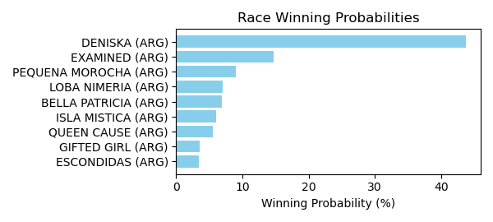

Figure: Winning Probability Distribution

NOTE: THIS RACE HAS HORSES THAT ARE MISSING CRITICAL DATA ELEMENTS

# Race: LRL | 2025-02-21 | Race #14 | Track: LAUREL PARK

Track: LAUREL PARK

|  |  |  |  |  |
| --- | --- | --- | --- | --- |
| Saddle Cloth # | Horse Name | Global Speed | Composite | Win Prob (%) |
| ['', 1, ''] | CAPRICHO MIO (ARG) * | 76.0 | 4.38 | 5.21 |
| ['', 2, ''] | CRUSH (ARG) * | 74.6 | 4.02 | 2.98 |
| ['', 3, ''] | MANE GARRINCHA (ARG) * | 76.0 | 4.44 | 5.47 |
| ['', 4, ''] | ADRIATICAN (ARG) * | 74.6 | 4.42 | 4.10 |
| ['', 5, ''] | DADO VISION (ARG) * | 76.0 | 4.64 | 6.44 |
| ['', 6, ''] | CORSICO (ARG) * | 66.3 | 4.64 | 0.93 |
| ['', 7, ''] | ECLOS (ARG) * | 88.7 | 4.18 | 56.43 |
| ['', 8, ''] | ELITE RIMOUT (ARG) * | 74.6 | 3.97 | 2.85 |
| ['', 9, ''] | MOVER LIGERO (ARG) * | 66.3 | 4.44 | 0.79 |
| ['', 10, ''] | ASTEGIANO (ARG) * | 76.0 | 4.37 | 5.19 |
| ['', 11, ''] | PERSIAN ISLAND (ARG) * | 76.0 | 4.64 | 6.42 |
| ['', 12, ''] | DELI WINNER (ARG) * | 74.6 | 4.11 | 3.18 |

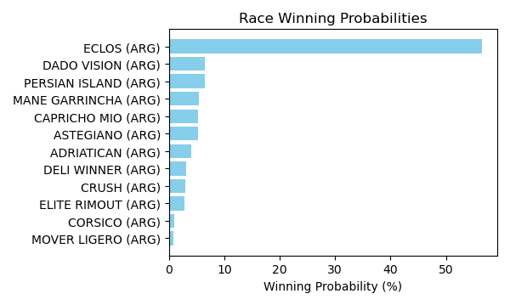

Figure: Winning Probability Distribution

NOTE: THIS RACE HAS HORSES THAT ARE MISSING CRITICAL DATA ELEMENTS

# Race: MVR | 2025-02-24 | Race #1 | Track: MAHONING VALLEY RACE COURSE

Track: MAHONING VALLEY RACE COURSE

|  |  |  |  |  |
| --- | --- | --- | --- | --- |
| Saddle Cloth # | Horse Name | Global Speed | Composite | Win Prob (%) |
| ['', 1, ''] | Divine Empire | 76.2 | 4.45 | 22.92 |
| ['', 2, ''] | CAESAREA * | 76.2 | 3.73 | 12.93 |
| ['', 3, ''] | Blustering Breeze | 76.2 | -2.53 | 0.09 |
| ['', 4, ''] | Galpin Sunday * | 76.2 | -5.18 | 0.01 |
| ['', 5, ''] | Great Revelation * | 76.2 | -9.14 | 0.00 |
| ['', 6, ''] | Beer Time * | 76.2 | -7.35 | 0.00 |
| ['', 7, ''] | Red in Front | 76.2 | 5.73 | 64.05 |

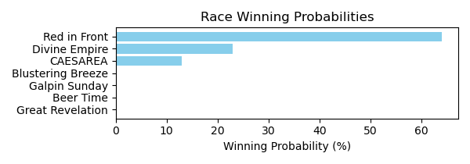

Figure: Winning Probability Distribution

NOTE: THIS RACE HAS HORSES THAT ARE MISSING CRITICAL DATA ELEMENTS

# Race: MVR | 2025-02-24 | Race #2 | Track: MAHONING VALLEY RACE COURSE

Track: MAHONING VALLEY RACE COURSE

|  |  |  |  |  |
| --- | --- | --- | --- | --- |
| Saddle Cloth # | Horse Name | Global Speed | Composite | Win Prob (%) |
| ['', 1, ''] | Dark Baron * | 104.0 | -4.37 | 0.00 |
| ['', 2, ''] | Capturethelaughter * | 104.0 | 8.10 | 73.46 |
| ['', 3, ''] | Torrefactor * | 104.0 | 4.47 | 4.03 |
| ['', 4, ''] | Verbier * | 104.0 | 2.61 | 0.91 |
| ['', 5, ''] | Gut Instinct * | 104.0 | 6.53 | 20.86 |
| ['', 6, ''] | Bayou Magic | 104.0 | 0.26 | 0.14 |
| ['', 7, ''] | Sicilian Style Two * | 104.0 | 2.07 | 0.59 |

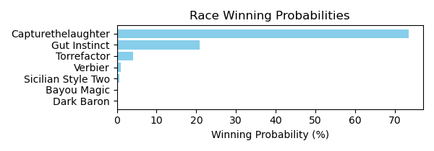

Figure: Winning Probability Distribution

NOTE: THIS RACE HAS HORSES THAT ARE MISSING CRITICAL DATA ELEMENTS

# Race: MVR | 2025-02-24 | Race #3 | Track: MAHONING VALLEY RACE COURSE

Track: MAHONING VALLEY RACE COURSE

|  |  |  |  |  |
| --- | --- | --- | --- | --- |
| Saddle Cloth # | Horse Name | Global Speed | Composite | Win Prob (%) |
| ['', 1, ''] | Bourbon Wisdom * | 104.1 | 7.46 | 20.04 |
| ['', 2, ''] | Cugine * | 104.1 | 6.43 | 8.83 |
| ['', 3, ''] | Morethanreadyeddie * | 104.1 | 8.78 | 57.49 |
| ['', 4, ''] | Napa Dude * | 104.1 | -0.97 | 0.02 |
| ['', 5, ''] | Credit River * | 104.1 | -4.24 | 0.00 |
| ['', 6, ''] | Bless the Kitten * | 104.1 | 6.65 | 10.47 |
| ['', 7, ''] | Royal Dragoon * | 104.1 | 1.22 | 0.14 |
| ['', 8, ''] | Hitsville * | 104.1 | -2.53 | 0.01 |
| ['', 9, ''] | See Spot Run * | 104.1 | 5.09 | 3.01 |

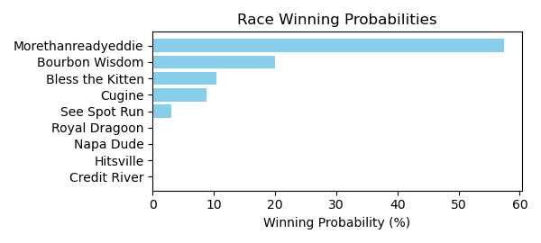

Figure: Winning Probability Distribution

NOTE: THIS RACE HAS HORSES THAT ARE MISSING CRITICAL DATA ELEMENTS

# Race: MVR | 2025-02-24 | Race #4 | Track: MAHONING VALLEY RACE COURSE

Track: MAHONING VALLEY RACE COURSE

|  |  |  |  |  |
| --- | --- | --- | --- | --- |
| Saddle Cloth # | Horse Name | Global Speed | Composite | Win Prob (%) |
| ['', 1, ''] | Doctor Wu * | 76.5 | 9.52 | 62.96 |
| ['', 2, ''] | Road to Stardom * | 76.5 | -5.47 | 0.00 |
| ['', 3, ''] | Southern Sense * | 76.5 | 1.34 | 0.09 |
| ['', 4, ''] | Game Boy Benny * | 76.5 | 7.94 | 17.83 |
| ['', 5, ''] | Scratchoff * | 76.5 | 3.15 | 0.38 |
| ['', 6, ''] | Outkissed * | 76.5 | 7.23 | 10.05 |
| ['', 7, ''] | Over the Hills * | 76.5 | -9.03 | 0.00 |
| ['', 8, ''] | P Money | 76.5 | 7.04 | 8.68 |

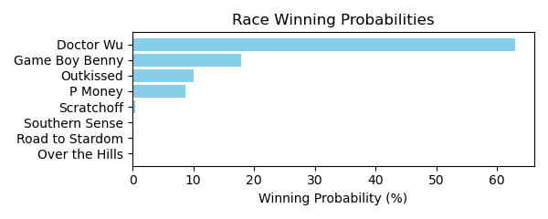

Figure: Winning Probability Distribution

NOTE: THIS RACE HAS HORSES THAT ARE MISSING CRITICAL DATA ELEMENTS

# Race: MVR | 2025-02-24 | Race #5 | Track: MAHONING VALLEY RACE COURSE

Track: MAHONING VALLEY RACE COURSE

|  |  |  |  |  |
| --- | --- | --- | --- | --- |
| Saddle Cloth # | Horse Name | Global Speed | Composite | Win Prob (%) |
| ['', 1, ''] | Ice Blast * | 104.0 | 3.35 | 2.73 |
| ['', 2, ''] | Boss Bear * | 104.0 | -5.61 | 0.00 |
| ['', 3, ''] | Exonerated Prez * | 104.0 | -7.91 | 0.00 |
| ['', 4, ''] | Had Right * | 104.0 | -0.49 | 0.13 |
| ['', 5, ''] | Mamba Forever * | 104.0 | -0.00 | 0.19 |
| ['', 6, ''] | Jarlian * | 104.0 | 6.11 | 24.77 |
| ['', 7, ''] | Kadesh * | 104.0 | 3.60 | 3.33 |
| ['', 8, ''] | Millard's Smile * | 104.0 | 1.84 | 0.81 |
| ['', 9, ''] | Small Sailor * | 104.0 | -4.58 | 0.00 |
| ['', 10, ''] | Leo and Royal * | 104.0 | 7.37 | 68.04 |

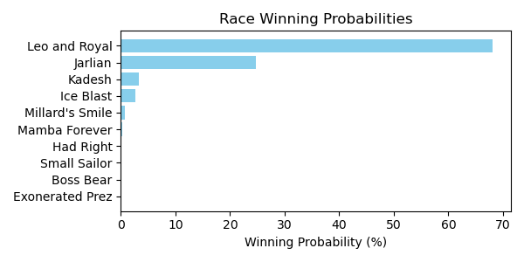

Figure: Winning Probability Distribution

NOTE: THIS RACE HAS HORSES THAT ARE MISSING CRITICAL DATA ELEMENTS

# Race: MVR | 2025-02-24 | Race #6 | Track: MAHONING VALLEY RACE COURSE

Track: MAHONING VALLEY RACE COURSE

|  |  |  |  |  |
| --- | --- | --- | --- | --- |
| Saddle Cloth # | Horse Name | Global Speed | Composite | Win Prob (%) |
| ['', 1, ''] | Money Room * | 104.1 | 1.35 | 1.15 |
| ['', 2, ''] | Delta Ridge * | 104.1 | -2.68 | 0.05 |
| ['', 3, ''] | Big Popper * | 104.1 | -4.42 | 0.01 |
| ['', 4, ''] | Last Cookie * | 104.1 | 6.57 | 74.93 |
| ['', 5, ''] | Tiz Speedy | 104.1 | -1.03 | 0.17 |
| ['', 6, ''] | Mitole's Wish * | 104.1 | -4.93 | 0.01 |
| ['', 7, ''] | Law of the Jungle | 104.1 | 5.13 | 23.65 |
| ['', 8, ''] | Panthera's Fate * | 104.1 | -3.01 | 0.04 |

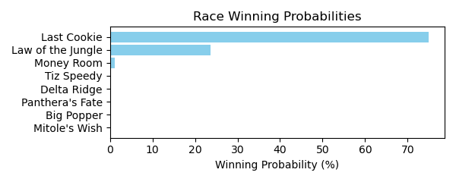

Figure: Winning Probability Distribution

NOTE: THIS RACE HAS HORSES THAT ARE MISSING CRITICAL DATA ELEMENTS

# Race: MVR | 2025-02-24 | Race #7 | Track: MAHONING VALLEY RACE COURSE

Track: MAHONING VALLEY RACE COURSE

|  |  |  |  |  |
| --- | --- | --- | --- | --- |
| Saddle Cloth # | Horse Name | Global Speed | Composite | Win Prob (%) |
| ['', 1, ''] | My Girl Kew * | 76.2 | 6.00 | 24.97 |
| ['', 2, ''] | Kiss Valentina * | 76.2 | 2.09 | 1.09 |
| ['', 3, ''] | Kiss Me Quick * | 76.2 | 6.87 | 49.76 |
| ['', 4, ''] | Beautiful Score * | 76.2 | -3.24 | 0.02 |
| ['', 5, ''] | Olympic Wings * | 76.2 | 2.38 | 1.38 |
| ['', 6, ''] | Hot Princess * | 76.2 | -2.98 | 0.02 |
| ['', 7, ''] | My Kinda Party * | 76.2 | 5.89 | 22.77 |

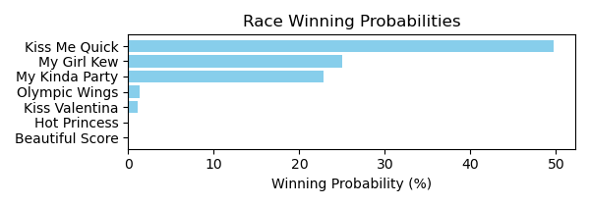

Figure: Winning Probability Distribution

NOTE: THIS RACE HAS HORSES THAT ARE MISSING CRITICAL DATA ELEMENTS

# Race: MVR | 2025-02-24 | Race #8 | Track: MAHONING VALLEY RACE COURSE

Track: MAHONING VALLEY RACE COURSE

|  |  |  |  |  |
| --- | --- | --- | --- | --- |
| Saddle Cloth # | Horse Name | Global Speed | Composite | Win Prob (%) |
| ['', 1, ''] | Princessofthenorth | 76.3 | 7.29 | 27.59 |
| ['', 2, ''] | Az We Speak * | 76.3 | 7.88 | 44.26 |
| ['', 3, ''] | Kerlo's Cause | 76.3 | -4.81 | 0.00 |
| ['', 4, ''] | Princess Is Olivia | 76.3 | 7.15 | 24.64 |
| ['', 5, ''] | Go Girl * | 76.3 | 4.31 | 2.54 |
| ['', 6, ''] | Beatiful Karla * | 76.3 | 0.14 | 0.09 |
| ['', 7, ''] | Devra Warrior | 76.3 | -3.23 | 0.01 |
| ['', 8, ''] | Ashlee's Ring | 76.3 | 2.09 | 0.43 |
| ['', 9, ''] | Sacred Connection * | 76.3 | 0.45 | 0.12 |
| ['', 10, ''] | Emerson Jones * | 76.3 | 1.74 | 0.32 |

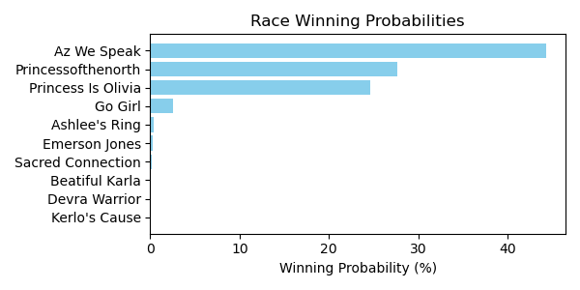

Figure: Winning Probability Distribution

NOTE: THIS RACE HAS HORSES THAT ARE MISSING CRITICAL DATA ELEMENTS

# Race: MVR | 2025-02-25 | Race #1 | Track: MAHONING VALLEY RACE COURSE

Track: MAHONING VALLEY RACE COURSE

|  |  |  |  |  |
| --- | --- | --- | --- | --- |
| Saddle Cloth # | Horse Name | Global Speed | Composite | Win Prob (%) |
| ['', 1, ''] | Master of the Nite * | 103.9 | 2.86 | 0.93 |
| ['', 2, ''] | Breakout Star | 103.9 | 7.05 | 26.45 |
| ['', 3, ''] | Ranseur * | 103.9 | -1.09 | 0.04 |
| ['', 4, ''] | Writeitontheice | 103.9 | -0.68 | 0.05 |
| ['', 5, ''] | Puff'smagicdragon | 103.9 | 7.79 | 47.84 |
| ['', 6, ''] | Royally Flushed * | 103.9 | 6.91 | 23.52 |
| ['', 7, ''] | Chaps Knight * | 103.9 | 3.16 | 1.18 |
| ['', 8, ''] | Euphoria Star | 103.9 | -6.07 | 0.00 |

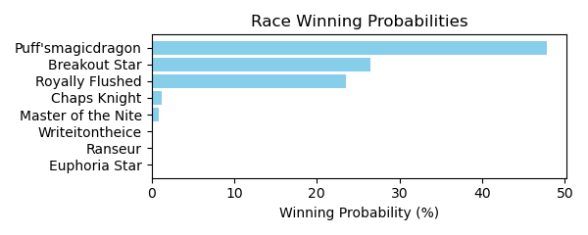

Figure: Winning Probability Distribution

NOTE: THIS RACE HAS HORSES THAT ARE MISSING CRITICAL DATA ELEMENTS

# Race: MVR | 2025-02-25 | Race #2 | Track: MAHONING VALLEY RACE COURSE

Track: MAHONING VALLEY RACE COURSE

|  |  |  |  |  |
| --- | --- | --- | --- | --- |
| Saddle Cloth # | Horse Name | Global Speed | Composite | Win Prob (%) |
| ['', 1, ''] | Kerri's Miracle * | 76.3 | 2.38 | 0.12 |
| ['', 2, ''] | Cause of Love * | 76.3 | 3.50 | 0.30 |
| ['', 3, ''] | Better Half * | 108.6 | 0.62 | 19.27 |
| ['', 4, ''] | Goodness Sakes * | 76.3 | -4.42 | 0.00 |
| ['', 5, ''] | High Fire * | 108.6 | 2.38 | 78.31 |
| ['', 6, ''] | Crossed Up * | 76.3 | 2.70 | 0.16 |
| ['', 7, ''] | The Miracle Kiut * | 76.3 | 5.77 | 1.84 |

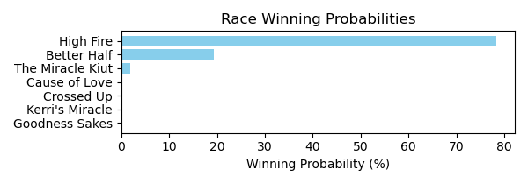

Figure: Winning Probability Distribution

NOTE: THIS RACE HAS HORSES THAT ARE MISSING CRITICAL DATA ELEMENTS

# Race: MVR | 2025-02-25 | Race #3 | Track: MAHONING VALLEY RACE COURSE

Track: MAHONING VALLEY RACE COURSE

|  |  |  |  |  |
| --- | --- | --- | --- | --- |
| Saddle Cloth # | Horse Name | Global Speed | Composite | Win Prob (%) |
| ['', 1, ''] | Lucky Penny Rose * | 104.0 | 1.61 | 0.37 |
| ['', 2, ''] | Gila | 104.0 | 8.34 | 82.03 |
| ['', 3, ''] | Lady Jasper * | 104.0 | 0.84 | 0.20 |
| ['', 4, ''] | Lofty Cowtown * | 104.0 | 5.52 | 8.56 |
| ['', 5, ''] | Divine Fashion * | 104.0 | 3.47 | 1.66 |
| ['', 6, ''] | Mobil Chic * | 104.0 | -4.96 | 0.00 |
| ['', 7, ''] | Mobil Lady * | 104.0 | 5.29 | 7.16 |

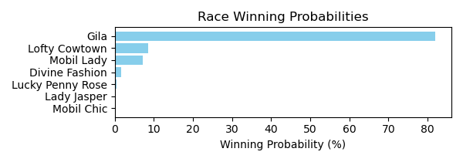

Figure: Winning Probability Distribution

NOTE: THIS RACE HAS HORSES THAT ARE MISSING CRITICAL DATA ELEMENTS

# Race: MVR | 2025-02-25 | Race #4 | Track: MAHONING VALLEY RACE COURSE

Track: MAHONING VALLEY RACE COURSE

|  |  |  |  |  |
| --- | --- | --- | --- | --- |
| Saddle Cloth # | Horse Name | Global Speed | Composite | Win Prob (%) |
| ['', 1, ''] | Play Ball * | 76.1 | -5.38 | 0.01 |
| ['', 2, ''] | Kid Russell * | 76.1 | -7.12 | 0.00 |
| ['', 3, ''] | Marvin's Express | 103.6 | -4.97 | 3.43 |
| ['', 4, ''] | El Marro * | 76.1 | 2.75 | 6.85 |
| ['', 5, ''] | dh-Spin Doctor * | 76.1 | 3.33 | 10.87 |
| ['', 6, ''] | Honor the D * | 76.1 | -4.75 | 0.02 |
| ['', 7, ''] | Bad Boy Boogie * | 82.1 | -9.63 | 0.00 |
| ['', 8, ''] | Keeping Score * | 76.1 | -9.01 | 0.00 |
| ['', 9, ''] | Beat the Dealer * | 76.1 | 5.80 | 78.82 |

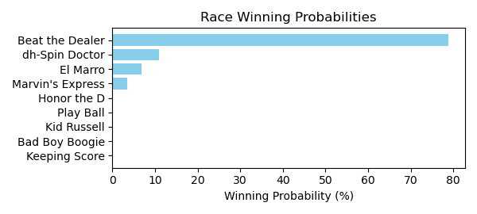

Figure: Winning Probability Distribution

NOTE: THIS RACE HAS HORSES THAT ARE MISSING CRITICAL DATA ELEMENTS

# Race: MVR | 2025-02-25 | Race #5 | Track: MAHONING VALLEY RACE COURSE

Track: MAHONING VALLEY RACE COURSE

|  |  |  |  |  |
| --- | --- | --- | --- | --- |
| Saddle Cloth # | Horse Name | Global Speed | Composite | Win Prob (%) |
| ['', 1, ''] | Lovebug | 76.1 | 6.91 | 70.02 |
| ['', 2, ''] | Rose's Wish * | 76.1 | 2.86 | 2.75 |
| ['', 3, ''] | Orgullosa Pacifica * | 76.1 | 2.07 | 1.46 |
| ['', 4, ''] | DEVILSGOLDENFIDDLE * | 74.6 | 4.32 | 6.41 |
| ['', 5, ''] | Miss Little Bit * | 66.4 | -9.30 | 0.00 |
| ['', 6, ''] | Wicked Eyes | 76.1 | -0.29 | 0.22 |
| ['', 7, ''] | FLYING PHOENIX * | 74.6 | 4.32 | 6.45 |
| ['', 8, ''] | Solo Surprise * | 76.1 | 3.13 | 3.40 |
| ['', 9, ''] | TURMALINA * | 76.1 | 4.39 | 9.29 |

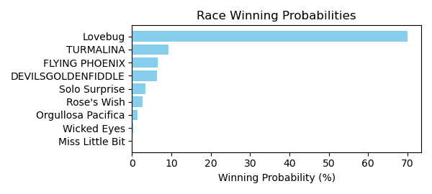

Figure: Winning Probability Distribution

NOTE: THIS RACE HAS HORSES THAT ARE MISSING CRITICAL DATA ELEMENTS

# Race: MVR | 2025-02-25 | Race #6 | Track: MAHONING VALLEY RACE COURSE

Track: MAHONING VALLEY RACE COURSE

|  |  |  |  |  |
| --- | --- | --- | --- | --- |
| Saddle Cloth # | Horse Name | Global Speed | Composite | Win Prob (%) |
| ['', 1, ''] | Bythenumbers * | 103.9 | -4.48 | 0.23 |
| ['', 2, ''] | Garden Secrets * | 103.9 | -2.20 | 1.39 |
| ['', 3, ''] | Elko * | 103.9 | -6.81 | 0.03 |
| ['', 4, ''] | Queen Lexi | 103.9 | 2.96 | 86.21 |
| ['', 5, ''] | Islandinthestream * | 103.9 | -3.22 | 0.61 |
| ['', 6, ''] | Hebrides * | 103.9 | -0.10 | 7.48 |
| ['', 7, ''] | Rumours Fly * | 103.9 | -5.76 | 0.08 |
| ['', 8, ''] | Mary Katherine * | 103.9 | -0.90 | 3.94 |
| ['', 9, ''] | Mangorita * | 103.9 | -6.92 | 0.03 |

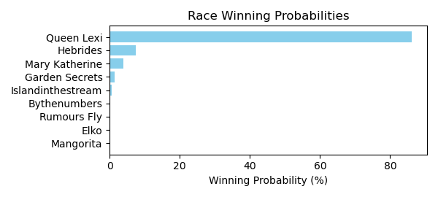

Figure: Winning Probability Distribution

NOTE: THIS RACE HAS HORSES THAT ARE MISSING CRITICAL DATA ELEMENTS

# Race: MVR | 2025-02-25 | Race #7 | Track: MAHONING VALLEY RACE COURSE

Track: MAHONING VALLEY RACE COURSE

|  |  |  |  |  |
| --- | --- | --- | --- | --- |
| Saddle Cloth # | Horse Name | Global Speed | Composite | Win Prob (%) |
| ['', 1, ''] | Battle of Bastogne * | 82.5 | -6.60 | 0.00 |
| ['', 2, ''] | Deus Ex Machina | 76.4 | -1.78 | 0.04 |
| ['', 3, ''] | Lucky Nineteen * | 76.4 | -1.03 | 0.08 |
| ['', 4, ''] | Bucket List | 76.4 | 2.34 | 1.17 |
| ['', 5, ''] | Buehler's Day Off * | 76.4 | 7.37 | 64.76 |
| ['', 6, ''] | Destino * | 76.4 | -6.76 | 0.00 |
| ['', 7, ''] | Sir * | 76.4 | 4.78 | 8.19 |
| ['', 8, ''] | Bailamos | 76.4 | 5.20 | 11.48 |
| ['', 9, ''] | Mshindi * | 76.4 | 3.33 | 2.57 |
| ['', 10, ''] | Hub | 76.4 | 5.21 | 11.58 |
| ['', 11, ''] | One Way Traffic | 82.5 | -1.94 | 0.13 |

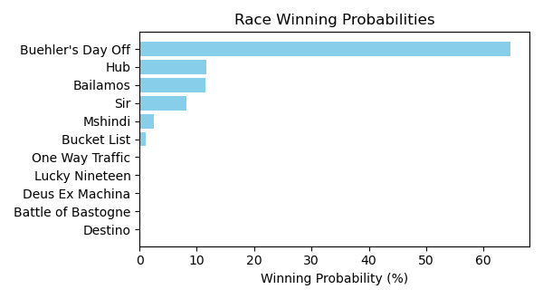

Figure: Winning Probability Distribution

NOTE: THIS RACE HAS HORSES THAT ARE MISSING CRITICAL DATA ELEMENTS

# Race: MVR | 2025-02-25 | Race #8 | Track: MAHONING VALLEY RACE COURSE

Track: MAHONING VALLEY RACE COURSE

|  |  |  |  |  |
| --- | --- | --- | --- | --- |
| Saddle Cloth # | Horse Name | Global Speed | Composite | Win Prob (%) |
| ['', 1, ''] | Domi * | 108.5 | -1.49 | 0.12 |
| ['', 2, ''] | Spuns Son | 108.5 | 5.88 | 43.76 |
| ['', 3, ''] | Convert * | 103.8 | 4.10 | 4.06 |
| ['', 4, ''] | Availability * | 108.5 | -2.81 | 0.04 |
| ['', 5, ''] | Ramsey * | 103.8 | -1.34 | 0.05 |
| ['', 6, ''] | Sage Runner * | 108.5 | 0.83 | 0.77 |
| ['', 7, ''] | Lt's Jacknthebox * | 108.5 | 6.08 | 51.19 |
| ['', 8, ''] | Bamby Boom | 71.0 | -2.17 | 0.00 |
| ['', 9, ''] | Golden Al | 108.5 | -6.37 | 0.00 |

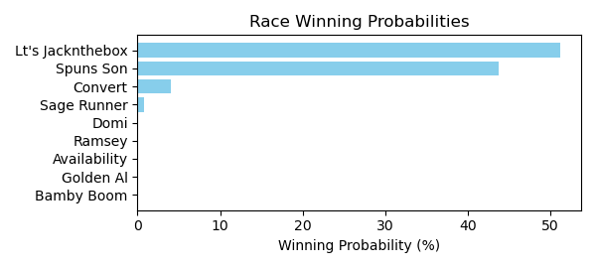

Figure: Winning Probability Distribution

NOTE: THIS RACE HAS HORSES THAT ARE MISSING CRITICAL DATA ELEMENTS

# Race: MVR | 2025-02-25 | Race #9 | Track: MAHONING VALLEY RACE COURSE

Track: MAHONING VALLEY RACE COURSE

|  |  |  |  |  |
| --- | --- | --- | --- | --- |
| Saddle Cloth # | Horse Name | Global Speed | Composite | Win Prob (%) |
| ['', 1, ''] | Dude the Legend * | 103.0 | -0.83 | 1.51 |
| ['', 2, ''] | Wild Domain * | 75.8 | 5.64 | 1.17 |
| ['', 3, ''] | Remix From Phoenix * | 75.8 | -0.51 | 0.01 |
| ['', 4, ''] | Skunk Ape * | 75.8 | -2.29 | 0.00 |
| ['', 5, ''] | Hidden Heart * | 103.0 | 4.35 | 95.13 |
| ['', 6, ''] | Indy's Hope * | 103.0 | -1.89 | 0.65 |
| ['', 7, ''] | RED CHIPS * | 75.8 | 5.01 | 0.70 |
| ['', 8, ''] | BUMPER STICKER * | 75.8 | 5.23 | 0.84 |

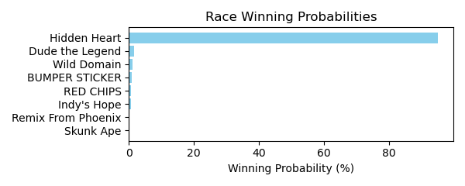

Figure: Winning Probability Distribution

NOTE: THIS RACE HAS HORSES THAT ARE MISSING CRITICAL DATA ELEMENTS

# Race: MVR | 2025-02-25 | Race #10 | Track: MAHONING VALLEY RACE COURSE

Track: MAHONING VALLEY RACE COURSE

|  |  |  |  |  |
| --- | --- | --- | --- | --- |
| Saddle Cloth # | Horse Name | Global Speed | Composite | Win Prob (%) |
| ['', 1, ''] | SILENT DRILL * | 75.9 | 4.01 | 10.68 |
| ['', 2, ''] | HIS ROYAL HIGHNESS * | 78.8 | 4.04 | 19.49 |
| ['', 3, ''] | Blue Blood Cowboy * | 75.9 | -4.03 | 0.02 |
| ['', 4, ''] | Vernon's Best * | 75.9 | 4.10 | 11.46 |
| ['', 5, ''] | P J's Boy * | 75.9 | 5.17 | 26.93 |
| ['', 6, ''] | Flaring Song * | 75.9 | 0.90 | 0.88 |
| ['', 7, ''] | Formyboys * | 103.1 | -1.49 | 30.52 |
| ['', 8, ''] | He Is Dynamic * | 75.9 | -6.42 | 0.00 |
| ['', 9, ''] | Lucky Kater * | 75.9 | -7.92 | 0.00 |

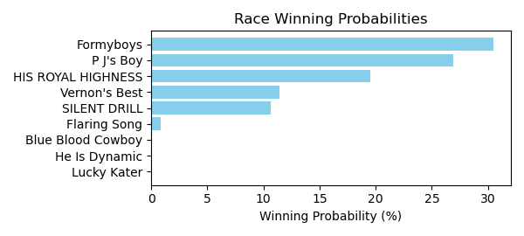

Figure: Winning Probability Distribution

NOTE: THIS RACE HAS HORSES THAT ARE MISSING CRITICAL DATA ELEMENTS

# Race: TOP | 2025-02-21 | Race #1 | Track: OAKLAWN PARK

Track: OAKLAWN PARK

|  |  |  |  |  |
| --- | --- | --- | --- | --- |
| Saddle Cloth # | Horse Name | Global Speed | Composite | Win Prob (%) |
| ['', 1, ''] | Max Mischief * | 76.3 | -8.07 | 0.01 |
| ['', 2, ''] | Levee Was Dry | 76.3 | 1.70 | 17.85 |
| ['', 3, ''] | HECKAMIGHTY * | 76.3 | 3.57 | 79.47 |
| ['', 4, ''] | Tactical Man * | 76.3 | -7.05 | 0.02 |
| ['', 5, ''] | Chun Money | 76.3 | -5.21 | 0.07 |
| ['', 6, ''] | Arjun for Karz | 76.3 | -9.75 | 0.00 |
| ['', 7, ''] | Good News Rocket | 76.3 | -1.05 | 1.97 |
| ['', 8, ''] | World Fair | 76.3 | -2.52 | 0.61 |

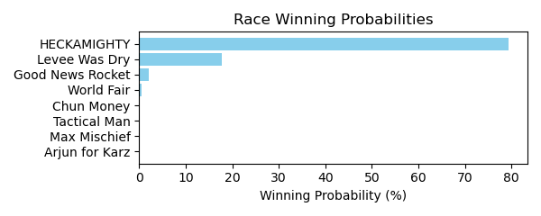

Figure: Winning Probability Distribution

NOTE: THIS RACE HAS HORSES THAT ARE MISSING CRITICAL DATA ELEMENTS

# Race: TOP | 2025-02-21 | Race #2 | Track: OAKLAWN PARK

Track: OAKLAWN PARK

|  |  |  |  |  |
| --- | --- | --- | --- | --- |
| Saddle Cloth # | Horse Name | Global Speed | Composite | Win Prob (%) |
| ['', 1, ''] | Paint Baller | 76.4 | 8.29 | 85.07 |
| ['', 2, ''] | Handsome Herb | 76.4 | -7.00 | 0.00 |
| ['', 3, ''] | Walstib | 76.4 | 1.25 | 0.30 |
| ['', 4, ''] | Trusted Image | 76.4 | -5.97 | 0.00 |
| ['', 5, ''] | JINXZI * | 76.4 | 5.86 | 12.17 |
| ['', 6, ''] | Tiz My Hero | 76.4 | -3.74 | 0.01 |
| ['', 7, ''] | Spielman | 76.4 | 0.31 | 0.14 |
| ['', 8, ''] | Simovic | 76.4 | 3.42 | 1.73 |
| ['', 9, ''] | Nyquist Frequency | 76.4 | 2.03 | 0.57 |

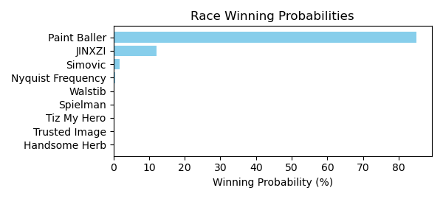

Figure: Winning Probability Distribution

NOTE: THIS RACE HAS HORSES THAT ARE MISSING CRITICAL DATA ELEMENTS

# Race: TOP | 2025-02-21 | Race #3 | Track: OAKLAWN PARK

Track: OAKLAWN PARK

|  |  |  |  |  |
| --- | --- | --- | --- | --- |
| Saddle Cloth # | Horse Name | Global Speed | Composite | Win Prob (%) |
| ['', 1, ''] | Peace Dog | 76.4 | 6.09 | 24.52 |
| ['', 2, ''] | Choctaw Zip | 76.4 | 7.31 | 65.20 |
| ['', 3, ''] | Blessed Vision | 76.4 | -0.94 | 0.09 |
| ['', 4, ''] | Miri a Coincidence | 76.4 | -6.29 | 0.00 |
| ['', 5, ''] | Cooler King | 76.4 | -3.97 | 0.01 |
| ['', 6, ''] | You Vee Cee | 76.4 | 4.93 | 9.73 |
| ['', 7, ''] | Changing Times | 76.4 | -8.30 | 0.00 |
| ['', 8, ''] | Macho Ronnie | 76.4 | -5.78 | 0.00 |
| ['', 9, ''] | I'm an Oak | 76.4 | -3.30 | 0.01 |
| ['', 10, ''] | Dicey Wager | 76.4 | -7.32 | 0.00 |
| ['', 11, ''] | Reef's Destiny | 76.4 | 1.07 | 0.44 |
| ['', 12, ''] | Colonel Barton | 76.4 | -6.57 | 0.00 |

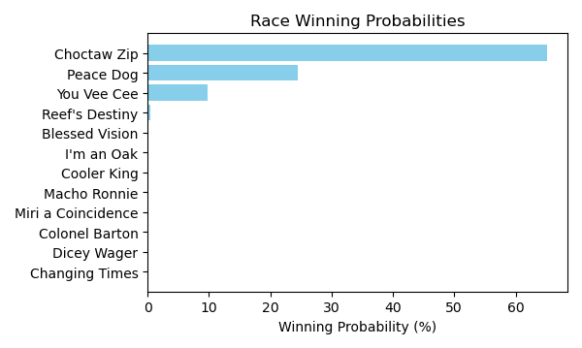

Figure: Winning Probability Distribution

NOTE: THIS RACE HAS HORSES THAT ARE MISSING CRITICAL DATA ELEMENTS

# Race: TOP | 2025-02-21 | Race #4 | Track: OAKLAWN PARK

Track: OAKLAWN PARK

|  |  |  |  |  |
| --- | --- | --- | --- | --- |
| Saddle Cloth # | Horse Name | Global Speed | Composite | Win Prob (%) |
| ['', 1, ''] | She's Solid Silver * | 76.3 | 0.39 | 0.25 |
| ['', 2, ''] | Sparkly | 76.3 | 6.78 | 42.17 |
| ['', 3, ''] | Hot Day | 76.3 | 5.47 | 14.75 |
| ['', 4, ''] | Lady Riley | 76.3 | -4.66 | 0.00 |
| ['', 5, ''] | Babe in the Woods | 76.3 | -3.22 | 0.01 |
| ['', 6, ''] | Be My Huckleberry | 76.3 | -9.20 | 0.00 |
| ['', 7, ''] | Wampus Kitten | 76.3 | -7.43 | 0.00 |
| ['', 8, ''] | Chica Arma | 76.3 | 6.80 | 42.65 |
| ['', 9, ''] | My Kinda Trouble * | 76.3 | -5.17 | 0.00 |
| ['', 10, ''] | Spin the Breeze | 76.3 | -2.12 | 0.03 |
| ['', 11, ''] | Twas Lola | 76.3 | -0.61 | 0.11 |

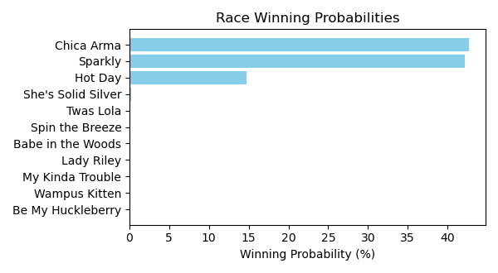

Figure: Winning Probability Distribution

NOTE: THIS RACE HAS HORSES THAT ARE MISSING CRITICAL DATA ELEMENTS

# Race: TOP | 2025-02-21 | Race #5 | Track: OAKLAWN PARK

Track: OAKLAWN PARK

|  |  |  |  |  |
| --- | --- | --- | --- | --- |
| Saddle Cloth # | Horse Name | Global Speed | Composite | Win Prob (%) |
| ['', 1, ''] | Preacher's Kid | 76.2 | -4.67 | 0.01 |
| ['', 2, ''] | Big Bourbon River | 76.2 | -6.58 | 0.00 |
| ['', 3, ''] | Museum Quality | 76.2 | 5.57 | 26.93 |
| ['', 4, ''] | Rerun | 76.2 | -7.12 | 0.00 |
| ['', 5, ''] | Austin's Map | 76.2 | -1.88 | 0.07 |
| ['', 6, ''] | Shot At Pure Peace | 76.2 | -10.32 | 0.00 |
| ['', 7, ''] | Mo Heartaches * | 76.2 | -5.10 | 0.01 |
| ['', 8, ''] | Safe Bet | 76.2 | 6.78 | 70.84 |
| ['', 9, ''] | Penrod | 76.2 | 2.41 | 2.15 |
| ['', 10, ''] | Run Deano Run | 76.2 | -8.66 | 0.00 |
| ['', 11, ''] | Gentle Ben | 76.2 | -10.08 | 0.00 |

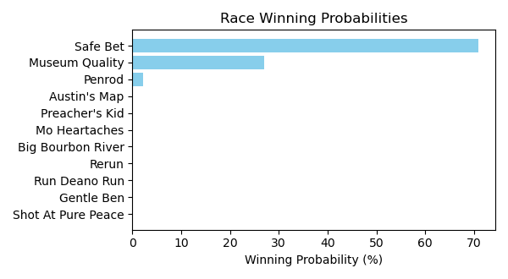

Figure: Winning Probability Distribution

NOTE: THIS RACE HAS HORSES THAT ARE MISSING CRITICAL DATA ELEMENTS

# Race: TOP | 2025-02-21 | Race #6 | Track: OAKLAWN PARK

Track: OAKLAWN PARK

|  |  |  |  |  |
| --- | --- | --- | --- | --- |
| Saddle Cloth # | Horse Name | Global Speed | Composite | Win Prob (%) |
| ['', 1, ''] | She's Not a Joke | 76.4 | 8.43 | 78.22 |
| ['', 2, ''] | Xyngin Spitfire | 76.4 | 5.28 | 6.31 |
| ['', 3, ''] | Our Keepsake | 76.4 | 2.85 | 0.90 |
| ['', 4, ''] | Scrupulous | 76.4 | 4.87 | 4.53 |
| ['', 5, ''] | What's to Do | 76.4 | 2.79 | 0.85 |
| ['', 6, ''] | Spirit Rules | 76.4 | -0.81 | 0.05 |
| ['', 7, ''] | Chojo * | 76.4 | -5.52 | 0.00 |
| ['', 8, ''] | Sweet Mother Mary | 76.4 | 2.74 | 0.82 |
| ['', 9, ''] | Q's Your Mama | 76.4 | 5.63 | 8.31 |

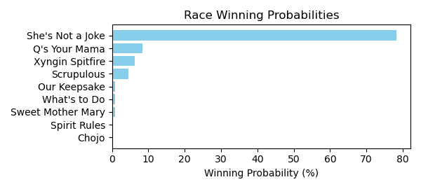

Figure: Winning Probability Distribution

NOTE: THIS RACE HAS HORSES THAT ARE MISSING CRITICAL DATA ELEMENTS

# Race: TOP | 2025-02-21 | Race #7 | Track: OAKLAWN PARK

Track: OAKLAWN PARK

|  |  |  |  |  |
| --- | --- | --- | --- | --- |
| Saddle Cloth # | Horse Name | Global Speed | Composite | Win Prob (%) |
| ['', 1, ''] | Viveca | 111.2 | -5.69 | 0.00 |
| ['', 2, ''] | Pink Ruby * | 111.2 | -7.91 | 0.00 |
| ['', 3, ''] | LOTTERY TICKET * | 111.2 | 4.28 | 3.80 |
| ['', 4, ''] | Zen Dreams | 111.2 | -3.16 | 0.01 |
| ['', 5, ''] | St. Albans Raid | 111.2 | -8.64 | 0.00 |
| ['', 6, ''] | My Shot | 111.2 | -1.24 | 0.05 |
| ['', 7, ''] | Vino Tiempo | 111.2 | -3.03 | 0.01 |
| ['', 8, ''] | Kerry's Kiss | 111.2 | 8.26 | 91.52 |
| ['', 9, ''] | FALL IN LOVE * | 111.2 | 4.53 | 4.62 |
| ['', 10, ''] | Cat Pays the Toll | 111.2 | -8.98 | 0.00 |

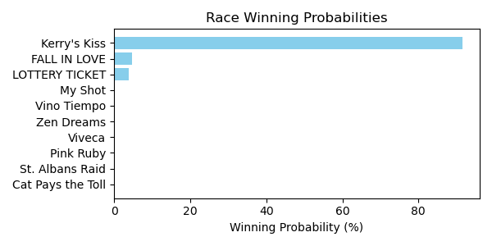

Figure: Winning Probability Distribution

NOTE: THIS RACE HAS HORSES THAT ARE MISSING CRITICAL DATA ELEMENTS

# Race: TOP | 2025-02-21 | Race #8 | Track: OAKLAWN PARK

Track: OAKLAWN PARK

|  |  |  |  |  |
| --- | --- | --- | --- | --- |
| Saddle Cloth # | Horse Name | Global Speed | Composite | Win Prob (%) |
| ['', 1, ''] | Golden Luna | 76.6 | -5.12 | 0.00 |
| ['', 2, ''] | El Diablo Rojo | 76.6 | 8.22 | 8.56 |
| ['', 3, ''] | Russian to Win | 76.6 | 8.76 | 13.18 |
| ['', 4, ''] | Pressure | 76.6 | -2.53 | 0.00 |
| ['', 5, ''] | Top Gun Tommy | 76.6 | 6.80 | 2.74 |
| ['', 6, ''] | Eternally Grateful | 76.6 | 9.62 | 26.18 |
| ['', 7, ''] | Vale | 76.6 | 2.10 | 0.06 |
| ['', 8, ''] | Raymond | 76.6 | 10.40 | 48.79 |
| ['', 9, ''] | Drill's Li'l Man * | 76.6 | 1.37 | 0.04 |
| ['', 10, ''] | Ian Glass | 76.6 | 4.53 | 0.45 |

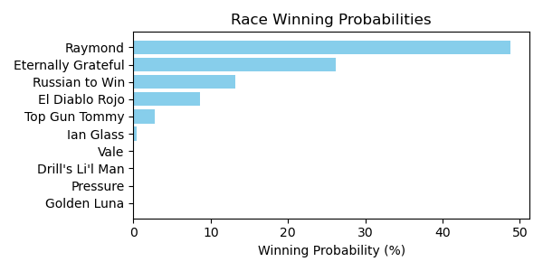

Figure: Winning Probability Distribution

NOTE: THIS RACE HAS HORSES THAT ARE MISSING CRITICAL DATA ELEMENTS

# Race: TOP | 2025-02-21 | Race #9 | Track: OAKLAWN PARK

Track: OAKLAWN PARK

|  |  |  |  |  |
| --- | --- | --- | --- | --- |
| Saddle Cloth # | Horse Name | Global Speed | Composite | Win Prob (%) |
| ['', 1, ''] | I'm McDreamy | 104.4 | 0.13 | 0.13 |
| ['', 2, ''] | Daily Grind | 104.4 | 6.68 | 25.42 |
| ['', 3, ''] | Millers Rite | 104.4 | 3.23 | 1.60 |
| ['', 4, ''] | Gun Party | 104.4 | -3.49 | 0.01 |
| ['', 5, ''] | Indy Magic | 104.4 | -5.34 | 0.00 |
| ['', 6, ''] | Liam's Journey | 104.4 | -6.54 | 0.00 |
| ['', 7, ''] | Gold Sweep | 104.4 | 1.31 | 0.35 |
| ['', 8, ''] | Caper's Hooley | 104.4 | 3.35 | 1.77 |
| ['', 9, ''] | Lat Long | 104.4 | 7.96 | 70.57 |
| ['', 10, ''] | Anthonian | 104.4 | 0.15 | 0.14 |

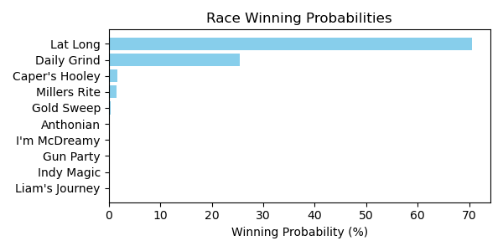

Figure: Winning Probability Distribution

NOTE: THIS RACE HAS HORSES THAT ARE MISSING CRITICAL DATA ELEMENTS

# Race: TOP | 2025-02-21 | Race #10 | Track: OAKLAWN PARK

Track: OAKLAWN PARK

|  |  |  |  |  |
| --- | --- | --- | --- | --- |
| Saddle Cloth # | Horse Name | Global Speed | Composite | Win Prob (%) |
| ['', 1, ''] | Ice Again * | 111.4 | 2.85 | 1.12 |
| ['', 2, ''] | Hollywood Ending | 111.4 | -3.18 | 0.01 |
| ['', 3, ''] | Mount Craig | 111.4 | 1.51 | 0.39 |
| ['', 4, ''] | Charbon | 111.4 | -0.84 | 0.06 |
| ['', 5, ''] | dh-Redbird Nation | 111.4 | -3.68 | 0.01 |
| ['', 6, ''] | Gluckstadt | 111.4 | 0.82 | 0.22 |
| ['', 7, ''] | Reveille Valley | 111.4 | 2.04 | 0.59 |
| ['', 8, ''] | Rivetage | 111.4 | -1.38 | 0.04 |
| ['', 9, ''] | dh-Fastened | 111.4 | -3.91 | 0.01 |
| ['', 10, ''] | Fear of Union | 111.4 | 8.25 | 84.82 |
| ['', 11, ''] | Famous Final Scene | 111.4 | 5.89 | 12.75 |

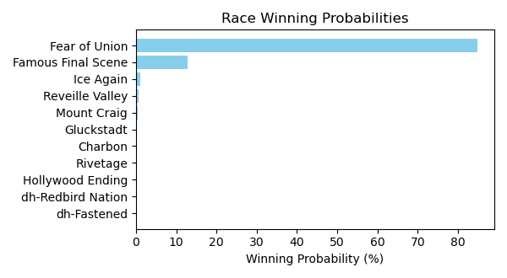

Figure: Winning Probability Distribution

NOTE: THIS RACE HAS HORSES THAT ARE MISSING CRITICAL DATA ELEMENTS

# Race: TOP | 2025-02-22 | Race #1 | Track: OAKLAWN PARK

Track: OAKLAWN PARK

|  |  |  |  |  |
| --- | --- | --- | --- | --- |
| Saddle Cloth # | Horse Name | Global Speed | Composite | Win Prob (%) |
| ['', 1, ''] | Fever Night | 111.6 | 2.79 | 1.61 |
| ['', 2, ''] | Zardun * | 111.6 | 6.10 | 22.84 |
| ['', 3, ''] | Clever Again * | 111.6 | 6.88 | 42.48 |
| ['', 4, ''] | Just Classic | 111.6 | -6.36 | 0.00 |
| ['', 5, ''] | Shepherd | 111.6 | -3.35 | 0.01 |
| ['', 6, ''] | Baobab * | 111.6 | 4.94 | 8.97 |
| ['', 7, ''] | Doroteo * | 111.6 | 5.82 | 18.17 |
| ['', 8, ''] | Crisis Manager | 111.6 | 2.96 | 1.85 |
| ['', 9, ''] | Hired Gun | 111.6 | 1.75 | 0.70 |
| ['', 10, ''] | Ripped | 111.6 | 3.71 | 3.37 |

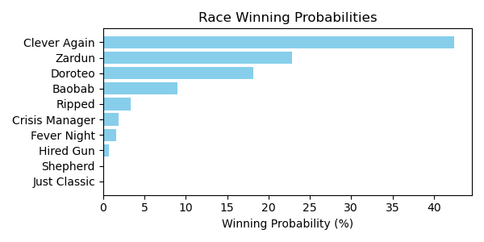

Figure: Winning Probability Distribution

NOTE: THIS RACE HAS HORSES THAT ARE MISSING CRITICAL DATA ELEMENTS

# Race: TOP | 2025-02-22 | Race #2 | Track: OAKLAWN PARK

Track: OAKLAWN PARK

|  |  |  |  |  |
| --- | --- | --- | --- | --- |
| Saddle Cloth # | Horse Name | Global Speed | Composite | Win Prob (%) |
| ['', 1, ''] | Distorted Pro | 76.7 | 5.98 | 1.78 |
| ['', 2, ''] | I'm Wide Awake | 76.7 | 9.76 | 36.77 |
| ['', 3, ''] | Rowdy Riot | 76.7 | 4.69 | 0.64 |
| ['', 4, ''] | Great Richie M | 76.7 | 6.98 | 3.98 |
| ['', 5, ''] | B Sudd | 76.7 | 6.85 | 3.59 |
| ['', 6, ''] | Manta Rey | 76.7 | 3.16 | 0.19 |
| ['', 7, ''] | Goodasiwonswas | 76.7 | 7.06 | 4.26 |
| ['', 8, ''] | Breslau | 76.7 | 2.46 | 0.11 |
| ['', 9, ''] | Run Jalen Run | 76.7 | 9.21 | 23.75 |
| ['', 10, ''] | Sitka | 76.7 | 9.25 | 24.52 |
| ['', 11, ''] | Red State | 76.7 | 4.14 | 0.41 |

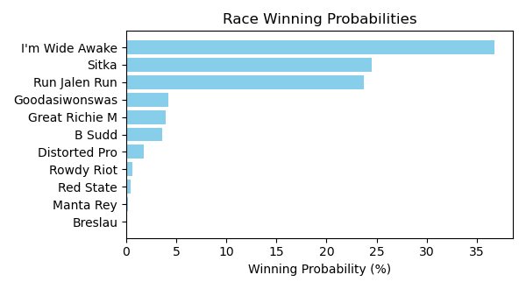

Figure: Winning Probability Distribution

NOTE: THIS RACE HAS HORSES THAT ARE MISSING CRITICAL DATA ELEMENTS

# Race: TOP | 2025-02-22 | Race #3 | Track: OAKLAWN PARK

Track: OAKLAWN PARK

|  |  |  |  |  |
| --- | --- | --- | --- | --- |
| Saddle Cloth # | Horse Name | Global Speed | Composite | Win Prob (%) |
| ['', 1, ''] | Ashburn Alley | 76.5 | 9.88 | 80.22 |
| ['', 2, ''] | Queen's Martini | 76.5 | -0.30 | 0.02 |
| ['', 3, ''] | Princess Is Olivia | 76.5 | 1.67 | 0.11 |
| ['', 4, ''] | Bennykayandsuzytoo | 76.5 | 7.35 | 10.68 |
| ['', 5, ''] | Tiffany Twist | 76.5 | 0.25 | 0.04 |
| ['', 6, ''] | Laurie's Secret | 76.5 | -9.16 | 0.00 |
| ['', 7, ''] | Insightful Miss | 76.5 | 6.31 | 4.64 |
| ['', 8, ''] | That's Our Vision * | 76.5 | -8.10 | 0.00 |
| ['', 9, ''] | Music Mistress | 76.5 | -4.84 | 0.00 |
| ['', 10, ''] | Theresasilverlinin | 76.5 | -5.93 | 0.00 |
| ['', 11, ''] | Brooklynn Drew | 76.5 | -4.49 | 0.00 |
| ['', 12, ''] | Gloriette | 76.5 | 6.15 | 4.07 |
| ['', 13, ''] | Managing Mischief | 76.5 | 1.28 | 0.08 |
| ['', 14, ''] | Popperina | 76.5 | 1.90 | 0.14 |

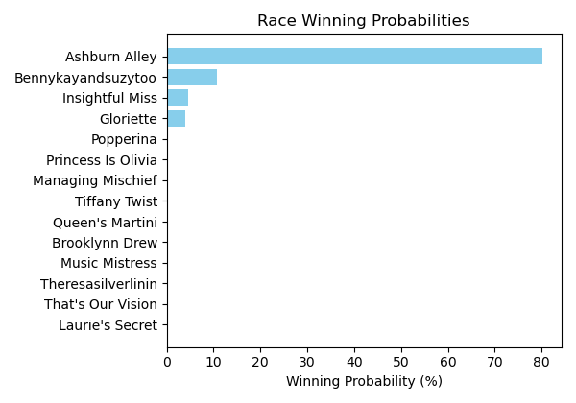

Figure: Winning Probability Distribution

NOTE: THIS RACE HAS HORSES THAT ARE MISSING CRITICAL DATA ELEMENTS

# Race: TOP | 2025-02-22 | Race #4 | Track: OAKLAWN PARK

Track: OAKLAWN PARK

|  |  |  |  |  |
| --- | --- | --- | --- | --- |
| Saddle Cloth # | Horse Name | Global Speed | Composite | Win Prob (%) |
| ['', 1, ''] | Benedetta | 76.6 | 6.83 | 20.36 |
| ['', 2, ''] | Mazoku | 76.6 | 7.89 | 47.66 |
| ['', 3, ''] | Justique | 76.6 | 5.76 | 8.66 |
| ['', 4, ''] | Sandy Bottom | 76.6 | 1.89 | 0.39 |
| ['', 5, ''] | Miss Arlington | 76.6 | -3.47 | 0.01 |
| ['', 6, ''] | Ms. Bucchero | 76.6 | 2.76 | 0.79 |
| ['', 7, ''] | American Band | 76.6 | 1.74 | 0.35 |
| ['', 8, ''] | Lady Moscato | 76.6 | 6.90 | 21.55 |
| ['', 9, ''] | Pistol | 76.6 | 1.31 | 0.25 |

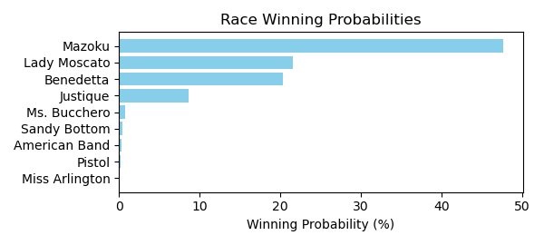

Figure: Winning Probability Distribution

NOTE: THIS RACE HAS HORSES THAT ARE MISSING CRITICAL DATA ELEMENTS

# Race: TOP | 2025-02-22 | Race #5 | Track: OAKLAWN PARK

Track: OAKLAWN PARK

|  |  |  |  |  |
| --- | --- | --- | --- | --- |
| Saddle Cloth # | Horse Name | Global Speed | Composite | Win Prob (%) |
| ['', 1, ''] | Oy Gevald * | 76.5 | 3.67 | 1.72 |
| ['', 2, ''] | Faust * | 76.5 | 6.61 | 18.12 |
| ['', 3, ''] | Sixtyseven Mustang * | 76.5 | 2.12 | 0.50 |
| ['', 4, ''] | Secret Legend | 76.5 | -1.42 | 0.03 |
| ['', 5, ''] | ZERO SUGAR * | 76.5 | 3.53 | 1.55 |
| ['', 6, ''] | Chases Magic * | 76.5 | -7.91 | 0.00 |
| ['', 7, ''] | CORNUCOPIAN * | 76.5 | 2.99 | 1.00 |
| ['', 8, ''] | Wise Decision | 76.5 | -5.97 | 0.00 |
| ['', 9, ''] | dh-Ready to Seize * | 76.5 | 2.48 | 0.67 |
| ['', 10, ''] | Max Got Excited | 76.5 | 8.41 | 76.41 |
| ['', 11, ''] | Gun Runner Charlie | 76.5 | -8.73 | 0.00 |
| ['', 12, ''] | Oil Capital * | 76.5 | -3.34 | 0.01 |

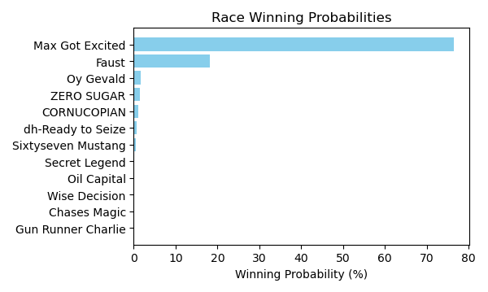

Figure: Winning Probability Distribution

NOTE: THIS RACE HAS HORSES THAT ARE MISSING CRITICAL DATA ELEMENTS

# Race: TOP | 2025-02-22 | Race #6 | Track: OAKLAWN PARK

Track: OAKLAWN PARK

|  |  |  |  |  |
| --- | --- | --- | --- | --- |
| Saddle Cloth # | Horse Name | Global Speed | Composite | Win Prob (%) |
| ['', 1, ''] | Elusive Target | 111.8 | 0.61 | 0.04 |
| ['', 2, ''] | Shot of Courage | 111.8 | 5.44 | 2.12 |
| ['', 3, ''] | One Giant Leap | 111.8 | -0.26 | 0.02 |
| ['', 4, ''] | B D Saints | 111.8 | 0.66 | 0.05 |
| ['', 5, ''] | Touch Of Glam (ARG) * | 111.8 | 1.33 | 0.08 |
| ['', 6, ''] | Nullify | 111.8 | 9.48 | 53.37 |
| ['', 7, ''] | Lambeth | 111.8 | 5.74 | 2.68 |
| ['', 8, ''] | Harleezy | 111.8 | 5.35 | 1.97 |
| ['', 9, ''] | Imperial Gun | 111.8 | -8.25 | 0.00 |
| ['', 10, ''] | Ethan Energy | 111.8 | 9.11 | 39.59 |
| ['', 11, ''] | Spoiler | 111.8 | 0.27 | 0.03 |
| ['', 12, ''] | Dynamis | 111.8 | 0.76 | 0.05 |

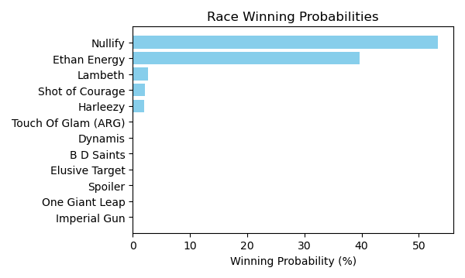

Figure: Winning Probability Distribution

NOTE: THIS RACE HAS HORSES THAT ARE MISSING CRITICAL DATA ELEMENTS

# Race: TOP | 2025-02-22 | Race #7 | Track: OAKLAWN PARK

Track: OAKLAWN PARK

|  |  |  |  |  |
| --- | --- | --- | --- | --- |
| Saddle Cloth # | Horse Name | Global Speed | Composite | Win Prob (%) |
| ['', 1, ''] | Carbone | 76.7 | 0.12 | 0.03 |
| ['', 2, ''] | Just Steel | 76.7 | 0.34 | 0.03 |
| ['', 3, ''] | Attache | 76.7 | 7.83 | 12.94 |
| ['', 4, ''] | Nasty Habit | 76.7 | 2.96 | 0.26 |
| ['', 5, ''] | Excitable Boy | 76.7 | 5.62 | 2.21 |
| ['', 6, ''] | Invulnerable | 76.7 | 6.19 | 3.48 |
| ['', 7, ''] | Eglise | 76.7 | 8.78 | 27.57 |
| ['', 8, ''] | Big City | 76.7 | 9.03 | 33.68 |
| ['', 9, ''] | Runaway Jack | 76.7 | 7.74 | 12.00 |
| ['', 10, ''] | Ninja Warrior | 76.7 | 7.20 | 7.80 |

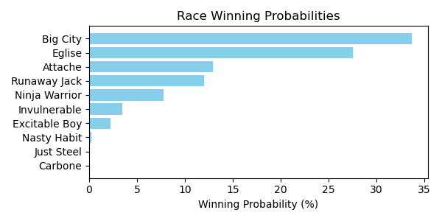

Figure: Winning Probability Distribution

NOTE: THIS RACE HAS HORSES THAT ARE MISSING CRITICAL DATA ELEMENTS

# Race: TOP | 2025-02-22 | Race #8 | Track: OAKLAWN PARK

Track: OAKLAWN PARK

|  |  |  |  |  |
| --- | --- | --- | --- | --- |
| Saddle Cloth # | Horse Name | Global Speed | Composite | Win Prob (%) |
| ['', 1, ''] | Under the Palms | 111.8 | 6.18 | 3.39 |
| ['', 2, ''] | Bru Na Boinne | 111.8 | 1.27 | 0.07 |
| ['', 3, ''] | Broughty Ferry | 111.8 | 4.32 | 0.76 |
| ['', 4, ''] | Gold Medal Anna | 111.8 | -1.18 | 0.01 |
| ['', 5, ''] | Peignoir | 111.8 | 6.81 | 5.60 |
| ['', 6, ''] | Majestic Oops | 111.8 | 3.13 | 0.29 |
| ['', 7, ''] | Bow Draw | 111.8 | 1.12 | 0.06 |
| ['', 8, ''] | Indy Label | 111.8 | 5.97 | 2.86 |
| ['', 9, ''] | Neom Beach | 111.8 | -4.32 | 0.00 |
| ['', 10, ''] | Amber Cascade | 111.8 | 7.53 | 9.96 |
| ['', 11, ''] | In Just My Heels | 111.8 | 10.09 | 77.00 |

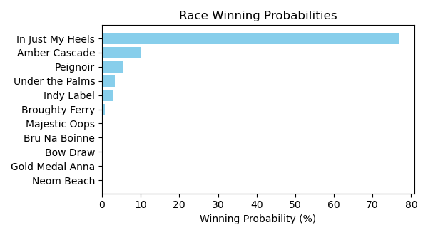

Figure: Winning Probability Distribution

NOTE: THIS RACE HAS HORSES THAT ARE MISSING CRITICAL DATA ELEMENTS

# Race: TOP | 2025-02-22 | Race #9 | Track: OAKLAWN PARK

Track: OAKLAWN PARK

|  |  |  |  |  |
| --- | --- | --- | --- | --- |
| Saddle Cloth # | Horse Name | Global Speed | Composite | Win Prob (%) |
| ['', 1, ''] | Muhimma | 111.6 | 8.19 | 15.69 |
| ['', 2, ''] | Necessity | 111.6 | 8.18 | 15.65 |
| ['', 3, ''] | Jenkin | 111.6 | 4.20 | 0.65 |
| ['', 4, ''] | Classic Appeal | 111.6 | 8.55 | 21.01 |
| ['', 5, ''] | Quickick | 111.6 | 4.99 | 1.22 |
| ['', 6, ''] | Take Charge Milady | 111.6 | 8.55 | 20.94 |
| ['', 7, ''] | Gunite Max | 111.6 | 3.16 | 0.28 |
| ['', 8, ''] | Going Steady | 111.6 | 3.89 | 0.51 |
| ['', 9, ''] | Look Forward | 111.6 | 8.15 | 15.20 |
| ['', 10, ''] | Flash Wear | 111.6 | -0.81 | 0.01 |
| ['', 11, ''] | Anonima | 111.6 | 6.89 | 5.55 |
| ['', 12, ''] | Quietside | 111.6 | 5.76 | 2.26 |
| ['', 13, ''] | Five G | 111.6 | 4.78 | 1.03 |

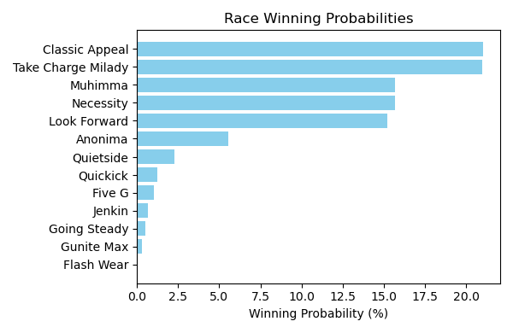

Figure: Winning Probability Distribution

NOTE: THIS RACE HAS HORSES THAT ARE MISSING CRITICAL DATA ELEMENTS

# Race: TOP | 2025-02-22 | Race #10 | Track: OAKLAWN PARK

Track: OAKLAWN PARK

|  |  |  |  |  |
| --- | --- | --- | --- | --- |
| Saddle Cloth # | Horse Name | Global Speed | Composite | Win Prob (%) |
| ['', 1, ''] | Crupi | 112.0 | 4.17 | 0.33 |
| ['', 2, ''] | Banishing | 112.0 | 10.47 | 51.44 |
| ['', 3, ''] | First Mission | 112.0 | 2.67 | 0.10 |
| ['', 4, ''] | Alexander Helios | 112.0 | 9.08 | 16.91 |
| ['', 5, ''] | Skinner | 112.0 | 7.46 | 4.62 |
| ['', 6, ''] | Full Screen | 112.0 | 3.39 | 0.18 |
| ['', 7, ''] | Dimatic | 112.0 | 2.20 | 0.07 |
| ['', 8, ''] | Baddest Good Boy | 112.0 | 9.38 | 21.59 |
| ['', 9, ''] | Henro | 112.0 | 4.62 | 0.48 |
| ['', 10, ''] | Cooke Creek | 112.0 | 6.76 | 2.65 |
| ['', 11, ''] | Tonka Warrior | 112.0 | 3.90 | 0.27 |
| ['', 12, ''] | Red Route One | 112.0 | 3.12 | 0.14 |
| ['', 13, ''] | Creative Minister | 112.0 | 5.76 | 1.19 |
| ['', 14, ''] | Seize the Night | 112.0 | -1.94 | 0.00 |

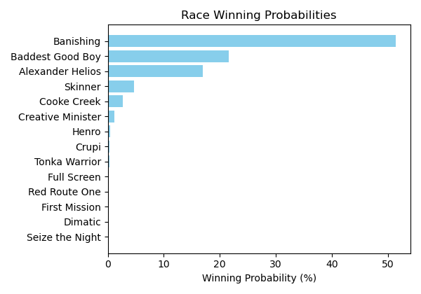

Figure: Winning Probability Distribution

NOTE: THIS RACE HAS HORSES THAT ARE MISSING CRITICAL DATA ELEMENTS

# Race: TOP | 2025-02-22 | Race #11 | Track: OAKLAWN PARK

Track: OAKLAWN PARK

|  |  |  |  |  |
| --- | --- | --- | --- | --- |
| Saddle Cloth # | Horse Name | Global Speed | Composite | Win Prob (%) |
| ['', 1, ''] | Coal Battle | 111.9 | 3.71 | 0.17 |
| ['', 2, ''] | Admiral Dennis | 111.9 | 4.12 | 0.23 |
| ['', 3, ''] | Sandman | 111.9 | 8.96 | 11.10 |
| ['', 4, ''] | Hypnus * | 111.9 | 7.71 | 4.09 |
| ['', 5, ''] | Madaket Road | 111.9 | 8.05 | 5.37 |
| ['', 6, ''] | Publisher | 111.9 | -0.99 | 0.00 |
| ['', 7, ''] | Dreaminblue | 111.9 | 9.73 | 20.57 |
| ['', 8, ''] | Innovator | 111.9 | 1.24 | 0.02 |
| ['', 9, ''] | Smoken Wicked | 111.9 | 10.09 | 27.34 |
| ['', 10, ''] | Bullard | 111.9 | 4.80 | 0.40 |
| ['', 11, ''] | Speed King | 111.9 | 10.09 | 27.27 |
| ['', 12, ''] | Brereton's Baytown | 111.9 | -1.05 | 0.00 |
| ['', 13, ''] | Tiztastic | 111.9 | 7.49 | 3.43 |
| ['', 14, ''] | Hot Gunner | 111.9 | -1.29 | 0.00 |

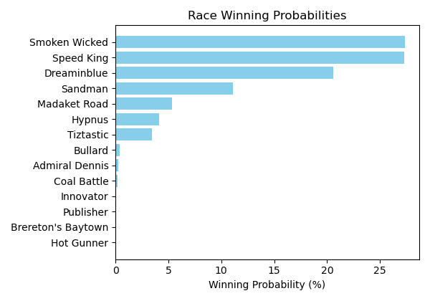

Figure: Winning Probability Distribution

NOTE: THIS RACE HAS HORSES THAT ARE MISSING CRITICAL DATA ELEMENTS

# Race: TOP | 2025-02-22 | Race #12 | Track: OAKLAWN PARK

Track: OAKLAWN PARK

|  |  |  |  |  |
| --- | --- | --- | --- | --- |
| Saddle Cloth # | Horse Name | Global Speed | Composite | Win Prob (%) |
| ['', 1, ''] | Butch * | 76.2 | -8.46 | 0.00 |
| ['', 2, ''] | MAYOR * | 76.2 | 4.14 | 4.91 |
| ['', 3, ''] | Cutting Class * | 76.2 | -8.74 | 0.00 |
| ['', 4, ''] | Bote | 76.2 | -2.71 | 0.02 |
| ['', 5, ''] | Cowboycents * | 76.2 | -5.59 | 0.00 |
| ['', 6, ''] | My Russian | 76.2 | -6.99 | 0.00 |
| ['', 7, ''] | DAWSON JAMES * | 76.2 | 4.23 | 5.30 |
| ['', 8, ''] | Two Dollar Eddie | 76.2 | 6.81 | 41.57 |
| ['', 9, ''] | Tizmarkus * | 76.2 | 6.30 | 27.62 |
| ['', 10, ''] | A P Ruly | 76.2 | 5.85 | 19.28 |
| ['', 11, ''] | Touchdown Arkansas * | 76.2 | -6.28 | 0.00 |
| ['', 12, ''] | Miracle Mack | 76.2 | -7.09 | 0.00 |
| ['', 13, ''] | Pearcy Road | 76.2 | -1.64 | 0.05 |
| ['', 14, ''] | God's Country | 76.2 | 2.43 | 1.25 |

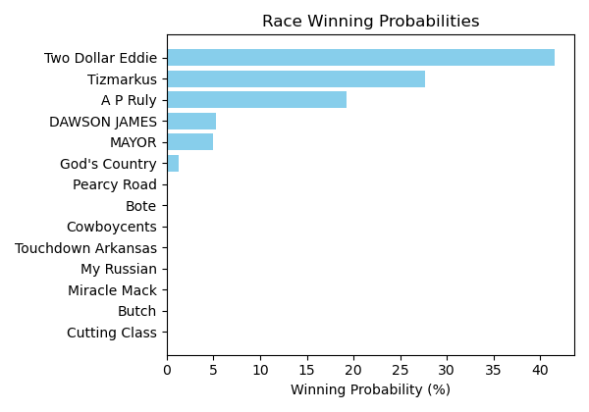

Figure: Winning Probability Distribution

NOTE: THIS RACE HAS HORSES THAT ARE MISSING CRITICAL DATA ELEMENTS

# Race: TOP | 2025-02-23 | Race #1 | Track: OAKLAWN PARK

Track: OAKLAWN PARK

|  |  |  |  |  |
| --- | --- | --- | --- | --- |
| Saddle Cloth # | Horse Name | Global Speed | Composite | Win Prob (%) |
| ['', 1, ''] | Fever Night | 111.6 | 2.65 | 1.45 |
| ['', 2, ''] | Zardun * | 111.6 | 6.08 | 22.54 |
| ['', 3, ''] | Clever Again * | 111.6 | 6.89 | 42.89 |
| ['', 4, ''] | Just Classic | 111.6 | -6.40 | 0.00 |
| ['', 5, ''] | Shepherd | 111.6 | -3.36 | 0.01 |
| ['', 6, ''] | Baobab * | 111.6 | 4.95 | 9.15 |
| ['', 7, ''] | Doroteo * | 111.6 | 5.81 | 18.18 |
| ['', 8, ''] | Crisis Manager | 111.6 | 2.94 | 1.82 |
| ['', 9, ''] | Hired Gun | 111.6 | 1.75 | 0.71 |
| ['', 10, ''] | Ripped | 111.6 | 3.66 | 3.24 |

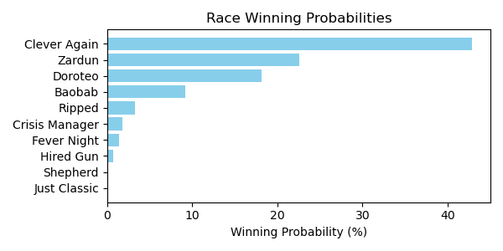

Figure: Winning Probability Distribution

NOTE: THIS RACE HAS HORSES THAT ARE MISSING CRITICAL DATA ELEMENTS

# Race: TOP | 2025-02-23 | Race #2 | Track: OAKLAWN PARK

Track: OAKLAWN PARK

|  |  |  |  |  |
| --- | --- | --- | --- | --- |
| Saddle Cloth # | Horse Name | Global Speed | Composite | Win Prob (%) |
| ['', 1, ''] | Distorted Pro | 76.7 | 6.16 | 2.03 |
| ['', 2, ''] | I'm Wide Awake | 76.7 | 9.71 | 34.62 |
| ['', 3, ''] | Rowdy Riot | 76.7 | 4.91 | 0.75 |
| ['', 4, ''] | Great Richie M | 76.7 | 7.23 | 4.76 |
| ['', 5, ''] | B Sudd | 76.7 | 6.90 | 3.66 |
| ['', 6, ''] | Manta Rey | 76.7 | 3.16 | 0.18 |
| ['', 7, ''] | Goodasiwonswas | 76.7 | 6.99 | 3.94 |
| ['', 8, ''] | Breslau | 76.7 | 2.49 | 0.11 |
| ['', 9, ''] | Run Jalen Run | 76.7 | 9.26 | 24.21 |
| ['', 10, ''] | Sitka | 76.7 | 9.32 | 25.34 |
| ['', 11, ''] | Red State | 76.7 | 4.18 | 0.41 |

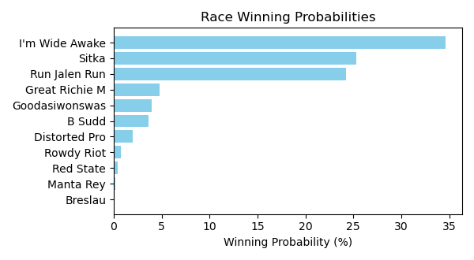

Figure: Winning Probability Distribution

NOTE: THIS RACE HAS HORSES THAT ARE MISSING CRITICAL DATA ELEMENTS

# Race: TOP | 2025-02-23 | Race #3 | Track: OAKLAWN PARK

Track: OAKLAWN PARK

|  |  |  |  |  |
| --- | --- | --- | --- | --- |
| Saddle Cloth # | Horse Name | Global Speed | Composite | Win Prob (%) |
| ['', 1, ''] | Ashburn Alley | 76.5 | 9.84 | 79.21 |
| ['', 2, ''] | Queen's Martini | 76.5 | -0.18 | 0.03 |
| ['', 3, ''] | Princess Is Olivia | 76.5 | 1.76 | 0.12 |
| ['', 4, ''] | Bennykayandsuzytoo | 76.5 | 7.37 | 10.93 |
| ['', 5, ''] | Tiffany Twist | 76.5 | 0.35 | 0.04 |
| ['', 6, ''] | Laurie's Secret | 76.5 | -9.16 | 0.00 |
| ['', 7, ''] | Insightful Miss | 76.5 | 6.35 | 4.85 |
| ['', 8, ''] | That's Our Vision * | 76.5 | -8.12 | 0.00 |
| ['', 9, ''] | Music Mistress | 76.5 | -4.78 | 0.00 |
| ['', 10, ''] | Theresasilverlinin | 76.5 | -5.90 | 0.00 |
| ['', 11, ''] | Brooklynn Drew | 76.5 | -4.51 | 0.00 |
| ['', 12, ''] | Gloriette | 76.5 | 6.28 | 4.58 |
| ['', 13, ''] | Managing Mischief | 76.5 | 1.28 | 0.08 |
| ['', 14, ''] | Popperina | 76.5 | 1.95 | 0.14 |

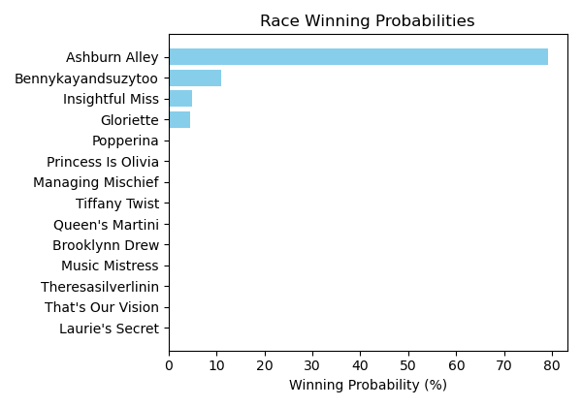

Figure: Winning Probability Distribution

NOTE: THIS RACE HAS HORSES THAT ARE MISSING CRITICAL DATA ELEMENTS

# Race: TOP | 2025-02-23 | Race #4 | Track: OAKLAWN PARK

Track: OAKLAWN PARK

|  |  |  |  |  |
| --- | --- | --- | --- | --- |
| Saddle Cloth # | Horse Name | Global Speed | Composite | Win Prob (%) |
| ['', 1, ''] | Benedetta | 76.6 | 6.88 | 20.94 |
| ['', 2, ''] | Mazoku | 76.6 | 7.92 | 47.85 |
| ['', 3, ''] | Justique | 76.6 | 5.76 | 8.52 |
| ['', 4, ''] | Sandy Bottom | 76.6 | 2.03 | 0.43 |
| ['', 5, ''] | Miss Arlington | 76.6 | -3.48 | 0.01 |
| ['', 6, ''] | Ms. Bucchero | 76.6 | 2.85 | 0.83 |
| ['', 7, ''] | American Band | 76.6 | 1.65 | 0.32 |
| ['', 8, ''] | Lady Moscato | 76.6 | 6.88 | 20.81 |
| ['', 9, ''] | Pistol | 76.6 | 1.50 | 0.28 |

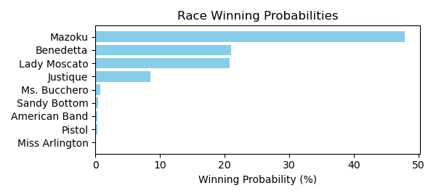

Figure: Winning Probability Distribution

NOTE: THIS RACE HAS HORSES THAT ARE MISSING CRITICAL DATA ELEMENTS

# Race: TOP | 2025-02-23 | Race #5 | Track: OAKLAWN PARK

Track: OAKLAWN PARK

|  |  |  |  |  |
| --- | --- | --- | --- | --- |
| Saddle Cloth # | Horse Name | Global Speed | Composite | Win Prob (%) |
| ['', 1, ''] | Oy Gevald * | 76.5 | 3.62 | 1.60 |
| ['', 2, ''] | Faust * | 76.5 | 6.68 | 18.60 |
| ['', 3, ''] | Sixtyseven Mustang * | 76.5 | 2.35 | 0.58 |
| ['', 4, ''] | Secret Legend | 76.5 | -1.27 | 0.03 |
| ['', 5, ''] | ZERO SUGAR * | 76.5 | 3.60 | 1.57 |
| ['', 6, ''] | Chases Magic * | 76.5 | -7.91 | 0.00 |
| ['', 7, ''] | CORNUCOPIAN * | 76.5 | 3.04 | 1.01 |
| ['', 8, ''] | Wise Decision | 76.5 | -5.96 | 0.00 |
| ['', 9, ''] | dh-Ready to Seize * | 76.5 | 2.37 | 0.59 |
| ['', 10, ''] | Max Got Excited | 76.5 | 8.44 | 76.00 |
| ['', 11, ''] | Gun Runner Charlie | 76.5 | -8.76 | 0.00 |
| ['', 12, ''] | Oil Capital * | 76.5 | -3.36 | 0.01 |

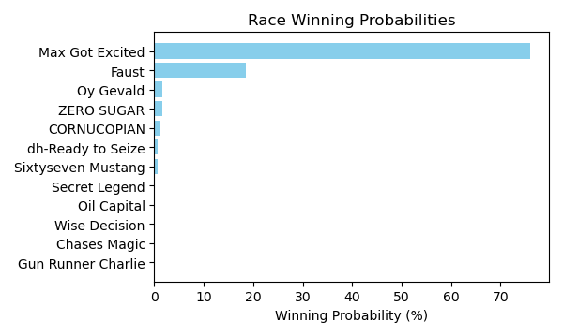

Figure: Winning Probability Distribution

NOTE: THIS RACE HAS HORSES THAT ARE MISSING CRITICAL DATA ELEMENTS

# Race: TOP | 2025-02-23 | Race #6 | Track: OAKLAWN PARK

Track: OAKLAWN PARK

|  |  |  |  |  |
| --- | --- | --- | --- | --- |
| Saddle Cloth # | Horse Name | Global Speed | Composite | Win Prob (%) |
| ['', 1, ''] | Elusive Target | 111.8 | 0.63 | 0.04 |
| ['', 2, ''] | Shot of Courage | 111.8 | 5.45 | 2.12 |
| ['', 3, ''] | One Giant Leap | 111.8 | -0.32 | 0.02 |
| ['', 4, ''] | B D Saints | 111.8 | 0.66 | 0.05 |
| ['', 5, ''] | Touch Of Glam (ARG) * | 111.8 | 1.33 | 0.08 |
| ['', 6, ''] | Nullify | 111.8 | 9.47 | 52.83 |
| ['', 7, ''] | Lambeth | 111.8 | 5.84 | 2.90 |
| ['', 8, ''] | Harleezy | 111.8 | 5.30 | 1.88 |
| ['', 9, ''] | Imperial Gun | 111.8 | -8.26 | 0.00 |
| ['', 10, ''] | Ethan Energy | 111.8 | 9.12 | 40.00 |
| ['', 11, ''] | Spoiler | 111.8 | 0.26 | 0.03 |
| ['', 12, ''] | Dynamis | 111.8 | 0.65 | 0.05 |

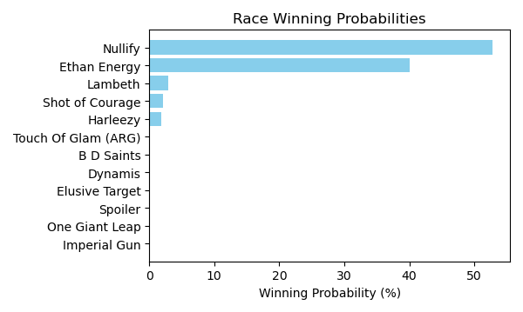

Figure: Winning Probability Distribution

NOTE: THIS RACE HAS HORSES THAT ARE MISSING CRITICAL DATA ELEMENTS

# Race: TOP | 2025-02-23 | Race #7 | Track: OAKLAWN PARK

Track: OAKLAWN PARK

|  |  |  |  |  |
| --- | --- | --- | --- | --- |
| Saddle Cloth # | Horse Name | Global Speed | Composite | Win Prob (%) |
| ['', 1, ''] | Carbone | 76.7 | 0.19 | 0.03 |
| ['', 2, ''] | Just Steel | 76.7 | 0.41 | 0.03 |
| ['', 3, ''] | Attache | 76.7 | 7.92 | 13.47 |
| ['', 4, ''] | Nasty Habit | 76.7 | 2.99 | 0.26 |
| ['', 5, ''] | Excitable Boy | 76.7 | 5.62 | 2.14 |
| ['', 6, ''] | Invulnerable | 76.7 | 6.18 | 3.36 |
| ['', 7, ''] | Eglise | 76.7 | 8.79 | 27.04 |
| ['', 8, ''] | Big City | 76.7 | 9.09 | 34.44 |
| ['', 9, ''] | Runaway Jack | 76.7 | 7.74 | 11.66 |
| ['', 10, ''] | Ninja Warrior | 76.7 | 7.20 | 7.56 |

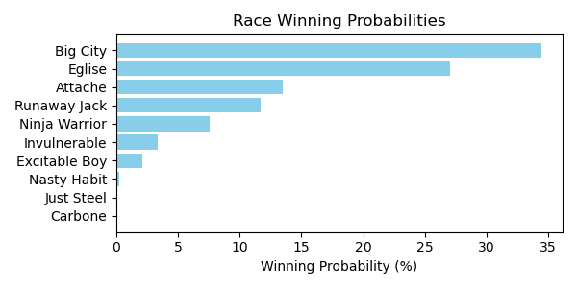

Figure: Winning Probability Distribution

NOTE: THIS RACE HAS HORSES THAT ARE MISSING CRITICAL DATA ELEMENTS

# Race: TOP | 2025-02-23 | Race #8 | Track: OAKLAWN PARK

Track: OAKLAWN PARK

|  |  |  |  |  |
| --- | --- | --- | --- | --- |
| Saddle Cloth # | Horse Name | Global Speed | Composite | Win Prob (%) |
| ['', 1, ''] | Under the Palms | 111.8 | 6.20 | 3.41 |
| ['', 2, ''] | Bru Na Boinne | 111.8 | 1.52 | 0.08 |
| ['', 3, ''] | Broughty Ferry | 111.8 | 4.39 | 0.80 |
| ['', 4, ''] | Gold Medal Anna | 111.8 | -1.43 | 0.01 |
| ['', 5, ''] | Peignoir | 111.8 | 6.85 | 5.74 |
| ['', 6, ''] | Majestic Oops | 111.8 | 3.06 | 0.28 |
| ['', 7, ''] | Bow Draw | 111.8 | 1.15 | 0.06 |
| ['', 8, ''] | Indy Label | 111.8 | 5.99 | 2.89 |
| ['', 9, ''] | Neom Beach | 111.8 | -4.33 | 0.00 |
| ['', 10, ''] | Amber Cascade | 111.8 | 7.55 | 10.10 |
| ['', 11, ''] | In Just My Heels | 111.8 | 10.09 | 76.64 |

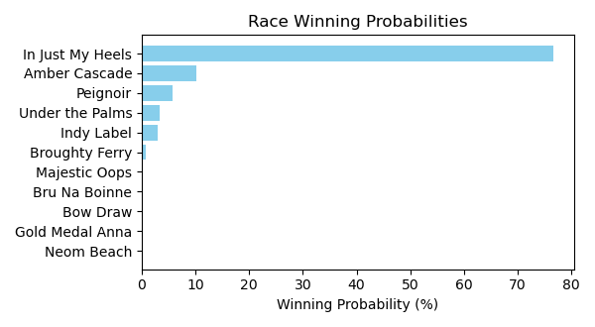

Figure: Winning Probability Distribution

NOTE: THIS RACE HAS HORSES THAT ARE MISSING CRITICAL DATA ELEMENTS

# Race: TOP | 2025-02-23 | Race #9 | Track: OAKLAWN PARK

Track: OAKLAWN PARK

|  |  |  |  |  |
| --- | --- | --- | --- | --- |
| Saddle Cloth # | Horse Name | Global Speed | Composite | Win Prob (%) |
| ['', 1, ''] | Muhimma | 111.6 | 8.19 | 15.99 |
| ['', 2, ''] | Necessity | 111.6 | 8.19 | 16.03 |
| ['', 3, ''] | Jenkin | 111.6 | 4.19 | 0.65 |
| ['', 4, ''] | Classic Appeal | 111.6 | 8.43 | 19.50 |
| ['', 5, ''] | Quickick | 111.6 | 4.99 | 1.24 |
| ['', 6, ''] | Take Charge Milady | 111.6 | 8.55 | 21.32 |
| ['', 7, ''] | Gunite Max | 111.6 | 3.08 | 0.27 |
| ['', 8, ''] | Going Steady | 111.6 | 3.81 | 0.48 |
| ['', 9, ''] | Look Forward | 111.6 | 8.15 | 15.58 |
| ['', 10, ''] | Flash Wear | 111.6 | -0.79 | 0.01 |
| ['', 11, ''] | Anonima | 111.6 | 6.87 | 5.57 |
| ['', 12, ''] | Quietside | 111.6 | 5.76 | 2.30 |
| ['', 13, ''] | Five G | 111.6 | 4.78 | 1.05 |

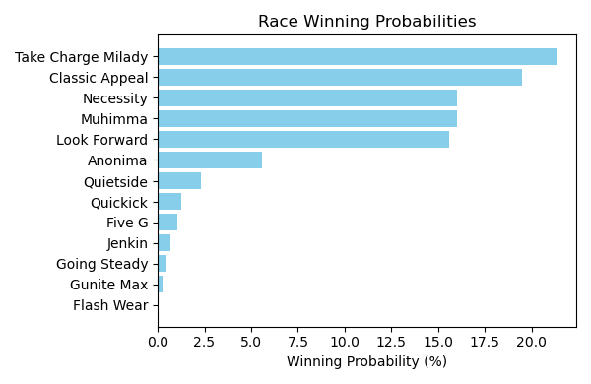

Figure: Winning Probability Distribution

NOTE: THIS RACE HAS HORSES THAT ARE MISSING CRITICAL DATA ELEMENTS

# Race: TOP | 2025-02-23 | Race #10 | Track: OAKLAWN PARK

Track: OAKLAWN PARK

|  |  |  |  |  |
| --- | --- | --- | --- | --- |
| Saddle Cloth # | Horse Name | Global Speed | Composite | Win Prob (%) |
| ['', 1, ''] | Crupi | 112.0 | 4.17 | 0.33 |
| ['', 2, ''] | Banishing | 112.0 | 10.48 | 51.44 |
| ['', 3, ''] | First Mission | 112.0 | 2.54 | 0.09 |
| ['', 4, ''] | Alexander Helios | 112.0 | 9.10 | 17.03 |
| ['', 5, ''] | Skinner | 112.0 | 7.47 | 4.65 |
| ['', 6, ''] | Full Screen | 112.0 | 3.32 | 0.17 |
| ['', 7, ''] | Dimatic | 112.0 | 2.20 | 0.07 |
| ['', 8, ''] | Baddest Good Boy | 112.0 | 9.38 | 21.43 |
| ['', 9, ''] | Henro | 112.0 | 4.64 | 0.48 |
| ['', 10, ''] | Cooke Creek | 112.0 | 6.79 | 2.69 |
| ['', 11, ''] | Tonka Warrior | 112.0 | 4.00 | 0.29 |
| ['', 12, ''] | Red Route One | 112.0 | 3.13 | 0.14 |
| ['', 13, ''] | Creative Minister | 112.0 | 5.77 | 1.19 |
| ['', 14, ''] | Seize the Night | 112.0 | -1.93 | 0.00 |

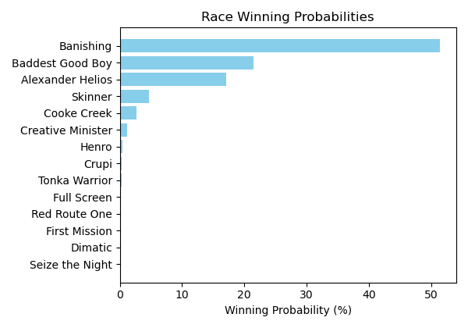

Figure: Winning Probability Distribution

NOTE: THIS RACE HAS HORSES THAT ARE MISSING CRITICAL DATA ELEMENTS

# Race: TOP | 2025-02-23 | Race #11 | Track: OAKLAWN PARK

Track: OAKLAWN PARK

|  |  |  |  |  |
| --- | --- | --- | --- | --- |
| Saddle Cloth # | Horse Name | Global Speed | Composite | Win Prob (%) |
| ['', 1, ''] | Coal Battle | 111.9 | 3.76 | 0.17 |
| ['', 2, ''] | Admiral Dennis | 111.9 | 4.12 | 0.23 |
| ['', 3, ''] | Sandman | 111.9 | 9.00 | 11.37 |
| ['', 4, ''] | Hypnus * | 111.9 | 7.71 | 4.05 |
| ['', 5, ''] | Madaket Road | 111.9 | 8.05 | 5.32 |
| ['', 6, ''] | Publisher | 111.9 | -0.98 | 0.00 |
| ['', 7, ''] | Dreaminblue | 111.9 | 9.73 | 20.31 |
| ['', 8, ''] | Innovator | 111.9 | 1.21 | 0.02 |
| ['', 9, ''] | Smoken Wicked | 111.9 | 10.11 | 27.64 |
| ['', 10, ''] | Bullard | 111.9 | 4.81 | 0.40 |
| ['', 11, ''] | Speed King | 111.9 | 10.09 | 27.08 |
| ['', 12, ''] | Brereton's Baytown | 111.9 | -1.20 | 0.00 |
| ['', 13, ''] | Tiztastic | 111.9 | 7.49 | 3.40 |
| ['', 14, ''] | Hot Gunner | 111.9 | -1.30 | 0.00 |

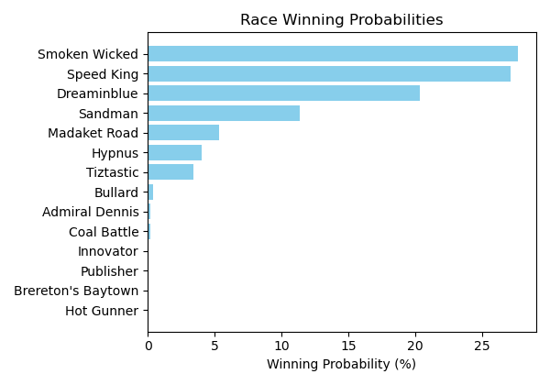

Figure: Winning Probability Distribution

NOTE: THIS RACE HAS HORSES THAT ARE MISSING CRITICAL DATA ELEMENTS

# Race: TOP | 2025-02-23 | Race #12 | Track: OAKLAWN PARK

Track: OAKLAWN PARK

|  |  |  |  |  |
| --- | --- | --- | --- | --- |
| Saddle Cloth # | Horse Name | Global Speed | Composite | Win Prob (%) |
| ['', 1, ''] | Butch * | 76.2 | -8.47 | 0.00 |
| ['', 2, ''] | MAYOR * | 76.2 | 4.19 | 5.02 |
| ['', 3, ''] | Cutting Class * | 76.2 | -8.76 | 0.00 |
| ['', 4, ''] | Bote | 76.2 | -2.73 | 0.02 |
| ['', 5, ''] | Cowboycents * | 76.2 | -5.60 | 0.00 |
| ['', 6, ''] | My Russian | 76.2 | -7.01 | 0.00 |
| ['', 7, ''] | DAWSON JAMES * | 76.2 | 4.34 | 5.68 |
| ['', 8, ''] | Two Dollar Eddie | 76.2 | 6.85 | 42.15 |
| ['', 9, ''] | Tizmarkus * | 76.2 | 6.29 | 26.89 |
| ['', 10, ''] | A P Ruly | 76.2 | 5.84 | 18.85 |
| ['', 11, ''] | Touchdown Arkansas * | 76.2 | -6.30 | 0.00 |
| ['', 12, ''] | Miracle Mack | 76.2 | -7.08 | 0.00 |
| ['', 13, ''] | Pearcy Road | 76.2 | -1.61 | 0.05 |
| ['', 14, ''] | God's Country | 76.2 | 2.53 | 1.34 |

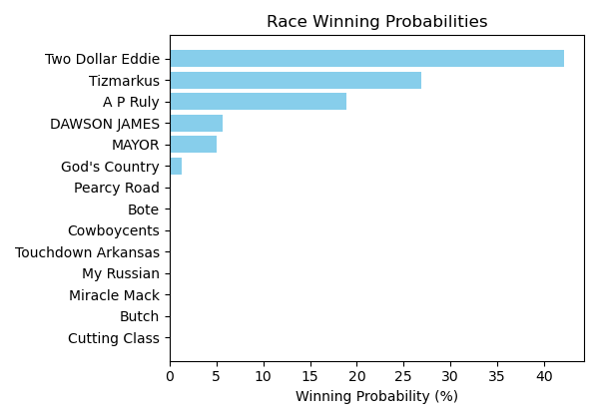

Figure: Winning Probability Distribution

NOTE: THIS RACE HAS HORSES THAT ARE MISSING CRITICAL DATA ELEMENTS

# Race: PRX | 2025-02-24 | Race #1 | Track: PARX RACING

Track: PARX RACING

|  |  |  |  |  |
| --- | --- | --- | --- | --- |
| Saddle Cloth # | Horse Name | Global Speed | Composite | Win Prob (%) |
| ['', 1, ''] | Five Star Fran * | 76.1 | 7.48 | 73.20 |
| ['', 2, ''] | No Fake | 88.8 | 2.88 | 23.39 |
| ['', 3, ''] | Aztec Bay * | 82.1 | -3.21 | 0.05 |
| ['', 4, ''] | Brooklyn Heights * | 82.1 | -8.52 | 0.00 |
| ['', 5, ''] | Union Belle * | 82.1 | -6.77 | 0.00 |
| ['', 6, ''] | Kaymus | 76.1 | 3.27 | 2.52 |
| ['', 7, ''] | Far too Foxy * | 70.8 | 3.09 | 0.77 |
| ['', 8, ''] | Lady Annabelle * | 76.1 | -1.22 | 0.07 |
| ['', 9, ''] | Chit Chat Chub * | 82.1 | -6.04 | 0.00 |
| ['', 10, ''] | Far Heart * | 82.1 | -5.99 | 0.01 |

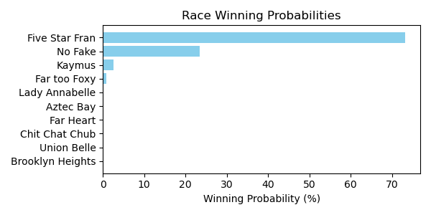

Figure: Winning Probability Distribution

NOTE: THIS RACE HAS HORSES THAT ARE MISSING CRITICAL DATA ELEMENTS

# Race: PRX | 2025-02-24 | Race #2 | Track: PARX RACING

Track: PARX RACING

|  |  |  |  |  |
| --- | --- | --- | --- | --- |
| Saddle Cloth # | Horse Name | Global Speed | Composite | Win Prob (%) |
| ['', 1, ''] | Private Cabana * | 89.1 | -6.52 | 0.00 |
| ['', 2, ''] | Four Eyes | 82.3 | -5.59 | 0.00 |
| ['', 3, ''] | Omaha Eight * | 71.0 | 0.80 | 0.00 |
| ['', 4, ''] | Whitewalker | 108.6 | 7.77 | 100.00 |
| ['', 5, ''] | Bustino Santino | 82.3 | 0.40 | 0.00 |
| ['', 6, ''] | Capitan George | 71.0 | 1.59 | 0.00 |
| ['', 7, ''] | Stay Funny * | 71.0 | -5.11 | 0.00 |
| ['', 8, ''] | Hyper Inflation * | 76.3 | -2.61 | 0.00 |
| ['', 9, ''] | Raleigh St. Clair | 82.3 | -0.48 | 0.00 |

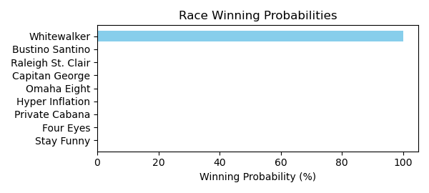

Figure: Winning Probability Distribution

NOTE: THIS RACE HAS HORSES THAT ARE MISSING CRITICAL DATA ELEMENTS

# Race: PRX | 2025-02-24 | Race #3 | Track: PARX RACING

Track: PARX RACING

|  |  |  |  |  |
| --- | --- | --- | --- | --- |
| Saddle Cloth # | Horse Name | Global Speed | Composite | Win Prob (%) |
| ['', 1, ''] | Missouri River | 108.8 | -1.09 | 0.06 |
| ['', 2, ''] | Sheer Dominance | 108.8 | -0.92 | 0.07 |
| ['', 3, ''] | Master Munnings | 108.8 | 7.55 | 58.11 |
| ['', 4, ''] | Heat Alert * | 108.8 | 7.14 | 41.76 |
| ['', 5, ''] | Spinning Heart * | 89.2 | -4.29 | 0.00 |
| ['', 6, ''] | Financial District | 104.0 | -6.98 | 0.00 |
| ['', 7, ''] | Hatmaker Gizmo | 108.8 | -9.07 | 0.00 |

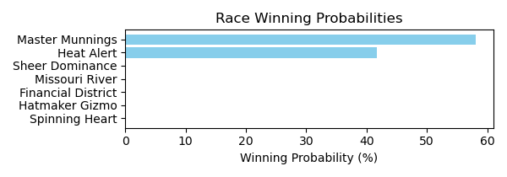

Figure: Winning Probability Distribution

NOTE: THIS RACE HAS HORSES THAT ARE MISSING CRITICAL DATA ELEMENTS

# Race: PRX | 2025-02-24 | Race #4 | Track: PARX RACING

Track: PARX RACING

|  |  |  |  |  |
| --- | --- | --- | --- | --- |
| Saddle Cloth # | Horse Name | Global Speed | Composite | Win Prob (%) |
| ['', 1, ''] | Vanellope * | 103.8 | 1.99 | 97.54 |
| ['', 2, ''] | Channel Loop | 103.8 | -3.42 | 1.29 |
| ['', 3, ''] | Zoning Order | 82.3 | -8.91 | 0.00 |
| ['', 4, ''] | Breezy Dance * | 108.6 | -9.40 | 0.03 |
| ['', 5, ''] | Love Like Crazy * | 76.3 | 3.30 | 1.13 |
| ['', 6, ''] | Red Haired Gal | 82.3 | -7.86 | 0.00 |
| ['', 7, ''] | Classic Mystery | 76.3 | -2.97 | 0.01 |

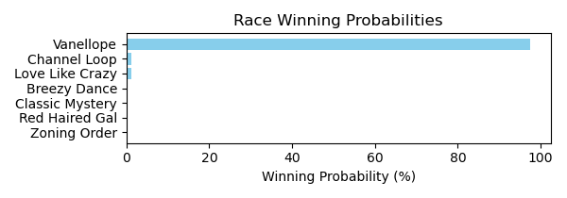

Figure: Winning Probability Distribution

NOTE: THIS RACE HAS HORSES THAT ARE MISSING CRITICAL DATA ELEMENTS

# Race: PRX | 2025-02-24 | Race #5 | Track: PARX RACING

Track: PARX RACING

|  |  |  |  |  |
| --- | --- | --- | --- | --- |
| Saddle Cloth # | Horse Name | Global Speed | Composite | Win Prob (%) |
| ['', 1, ''] | Creme Caramel * | 82.2 | -2.76 | 0.00 |
| ['', 2, ''] | Boca Royalty * | 76.2 | -6.11 | 0.00 |
| ['', 3, ''] | La Tourista | 82.2 | -3.40 | 0.00 |
| ['', 4, ''] | Goldieness * | 82.2 | -6.97 | 0.00 |
| ['', 5, ''] | Mended We Stand * | 82.2 | 6.90 | 2.04 |
| ['', 6, ''] | Jezebel Jade * | 76.2 | 4.19 | 0.07 |
| ['', 7, ''] | Between Dreams * | 82.2 | -9.07 | 0.00 |
| ['', 8, ''] | Bonita Lassie * | 108.4 | 5.19 | 97.88 |
| ['', 9, ''] | Luna T * | 76.2 | -6.22 | 0.00 |
| ['', 10, ''] | Melodia * | 82.2 | -7.35 | 0.00 |

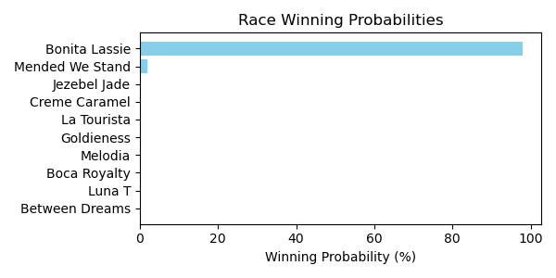

Figure: Winning Probability Distribution

NOTE: THIS RACE HAS HORSES THAT ARE MISSING CRITICAL DATA ELEMENTS

# Race: PRX | 2025-02-24 | Race #6 | Track: PARX RACING

Track: PARX RACING

|  |  |  |  |  |
| --- | --- | --- | --- | --- |
| Saddle Cloth # | Horse Name | Global Speed | Composite | Win Prob (%) |
| ['', 1, ''] | Awesome for Sure | 82.5 | 0.77 | 0.74 |
| ['', 2, ''] | Rejected Again * | 82.5 | 0.33 | 0.52 |
| ['', 3, ''] | Kate's Golden Dude | 82.5 | 6.02 | 49.68 |
| ['', 4, ''] | Jw's Third Mischie * | 82.5 | 2.65 | 3.36 |
| ['', 5, ''] | Sal N Louie * | 82.5 | 5.89 | 44.88 |
| ['', 6, ''] | Harley's Charly * | 82.5 | -2.58 | 0.05 |
| ['', 7, ''] | Copperhead Creek * | 108.8 | -8.62 | 0.08 |
| ['', 8, ''] | Liberty Star * | 82.5 | 0.51 | 0.61 |
| ['', 9, ''] | Captain Chazz * | 71.1 | 0.69 | 0.07 |

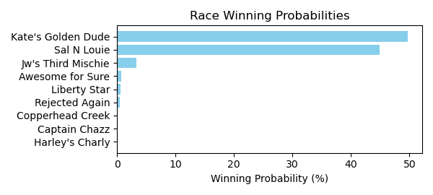

Figure: Winning Probability Distribution

NOTE: THIS RACE HAS HORSES THAT ARE MISSING CRITICAL DATA ELEMENTS

# Race: PRX | 2025-02-24 | Race #7 | Track: PARX RACING

Track: PARX RACING

|  |  |  |  |  |
| --- | --- | --- | --- | --- |
| Saddle Cloth # | Horse Name | Global Speed | Composite | Win Prob (%) |
| ['', 1, ''] | Lucky Dude * | 111.6 | 8.88 | 51.42 |
| ['', 2, ''] | Zippy Gizmo | 109.0 | -7.22 | 0.00 |
| ['', 3, ''] | More Vino | 82.6 | -5.72 | 0.00 |
| ['', 4, ''] | Group Hug | 76.5 | 2.01 | 0.00 |
| ['', 5, ''] | Tycoon * | 109.0 | 7.82 | 13.05 |
| ['', 6, ''] | Assembly Point (BRZ) * | 109.0 | 8.16 | 17.07 |
| ['', 7, ''] | Youbetterbejoking * | 109.0 | 7.39 | 9.26 |
| ['', 8, ''] | Jewels in the Bay * | 111.6 | 6.72 | 9.13 |
| ['', 9, ''] | Check My Six * | 109.0 | -4.12 | 0.00 |
| ['', 10, ''] | Warrior's Vendetta * | 109.0 | -4.16 | 0.00 |
| ['', 11, ''] | Batter Up Bud * | 111.6 | 0.64 | 0.07 |

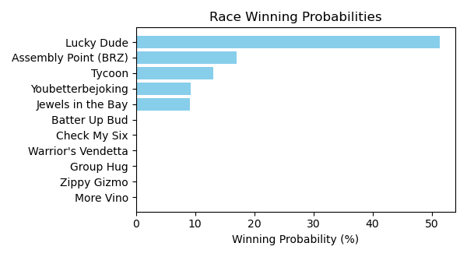

Figure: Winning Probability Distribution

NOTE: THIS RACE HAS HORSES THAT ARE MISSING CRITICAL DATA ELEMENTS

# Race: PRX | 2025-02-24 | Race #8 | Track: PARX RACING

Track: PARX RACING

|  |  |  |  |  |
| --- | --- | --- | --- | --- |
| Saddle Cloth # | Horse Name | Global Speed | Composite | Win Prob (%) |
| ['', 1, ''] | Smoke Wagon * | 109.1 | 4.47 | 0.94 |
| ['', 2, ''] | Ira the Icon * | 109.1 | -0.40 | 0.02 |
| ['', 3, ''] | Mo Rewards | 109.1 | 6.88 | 6.45 |
| ['', 4, ''] | Ike's Gamble | 109.1 | 9.65 | 59.43 |
| ['', 5, ''] | Prince Colton * | 76.6 | 5.44 | 0.00 |
| ['', 6, ''] | Double Your Money | 109.1 | 8.92 | 33.16 |

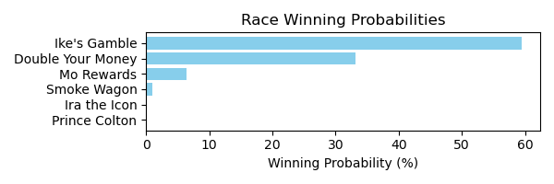

Figure: Winning Probability Distribution

NOTE: THIS RACE HAS HORSES THAT ARE MISSING CRITICAL DATA ELEMENTS

# Race: PRX | 2025-02-24 | Race #9 | Track: PARX RACING

Track: PARX RACING

|  |  |  |  |  |
| --- | --- | --- | --- | --- |
| Saddle Cloth # | Horse Name | Global Speed | Composite | Win Prob (%) |
| ['', 1, ''] | Tara's Talent | 82.5 | 4.58 | 20.36 |
| ['', 2, ''] | True Phenomenon * | 82.5 | -5.24 | 0.01 |
| ['', 3, ''] | Aegean Sea * | 82.5 | 0.46 | 0.76 |
| ['', 4, ''] | Dream Chaser | 89.2 | 4.58 | 78.78 |
| ['', 5, ''] | Empress Deona | 76.4 | -6.66 | 0.00 |
| ['', 6, ''] | Et's Moon Maiden * | 82.5 | -4.13 | 0.02 |
| ['', 7, ''] | Bustin Down Doors | 82.5 | -2.42 | 0.08 |
| ['', 8, ''] | Ree Nee's Six * | 82.5 | -5.43 | 0.01 |

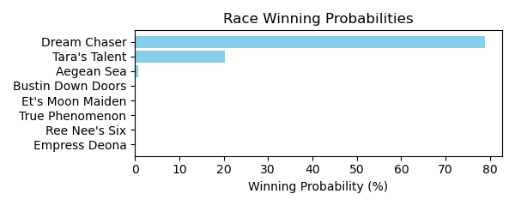

Figure: Winning Probability Distribution

NOTE: THIS RACE HAS HORSES THAT ARE MISSING CRITICAL DATA ELEMENTS

# Race: PRX | 2025-02-24 | Race #10 | Track: PARX RACING

Track: PARX RACING

|  |  |  |  |  |
| --- | --- | --- | --- | --- |
| Saddle Cloth # | Horse Name | Global Speed | Composite | Win Prob (%) |
| ['', 1, ''] | This Run's for You * | 76.5 | -0.34 | 0.00 |
| ['', 2, ''] | Yuletide Gallop * | 82.6 | -8.40 | 0.00 |
| ['', 3, ''] | Level Up * | 111.5 | 8.96 | 99.80 |
| ['', 4, ''] | Disturbed * | 76.5 | 6.82 | 0.02 |
| ['', 5, ''] | Tatum | 82.6 | -4.45 | 0.00 |
| ['', 6, ''] | Noble Gaston * | 71.1 | 3.63 | 0.00 |
| ['', 7, ''] | Olliemeister * | 76.5 | 0.16 | 0.00 |
| ['', 8, ''] | Runyonesque * | 82.6 | 5.86 | 0.03 |
| ['', 9, ''] | Ninja Prize * | 76.5 | 5.00 | 0.00 |
| ['', 10, ''] | Commingling * | 82.6 | 2.49 | 0.00 |
| ['', 11, ''] | A Dangerous Guy * | 82.6 | -8.56 | 0.00 |
| ['', 12, ''] | Roan Burgundy * | 89.4 | 6.38 | 0.15 |

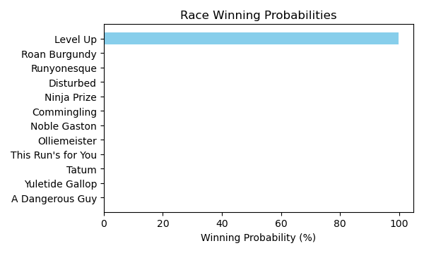

Figure: Winning Probability Distribution

NOTE: THIS RACE HAS HORSES THAT ARE MISSING CRITICAL DATA ELEMENTS

# Race: PEN | 2025-02-21 | Race #1 | Track: PENN NATIONAL

Track: PENN NATIONAL

|  |  |  |  |  |
| --- | --- | --- | --- | --- |
| Saddle Cloth # | Horse Name | Global Speed | Composite | Win Prob (%) |
| ['', 1, ''] | We're Even * | 104.0 | 1.13 | 0.33 |
| ['', 2, ''] | Make Me Lucky * | 104.0 | 4.38 | 4.47 |
| ['', 3, ''] | Bronx Boys * | 104.0 | 8.04 | 84.14 |
| ['', 4, ''] | Bejuco * | 104.0 | 3.79 | 2.79 |
| ['', 5, ''] | Midnight Tempesta | 104.0 | -0.00 | 0.13 |
| ['', 6, ''] | Tiz Marks Spirit | 104.0 | 5.12 | 8.13 |
| ['', 7, ''] | Tony's Mo | 104.0 | -5.71 | 0.00 |

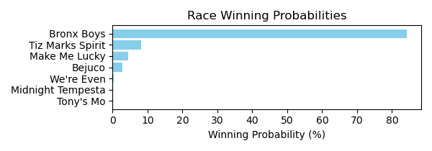

Figure: Winning Probability Distribution

NOTE: THIS RACE HAS HORSES THAT ARE MISSING CRITICAL DATA ELEMENTS

# Race: PEN | 2025-02-21 | Race #2 | Track: PENN NATIONAL

Track: PENN NATIONAL

|  |  |  |  |  |
| --- | --- | --- | --- | --- |
| Saddle Cloth # | Horse Name | Global Speed | Composite | Win Prob (%) |
| ['', 1, ''] | Whiskey Row | 103.6 | 3.95 | 2.94 |
| ['', 2, ''] | Free Folk * | 103.6 | -1.19 | 0.05 |
| ['', 3, ''] | Warrior On Tap * | 103.6 | 5.16 | 7.77 |
| ['', 4, ''] | Uncle Georgy | 103.6 | 2.68 | 1.06 |
| ['', 5, ''] | Brady * | 103.6 | -7.20 | 0.00 |
| ['', 6, ''] | Jiggery Pokery * | 103.6 | -9.25 | 0.00 |
| ['', 7, ''] | dh-Town Kisser | 103.6 | 8.18 | 86.46 |
| ['', 8, ''] | Letsgetluckytonite * | 103.6 | 3.20 | 1.62 |
| ['', 9, ''] | Social Joe * | 103.6 | -4.33 | 0.00 |
| ['', 10, ''] | Have No Regrets * | 103.6 | -0.68 | 0.07 |
| ['', 11, ''] | Sweet Spite * | 103.6 | -2.06 | 0.02 |

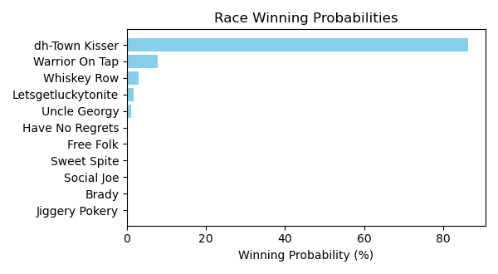

Figure: Winning Probability Distribution

NOTE: THIS RACE HAS HORSES THAT ARE MISSING CRITICAL DATA ELEMENTS

# Race: PEN | 2025-02-21 | Race #3 | Track: PENN NATIONAL

Track: PENN NATIONAL

|  |  |  |  |  |
| --- | --- | --- | --- | --- |
| Saddle Cloth # | Horse Name | Global Speed | Composite | Win Prob (%) |
| ['', 1, ''] | Causalistic * | 108.6 | -7.10 | 0.00 |
| ['', 2, ''] | Textpectation * | 108.6 | -3.60 | 0.01 |
| ['', 3, ''] | Honorable Avenue * | 108.6 | -5.34 | 0.00 |
| ['', 4, ''] | Mighty Minion * | 108.6 | 1.80 | 0.76 |
| ['', 5, ''] | Eye On the Candy | 108.6 | -1.90 | 0.04 |
| ['', 6, ''] | Spinning Musician * | 108.6 | -1.27 | 0.07 |
| ['', 7, ''] | Lafitte's Fleet | 108.6 | 7.84 | 95.10 |
| ['', 8, ''] | Rustys Gfivefifty * | 108.6 | 3.51 | 2.98 |
| ['', 9, ''] | Box Office Warrior * | 108.6 | -8.70 | 0.00 |
| ['', 10, ''] | Critical Thinking * | 108.6 | -4.86 | 0.00 |
| ['', 11, ''] | Rockin the Palace * | 108.6 | 2.19 | 1.03 |
| ['', 12, ''] | Berks | 108.6 | -5.78 | 0.00 |

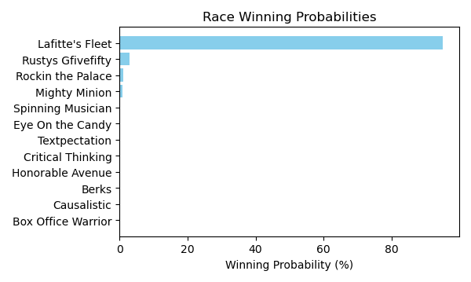

Figure: Winning Probability Distribution

NOTE: THIS RACE HAS HORSES THAT ARE MISSING CRITICAL DATA ELEMENTS

# Race: PEN | 2025-02-21 | Race #4 | Track: PENN NATIONAL

Track: PENN NATIONAL

|  |  |  |  |  |
| --- | --- | --- | --- | --- |
| Saddle Cloth # | Horse Name | Global Speed | Composite | Win Prob (%) |
| ['', 1, ''] | Dance a Dini * | 104.2 | -0.83 | 0.07 |
| ['', 2, ''] | Jump for the Win * | 104.2 | 2.10 | 0.71 |
| ['', 3, ''] | First Glimpse | 104.2 | -7.74 | 0.00 |
| ['', 4, ''] | Roadtriptonowhere * | 104.2 | 7.95 | 75.97 |
| ['', 5, ''] | Entrust * | 104.2 | 4.97 | 7.02 |
| ['', 6, ''] | Tallahatchiebridge | 104.2 | 2.79 | 1.23 |
| ['', 7, ''] | Tubtimsiam | 104.2 | 5.92 | 15.00 |

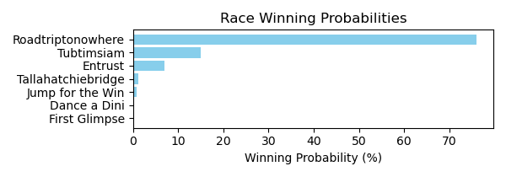

Figure: Winning Probability Distribution

NOTE: THIS RACE HAS HORSES THAT ARE MISSING CRITICAL DATA ELEMENTS

# Race: PEN | 2025-02-21 | Race #5 | Track: PENN NATIONAL

Track: PENN NATIONAL

|  |  |  |  |  |
| --- | --- | --- | --- | --- |
| Saddle Cloth # | Horse Name | Global Speed | Composite | Win Prob (%) |
| ['', 1, ''] | Uptown Charly Girl * | 103.6 | 5.59 | 39.75 |
| ['', 2, ''] | Smiles for David | 103.6 | -8.08 | 0.00 |
| ['', 3, ''] | Floraloats * | 103.6 | -5.06 | 0.01 |
| ['', 4, ''] | Adios Meister * | 103.6 | -9.76 | 0.00 |
| ['', 5, ''] | Maggie K * | 103.6 | -2.36 | 0.07 |
| ['', 6, ''] | Jayce and Liam * | 103.6 | 4.66 | 18.87 |
| ['', 7, ''] | Urban Dancer | 103.6 | 5.63 | 41.24 |
| ['', 8, ''] | Pull No Punches | 103.6 | -5.35 | 0.01 |
| ['', 9, ''] | Forever Fifi * | 103.6 | -2.54 | 0.06 |
| ['', 10, ''] | Silent Diva | 103.6 | -10.24 | 0.00 |

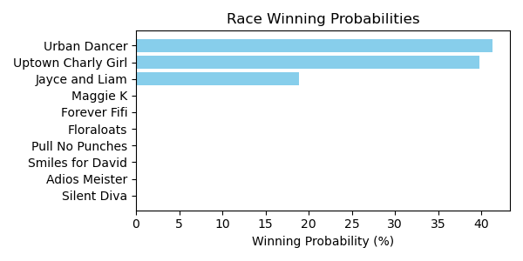

Figure: Winning Probability Distribution

NOTE: THIS RACE HAS HORSES THAT ARE MISSING CRITICAL DATA ELEMENTS

# Race: PEN | 2025-02-21 | Race #6 | Track: PENN NATIONAL

Track: PENN NATIONAL

|  |  |  |  |  |
| --- | --- | --- | --- | --- |
| Saddle Cloth # | Horse Name | Global Speed | Composite | Win Prob (%) |
| ['', 1, ''] | Whiskeyromeosierra * | 104.3 | 7.98 | 10.27 |
| ['', 2, ''] | Synonym | 104.3 | -5.62 | 0.00 |
| ['', 3, ''] | Brother Brad | 104.3 | -0.33 | 0.01 |
| ['', 4, ''] | Take the Pledge * | 104.3 | 10.15 | 58.13 |
| ['', 5, ''] | Stormquist | 104.3 | 2.68 | 0.15 |
| ['', 6, ''] | Socially Awkward * | 104.3 | 7.50 | 7.02 |
| ['', 7, ''] | Easter Bet * | 104.3 | 1.60 | 0.06 |
| ['', 8, ''] | Tarsus Warrior * | 104.3 | 1.20 | 0.05 |
| ['', 9, ''] | Skimble Shanks * | 104.3 | 9.06 | 24.31 |
| ['', 10, ''] | Egot a Poker Face * | 104.3 | -7.88 | 0.00 |
| ['', 11, ''] | Battuta d'Oro | 104.3 | -5.55 | 0.00 |

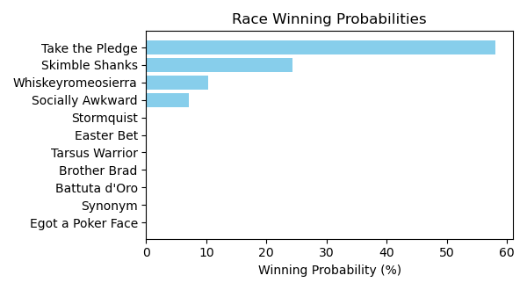

Figure: Winning Probability Distribution

NOTE: THIS RACE HAS HORSES THAT ARE MISSING CRITICAL DATA ELEMENTS

# Race: PEN | 2025-02-21 | Race #7 | Track: PENN NATIONAL

Track: PENN NATIONAL

|  |  |  |  |  |
| --- | --- | --- | --- | --- |
| Saddle Cloth # | Horse Name | Global Speed | Composite | Win Prob (%) |
| ['', 1, ''] | Grated Coconut | 108.6 | -6.31 | 0.00 |
| ['', 2, ''] | Watasha | 108.6 | 5.08 | 17.66 |
| ['', 3, ''] | Lucky Lucky Luke * | 108.6 | 4.38 | 10.07 |
| ['', 4, ''] | Moonset * | 108.6 | 3.75 | 6.06 |
| ['', 5, ''] | Long Tom * | 108.6 | -9.78 | 0.00 |
| ['', 6, ''] | Chucka Moon * | 108.6 | 3.20 | 3.91 |
| ['', 7, ''] | Sheltrfromthestorm * | 108.6 | 6.65 | 62.06 |
| ['', 8, ''] | Riverboat Bandit * | 108.6 | -0.62 | 0.18 |
| ['', 9, ''] | Graft | 108.6 | -6.63 | 0.00 |
| ['', 10, ''] | Grumpy Brooksie * | 108.6 | -2.93 | 0.03 |
| ['', 11, ''] | Sugar Gray Leonard | 108.6 | -3.87 | 0.01 |

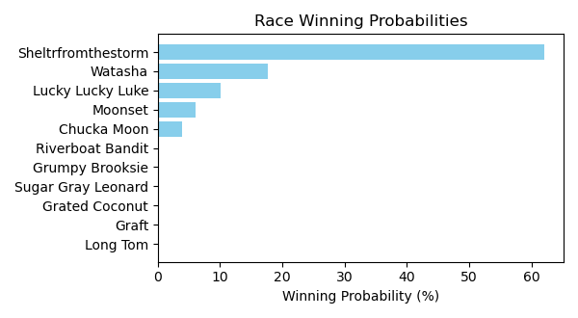

Figure: Winning Probability Distribution

NOTE: THIS RACE HAS HORSES THAT ARE MISSING CRITICAL DATA ELEMENTS

# Race: PEN | 2025-02-21 | Race #8 | Track: PENN NATIONAL

Track: PENN NATIONAL

|  |  |  |  |  |
| --- | --- | --- | --- | --- |
| Saddle Cloth # | Horse Name | Global Speed | Composite | Win Prob (%) |
| ['', 1, ''] | Ninja Kitty * | 70.8 | 3.85 | 54.61 |
| ['', 2, ''] | It's Saul Goodman * | 70.8 | -2.26 | 0.41 |
| ['', 3, ''] | Mobot * | 70.8 | -0.42 | 1.79 |
| ['', 4, ''] | Dave Did It * | 70.8 | -6.84 | 0.01 |
| ['', 5, ''] | Wild Nugget * | 70.8 | 3.56 | 43.16 |
| ['', 6, ''] | Search for Hope * | 70.8 | -6.73 | 0.01 |
| ['', 7, ''] | Michaelshatrick * | 70.8 | -10.36 | 0.00 |

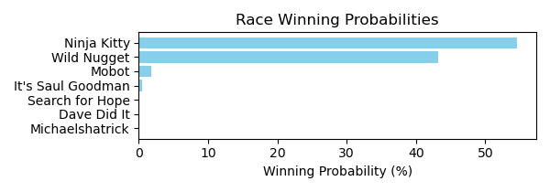

Figure: Winning Probability Distribution

NOTE: THIS RACE HAS HORSES THAT ARE MISSING CRITICAL DATA ELEMENTS

# Race: PEN | 2025-02-21 | Race #9 | Track: PENN NATIONAL

Track: PENN NATIONAL

|  |  |  |  |  |
| --- | --- | --- | --- | --- |
| Saddle Cloth # | Horse Name | Global Speed | Composite | Win Prob (%) |
| ['', 1, ''] | Carly Hustle * | 76.3 | -7.20 | 0.00 |
| ['', 2, ''] | I'm Heading East * | 76.3 | -7.13 | 0.00 |
| ['', 3, ''] | Melodious Singer * | 76.3 | -6.99 | 0.00 |
| ['', 4, ''] | Stormy Spell * | 76.3 | -6.75 | 0.00 |
| ['', 5, ''] | Tilted Tiara * | 76.3 | 3.73 | 1.85 |
| ['', 6, ''] | Kelly's Party Girl | 76.3 | -4.84 | 0.00 |
| ['', 7, ''] | Happy Tappy Tim * | 76.3 | 7.20 | 29.55 |
| ['', 8, ''] | Queen Wiggy * | 76.3 | 8.24 | 67.98 |
| ['', 9, ''] | Stephanie My Love * | 76.3 | 2.37 | 0.62 |
| ['', 10, ''] | Uptown Seraphina * | 76.3 | -9.57 | 0.00 |

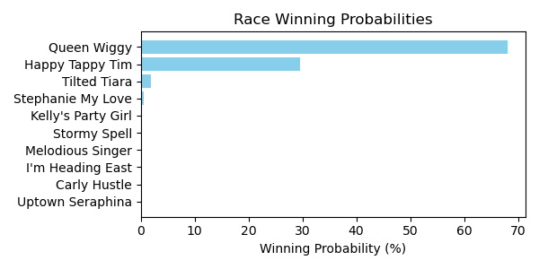

Figure: Winning Probability Distribution

NOTE: THIS RACE HAS HORSES THAT ARE MISSING CRITICAL DATA ELEMENTS

# Race: PEN | 2025-02-21 | Race #10 | Track: PENN NATIONAL

Track: PENN NATIONAL

|  |  |  |  |  |
| --- | --- | --- | --- | --- |
| Saddle Cloth # | Horse Name | Global Speed | Composite | Win Prob (%) |
| ['', 1, ''] | Mat Matters * | 71.1 | -0.95 | 0.01 |
| ['', 2, ''] | Mitropanos * | 71.1 | -0.03 | 0.03 |
| ['', 3, ''] | Jmr Speedy Escape | 71.1 | 6.50 | 4.77 |
| ['', 4, ''] | Valyrian Sky | 71.1 | -6.83 | 0.00 |
| ['', 5, ''] | Tactical Humor * | 71.1 | -8.97 | 0.00 |
| ['', 6, ''] | Prom Knight * | 71.1 | 10.24 | 95.16 |
| ['', 7, ''] | Valore | 71.1 | 0.21 | 0.03 |

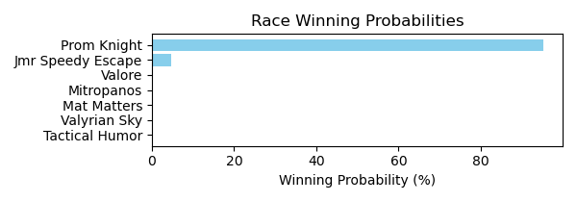

Figure: Winning Probability Distribution

NOTE: THIS RACE HAS HORSES THAT ARE MISSING CRITICAL DATA ELEMENTS

# Race: HOU | 2025-02-21 | Race #2 | Track: SAM HOUSTON RACE PARK

Track: SAM HOUSTON RACE PARK

|  |  |  |  |  |
| --- | --- | --- | --- | --- |
| Saddle Cloth # | Horse Name | Global Speed | Composite | Win Prob (%) |
| ['', 1, ''] | Cafezinho | 111.3 | -8.75 | 0.00 |
| ['', 2, ''] | Cactus Blossom | 111.3 | -1.34 | 0.05 |
| ['', 3, ''] | Lexington Diva | 111.3 | 0.50 | 0.20 |
| ['', 4, ''] | Keep the Bling | 111.3 | -10.39 | 0.00 |
| ['', 5, ''] | Tituba | 111.3 | -6.56 | 0.00 |
| ['', 6, ''] | Including Ellie | 111.3 | -3.80 | 0.01 |
| ['', 7, ''] | Cashmere Dancer | 111.3 | 0.97 | 0.29 |
| ['', 8, ''] | Arinniti (FR) | 111.3 | 0.65 | 0.23 |
| ['', 9, ''] | Contrabbanda | 111.3 | 8.25 | 99.23 |

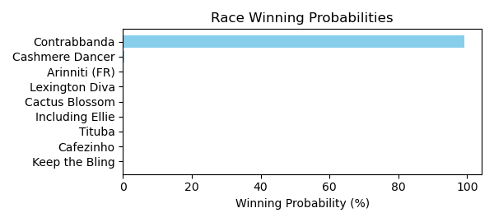

Figure: Winning Probability Distribution

NOTE: THIS RACE HAS HORSES THAT ARE MISSING CRITICAL DATA ELEMENTS

# Race: HOU | 2025-02-21 | Race #3 | Track: SAM HOUSTON RACE PARK

Track: SAM HOUSTON RACE PARK

|  |  |  |  |  |
| --- | --- | --- | --- | --- |
| Saddle Cloth # | Horse Name | Global Speed | Composite | Win Prob (%) |
| ['', 1, ''] | Cheers to Candy | 66.4 | -2.13 | 0.04 |
| ['', 2, ''] | RISKY WITH WHISKEY * | 66.4 | 5.14 | 14.32 |
| ['', 3, ''] | TIZ ANOTHER BUNNY * | 66.4 | 4.86 | 11.37 |
| ['', 4, ''] | Karanthos | 66.4 | 6.66 | 48.17 |
| ['', 5, ''] | CAUSE IM THE KING * | 66.4 | 4.98 | 12.53 |
| ['', 6, ''] | WORK ZONE * | 66.4 | 5.08 | 13.56 |
| ['', 7, ''] | The Last Moxy | 66.4 | -8.33 | 0.00 |
| ['', 8, ''] | Instant Karma | 66.4 | -7.61 | 0.00 |

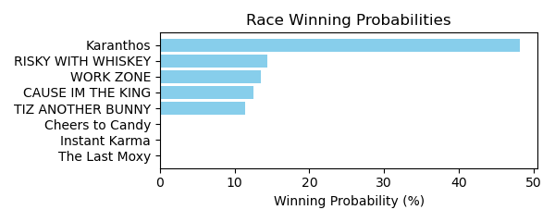

Figure: Winning Probability Distribution

NOTE: THIS RACE HAS HORSES THAT ARE MISSING CRITICAL DATA ELEMENTS

# Race: HOU | 2025-02-21 | Race #4 | Track: SAM HOUSTON RACE PARK

Track: SAM HOUSTON RACE PARK

|  |  |  |  |  |
| --- | --- | --- | --- | --- |
| Saddle Cloth # | Horse Name | Global Speed | Composite | Win Prob (%) |
| ['', 1, ''] | Reckless Red | 76.3 | -5.18 | 0.01 |
| ['', 2, ''] | Send Off | 76.3 | -6.34 | 0.00 |
| ['', 3, ''] | Samurai's Grandson * | 76.3 | -0.28 | 0.34 |
| ['', 4, ''] | Weird Year | 76.3 | 6.69 | 88.50 |
| ['', 5, ''] | Midnight Hunter | 76.3 | -7.11 | 0.00 |
| ['', 6, ''] | Fifteen Love Back | 76.3 | -4.53 | 0.01 |
| ['', 7, ''] | Sam Sez | 76.3 | 0.82 | 0.81 |
| ['', 8, ''] | Affectionto Autism | 76.3 | -4.55 | 0.01 |
| ['', 9, ''] | Ima Big Bopper | 76.3 | 3.60 | 7.48 |
| ['', 10, ''] | Suitable | 76.3 | 2.38 | 2.83 |

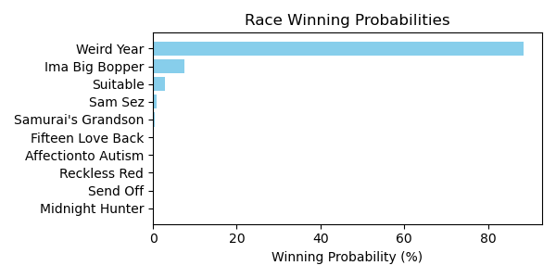

Figure: Winning Probability Distribution

NOTE: THIS RACE HAS HORSES THAT ARE MISSING CRITICAL DATA ELEMENTS

# Race: HOU | 2025-02-21 | Race #5 | Track: SAM HOUSTON RACE PARK

Track: SAM HOUSTON RACE PARK

|  |  |  |  |  |
| --- | --- | --- | --- | --- |
| Saddle Cloth # | Horse Name | Global Speed | Composite | Win Prob (%) |
| ['', 1, ''] | Bishop Creek | 103.8 | -4.86 | 0.02 |
| ['', 2, ''] | Feather Laine * | 103.8 | -4.73 | 0.02 |
| ['', 3, ''] | Atlantic Storm | 103.8 | -7.84 | 0.00 |
| ['', 4, ''] | EXPAT * | 103.8 | 4.95 | 46.48 |
| ['', 5, ''] | Follow the Star | 103.8 | 2.45 | 6.30 |
| ['', 6, ''] | Roaring Rapids * | 103.8 | 4.55 | 33.77 |
| ['', 7, ''] | Kantake | 103.8 | 3.28 | 12.28 |
| ['', 8, ''] | Philanthroper | 103.8 | 0.31 | 1.14 |

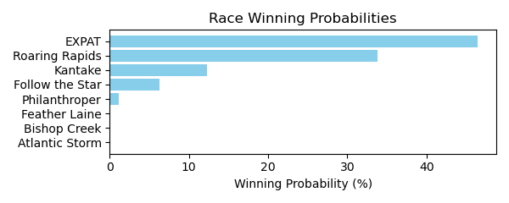

Figure: Winning Probability Distribution

NOTE: THIS RACE HAS HORSES THAT ARE MISSING CRITICAL DATA ELEMENTS

# Race: HOU | 2025-02-21 | Race #6 | Track: SAM HOUSTON RACE PARK

Track: SAM HOUSTON RACE PARK

|  |  |  |  |  |
| --- | --- | --- | --- | --- |
| Saddle Cloth # | Horse Name | Global Speed | Composite | Win Prob (%) |
| ['', 1, ''] | Essay | 76.4 | -1.72 | 0.01 |
| ['', 2, ''] | Son of a Bling | 76.4 | -3.71 | 0.00 |
| ['', 3, ''] | I'm a Cowboy | 76.4 | 2.72 | 0.40 |
| ['', 4, ''] | Texas Holdem | 76.4 | 6.12 | 6.05 |
| ['', 5, ''] | Red Summerbird | 76.4 | 8.28 | 34.00 |
| ['', 6, ''] | Bling Mountain | 76.4 | 4.86 | 2.21 |
| ['', 7, ''] | Tx Code | 76.4 | 8.93 | 57.31 |
| ['', 8, ''] | Bandera Bling | 76.4 | -1.26 | 0.02 |

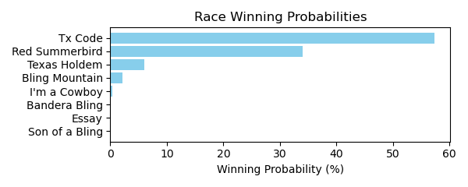

Figure: Winning Probability Distribution

NOTE: THIS RACE HAS HORSES THAT ARE MISSING CRITICAL DATA ELEMENTS

# Race: HOU | 2025-02-21 | Race #7 | Track: SAM HOUSTON RACE PARK

Track: SAM HOUSTON RACE PARK

|  |  |  |  |  |
| --- | --- | --- | --- | --- |
| Saddle Cloth # | Horse Name | Global Speed | Composite | Win Prob (%) |
| ['', 1, ''] | What Maggie Wants | 76.1 | -7.84 | 0.00 |
| ['', 2, ''] | Songerie | 76.1 | 8.68 | 75.43 |
| ['', 3, ''] | Lavender Will | 76.1 | -6.47 | 0.00 |
| ['', 4, ''] | Imagoldensong | 76.1 | -8.52 | 0.00 |
| ['', 5, ''] | Spirit of Veterans | 76.1 | -4.04 | 0.00 |
| ['', 6, ''] | Stacy's Princess | 76.1 | 2.65 | 0.61 |
| ['', 7, ''] | STELLA RIDGE * | 76.1 | 4.80 | 3.39 |
| ['', 8, ''] | YODA WINNER * | 76.1 | 5.09 | 4.27 |
| ['', 9, ''] | Klassy Rose Chrome | 76.1 | 6.70 | 15.52 |
| ['', 10, ''] | Faith and Devotion * | 76.1 | 2.98 | 0.79 |
| ['', 11, ''] | Indy La Primera | 76.1 | -9.32 | 0.00 |

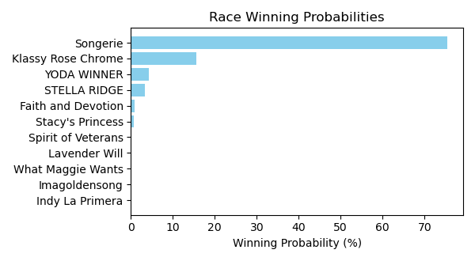

Figure: Winning Probability Distribution

NOTE: THIS RACE HAS HORSES THAT ARE MISSING CRITICAL DATA ELEMENTS

# Race: HOU | 2025-02-21 | Race #8 | Track: SAM HOUSTON RACE PARK

Track: SAM HOUSTON RACE PARK

|  |  |  |  |  |
| --- | --- | --- | --- | --- |
| Saddle Cloth # | Horse Name | Global Speed | Composite | Win Prob (%) |
| ['', 1, ''] | Missingyoucrazy | 111.6 | 1.07 | 9.47 |
| ['', 2, ''] | Ziti (FR) | 111.6 | 2.98 | 43.72 |
| ['', 3, ''] | Blueberry Eyes | 111.6 | 2.18 | 23.07 |
| ['', 4, ''] | Tizawiz | 111.6 | -3.24 | 0.30 |
| ['', 5, ''] | Chaton Rouge | 111.6 | 1.78 | 16.65 |
| ['', 6, ''] | Panthera | 111.6 | 0.65 | 6.75 |
| ['', 7, ''] | Girls Got Game | 111.6 | -8.20 | 0.01 |
| ['', 8, ''] | Gold Makin Girl | 111.6 | -6.00 | 0.03 |

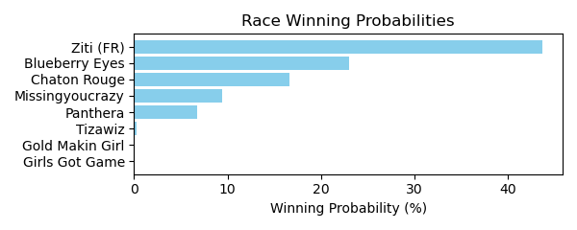

Figure: Winning Probability Distribution

NOTE: THIS RACE HAS HORSES THAT ARE MISSING CRITICAL DATA ELEMENTS

# Race: HOU | 2025-02-21 | Race #9 | Track: SAM HOUSTON RACE PARK

Track: SAM HOUSTON RACE PARK

|  |  |  |  |  |
| --- | --- | --- | --- | --- |
| Saddle Cloth # | Horse Name | Global Speed | Composite | Win Prob (%) |
| ['', 1, ''] | Win Worthy | 111.4 | 1.83 | 0.21 |
| ['', 2, ''] | Deanos Cape | 111.4 | 6.52 | 9.16 |
| ['', 3, ''] | Catholic Guilt | 111.4 | 6.87 | 12.14 |
| ['', 4, ''] | Special Moment | 111.4 | 4.54 | 1.87 |
| ['', 5, ''] | Barbacoa | 111.4 | 6.72 | 10.71 |
| ['', 6, ''] | Playboy Style | 111.4 | -3.35 | 0.00 |
| ['', 7, ''] | Shamayim | 111.4 | 8.99 | 65.82 |
| ['', 8, ''] | Hello Hello Mister | 111.4 | -5.48 | 0.00 |
| ['', 9, ''] | Cool Memory | 111.4 | -0.31 | 0.04 |
| ['', 10, ''] | Kentucky Peerless * | 111.4 | -0.29 | 0.04 |
| ['', 11, ''] | Absolute Courage | 111.4 | -5.39 | 0.00 |

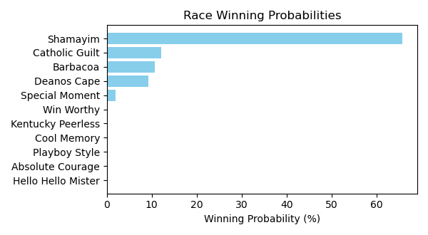

Figure: Winning Probability Distribution

NOTE: THIS RACE HAS HORSES THAT ARE MISSING CRITICAL DATA ELEMENTS

# Race: HOU | 2025-02-21 | Race #10 | Track: SAM HOUSTON RACE PARK

Track: SAM HOUSTON RACE PARK

|  |  |  |  |  |
| --- | --- | --- | --- | --- |
| Saddle Cloth # | Horse Name | Global Speed | Composite | Win Prob (%) |
| ['', 1, ''] | Pollito Tito * | 82.3 | 5.47 | 13.21 |
| ['', 2, ''] | Obvious Conclusion | 82.3 | -0.09 | 0.15 |
| ['', 3, ''] | Super Ekati | 82.3 | -1.75 | 0.04 |
| ['', 4, ''] | Silent Bling | 82.3 | 3.73 | 3.28 |
| ['', 5, ''] | Travel Guru | 82.3 | -9.13 | 0.00 |
| ['', 6, ''] | Second Battalion | 82.3 | -9.77 | 0.00 |
| ['', 7, ''] | Curly's One Thing * | 82.3 | 3.63 | 3.03 |
| ['', 8, ''] | Bradix | 82.3 | -5.26 | 0.00 |
| ['', 9, ''] | Fist Bump Ridge | 82.3 | -7.74 | 0.00 |
| ['', 10, ''] | The Devil's Bet | 82.3 | 7.72 | 79.32 |
| ['', 11, ''] | Binary Code * | 82.3 | -5.31 | 0.00 |
| ['', 12, ''] | Moro Trendsetter * | 82.3 | -5.49 | 0.00 |
| ['', 13, ''] | Expect Glory | 82.3 | 2.21 | 0.97 |
| ['', 14, ''] | Rockets Red Flair | 82.3 | -6.89 | 0.00 |

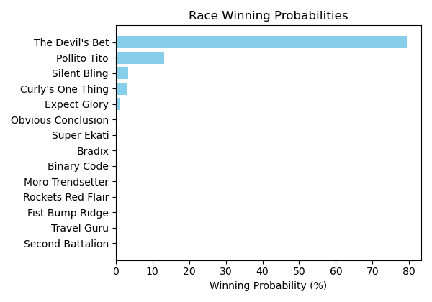

Figure: Winning Probability Distribution

NOTE: THIS RACE HAS HORSES THAT ARE MISSING CRITICAL DATA ELEMENTS

# Race: HOU | 2025-02-22 | Race #1 | Track: SAM HOUSTON RACE PARK

Track: SAM HOUSTON RACE PARK

|  |  |  |  |  |
| --- | --- | --- | --- | --- |
| Saddle Cloth # | Horse Name | Global Speed | Composite | Win Prob (%) |
| ['', 1, ''] | Transactional (GB) | 111.6 | 5.06 | 45.36 |
| ['', 2, ''] | Keraunos | 111.6 | 5.02 | 43.87 |
| ['', 3, ''] | Big Commerce | 111.6 | -2.18 | 0.14 |
| ['', 4, ''] | Wrinkle Road | 111.6 | -1.74 | 0.20 |
| ['', 5, ''] | Den's Good Grace | 111.6 | 1.52 | 2.66 |
| ['', 6, ''] | Brilliant Spin | 111.6 | 1.23 | 2.12 |
| ['', 7, ''] | Summer Lover | 111.6 | 2.43 | 5.51 |
| ['', 8, ''] | Supreme Leader | 111.6 | -2.12 | 0.15 |

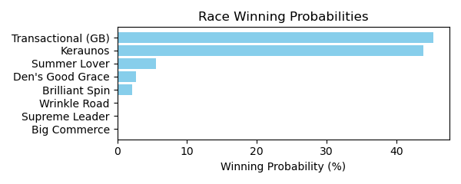

Figure: Winning Probability Distribution

NOTE: THIS RACE HAS HORSES THAT ARE MISSING CRITICAL DATA ELEMENTS

# Race: HOU | 2025-02-22 | Race #2 | Track: SAM HOUSTON RACE PARK

Track: SAM HOUSTON RACE PARK

|  |  |  |  |  |
| --- | --- | --- | --- | --- |
| Saddle Cloth # | Horse Name | Global Speed | Composite | Win Prob (%) |
| ['', 1, ''] | Texas Red Bel | 76.3 | 6.91 | 56.60 |
| ['', 2, ''] | Eagle Express | 76.3 | 5.79 | 23.01 |
| ['', 3, ''] | Natural Touch | 76.3 | 4.30 | 7.00 |
| ['', 4, ''] | Stormy Bisonette | 76.3 | -5.57 | 0.00 |
| ['', 5, ''] | Mola Mia | 76.3 | -7.74 | 0.00 |
| ['', 6, ''] | Its My Money Too | 76.3 | 5.11 | 13.38 |
| ['', 7, ''] | Claudette Heir | 76.3 | -4.60 | 0.01 |
| ['', 8, ''] | Sharp Likeness | 76.3 | -9.21 | 0.00 |
| ['', 9, ''] | Mayapretty | 76.3 | -7.63 | 0.00 |

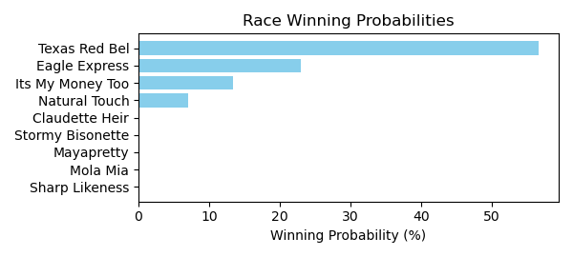

Figure: Winning Probability Distribution

NOTE: THIS RACE HAS HORSES THAT ARE MISSING CRITICAL DATA ELEMENTS

# Race: HOU | 2025-02-22 | Race #3 | Track: SAM HOUSTON RACE PARK

Track: SAM HOUSTON RACE PARK

|  |  |  |  |  |
| --- | --- | --- | --- | --- |
| Saddle Cloth # | Horse Name | Global Speed | Composite | Win Prob (%) |
| ['', 1, ''] | Say as I Say | 66.3 | 5.44 | 20.70 |
| ['', 2, ''] | OURAY DREAMIN * | 66.3 | 5.43 | 20.43 |
| ['', 3, ''] | AUTISM RIGHTS * | 66.3 | 5.12 | 15.99 |
| ['', 4, ''] | Blake's Song | 66.3 | -5.52 | 0.00 |
| ['', 5, ''] | CATSGOTACODE * | 66.3 | 5.52 | 21.95 |
| ['', 6, ''] | Retired Blessing * | 66.3 | -5.07 | 0.00 |
| ['', 7, ''] | Belleria Baby | 66.3 | -9.90 | 0.00 |
| ['', 8, ''] | Glitters Andie | 66.3 | -3.51 | 0.02 |
| ['', 9, ''] | MAYPEARL * | 66.3 | 5.45 | 20.90 |

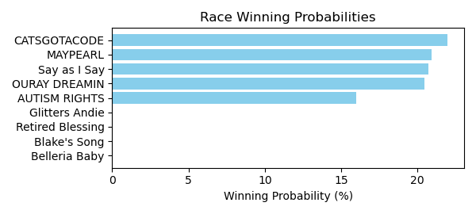

Figure: Winning Probability Distribution

NOTE: THIS RACE HAS HORSES THAT ARE MISSING CRITICAL DATA ELEMENTS

# Race: HOU | 2025-02-22 | Race #4 | Track: SAM HOUSTON RACE PARK

Track: SAM HOUSTON RACE PARK

|  |  |  |  |  |
| --- | --- | --- | --- | --- |
| Saddle Cloth # | Horse Name | Global Speed | Composite | Win Prob (%) |
| ['', 1, ''] | Chief Brady | 66.7 | 0.60 | 0.02 |
| ['', 2, ''] | Jackman's Ride | 66.7 | 9.52 | 24.95 |
| ['', 3, ''] | Bandera Azteca | 66.7 | 3.88 | 0.27 |
| ['', 4, ''] | Trust Daddy | 66.7 | 8.90 | 15.22 |
| ['', 5, ''] | Talk About Autism | 66.7 | -5.09 | 0.00 |
| ['', 6, ''] | Balsa | 66.7 | 1.07 | 0.03 |
| ['', 7, ''] | Hap Hot | 66.7 | 7.71 | 5.87 |
| ['', 8, ''] | Speight and Malice | 66.7 | 10.09 | 39.34 |
| ['', 9, ''] | Prayforpeace | 66.7 | 8.82 | 14.29 |

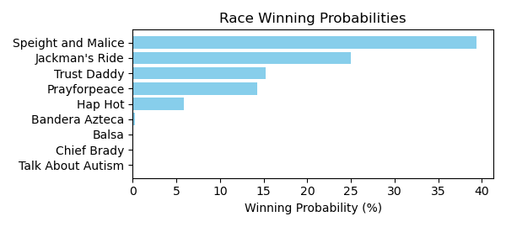

Figure: Winning Probability Distribution

NOTE: THIS RACE HAS HORSES THAT ARE MISSING CRITICAL DATA ELEMENTS

# Race: HOU | 2025-02-22 | Race #5 | Track: SAM HOUSTON RACE PARK

Track: SAM HOUSTON RACE PARK

|  |  |  |  |  |
| --- | --- | --- | --- | --- |
| Saddle Cloth # | Horse Name | Global Speed | Composite | Win Prob (%) |
| ['', 1, ''] | True Blue Sky * | 104.1 | 9.15 | 86.12 |
| ['', 2, ''] | Fella's Sister | 104.1 | 5.11 | 3.40 |
| ['', 3, ''] | Desert Glow | 104.1 | -1.40 | 0.02 |
| ['', 4, ''] | Drenched | 104.1 | 0.30 | 0.07 |
| ['', 5, ''] | Grand Prairie Gal | 104.1 | 2.83 | 0.55 |
| ['', 6, ''] | San Mateo Kat | 104.1 | -6.37 | 0.00 |
| ['', 7, ''] | Wilburnsclassylady | 104.1 | 6.42 | 9.72 |
| ['', 8, ''] | Tura Lura * | 104.1 | 0.90 | 0.12 |

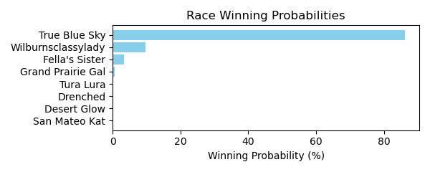

Figure: Winning Probability Distribution

NOTE: THIS RACE HAS HORSES THAT ARE MISSING CRITICAL DATA ELEMENTS

# Race: HOU | 2025-02-22 | Race #6 | Track: SAM HOUSTON RACE PARK

Track: SAM HOUSTON RACE PARK

|  |  |  |  |  |
| --- | --- | --- | --- | --- |
| Saddle Cloth # | Horse Name | Global Speed | Composite | Win Prob (%) |
| ['', 1, ''] | Zippy Season * | 76.0 | -8.05 | 0.01 |
| ['', 2, ''] | Gospel Stunning | 76.0 | -2.73 | 0.93 |
| ['', 3, ''] | Pebbles B Awesome | 76.0 | 1.29 | 23.12 |
| ['', 4, ''] | Tribe | 76.0 | 0.03 | 8.45 |
| ['', 5, ''] | West Texas Ruby * | 76.0 | -10.26 | 0.00 |
| ['', 6, ''] | My Last Chance * | 76.0 | -10.40 | 0.00 |
| ['', 7, ''] | No Moro Here * | 76.0 | -7.10 | 0.03 |
| ['', 8, ''] | Western Sky | 76.0 | -6.94 | 0.03 |
| ['', 9, ''] | Lemon Marmalade | 76.0 | -2.66 | 0.98 |
| ['', 10, ''] | Along Came Thunder | 76.0 | -4.38 | 0.25 |
| ['', 11, ''] | Iced Up | 76.0 | -10.12 | 0.00 |
| ['', 12, ''] | Breezy Bay | 76.0 | -7.30 | 0.02 |
| ['', 13, ''] | JAMIE ZEE * | 76.0 | 2.56 | 63.68 |
| ['', 14, ''] | Joyful Pursuit | 76.0 | -1.49 | 2.49 |

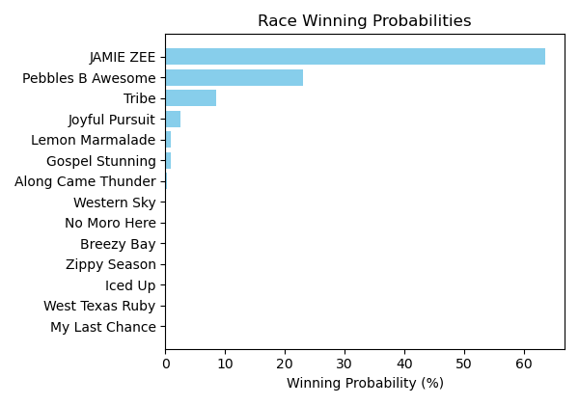

Figure: Winning Probability Distribution

NOTE: THIS RACE HAS HORSES THAT ARE MISSING CRITICAL DATA ELEMENTS

# Race: HOU | 2025-02-22 | Race #7 | Track: SAM HOUSTON RACE PARK

Track: SAM HOUSTON RACE PARK

|  |  |  |  |  |
| --- | --- | --- | --- | --- |
| Saddle Cloth # | Horse Name | Global Speed | Composite | Win Prob (%) |
| ['', 1, ''] | Big Bernie | 76.7 | 3.99 | 2.94 |
| ['', 2, ''] | Established | 76.7 | 5.28 | 8.21 |
| ['', 3, ''] | Sir Sterling | 76.7 | 2.66 | 1.01 |
| ['', 4, ''] | Kentucky Dawn | 76.7 | -2.99 | 0.01 |
| ['', 5, ''] | Kupuna | 76.7 | 6.69 | 25.51 |
| ['', 6, ''] | General Shipman | 76.7 | -0.79 | 0.06 |
| ['', 7, ''] | Halmstad | 76.7 | 6.59 | 23.53 |
| ['', 8, ''] | Toddchero | 76.7 | 7.22 | 38.72 |

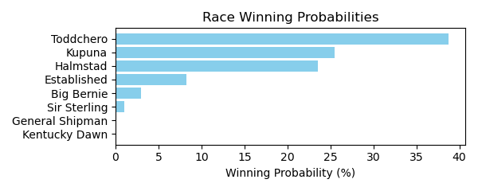

Figure: Winning Probability Distribution

NOTE: THIS RACE HAS HORSES THAT ARE MISSING CRITICAL DATA ELEMENTS

# Race: HOU | 2025-02-22 | Race #8 | Track: SAM HOUSTON RACE PARK

Track: SAM HOUSTON RACE PARK

|  |  |  |  |  |
| --- | --- | --- | --- | --- |
| Saddle Cloth # | Horse Name | Global Speed | Composite | Win Prob (%) |
| ['', 1, ''] | Uptown Tappin | 111.6 | -4.89 | 0.00 |
| ['', 2, ''] | Coastal Brink | 111.6 | 8.25 | 45.76 |
| ['', 3, ''] | Gold Prize | 111.6 | 1.01 | 0.14 |
| ['', 4, ''] | Barefoot Samurai | 111.6 | 1.82 | 0.27 |
| ['', 5, ''] | Dominant Spirit | 111.6 | 1.41 | 0.19 |
| ['', 6, ''] | Regal Terka | 111.6 | 3.60 | 1.11 |
| ['', 7, ''] | Moon Cat | 111.6 | 5.00 | 3.38 |
| ['', 8, ''] | Singing Dixie | 111.6 | -4.05 | 0.00 |
| ['', 9, ''] | Excaping the Blues | 111.6 | 8.34 | 49.14 |

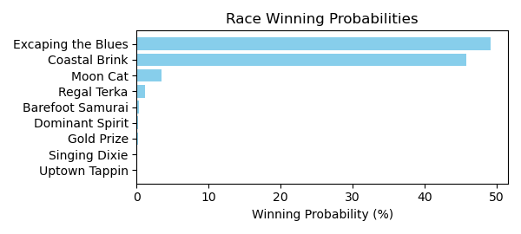

Figure: Winning Probability Distribution

NOTE: THIS RACE HAS HORSES THAT ARE MISSING CRITICAL DATA ELEMENTS

# Race: HOU | 2025-02-22 | Race #9 | Track: SAM HOUSTON RACE PARK

Track: SAM HOUSTON RACE PARK

|  |  |  |  |  |
| --- | --- | --- | --- | --- |
| Saddle Cloth # | Horse Name | Global Speed | Composite | Win Prob (%) |
| ['', 1, ''] | Midnight Twister * | 76.0 | 5.08 | 8.29 |
| ['', 2, ''] | Going to Sanantone | 76.0 | -3.82 | 0.01 |
| ['', 3, ''] | Gus Cause | 76.0 | -7.01 | 0.00 |
| ['', 4, ''] | Texano Hero | 76.0 | -5.39 | 0.00 |
| ['', 5, ''] | Sir Lancelot Ridge | 76.0 | -1.73 | 0.04 |
| ['', 6, ''] | Sippin Scotch | 76.0 | 6.88 | 34.96 |
| ['', 7, ''] | Fly Red Bird Fly | 76.0 | 4.86 | 6.92 |
| ['', 8, ''] | KEEP A COPY * | 76.0 | 5.89 | 15.82 |
| ['', 9, ''] | Chasing the Rush | 76.0 | -1.41 | 0.05 |
| ['', 10, ''] | Oklahoma Flame | 76.0 | -0.44 | 0.10 |
| ['', 11, ''] | Redfortyseven | 76.0 | -1.73 | 0.04 |
| ['', 12, ''] | Golden Pursuit | 76.0 | 3.36 | 2.08 |
| ['', 13, ''] | Xander S | 76.0 | 3.59 | 2.52 |
| ['', 14, ''] | Dustins Denile * | 76.0 | 6.66 | 29.18 |

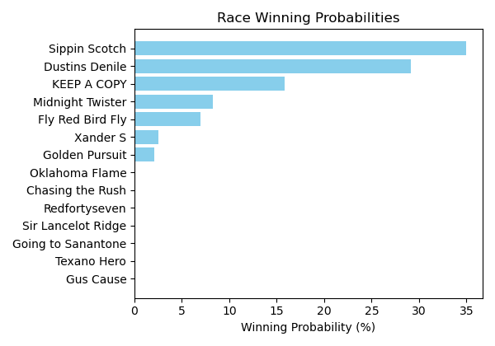

Figure: Winning Probability Distribution

NOTE: THIS RACE HAS HORSES THAT ARE MISSING CRITICAL DATA ELEMENTS

# Race: HOU | 2025-02-23 | Race #2 | Track: SAM HOUSTON RACE PARK

Track: SAM HOUSTON RACE PARK

|  |  |  |  |  |
| --- | --- | --- | --- | --- |
| Saddle Cloth # | Horse Name | Global Speed | Composite | Win Prob (%) |
| ['', 1, ''] | School Teacher | 111.0 | 1.36 | 3.96 |
| ['', 2, ''] | Fun as All Git Out * | 111.0 | -6.35 | 0.01 |
| ['', 3, ''] | Maddie's Maverick | 111.0 | -5.77 | 0.01 |
| ['', 4, ''] | Sherrys Ridge | 111.0 | -7.86 | 0.00 |
| ['', 5, ''] | Cayman Hot | 111.0 | -1.92 | 0.29 |
| ['', 6, ''] | Miss Motor Mouth * | 111.0 | -8.61 | 0.00 |
| ['', 7, ''] | Mighty Enticing * | 111.0 | -4.76 | 0.03 |
| ['', 8, ''] | Wild Steel | 111.0 | 5.34 | 95.70 |

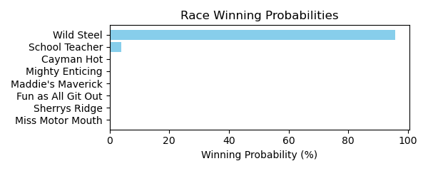

Figure: Winning Probability Distribution

NOTE: THIS RACE HAS HORSES THAT ARE MISSING CRITICAL DATA ELEMENTS

# Race: HOU | 2025-02-23 | Race #3 | Track: SAM HOUSTON RACE PARK

Track: SAM HOUSTON RACE PARK

|  |  |  |  |  |
| --- | --- | --- | --- | --- |
| Saddle Cloth # | Horse Name | Global Speed | Composite | Win Prob (%) |
| ['', 1, ''] | Honest | 82.3 | 5.87 | 30.08 |
| ['', 2, ''] | God Knows Why | 82.3 | -4.44 | 0.01 |
| ['', 3, ''] | Bling Baby | 82.3 | 6.00 | 33.45 |
| ['', 4, ''] | Gee She's Fancy | 82.3 | -2.18 | 0.05 |
| ['', 5, ''] | Avaling | 82.3 | 5.11 | 16.39 |
| ['', 6, ''] | Midshipman's Lady | 82.3 | 5.22 | 17.93 |
| ['', 7, ''] | Sassy Flyer | 82.3 | 2.38 | 1.84 |
| ['', 8, ''] | All American Lady | 82.3 | -0.11 | 0.25 |

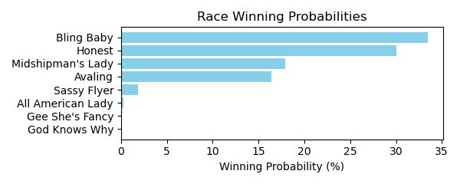

Figure: Winning Probability Distribution

NOTE: THIS RACE HAS HORSES THAT ARE MISSING CRITICAL DATA ELEMENTS

# Race: HOU | 2025-02-23 | Race #4 | Track: SAM HOUSTON RACE PARK

Track: SAM HOUSTON RACE PARK

|  |  |  |  |  |
| --- | --- | --- | --- | --- |
| Saddle Cloth # | Horse Name | Global Speed | Composite | Win Prob (%) |
| ['', 1, ''] | Highlander Honey | 103.7 | 2.90 | 21.96 |
| ['', 2, ''] | Anna Up | 103.7 | -4.00 | 0.09 |
| ['', 3, ''] | Candy Oak | 103.7 | -4.69 | 0.05 |
| ['', 4, ''] | Miss Escapade | 103.7 | -3.40 | 0.14 |
| ['', 5, ''] | Perceptive | 103.7 | 3.87 | 47.55 |
| ['', 6, ''] | Teardrop Tiara | 103.7 | 3.29 | 29.97 |
| ['', 7, ''] | Gospel Extra | 103.7 | -6.39 | 0.01 |
| ['', 8, ''] | Annamaria | 103.7 | -9.69 | 0.00 |
| ['', 9, ''] | Gospel Freely | 103.7 | -2.88 | 0.21 |
| ['', 10, ''] | Ize a Blast | 103.7 | -6.16 | 0.02 |

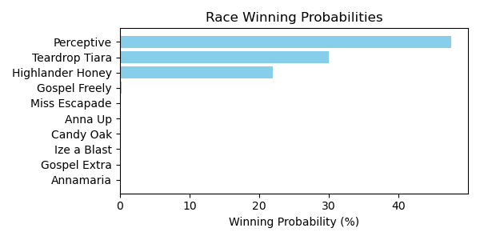

Figure: Winning Probability Distribution

NOTE: THIS RACE HAS HORSES THAT ARE MISSING CRITICAL DATA ELEMENTS

# Race: HOU | 2025-02-23 | Race #5 | Track: SAM HOUSTON RACE PARK

Track: SAM HOUSTON RACE PARK

|  |  |  |  |  |
| --- | --- | --- | --- | --- |
| Saddle Cloth # | Horse Name | Global Speed | Composite | Win Prob (%) |
| ['', 1, ''] | Gospel B. Havior | 103.9 | -1.20 | 0.06 |
| ['', 2, ''] | Kamikaze | 103.9 | -2.91 | 0.01 |
| ['', 3, ''] | Utsira | 103.9 | -8.26 | 0.00 |
| ['', 4, ''] | Contessa's Song | 103.9 | 2.68 | 1.23 |
| ['', 5, ''] | County Slugger | 103.9 | 7.61 | 63.46 |
| ['', 6, ''] | Charluche | 103.9 | -0.52 | 0.10 |
| ['', 7, ''] | Chainsaw City | 103.9 | -1.10 | 0.06 |
| ['', 8, ''] | Boltoro | 103.9 | 6.87 | 35.09 |

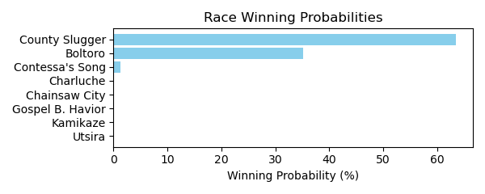

Figure: Winning Probability Distribution

NOTE: THIS RACE HAS HORSES THAT ARE MISSING CRITICAL DATA ELEMENTS

# Race: HOU | 2025-02-23 | Race #6 | Track: SAM HOUSTON RACE PARK

Track: SAM HOUSTON RACE PARK

|  |  |  |  |  |
| --- | --- | --- | --- | --- |
| Saddle Cloth # | Horse Name | Global Speed | Composite | Win Prob (%) |
| ['', 1, ''] | Pudding | 66.6 | 8.50 | 40.09 |
| ['', 2, ''] | Playing Hardball | 66.6 | 7.20 | 14.27 |
| ['', 3, ''] | Fort Hood | 66.6 | 3.71 | 0.87 |
| ['', 4, ''] | My Little Prince | 66.6 | -6.79 | 0.00 |
| ['', 5, ''] | Champagne Stooper | 66.6 | 1.91 | 0.21 |
| ['', 6, ''] | Perliano | 66.6 | 6.35 | 7.23 |
| ['', 7, ''] | Rocking Rocket | 66.6 | 8.40 | 37.25 |
| ['', 8, ''] | Cinco Steve | 66.6 | 0.53 | 0.07 |
| ['', 9, ''] | Sidetown | 66.6 | -1.01 | 0.02 |

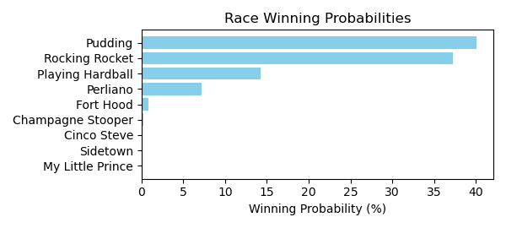

Figure: Winning Probability Distribution

NOTE: THIS RACE HAS HORSES THAT ARE MISSING CRITICAL DATA ELEMENTS

# Race: HOU | 2025-02-23 | Race #7 | Track: SAM HOUSTON RACE PARK

Track: SAM HOUSTON RACE PARK

|  |  |  |  |  |
| --- | --- | --- | --- | --- |
| Saddle Cloth # | Horse Name | Global Speed | Composite | Win Prob (%) |
| ['', 1, ''] | Piccolo Uomo | 76.2 | -3.55 | 0.01 |
| ['', 2, ''] | Blame Dennis | 76.2 | -6.71 | 0.00 |
| ['', 3, ''] | Wonderful News | 76.2 | -9.52 | 0.00 |
| ['', 4, ''] | Doc Henry Ridge | 76.2 | -9.86 | 0.00 |
| ['', 5, ''] | Midnight Talker | 76.2 | 1.44 | 0.37 |
| ['', 6, ''] | Tough Trooper | 76.2 | -6.01 | 0.00 |
| ['', 7, ''] | TOO COLD AT HOME * | 76.2 | 4.49 | 4.30 |
| ['', 8, ''] | Fully Funded | 76.2 | -2.48 | 0.02 |
| ['', 9, ''] | Lone Tree | 76.2 | 3.59 | 2.08 |
| ['', 10, ''] | Give Him Time | 76.2 | -7.79 | 0.00 |
| ['', 11, ''] | Brewing | 76.2 | 8.34 | 93.23 |

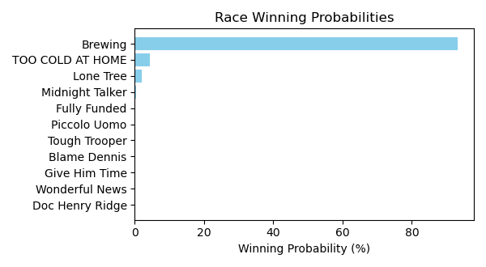

Figure: Winning Probability Distribution

NOTE: THIS RACE HAS HORSES THAT ARE MISSING CRITICAL DATA ELEMENTS

# Race: HOU | 2025-02-23 | Race #8 | Track: SAM HOUSTON RACE PARK

Track: SAM HOUSTON RACE PARK

|  |  |  |  |  |
| --- | --- | --- | --- | --- |
| Saddle Cloth # | Horse Name | Global Speed | Composite | Win Prob (%) |
| ['', 1, ''] | Big Nickel | 103.6 | 3.82 | 65.10 |
| ['', 2, ''] | Keep Up the Pace | 103.6 | -4.16 | 0.11 |
| ['', 3, ''] | Map This Out * | 103.6 | 3.04 | 34.73 |
| ['', 4, ''] | Can't Know * | 103.6 | -8.33 | 0.00 |
| ['', 5, ''] | Hank Ridge * | 103.6 | -9.39 | 0.00 |
| ['', 6, ''] | Nightlinger * | 103.6 | -5.65 | 0.03 |
| ['', 7, ''] | Floating Smokey | 103.6 | -10.14 | 0.00 |
| ['', 8, ''] | Rock Island Rocket * | 103.6 | -6.37 | 0.02 |

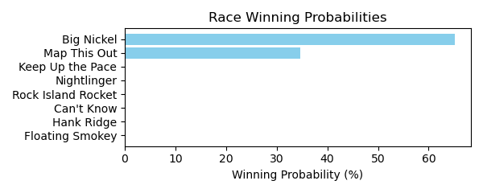

Figure: Winning Probability Distribution

NOTE: THIS RACE HAS HORSES THAT ARE MISSING CRITICAL DATA ELEMENTS

# Race: HOU | 2025-02-23 | Race #9 | Track: SAM HOUSTON RACE PARK

Track: SAM HOUSTON RACE PARK

|  |  |  |  |  |
| --- | --- | --- | --- | --- |
| Saddle Cloth # | Horse Name | Global Speed | Composite | Win Prob (%) |
| ['', 1, ''] | El Mero Mero | 76.4 | -2.57 | 0.02 |
| ['', 2, ''] | My Boy Bling | 76.4 | -0.33 | 0.09 |
| ['', 3, ''] | Bronte Diem | 76.4 | -6.08 | 0.00 |
| ['', 4, ''] | Cadillac Cowboy | 76.4 | 5.77 | 12.05 |
| ['', 5, ''] | Mister Monte Carlo | 76.4 | 2.27 | 0.73 |
| ['', 6, ''] | Optimal Trip | 76.4 | 4.30 | 3.71 |
| ['', 7, ''] | Samsplayerslounge | 76.4 | 4.50 | 4.35 |
| ['', 8, ''] | In Bond We Trust | 76.4 | -9.64 | 0.00 |
| ['', 9, ''] | Do Your Job | 76.4 | 0.61 | 0.19 |
| ['', 10, ''] | Ooey Gooey Chewy | 76.4 | 4.90 | 5.98 |
| ['', 11, ''] | Legendary Lore | 76.4 | 8.02 | 72.88 |

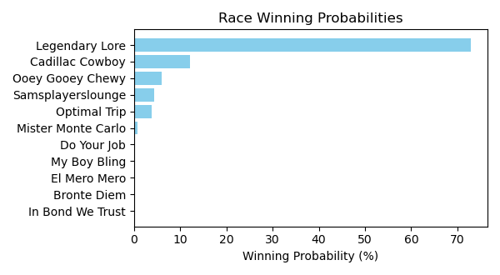

Figure: Winning Probability Distribution

NOTE: THIS RACE HAS HORSES THAT ARE MISSING CRITICAL DATA ELEMENTS

# Race: HOU | 2025-02-23 | Race #10 | Track: SAM HOUSTON RACE PARK

Track: SAM HOUSTON RACE PARK

|  |  |  |  |  |
| --- | --- | --- | --- | --- |
| Saddle Cloth # | Horse Name | Global Speed | Composite | Win Prob (%) |
| ['', 1, ''] | Levy | 89.3 | -1.07 | 0.04 |
| ['', 2, ''] | Will the Thrill | 89.3 | -2.17 | 0.02 |
| ['', 3, ''] | Nightwind | 89.3 | 4.33 | 3.12 |
| ['', 4, ''] | Federal Hill | 89.3 | 1.02 | 0.22 |
| ['', 5, ''] | Macho Grande | 89.3 | 8.60 | 95.17 |
| ['', 6, ''] | Union Data | 89.3 | 1.61 | 0.35 |
| ['', 7, ''] | Hard Gold | 89.3 | -2.12 | 0.02 |
| ['', 8, ''] | Fast Traffic | 89.3 | 2.11 | 0.53 |
| ['', 9, ''] | Big Muckity | 89.3 | 0.38 | 0.13 |
| ['', 10, ''] | Sniveling * | 89.3 | -6.68 | 0.00 |
| ['', 11, ''] | Malibu S S | 89.3 | -3.38 | 0.01 |
| ['', 12, ''] | Texas Titan | 89.3 | -9.12 | 0.00 |
| ['', 13, ''] | R D C Posse | 89.3 | 1.75 | 0.40 |

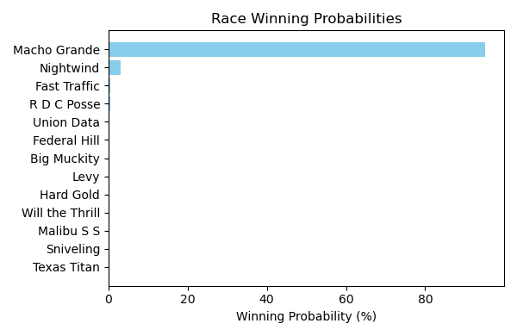

Figure: Winning Probability Distribution

NOTE: THIS RACE HAS HORSES THAT ARE MISSING CRITICAL DATA ELEMENTS

# Race: HOU | 2025-02-23 | Race #11 | Track: SAM HOUSTON RACE PARK

Track: SAM HOUSTON RACE PARK

|  |  |  |  |  |
| --- | --- | --- | --- | --- |
| Saddle Cloth # | Horse Name | Global Speed | Composite | Win Prob (%) |
| ['', 1, ''] | Violet Kitten | 103.9 | 4.13 | 5.55 |
| ['', 2, ''] | Catalyst | 103.9 | 6.33 | 32.35 |
| ['', 3, ''] | La Ronalda Y G | 103.9 | -7.14 | 0.00 |
| ['', 4, ''] | Wandering Kirby * | 103.9 | -8.58 | 0.00 |
| ['', 5, ''] | My Sweet Love | 103.9 | -6.55 | 0.00 |
| ['', 6, ''] | Summertimee | 103.9 | 0.20 | 0.24 |
| ['', 7, ''] | Razors Edge | 103.9 | -9.91 | 0.00 |
| ['', 8, ''] | Wonder Wave (IRE) | 103.9 | 2.27 | 1.25 |
| ['', 9, ''] | Sugarcoat | 103.9 | 7.11 | 60.10 |
| ['', 10, ''] | Tiz a Knockout | 103.9 | 1.12 | 0.50 |

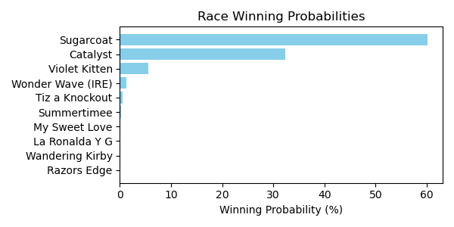

Figure: Winning Probability Distribution

NOTE: THIS RACE HAS HORSES THAT ARE MISSING CRITICAL DATA ELEMENTS

# Race: TSA | 2025-02-21 | Race #1 | Track: SANTA ANITA PARK

Track: SANTA ANITA PARK

|  |  |  |  |  |
| --- | --- | --- | --- | --- |
| Saddle Cloth # | Horse Name | Global Speed | Composite | Win Prob (%) |
| ['', 1, ''] | Oscar Joy | 82.7 | 2.98 | 1.53 |
| ['', 2, ''] | Private Gem | 82.7 | 3.41 | 2.16 |
| ['', 3, ''] | Travelin' Show | 82.7 | 3.77 | 2.87 |
| ['', 5, ''] | Enough Already | 82.7 | 1.19 | 0.36 |
| ['', 6, ''] | Bolt Supremacy | 82.7 | 0.37 | 0.19 |
| ['', 7, ''] | Naftis | 82.7 | 2.40 | 0.96 |
| ['', 8, ''] | Mr. Leasure | 82.7 | 8.10 | 91.92 |

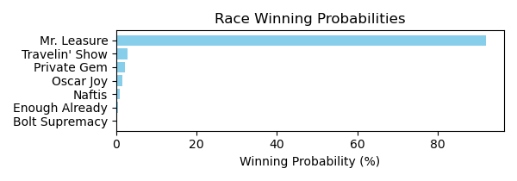

Figure: Winning Probability Distribution

NOTE: THIS RACE HAS HORSES THAT ARE MISSING CRITICAL DATA ELEMENTS

# Race: TSA | 2025-02-21 | Race #2 | Track: SANTA ANITA PARK

Track: SANTA ANITA PARK

|  |  |  |  |  |
| --- | --- | --- | --- | --- |
| Saddle Cloth # | Horse Name | Global Speed | Composite | Win Prob (%) |
| ['', 1, ''] | Pineapple Juice | 76.4 | -7.20 | 0.00 |
| ['', 2, ''] | Blue Silver | 76.4 | -2.05 | 0.05 |
| ['', 3, ''] | Gianola | 76.4 | 6.69 | 57.09 |
| ['', 4, ''] | Golden River | 76.4 | 0.46 | 0.39 |
| ['', 5, ''] | Momo's Kiddo | 76.4 | -1.50 | 0.08 |
| ['', 6, ''] | Candy's Wildcat | 76.4 | -0.75 | 0.15 |
| ['', 7, ''] | Constant Conflict | 76.4 | 6.32 | 42.24 |

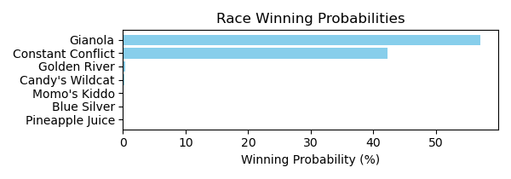

Figure: Winning Probability Distribution

NOTE: THIS RACE HAS HORSES THAT ARE MISSING CRITICAL DATA ELEMENTS

# Race: TSA | 2025-02-21 | Race #3 | Track: SANTA ANITA PARK

Track: SANTA ANITA PARK

|  |  |  |  |  |
| --- | --- | --- | --- | --- |
| Saddle Cloth # | Horse Name | Global Speed | Composite | Win Prob (%) |
| ['', 1, ''] | Old Triangle | 76.6 | 6.70 | 2.07 |
| ['', 2, ''] | Mr. Big Heart | 76.6 | -9.43 | 0.00 |
| ['', 3, ''] | Trinidad * | 76.6 | 3.48 | 0.16 |
| ['', 4, ''] | Wound Up | 76.6 | 11.51 | 97.23 |
| ['', 5, ''] | Clever Clover | 76.6 | -1.55 | 0.00 |
| ['', 6, ''] | Stan From Malibu | 76.6 | -0.95 | 0.00 |
| ['', 7, ''] | Square Cat | 76.6 | -5.28 | 0.00 |
| ['', 8, ''] | Harcyn | 76.6 | 4.96 | 0.52 |
| ['', 9, ''] | Idiot's Gold | 76.6 | -2.20 | 0.00 |
| ['', 10, ''] | Come Out Fighting | 76.6 | 0.07 | 0.01 |

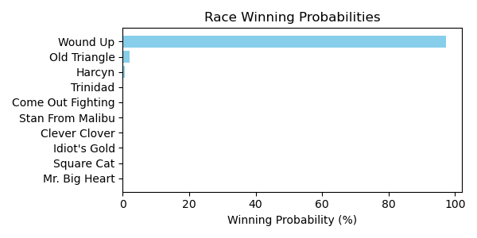

Figure: Winning Probability Distribution

NOTE: THIS RACE HAS HORSES THAT ARE MISSING CRITICAL DATA ELEMENTS

# Race: TSA | 2025-02-21 | Race #4 | Track: SANTA ANITA PARK

Track: SANTA ANITA PARK

|  |  |  |  |  |
| --- | --- | --- | --- | --- |
| Saddle Cloth # | Horse Name | Global Speed | Composite | Win Prob (%) |
| ['', 1, ''] | Shop Till You Drop | 71.0 | 7.25 | 83.33 |
| ['', 2, ''] | Amelia Bleu | 71.0 | 1.68 | 0.97 |
| ['', 3, ''] | Feisty Mitole | 71.0 | 4.29 | 7.82 |
| ['', 4, ''] | Sabres | 71.0 | -0.56 | 0.16 |
| ['', 5, ''] | Moonlight Tryst | 71.0 | 3.31 | 3.58 |
| ['', 6, ''] | Putt for Dough | 71.0 | 3.49 | 4.13 |
| ['', 7, ''] | The Shushala | 71.0 | -8.18 | 0.00 |
| ['', 8, ''] | Miss Pixy Stix | 71.0 | -5.00 | 0.00 |

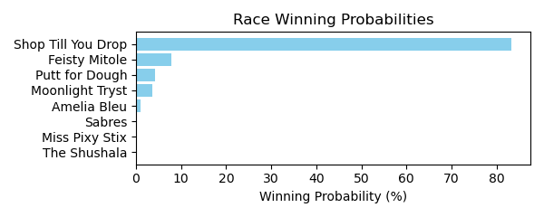

Figure: Winning Probability Distribution

NOTE: THIS RACE HAS HORSES THAT ARE MISSING CRITICAL DATA ELEMENTS

# Race: TSA | 2025-02-21 | Race #5 | Track: SANTA ANITA PARK

Track: SANTA ANITA PARK

|  |  |  |  |  |
| --- | --- | --- | --- | --- |
| Saddle Cloth # | Horse Name | Global Speed | Composite | Win Prob (%) |
| ['', 1, ''] | Atia * | 104.3 | -6.26 | 0.01 |
| ['', 2, ''] | Big Leap | 104.3 | -2.06 | 0.41 |
| ['', 3, ''] | Authentic Grace | 104.3 | -6.26 | 0.01 |
| ['', 4, ''] | Delightful Laura * | 104.3 | 0.14 | 2.37 |
| ['', 5, ''] | Lee's Baby Girl | 104.3 | 4.10 | 56.42 |
| ['', 6, ''] | Allihies * | 104.3 | -9.57 | 0.00 |
| ['', 7, ''] | Giggle Giggle | 104.3 | -6.94 | 0.01 |
| ['', 8, ''] | TAVOLARA * | 104.3 | 3.43 | 33.06 |
| ['', 9, ''] | Cause I'm Perfect | 104.3 | -8.49 | 0.00 |
| ['', 10, ''] | Aggro | 104.3 | 1.61 | 7.70 |

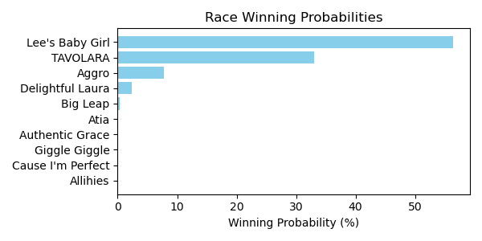

Figure: Winning Probability Distribution

NOTE: THIS RACE HAS HORSES THAT ARE MISSING CRITICAL DATA ELEMENTS

# Race: TSA | 2025-02-21 | Race #6 | Track: SANTA ANITA PARK

Track: SANTA ANITA PARK

|  |  |  |  |  |
| --- | --- | --- | --- | --- |
| Saddle Cloth # | Horse Name | Global Speed | Composite | Win Prob (%) |
| ['', 1, ''] | Barely Funtional | 104.5 | 7.11 | 16.38 |
| ['', 2, ''] | Malibu Rocks | 104.5 | 6.72 | 11.93 |
| ['', 3, ''] | Manitowish | 104.5 | -1.17 | 0.02 |
| ['', 4, ''] | Cowboy Mike | 104.5 | 8.96 | 71.66 |
| ['', 5, ''] | Il Bellator | 104.5 | -6.26 | 0.00 |

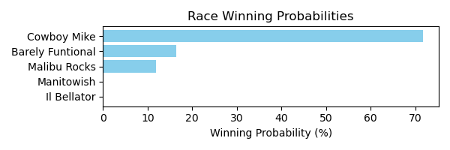

Figure: Winning Probability Distribution

NOTE: THIS RACE HAS HORSES THAT ARE MISSING CRITICAL DATA ELEMENTS

# Race: TSA | 2025-02-21 | Race #7 | Track: SANTA ANITA PARK

Track: SANTA ANITA PARK

|  |  |  |  |  |
| --- | --- | --- | --- | --- |
| Saddle Cloth # | Horse Name | Global Speed | Composite | Win Prob (%) |
| ['', 1, ''] | Take Another Card | 104.2 | 5.28 | 1.61 |
| ['', 2, ''] | Resolve | 104.2 | 8.21 | 16.84 |
| ['', 3, ''] | Tigerish | 104.2 | 4.31 | 0.74 |
| ['', 4, ''] | Tequilaandtherapy | 104.2 | 5.72 | 2.30 |
| ['', 5, ''] | Canto Della Terra (IRE) * | 104.2 | 9.81 | 60.48 |
| ['', 6, ''] | Amorita | 104.2 | 6.04 | 2.97 |
| ['', 7, ''] | Firenze Flavor | 104.2 | 8.07 | 15.06 |
| ['', 8, ''] | Polythene Pam | 104.2 | -6.27 | 0.00 |

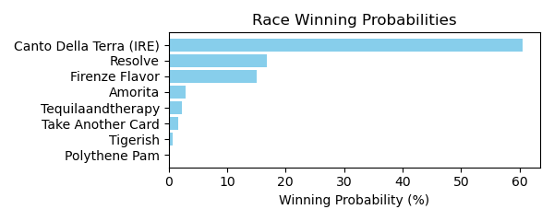

Figure: Winning Probability Distribution

NOTE: THIS RACE HAS HORSES THAT ARE MISSING CRITICAL DATA ELEMENTS

# Race: TSA | 2025-02-21 | Race #8 | Track: SANTA ANITA PARK

Track: SANTA ANITA PARK

|  |  |  |  |  |
| --- | --- | --- | --- | --- |
| Saddle Cloth # | Horse Name | Global Speed | Composite | Win Prob (%) |
| ['', 1, ''] | Surf Song | 76.4 | 4.29 | 2.88 |
| ['', 2, ''] | Cooey * | 76.4 | 6.63 | 18.69 |
| ['', 3, ''] | VELOCITY * | 76.4 | 5.80 | 9.65 |
| ['', 4, ''] | PRISTINE * | 76.4 | 6.08 | 12.02 |
| ['', 5, ''] | PUTONAHAPPYFACE * | 76.4 | 6.07 | 11.92 |
| ['', 6, ''] | BRILLIANTLY * | 76.4 | 5.73 | 9.11 |
| ['', 7, ''] | FORMULA ROSSA * | 76.4 | 6.01 | 11.41 |
| ['', 8, ''] | DON'T TEMPT HER * | 76.4 | 5.95 | 10.88 |
| ['', 9, ''] | NIKOLINA * | 76.4 | 6.22 | 13.44 |

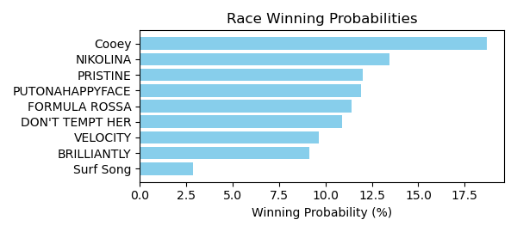

Figure: Winning Probability Distribution

NOTE: THIS RACE HAS HORSES THAT ARE MISSING CRITICAL DATA ELEMENTS

# Race: TSA | 2025-02-21 | Race #9 | Track: SANTA ANITA PARK

Track: SANTA ANITA PARK

|  |  |  |  |  |
| --- | --- | --- | --- | --- |
| Saddle Cloth # | Horse Name | Global Speed | Composite | Win Prob (%) |
| ['', 1, ''] | Unwritten Code | 76.5 | 7.34 | 21.25 |
| ['', 2, ''] | Cheeky Gal | 76.5 | -4.10 | 0.00 |
| ['', 3, ''] | Dancing Soul | 76.5 | -0.96 | 0.03 |
| ['', 4, ''] | Tiergarten | 76.5 | 4.73 | 2.63 |
| ['', 5, ''] | A Real Jewel | 76.5 | -4.58 | 0.00 |
| ['', 6, ''] | Satoshi | 76.5 | -4.82 | 0.00 |
| ['', 7, ''] | Gypsy Lynn | 76.5 | -5.48 | 0.00 |
| ['', 8, ''] | Dr. Ray D. | 76.5 | 8.92 | 75.12 |
| ['', 9, ''] | Red Diamond | 76.5 | 3.07 | 0.70 |
| ['', 10, ''] | Katerini | 76.5 | 1.88 | 0.27 |

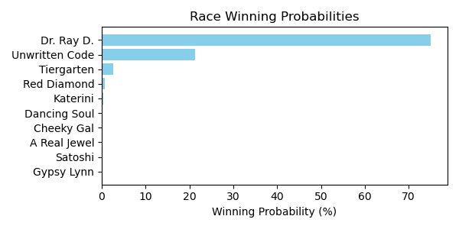

Figure: Winning Probability Distribution

NOTE: THIS RACE HAS HORSES THAT ARE MISSING CRITICAL DATA ELEMENTS

# Race: TSA | 2025-02-22 | Race #1 | Track: SANTA ANITA PARK

Track: SANTA ANITA PARK

|  |  |  |  |  |
| --- | --- | --- | --- | --- |
| Saddle Cloth # | Horse Name | Global Speed | Composite | Win Prob (%) |
| ['', 1, ''] | America's Mark | 82.4 | 8.18 | 0.61 |
| ['', 2, ''] | Chilly Philly | 103.9 | 4.57 | 2.53 |
| ['', 3, ''] | Heras Hope | 76.3 | -0.57 | 0.00 |
| ['', 4, ''] | Thirsty Destiny | 76.3 | 1.53 | 0.00 |
| ['', 5, ''] | Press Your Luck | 76.3 | 6.06 | 0.03 |
| ['', 6, ''] | Sunset Grazen | 103.9 | 1.99 | 0.32 |
| ['', 7, ''] | Lady Mendelssohn | 103.9 | 9.12 | 96.50 |

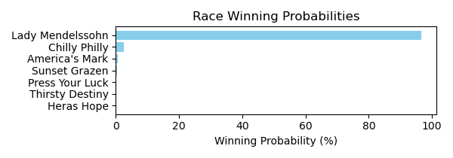

Figure: Winning Probability Distribution

NOTE: THIS RACE HAS HORSES THAT ARE MISSING CRITICAL DATA ELEMENTS

# Race: TSA | 2025-02-22 | Race #2 | Track: SANTA ANITA PARK

Track: SANTA ANITA PARK

|  |  |  |  |  |
| --- | --- | --- | --- | --- |
| Saddle Cloth # | Horse Name | Global Speed | Composite | Win Prob (%) |
| ['', 1, ''] | BRANDON'S GIRL * | 74.0 | 5.40 | 17.96 |
| ['', 2, ''] | Buds N Suds | 76.2 | 5.42 | 28.32 |
| ['', 3, ''] | Kulbit | 70.9 | -7.46 | 0.00 |
| ['', 4, ''] | FREE NOMINATION * | 74.0 | 5.20 | 15.26 |
| ['', 5, ''] | Dixie Allure * | 70.9 | 4.00 | 3.19 |
| ['', 6, ''] | Tropical Rain Day | 82.2 | 2.52 | 9.34 |
| ['', 7, ''] | LADY OF SKY * | 74.0 | 5.15 | 14.68 |
| ['', 8, ''] | Tapatia Leah | 70.9 | 5.58 | 11.26 |

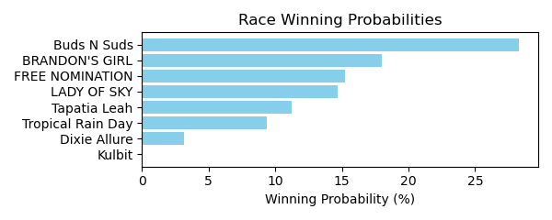

Figure: Winning Probability Distribution

NOTE: THIS RACE HAS HORSES THAT ARE MISSING CRITICAL DATA ELEMENTS

# Race: TSA | 2025-02-22 | Race #3 | Track: SANTA ANITA PARK

Track: SANTA ANITA PARK

|  |  |  |  |  |
| --- | --- | --- | --- | --- |
| Saddle Cloth # | Horse Name | Global Speed | Composite | Win Prob (%) |
| ['', 1, ''] | Queen Maxima | 82.7 | 6.03 | 0.34 |
| ['', 2, ''] | Laulne (FR) | 82.7 | 2.01 | 0.01 |
| ['', 3, ''] | Arctic Breeze | 111.8 | 5.87 | 99.18 |
| ['', 4, ''] | Ma Rae's Girl | 82.7 | 2.23 | 0.02 |
| ['', 5, ''] | Stay and Scam | 82.7 | 5.58 | 0.24 |
| ['', 6, ''] | Miss Roberts (GB) | 82.7 | 5.48 | 0.22 |

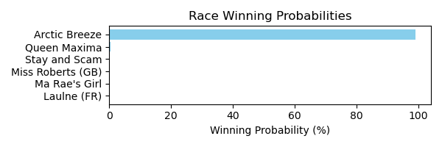

Figure: Winning Probability Distribution

NOTE: THIS RACE HAS HORSES THAT ARE MISSING CRITICAL DATA ELEMENTS

# Race: TSA | 2025-02-22 | Race #4 | Track: SANTA ANITA PARK

Track: SANTA ANITA PARK

|  |  |  |  |  |
| --- | --- | --- | --- | --- |
| Saddle Cloth # | Horse Name | Global Speed | Composite | Win Prob (%) |
| ['', 1, ''] | Aurelian Man | 104.2 | 7.38 | 13.53 |
| ['', 2, ''] | Taishan | 104.2 | 6.91 | 9.27 |
| ['', 3, ''] | Atomic Drop | 104.2 | -0.30 | 0.03 |
| ['', 4, ''] | Impossible Task | 104.2 | 4.16 | 1.03 |
| ['', 5, ''] | Kingmeister | 104.2 | 2.73 | 0.33 |
| ['', 6, ''] | Druidic | 104.2 | 9.53 | 75.81 |
| ['', 7, ''] | Upward Mobility | 76.5 | -6.37 | 0.00 |
| ['', 8, ''] | Letshaveonemore | 82.6 | -5.78 | 0.00 |

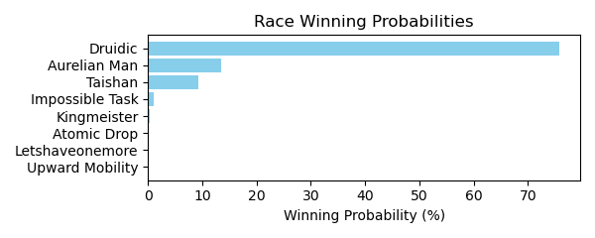

Figure: Winning Probability Distribution

NOTE: THIS RACE HAS HORSES THAT ARE MISSING CRITICAL DATA ELEMENTS

# Race: TSA | 2025-02-22 | Race #5 | Track: SANTA ANITA PARK

Track: SANTA ANITA PARK

|  |  |  |  |  |
| --- | --- | --- | --- | --- |
| Saddle Cloth # | Horse Name | Global Speed | Composite | Win Prob (%) |
| ['', 1, ''] | Speed of Elon * | 104.2 | 3.23 | 2.94 |
| ['', 2, ''] | King of Clubs * | 82.6 | 8.06 | 1.86 |
| ['', 3, ''] | Annan | 76.5 | 8.15 | 0.59 |
| ['', 4, ''] | Going Nowhere | 82.6 | 3.45 | 0.05 |
| ['', 5, ''] | It's My World | 118.4 | -2.89 | 0.37 |
| ['', 6, ''] | Danzing Wild Cat | 104.2 | 5.14 | 13.50 |
| ['', 7, ''] | OM BREW * | 97.5 | 7.13 | 17.52 |
| ['', 8, ''] | Miles Finch | 104.2 | 7.05 | 62.29 |
| ['', 9, ''] | Uncle Evco | 104.2 | -2.55 | 0.03 |
| ['', 10, ''] | Fight Back | 104.2 | 1.67 | 0.84 |

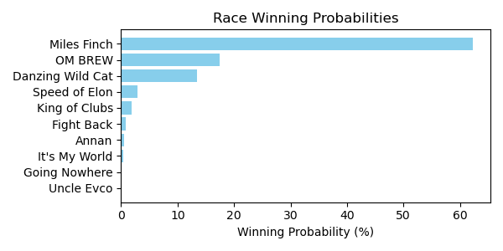

Figure: Winning Probability Distribution

NOTE: THIS RACE HAS HORSES THAT ARE MISSING CRITICAL DATA ELEMENTS

# Race: TSA | 2025-02-22 | Race #6 | Track: SANTA ANITA PARK

Track: SANTA ANITA PARK

|  |  |  |  |  |
| --- | --- | --- | --- | --- |
| Saddle Cloth # | Horse Name | Global Speed | Composite | Win Prob (%) |
| ['', 1, ''] | Wine and Whisky | 76.5 | -7.01 | 0.00 |
| ['', 2, ''] | Enos Slaughter | 104.3 | -6.81 | 0.00 |
| ['', 3, ''] | Happy Does | 104.3 | 6.55 | 15.99 |
| ['', 4, ''] | Coolwind | 104.3 | 1.27 | 0.23 |
| ['', 5, ''] | Rich Gold | 104.3 | 0.77 | 0.16 |
| ['', 6, ''] | J. B. Books | 109.0 | -2.08 | 0.04 |
| ['', 7, ''] | Upstart Yankee | 104.3 | -4.20 | 0.00 |
| ['', 8, ''] | Crown Magic | 104.3 | 7.35 | 30.44 |
| ['', 9, ''] | Quality Cat | 104.3 | -0.47 | 0.06 |
| ['', 10, ''] | Veritas Aequitas | 104.3 | 8.05 | 53.08 |

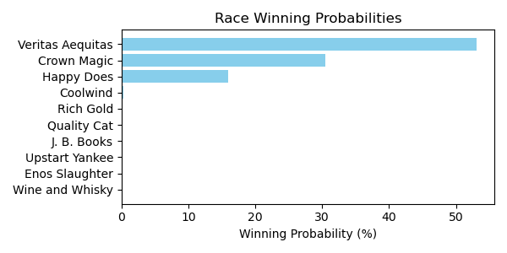

Figure: Winning Probability Distribution

NOTE: THIS RACE HAS HORSES THAT ARE MISSING CRITICAL DATA ELEMENTS

# Race: TSA | 2025-02-22 | Race #7 | Track: SANTA ANITA PARK

Track: SANTA ANITA PARK

|  |  |  |  |  |
| --- | --- | --- | --- | --- |
| Saddle Cloth # | Horse Name | Global Speed | Composite | Win Prob (%) |
| ['', 1, ''] | Sasafran | 104.0 | 5.82 | 12.97 |
| ['', 2, ''] | Guiltyofhavingfun | 104.0 | 6.07 | 15.80 |
| ['', 3, ''] | Renatus | 104.0 | -4.21 | 0.00 |
| ['', 4, ''] | Hello Kid O Kid O | 104.0 | 6.44 | 21.23 |
| ['', 5, ''] | Z's Wardrobe | 104.0 | -2.63 | 0.02 |
| ['', 6, ''] | Maga Kai | 104.0 | -0.24 | 0.10 |
| ['', 7, ''] | SUNTORY TIME * | 99.9 | 7.73 | 26.31 |
| ['', 8, ''] | Odies Memory Lane | 82.5 | 5.85 | 0.18 |
| ['', 9, ''] | Orange Thunder | 104.0 | 6.55 | 23.29 |
| ['', 10, ''] | Big Whoosh | 104.0 | -0.53 | 0.08 |
| ['', 12, ''] | Om N Joy | 82.5 | 2.00 | 0.01 |
| ['', 13, ''] | Mrazek's Old Dream | 104.0 | -5.38 | 0.00 |

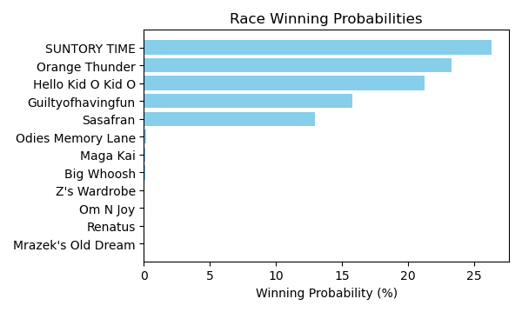

Figure: Winning Probability Distribution

NOTE: THIS RACE HAS HORSES THAT ARE MISSING CRITICAL DATA ELEMENTS

# Race: TSA | 2025-02-22 | Race #8 | Track: SANTA ANITA PARK

Track: SANTA ANITA PARK

|  |  |  |  |  |
| --- | --- | --- | --- | --- |
| Saddle Cloth # | Horse Name | Global Speed | Composite | Win Prob (%) |
| ['', 1, ''] | KID DYNASTY * | 82.6 | 4.36 | 14.15 |
| ['', 2, ''] | KING STEPHEN * | 82.6 | 4.16 | 12.04 |
| ['', 3, ''] | PRAYER * | 82.6 | 4.26 | 13.09 |
| ['', 4, ''] | ROADHOUSE RUMBLE * | 82.6 | 4.15 | 11.95 |
| ['', 5, ''] | CHARLIE FOXTROT * | 82.6 | 4.29 | 13.39 |
| ['', 6, ''] | Lead Pipe Joe * | 82.6 | -5.25 | 0.01 |
| ['', 7, ''] | VOLDEMORT * | 82.6 | 4.05 | 11.01 |
| ['', 8, ''] | TIZ SECURE * | 82.6 | 3.88 | 9.60 |
| ['', 9, ''] | FIVE STAR LOVE * | 82.6 | 4.41 | 14.76 |

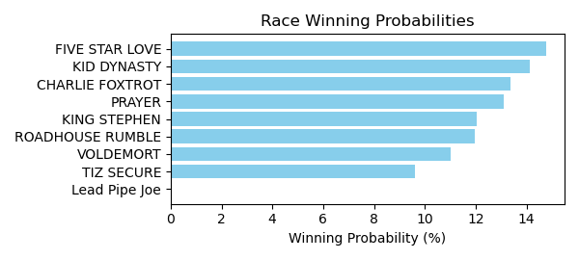

Figure: Winning Probability Distribution

NOTE: THIS RACE HAS HORSES THAT ARE MISSING CRITICAL DATA ELEMENTS

# Race: TSA | 2025-02-22 | Race #9 | Track: SANTA ANITA PARK

Track: SANTA ANITA PARK

|  |  |  |  |  |
| --- | --- | --- | --- | --- |
| Saddle Cloth # | Horse Name | Global Speed | Composite | Win Prob (%) |
| ['', 1, ''] | King Apollo | 76.7 | 7.99 | 0.47 |
| ['', 2, ''] | Ghostly Act | 82.8 | 9.66 | 6.09 |
| ['', 3, ''] | Western Avenue | 76.7 | 3.57 | 0.01 |
| ['', 4, ''] | Money Makes Money | 82.8 | 8.98 | 3.53 |
| ['', 5, ''] | Guy Named Joe | 118.7 | -2.78 | 0.38 |
| ['', 6, ''] | Dancing Rinca | 76.7 | 9.27 | 1.30 |
| ['', 7, ''] | Santo Dios (ARG) | 76.7 | 1.71 | 0.00 |
| ['', 8, ''] | dh-Irish Royalty | 76.7 | 6.72 | 0.17 |
| ['', 9, ''] | News At Ten (GB) | 82.8 | 0.24 | 0.00 |
| ['', 10, ''] | Geezer | 82.8 | 6.99 | 0.72 |
| ['', 11, ''] | Tom Horn | 104.5 | 6.01 | 25.19 |
| ['', 12, ''] | Father Delay | 82.8 | 3.91 | 0.06 |
| ['', 13, ''] | Noble Reflection | 76.7 | 7.34 | 0.28 |
| ['', 14, ''] | Moody Jim (IRE) | 104.5 | 7.14 | 61.79 |

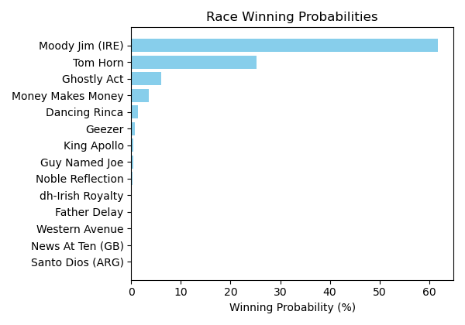

Figure: Winning Probability Distribution

NOTE: THIS RACE HAS HORSES THAT ARE MISSING CRITICAL DATA ELEMENTS

# Race: TSA | 2025-02-22 | Race #10 | Track: SANTA ANITA PARK

Track: SANTA ANITA PARK

|  |  |  |  |  |
| --- | --- | --- | --- | --- |
| Saddle Cloth # | Horse Name | Global Speed | Composite | Win Prob (%) |
| ['', 1, ''] | Star of The Night (IRE) | 118.5 | -1.03 | 0.02 |
| ['', 2, ''] | Eternal Reign (IRE) * | 104.3 | 10.03 | 8.96 |
| ['', 3, ''] | Cornelia Fort | 82.7 | 1.47 | 0.00 |
| ['', 4, ''] | NEEDLEPOINT (IRE) * | 82.7 | 8.50 | 0.03 |
| ['', 5, ''] | dh-Everything Bugs Me | 118.5 | 0.19 | 0.06 |
| ['', 6, ''] | Tirupati | 104.3 | 5.59 | 0.26 |
| ['', 7, ''] | Quick Kate | 76.6 | -5.80 | 0.00 |
| ['', 8, ''] | Sophisticate | 118.5 | 9.27 | 82.91 |
| ['', 9, ''] | Prancingthruparis | 76.6 | 7.19 | 0.00 |
| ['', 10, ''] | Lady Monclaire | 104.3 | 5.10 | 0.17 |
| ['', 11, ''] | Magic Light | 104.3 | -3.12 | 0.00 |
| ['', 12, ''] | Kentucky Gal (IRE) * | 118.5 | 6.28 | 7.58 |
| ['', 13, ''] | Over Attracted | 82.7 | 0.75 | 0.00 |
| ['', 14, ''] | Shuangxi (IRE) | 82.7 | 0.61 | 0.00 |

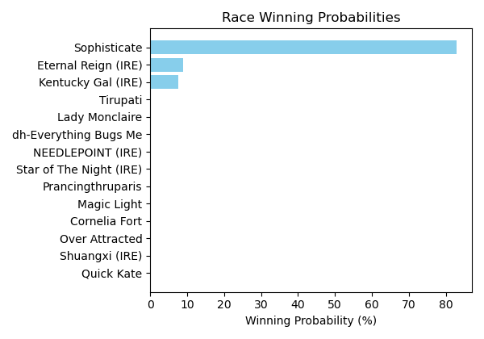

Figure: Winning Probability Distribution

NOTE: THIS RACE HAS HORSES THAT ARE MISSING CRITICAL DATA ELEMENTS

# Race: SUN | 2025-02-21 | Race #1 | Track: SUNLAND PARK

Track: SUNLAND PARK

|  |  |  |  |  |
| --- | --- | --- | --- | --- |
| Saddle Cloth # | Horse Name | Global Speed | Composite | Win Prob (%) |
| ['', 1, ''] | FERRARI MONEY * | 70.9 | 4.20 | 3.44 |
| ['', 2, ''] | Native Charmer | 70.9 | 7.24 | 39.22 |
| ['', 3, ''] | LADYPACKSAPISTOL * | 70.9 | 4.27 | 3.65 |
| ['', 4, ''] | Alexandra Elaine * | 70.9 | 7.54 | 49.67 |
| ['', 5, ''] | Klimt's Girl * | 70.9 | -7.61 | 0.00 |
| ['', 6, ''] | Toni the Grrreat * | 70.9 | -8.16 | 0.00 |
| ['', 7, ''] | PINK MOSCATO * | 70.9 | 4.39 | 4.02 |

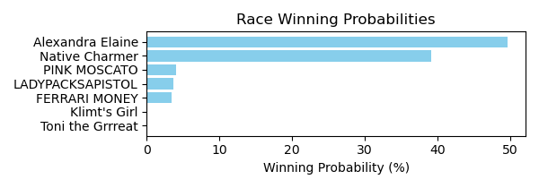

Figure: Winning Probability Distribution

NOTE: THIS RACE HAS HORSES THAT ARE MISSING CRITICAL DATA ELEMENTS

# Race: SUN | 2025-02-21 | Race #2 | Track: SUNLAND PARK

Track: SUNLAND PARK

|  |  |  |  |  |
| --- | --- | --- | --- | --- |
| Saddle Cloth # | Horse Name | Global Speed | Composite | Win Prob (%) |
| ['', 1, ''] | Piney Bluff * | 82.4 | -2.21 | 0.81 |
| ['', 2, ''] | Midnight Split * | 82.4 | 1.85 | 20.73 |
| ['', 3, ''] | Abetemarco * | 82.4 | 2.00 | 23.43 |
| ['', 4, ''] | Storey's Fury * | 82.4 | -4.58 | 0.12 |
| ['', 5, ''] | Lewis Bere (FR) * | 82.4 | -8.70 | 0.00 |
| ['', 6, ''] | Attila the Star * | 82.4 | 2.20 | 27.55 |
| ['', 7, ''] | Pass It Around * | 82.4 | -8.28 | 0.01 |
| ['', 8, ''] | Race for Dough | 82.4 | 2.19 | 27.35 |

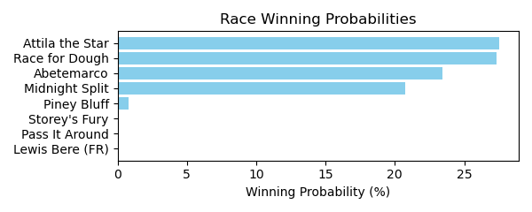

Figure: Winning Probability Distribution

NOTE: THIS RACE HAS HORSES THAT ARE MISSING CRITICAL DATA ELEMENTS

# Race: SUN | 2025-02-21 | Race #3 | Track: SUNLAND PARK

Track: SUNLAND PARK

|  |  |  |  |  |
| --- | --- | --- | --- | --- |
| Saddle Cloth # | Horse Name | Global Speed | Composite | Win Prob (%) |
| ['', 1, ''] | My Yellowstone * | 76.0 | -9.04 | 0.00 |
| ['', 2, ''] | Kiamanasjoyousday * | 76.0 | -6.36 | 0.00 |
| ['', 3, ''] | LEGION HEIRESS * | 76.0 | 3.71 | 3.38 |
| ['', 4, ''] | Mo Money Time * | 76.0 | 7.90 | 96.36 |
| ['', 5, ''] | Aunt Bennie * | 76.0 | -5.27 | 0.00 |
| ['', 6, ''] | Sir Liams Love * | 76.0 | -8.56 | 0.00 |
| ['', 7, ''] | Back Pay * | 76.0 | -6.32 | 0.00 |
| ['', 8, ''] | Attila Style * | 76.0 | 0.51 | 0.26 |

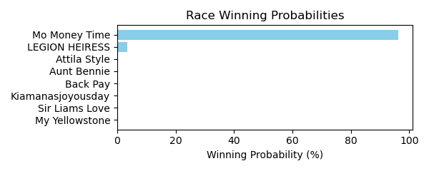

Figure: Winning Probability Distribution

NOTE: THIS RACE HAS HORSES THAT ARE MISSING CRITICAL DATA ELEMENTS

# Race: SUN | 2025-02-21 | Race #4 | Track: SUNLAND PARK

Track: SUNLAND PARK

|  |  |  |  |  |
| --- | --- | --- | --- | --- |
| Saddle Cloth # | Horse Name | Global Speed | Composite | Win Prob (%) |
| ['', 1, ''] | Beach Storm * | 103.7 | -2.35 | 0.03 |
| ['', 2, ''] | Spend Again * | 103.7 | -7.01 | 0.00 |
| ['', 3, ''] | Desert Punk * | 103.7 | -1.45 | 0.07 |
| ['', 4, ''] | Angela's Angel * | 103.7 | -2.41 | 0.03 |
| ['', 5, ''] | Copper State * | 103.7 | -3.55 | 0.01 |
| ['', 6, ''] | Midevil Mayhem * | 103.7 | 7.64 | 99.83 |
| ['', 7, ''] | Smoke Stack * | 103.7 | -3.21 | 0.02 |

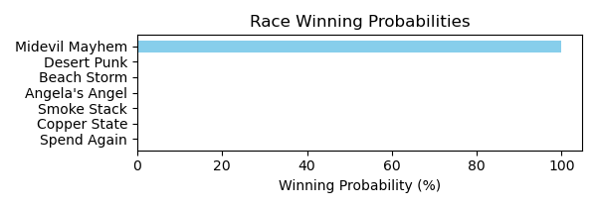

Figure: Winning Probability Distribution

NOTE: THIS RACE HAS HORSES THAT ARE MISSING CRITICAL DATA ELEMENTS

# Race: SUN | 2025-02-21 | Race #5 | Track: SUNLAND PARK

Track: SUNLAND PARK

|  |  |  |  |  |
| --- | --- | --- | --- | --- |
| Saddle Cloth # | Horse Name | Global Speed | Composite | Win Prob (%) |
| ['', 1, ''] | TRAFFICSTORM * | 82.1 | 5.74 | 11.74 |
| ['', 2, ''] | American Ranger Bb * | 82.1 | 7.23 | 38.70 |
| ['', 3, ''] | Bye Bye Russ * | 82.1 | 5.68 | 11.18 |
| ['', 4, ''] | American Knight * | 82.1 | -2.06 | 0.02 |
| ['', 5, ''] | Call Me Hollywood * | 82.1 | -7.25 | 0.00 |
| ['', 6, ''] | Shiny Shores * | 82.1 | -1.18 | 0.05 |
| ['', 7, ''] | Nobody's Perfect * | 82.1 | 6.75 | 26.38 |
| ['', 8, ''] | AMERICAN STORM * | 82.1 | 5.76 | 11.93 |

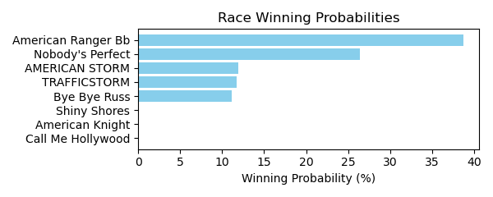

Figure: Winning Probability Distribution

NOTE: THIS RACE HAS HORSES THAT ARE MISSING CRITICAL DATA ELEMENTS

# Race: SUN | 2025-02-21 | Race #6 | Track: SUNLAND PARK

Track: SUNLAND PARK

|  |  |  |  |  |
| --- | --- | --- | --- | --- |
| Saddle Cloth # | Horse Name | Global Speed | Composite | Win Prob (%) |
| ['', 1, ''] | Grey Storm * | 104.1 | -1.24 | 0.28 |
| ['', 2, ''] | Loco Luna * | 104.1 | -5.71 | 0.01 |
| ['', 3, ''] | Grazen Boy * | 104.1 | 3.42 | 11.80 |
| ['', 4, ''] | Capital Joke * | 104.1 | -1.86 | 0.17 |
| ['', 5, ''] | Projection * | 104.1 | 3.73 | 15.11 |
| ['', 6, ''] | Zia Zapper * | 104.1 | 0.25 | 0.93 |
| ['', 7, ''] | Mastering | 104.1 | 5.68 | 71.70 |

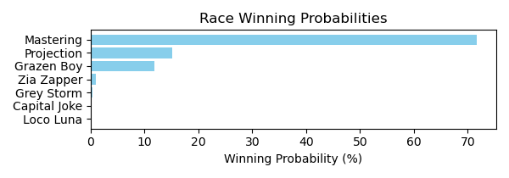

Figure: Winning Probability Distribution

NOTE: THIS RACE HAS HORSES THAT ARE MISSING CRITICAL DATA ELEMENTS

# Race: SUN | 2025-02-21 | Race #7 | Track: SUNLAND PARK

Track: SUNLAND PARK

|  |  |  |  |  |
| --- | --- | --- | --- | --- |
| Saddle Cloth # | Horse Name | Global Speed | Composite | Win Prob (%) |
| ['', 1, ''] | Sir Ruckus * | 66.5 | -4.89 | 0.02 |
| ['', 2, ''] | Auspice * | 66.5 | -9.14 | 0.00 |
| ['', 3, ''] | Runaway Goddess * | 66.5 | -8.65 | 0.00 |
| ['', 4, ''] | Finally an Eddie * | 66.5 | -7.95 | 0.00 |
| ['', 5, ''] | Jamie Can't Dance * | 66.5 | -9.85 | 0.00 |
| ['', 6, ''] | Ronchetti * | 66.5 | 1.08 | 1.95 |
| ['', 7, ''] | Moon Shine Time * | 66.5 | 2.74 | 7.33 |
| ['', 8, ''] | Latigo Ellis * | 66.5 | 5.88 | 90.70 |

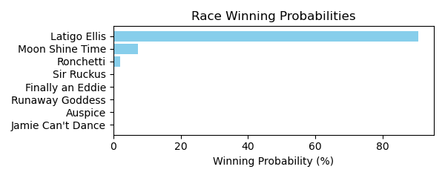

Figure: Winning Probability Distribution

NOTE: THIS RACE HAS HORSES THAT ARE MISSING CRITICAL DATA ELEMENTS

# Race: SUN | 2025-02-21 | Race #8 | Track: SUNLAND PARK

Track: SUNLAND PARK

|  |  |  |  |  |
| --- | --- | --- | --- | --- |
| Saddle Cloth # | Horse Name | Global Speed | Composite | Win Prob (%) |
| ['', 1, ''] | Desertrose Oftexas * | 82.4 | -3.54 | 0.01 |
| ['', 2, ''] | Turn On Arch * | 82.4 | 5.09 | 11.62 |
| ['', 3, ''] | Shelly d'Oro * | 82.4 | -2.65 | 0.02 |
| ['', 4, ''] | Awesome Walker * | 82.4 | -0.74 | 0.11 |
| ['', 5, ''] | Quite Lovely * | 82.4 | 7.42 | 75.02 |
| ['', 6, ''] | Maddie Poppe * | 82.4 | -5.58 | 0.00 |
| ['', 7, ''] | Time Is Precious * | 82.4 | 4.05 | 5.06 |
| ['', 8, ''] | Shell Game * | 82.4 | 4.65 | 8.15 |

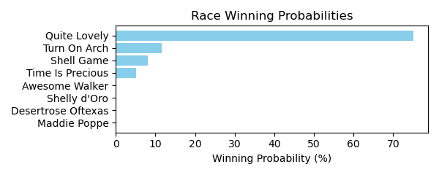

Figure: Winning Probability Distribution

NOTE: THIS RACE HAS HORSES THAT ARE MISSING CRITICAL DATA ELEMENTS

# Race: SUN | 2025-02-21 | Race #9 | Track: SUNLAND PARK

Track: SUNLAND PARK

|  |  |  |  |  |
| --- | --- | --- | --- | --- |
| Saddle Cloth # | Horse Name | Global Speed | Composite | Win Prob (%) |
| ['', 1, ''] | Bella Baby | 76.3 | -4.28 | 0.01 |
| ['', 2, ''] | Blue Cowgirl * | 76.3 | -7.01 | 0.00 |
| ['', 3, ''] | Rose Girl * | 76.3 | 6.31 | 70.14 |
| ['', 4, ''] | Run Like Kate * | 76.3 | -0.49 | 0.30 |
| ['', 5, ''] | Anna B * | 76.3 | 5.18 | 28.43 |
| ['', 6, ''] | Allergic to Logic * | 76.3 | -6.56 | 0.00 |
| ['', 7, ''] | Boston Princess | 76.3 | 1.05 | 1.05 |
| ['', 8, ''] | Lucky Vegas * | 76.3 | -2.93 | 0.04 |
| ['', 9, ''] | Birdie Curdy * | 76.3 | -4.30 | 0.01 |

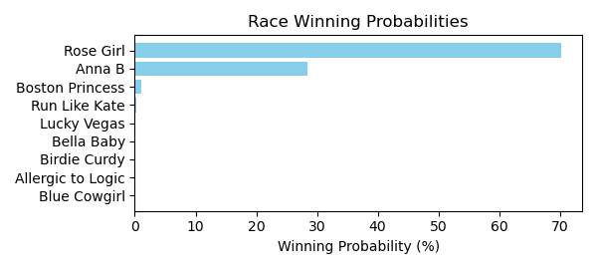

Figure: Winning Probability Distribution

NOTE: THIS RACE HAS HORSES THAT ARE MISSING CRITICAL DATA ELEMENTS

# Race: TAM | 2025-02-21 | Race #1 | Track: TAMPA BAY DOWNS

Track: TAMPA BAY DOWNS

|  |  |  |  |  |
| --- | --- | --- | --- | --- |
| Saddle Cloth # | Horse Name | Global Speed | Composite | Win Prob (%) |
| ['', 1, ''] | Once an Eagle | 103.8 | 0.91 | 0.32 |
| ['', 2, ''] | Pola of Trouble | 106.4 | 3.96 | 6.29 |
| ['', 3, ''] | Humor Sense | 106.4 | 5.11 | 15.80 |
| ['', 4, ''] | One Violent Affair | 111.1 | 5.91 | 76.02 |
| ['', 5, ''] | Spring Spinning | 103.8 | -9.24 | 0.00 |
| ['', 6, ''] | Moon Rose | 89.0 | -1.21 | 0.00 |
| ['', 7, ''] | Naa Dudette | 103.8 | 2.90 | 1.57 |

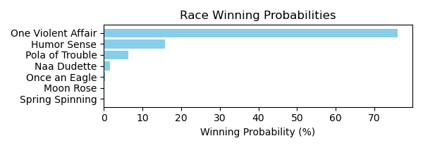

Figure: Winning Probability Distribution

NOTE: THIS RACE HAS HORSES THAT ARE MISSING CRITICAL DATA ELEMENTS

# Race: TAM | 2025-02-21 | Race #2 | Track: TAMPA BAY DOWNS

Track: TAMPA BAY DOWNS

|  |  |  |  |  |
| --- | --- | --- | --- | --- |
| Saddle Cloth # | Horse Name | Global Speed | Composite | Win Prob (%) |
| ['', 1, ''] | Rusty Pistol | 76.2 | 1.48 | 0.06 |
| ['', 2, ''] | Sharpazano | 66.5 | 0.19 | 0.00 |
| ['', 3, ''] | Lao Way | 103.7 | -9.00 | 0.00 |
| ['', 4, ''] | Stanley Cat | 76.2 | 7.39 | 6.70 |
| ['', 5, ''] | We Got This | 103.7 | -8.95 | 0.00 |
| ['', 6, ''] | Vigano | 103.7 | 3.72 | 86.63 |
| ['', 7, ''] | This Time Yes | 103.7 | -8.73 | 0.00 |
| ['', 8, ''] | SECRET EMPIRE * | 89.0 | 4.18 | 6.59 |

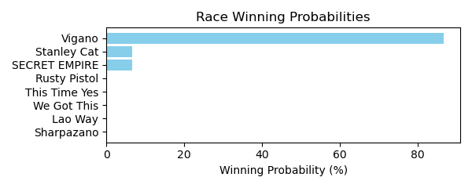

Figure: Winning Probability Distribution

NOTE: THIS RACE HAS HORSES THAT ARE MISSING CRITICAL DATA ELEMENTS

# Race: TAM | 2025-02-21 | Race #3 | Track: TAMPA BAY DOWNS

Track: TAMPA BAY DOWNS

|  |  |  |  |  |
| --- | --- | --- | --- | --- |
| Saddle Cloth # | Horse Name | Global Speed | Composite | Win Prob (%) |
| ['', 1, ''] | Kenric | 82.2 | -6.53 | 0.00 |
| ['', 2, ''] | Firstflashofmoon | 82.2 | -1.15 | 0.00 |
| ['', 3, ''] | Gentleman Caller | 111.0 | -1.11 | 1.22 |
| ['', 4, ''] | In the Weeds | 111.0 | 4.22 | 86.65 |
| ['', 5, ''] | Frankie R. | 106.3 | -10.13 | 0.00 |
| ['', 6, ''] | Asaasy | 103.6 | 2.37 | 4.54 |
| ['', 7, ''] | Trophy Collector | 82.2 | 5.30 | 0.65 |
| ['', 8, ''] | Starship Magellan | 106.3 | -4.64 | 0.03 |
| ['', 9, ''] | Zimbawee | 103.6 | 1.98 | 3.33 |
| ['', 10, ''] | Johnny From Boston | 106.3 | 1.40 | 3.57 |
| ['', 11, ''] | Munger | 76.2 | -8.95 | 0.00 |
| ['', 12, ''] | Red Abarrio | 82.2 | -2.23 | 0.00 |

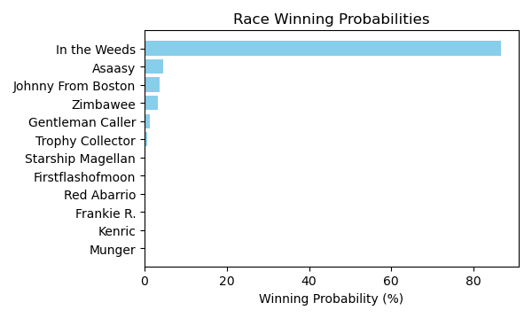

Figure: Winning Probability Distribution

NOTE: THIS RACE HAS HORSES THAT ARE MISSING CRITICAL DATA ELEMENTS

# Race: TAM | 2025-02-21 | Race #4 | Track: TAMPA BAY DOWNS

Track: TAMPA BAY DOWNS

|  |  |  |  |  |
| --- | --- | --- | --- | --- |
| Saddle Cloth # | Horse Name | Global Speed | Composite | Win Prob (%) |
| ['', 1, ''] | Funkenstein | 111.4 | -6.49 | 0.01 |
| ['', 2, ''] | Bryce Canyon | 111.4 | 4.25 | 40.92 |
| ['', 3, ''] | King Ramos | 106.7 | 4.21 | 15.55 |
| ['', 4, ''] | Classic King | 104.0 | -8.44 | 0.00 |
| ['', 5, ''] | Henrythethird | 111.4 | -8.65 | 0.00 |
| ['', 6, ''] | Redisur | 111.4 | -5.03 | 0.02 |
| ['', 7, ''] | Eric the Salesman | 111.4 | -9.59 | 0.00 |
| ['', 8, ''] | Tiz a Prince | 111.4 | -6.19 | 0.01 |
| ['', 9, ''] | Kartano | 111.4 | 0.56 | 2.14 |
| ['', 10, ''] | Mackenzie's Novva | 89.2 | -6.40 | 0.00 |
| ['', 11, ''] | Burning Man | 111.4 | -3.82 | 0.06 |
| ['', 12, ''] | Mr Tito's | 106.7 | 5.42 | 41.16 |
| ['', 13, ''] | He's a Good Dancer | 71.1 | -3.78 | 0.00 |
| ['', 14, ''] | Joe's Had Enough | 111.4 | -3.06 | 0.12 |

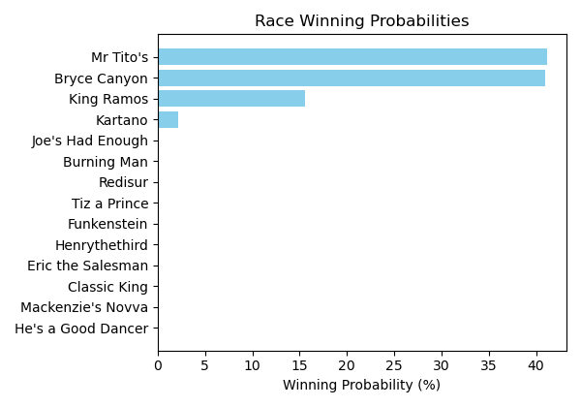

Figure: Winning Probability Distribution

NOTE: THIS RACE HAS HORSES THAT ARE MISSING CRITICAL DATA ELEMENTS

# Race: TAM | 2025-02-21 | Race #5 | Track: TAMPA BAY DOWNS

Track: TAMPA BAY DOWNS

|  |  |  |  |  |
| --- | --- | --- | --- | --- |
| Saddle Cloth # | Horse Name | Global Speed | Composite | Win Prob (%) |
| ['', 1, ''] | Art Nouveau * | 103.7 | 3.97 | 2.34 |
| ['', 2, ''] | COME A WALTZING * | 100.8 | 5.60 | 4.83 |
| ['', 3, ''] | Delayed | 103.7 | 2.69 | 0.84 |
| ['', 4, ''] | Inclusive Justice * | 103.7 | 4.01 | 2.40 |
| ['', 5, ''] | Crafty Collector * | 103.7 | 4.97 | 5.21 |
| ['', 6, ''] | Nouveau * | 106.3 | -7.21 | 0.00 |
| ['', 7, ''] | Dyna Soar | 111.0 | 3.43 | 6.62 |
| ['', 8, ''] | Marty's Gal | 82.2 | -6.16 | 0.00 |
| ['', 9, ''] | Michaela | 111.0 | 6.44 | 73.24 |
| ['', 10, ''] | Miss C Banker | 76.2 | 1.29 | 0.00 |
| ['', 11, ''] | Full Exchange | 103.7 | -0.80 | 0.05 |
| ['', 12, ''] | PARTLY SUNNY * | 100.8 | 5.46 | 4.31 |
| ['', 13, ''] | Sip'n' Speed | 103.7 | -0.45 | 0.07 |
| ['', 14, ''] | Tap Bonnet | 103.7 | -0.16 | 0.09 |

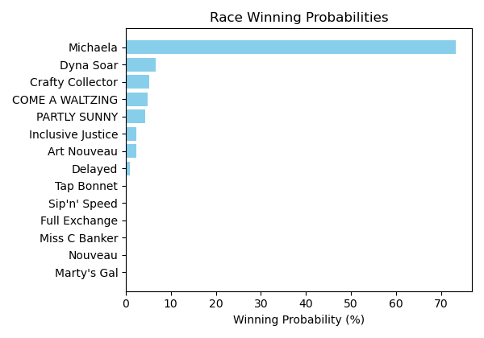

Figure: Winning Probability Distribution

NOTE: THIS RACE HAS HORSES THAT ARE MISSING CRITICAL DATA ELEMENTS

# Race: TAM | 2025-02-21 | Race #6 | Track: TAMPA BAY DOWNS

Track: TAMPA BAY DOWNS

|  |  |  |  |  |
| --- | --- | --- | --- | --- |
| Saddle Cloth # | Horse Name | Global Speed | Composite | Win Prob (%) |
| ['', 1, ''] | Megan Makin Money | 66.5 | -3.35 | 0.00 |
| ['', 2, ''] | Foxy Lady | 76.3 | -8.03 | 0.00 |
| ['', 3, ''] | Delta Charm | 71.0 | -0.67 | 0.00 |
| ['', 4, ''] | Explosive Exchange | 76.3 | 3.75 | 0.21 |
| ['', 5, ''] | Ideal Breeze | 89.1 | 5.07 | 8.00 |
| ['', 6, ''] | Wait a Sec | 89.1 | -6.97 | 0.00 |
| ['', 7, ''] | Ritabook | 89.1 | 3.96 | 3.29 |
| ['', 8, ''] | Sassy Charlee | 82.4 | 7.10 | 10.56 |
| ['', 9, ''] | Moretastic | 89.1 | 7.91 | 77.93 |

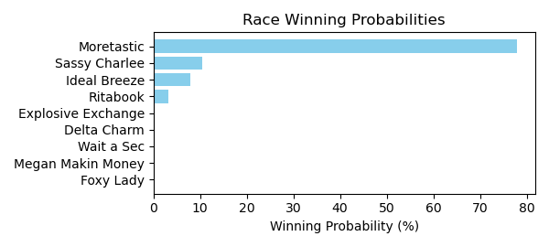

Figure: Winning Probability Distribution

NOTE: THIS RACE HAS HORSES THAT ARE MISSING CRITICAL DATA ELEMENTS

# Race: TAM | 2025-02-21 | Race #7 | Track: TAMPA BAY DOWNS

Track: TAMPA BAY DOWNS

|  |  |  |  |  |
| --- | --- | --- | --- | --- |
| Saddle Cloth # | Horse Name | Global Speed | Composite | Win Prob (%) |
| ['', 1, ''] | Mischievous Han | 111.4 | 0.25 | 0.77 |
| ['', 2, ''] | CONSOLATION PRIZE * | 97.2 | 4.99 | 1.99 |
| ['', 3, ''] | Sacred Fire * | 82.5 | -7.63 | 0.00 |
| ['', 4, ''] | No Merlot | 104.0 | -4.33 | 0.00 |
| ['', 5, ''] | BLISTERING * | 62.8 | 5.73 | 0.00 |
| ['', 6, ''] | Twelve Treasures * | 104.0 | 7.51 | 58.59 |
| ['', 7, ''] | Authentic Honour | 104.0 | -3.38 | 0.01 |
| ['', 8, ''] | Pico Plat | 82.5 | 2.58 | 0.02 |
| ['', 9, ''] | Cafe La Paix (FR) | 111.4 | -0.31 | 0.49 |
| ['', 10, ''] | Mr Miles | 111.4 | -5.88 | 0.01 |
| ['', 11, ''] | The Great Oscar | 104.0 | 6.81 | 33.49 |
| ['', 12, ''] | Peace Cloud * | 104.0 | -2.30 | 0.02 |
| ['', 13, ''] | IRON EDGE * | 97.2 | 4.94 | 1.91 |
| ['', 14, ''] | PISTOL HIP SAM * | 97.2 | 5.36 | 2.69 |

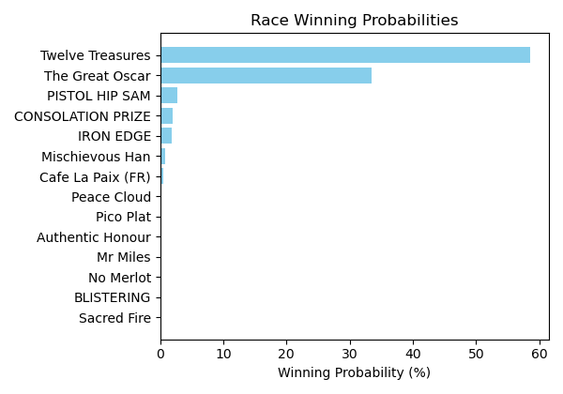

Figure: Winning Probability Distribution

NOTE: THIS RACE HAS HORSES THAT ARE MISSING CRITICAL DATA ELEMENTS

# Race: TAM | 2025-02-21 | Race #8 | Track: TAMPA BAY DOWNS

Track: TAMPA BAY DOWNS

|  |  |  |  |  |
| --- | --- | --- | --- | --- |
| Saddle Cloth # | Horse Name | Global Speed | Composite | Win Prob (%) |
| ['', 1, ''] | Likebelivingnmagic | 89.2 | 5.46 | 0.80 |
| ['', 2, ''] | Chasentheone | 111.4 | 5.93 | 97.71 |
| ['', 3, ''] | Defiant Malice | 76.4 | -7.10 | 0.00 |
| ['', 4, ''] | Paralegal | 82.5 | -0.94 | 0.00 |
| ['', 5, ''] | Maptitude | 76.4 | 4.31 | 0.02 |
| ['', 6, ''] | Handsome Playboy | 89.2 | -0.85 | 0.01 |
| ['', 7, ''] | Bahamian Native | 104.0 | 1.31 | 0.56 |
| ['', 8, ''] | Smart Joker | 76.4 | 8.04 | 0.48 |
| ['', 9, ''] | Road Minister | 76.4 | -3.07 | 0.00 |
| ['', 10, ''] | Storm's Reflection | 104.0 | -6.06 | 0.00 |
| ['', 11, ''] | Jabran | 71.1 | 1.88 | 0.00 |
| ['', 12, ''] | Mr Scatter | 108.8 | -0.28 | 0.41 |

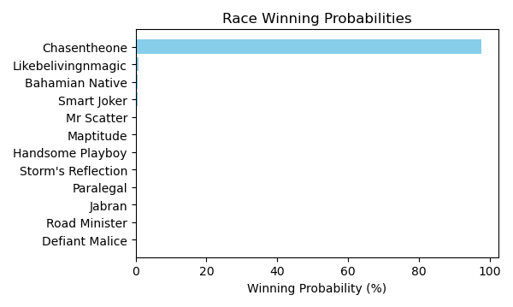

Figure: Winning Probability Distribution

NOTE: THIS RACE HAS HORSES THAT ARE MISSING CRITICAL DATA ELEMENTS

# Race: TAM | 2025-02-21 | Race #9 | Track: TAMPA BAY DOWNS

Track: TAMPA BAY DOWNS

|  |  |  |  |  |
| --- | --- | --- | --- | --- |
| Saddle Cloth # | Horse Name | Global Speed | Composite | Win Prob (%) |
| ['', 1, ''] | Tendresse * | 124.3 | -7.34 | 0.01 |
| ['', 2, ''] | Enchant | 104.1 | 3.28 | 1.21 |
| ['', 3, ''] | Don't Touch Me (IRE) | 76.4 | -8.75 | 0.00 |
| ['', 4, ''] | Mizoula (IRE) | 135.1 | -2.01 | 8.60 |
| ['', 5, ''] | Autumn's Turn | 111.5 | -6.17 | 0.00 |
| ['', 6, ''] | Amata | 89.3 | -7.78 | 0.00 |
| ['', 7, ''] | Hidden Presence | 124.3 | 2.79 | 46.15 |
| ['', 8, ''] | Ocean Mermaid (GB) | 89.3 | 3.73 | 0.09 |
| ['', 9, ''] | Zeliha | 104.1 | 5.04 | 4.95 |
| ['', 10, ''] | Strike Up * | 104.1 | -3.42 | 0.01 |
| ['', 11, ''] | COUNTERINTELIGENCE (GB) * | 111.5 | 4.72 | 16.70 |
| ['', 12, ''] | This Country | 135.1 | -0.82 | 22.27 |

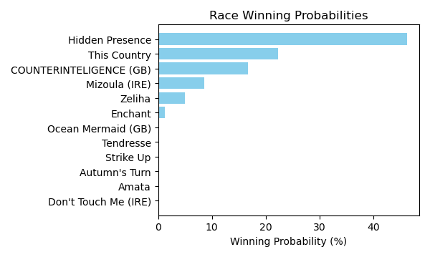

Figure: Winning Probability Distribution

NOTE: THIS RACE HAS HORSES THAT ARE MISSING CRITICAL DATA ELEMENTS

# Race: TUP | 2025-02-22 | Race #2 | Track: TURF PARADISE

Track: TURF PARADISE

|  |  |  |  |  |
| --- | --- | --- | --- | --- |
| Saddle Cloth # | Horse Name | Global Speed | Composite | Win Prob (%) |
| ['', 1, ''] | Stormcatsong * | 76.6 | -6.85 | 0.00 |
| ['', 2, ''] | Caution Cardinal * | 76.6 | 1.13 | 0.08 |
| ['', 3, ''] | Pop d'Oro | 76.6 | 7.92 | 19.15 |
| ['', 4, ''] | U Can Do U * | 76.6 | 1.78 | 0.14 |
| ['', 5, ''] | Laws of Man * | 76.6 | 9.72 | 80.62 |

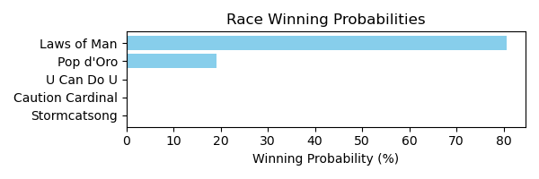

Figure: Winning Probability Distribution

NOTE: THIS RACE HAS HORSES THAT ARE MISSING CRITICAL DATA ELEMENTS

# Race: TUP | 2025-02-22 | Race #3 | Track: TURF PARADISE

Track: TURF PARADISE

|  |  |  |  |  |
| --- | --- | --- | --- | --- |
| Saddle Cloth # | Horse Name | Global Speed | Composite | Win Prob (%) |
| ['', 1, ''] | Now and Zen * | 76.4 | 7.41 | 79.63 |
| ['', 2, ''] | Who Is Pavel * | 76.4 | -3.00 | 0.02 |
| ['', 3, ''] | Knightline * | 76.4 | -9.64 | 0.00 |
| ['', 4, ''] | J C's a Legend * | 76.4 | 5.64 | 19.35 |
| ['', 5, ''] | Further Evidence * | 76.4 | 1.94 | 1.00 |
| ['', 6, ''] | Thirsty Friend | 76.4 | -9.91 | 0.00 |

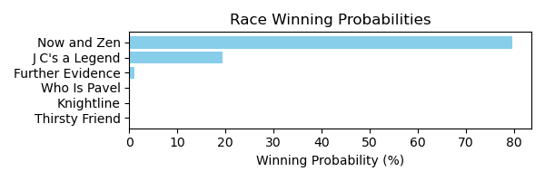

Figure: Winning Probability Distribution

NOTE: THIS RACE HAS HORSES THAT ARE MISSING CRITICAL DATA ELEMENTS

# Race: TUP | 2025-02-22 | Race #4 | Track: TURF PARADISE

Track: TURF PARADISE

|  |  |  |  |  |
| --- | --- | --- | --- | --- |
| Saddle Cloth # | Horse Name | Global Speed | Composite | Win Prob (%) |
| ['', 1, ''] | Canada Candy * | 103.9 | 2.95 | 0.17 |
| ['', 2, ''] | If You Want It | 103.9 | 10.86 | 92.76 |
| ['', 3, ''] | Can'thelpfallin (IRE) * | 103.9 | 1.55 | 0.05 |
| ['', 4, ''] | Aloha Kitten | 103.9 | 6.21 | 2.24 |
| ['', 5, ''] | Lock It Down | 103.9 | -1.85 | 0.00 |
| ['', 6, ''] | Gypsy Wife | 103.9 | 6.72 | 3.38 |
| ['', 7, ''] | Willing to Burn * | 103.9 | 5.62 | 1.40 |

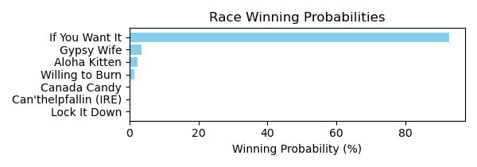

Figure: Winning Probability Distribution

NOTE: THIS RACE HAS HORSES THAT ARE MISSING CRITICAL DATA ELEMENTS

# Race: TUP | 2025-02-22 | Race #5 | Track: TURF PARADISE

Track: TURF PARADISE

|  |  |  |  |  |
| --- | --- | --- | --- | --- |
| Saddle Cloth # | Horse Name | Global Speed | Composite | Win Prob (%) |
| ['', 1, ''] | Let Me Love You * | 103.9 | -6.61 | 0.03 |
| ['', 2, ''] | Unaudited * | 103.9 | 3.33 | 98.54 |
| ['', 3, ''] | Candy Crusher | 103.9 | -4.18 | 0.24 |
| ['', 4, ''] | Benny Buckets * | 103.9 | -5.49 | 0.09 |
| ['', 5, ''] | Run Baba Run | 103.9 | -7.50 | 0.02 |
| ['', 6, ''] | Eddie's Wave * | 103.9 | -7.31 | 0.02 |
| ['', 7, ''] | Sunset Storm | 103.9 | -2.41 | 1.00 |
| ['', 8, ''] | Attain * | 103.9 | -5.83 | 0.06 |

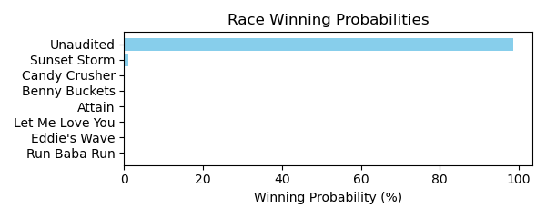

Figure: Winning Probability Distribution

NOTE: THIS RACE HAS HORSES THAT ARE MISSING CRITICAL DATA ELEMENTS

# Race: TUP | 2025-02-22 | Race #6 | Track: TURF PARADISE

Track: TURF PARADISE

|  |  |  |  |  |
| --- | --- | --- | --- | --- |
| Saddle Cloth # | Horse Name | Global Speed | Composite | Win Prob (%) |
| ['', 1, ''] | Cy's Silkstocking | 70.9 | 6.94 | 99.31 |
| ['', 2, ''] | Parker's Fifteen * | 70.9 | -4.33 | 0.01 |
| ['', 3, ''] | Prancing Matilda * | 70.9 | -3.15 | 0.03 |
| ['', 4, ''] | California Diva * | 70.9 | -8.48 | 0.00 |
| ['', 5, ''] | Onella | 70.9 | 0.18 | 0.44 |
| ['', 6, ''] | Sorority Party * | 70.9 | -1.29 | 0.14 |
| ['', 7, ''] | Keepyourpranceon * | 70.9 | -2.28 | 0.06 |
| ['', 8, ''] | O C Rhapsody * | 70.9 | -9.05 | 0.00 |

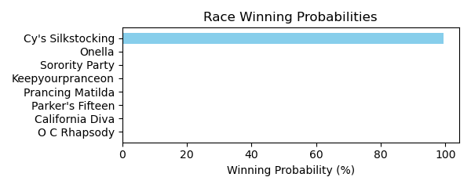

Figure: Winning Probability Distribution

NOTE: THIS RACE HAS HORSES THAT ARE MISSING CRITICAL DATA ELEMENTS

# Race: TUP | 2025-02-22 | Race #7 | Track: TURF PARADISE

Track: TURF PARADISE

|  |  |  |  |  |
| --- | --- | --- | --- | --- |
| Saddle Cloth # | Horse Name | Global Speed | Composite | Win Prob (%) |
| ['', 1, ''] | dq-Swampdrainer * | 104.0 | 7.82 | 29.85 |
| ['', 2, ''] | Rosenquist | 104.0 | 8.53 | 52.55 |
| ['', 3, ''] | National Generaux (IRE) | 104.0 | 6.62 | 11.38 |
| ['', 4, ''] | Mangia Pane * | 104.0 | 5.79 | 5.86 |
| ['', 5, ''] | Big Stick * | 104.0 | 1.95 | 0.27 |
| ['', 6, ''] | San Andres | 104.0 | 0.36 | 0.08 |
| ['', 7, ''] | Levon * | 104.0 | -1.06 | 0.02 |

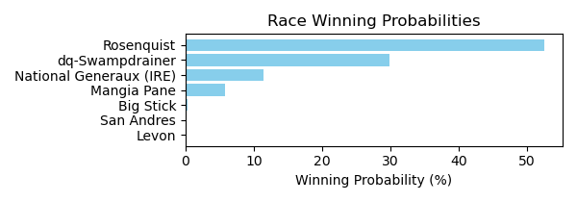

Figure: Winning Probability Distribution

NOTE: THIS RACE HAS HORSES THAT ARE MISSING CRITICAL DATA ELEMENTS

# Race: TUP | 2025-02-22 | Race #8 | Track: TURF PARADISE

Track: TURF PARADISE

|  |  |  |  |  |
| --- | --- | --- | --- | --- |
| Saddle Cloth # | Horse Name | Global Speed | Composite | Win Prob (%) |
| ['', 1, ''] | Dads Estrella | 76.4 | 8.25 | 22.17 |
| ['', 2, ''] | Go Go Sadie * | 76.4 | 6.44 | 5.23 |
| ['', 3, ''] | Grease Missle | 76.4 | 0.12 | 0.03 |
| ['', 4, ''] | Ima Trouble Maker * | 76.4 | -2.94 | 0.00 |
| ['', 5, ''] | Lucky Burglar * | 76.4 | 6.93 | 7.71 |
| ['', 6, ''] | Desert Gal * | 76.4 | 6.59 | 5.90 |
| ['', 7, ''] | Calebs Lady * | 76.4 | 3.20 | 0.39 |
| ['', 8, ''] | Stormylux * | 76.4 | 9.46 | 58.56 |

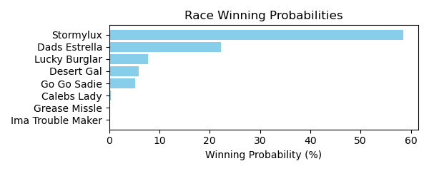

Figure: Winning Probability Distribution

NOTE: THIS RACE HAS HORSES THAT ARE MISSING CRITICAL DATA ELEMENTS

# Race: TUP | 2025-02-24 | Race #3 | Track: TURF PARADISE

Track: TURF PARADISE

|  |  |  |  |  |
| --- | --- | --- | --- | --- |
| Saddle Cloth # | Horse Name | Global Speed | Composite | Win Prob (%) |
| ['', 1, ''] | ROYAL INTEGRITY * | 76.2 | 5.35 | 29.66 |
| ['', 2, ''] | Swiss Dancer | 76.2 | 2.16 | 2.31 |
| ['', 3, ''] | CASHOUT CAROL * | 76.2 | 5.28 | 28.01 |
| ['', 4, ''] | Blue Spirit | 76.2 | -5.57 | 0.00 |
| ['', 5, ''] | Frank's Lorraine * | 76.2 | -5.04 | 0.01 |
| ['', 6, ''] | Mocktails Anyone * | 76.2 | 5.72 | 40.00 |
| ['', 7, ''] | Denada | 76.2 | -5.16 | 0.01 |

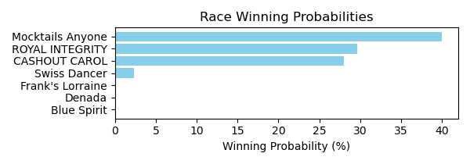

Figure: Winning Probability Distribution

NOTE: THIS RACE HAS HORSES THAT ARE MISSING CRITICAL DATA ELEMENTS

# Race: TUP | 2025-02-24 | Race #4 | Track: TURF PARADISE

Track: TURF PARADISE

|  |  |  |  |  |
| --- | --- | --- | --- | --- |
| Saddle Cloth # | Horse Name | Global Speed | Composite | Win Prob (%) |
| ['', 1, ''] | Aventapp | 82.5 | 5.36 | 5.18 |
| ['', 2, ''] | Big Beauty * | 82.5 | 8.12 | 47.06 |
| ['', 3, ''] | Veronica's Delight * | 82.5 | 3.59 | 1.25 |
| ['', 4, ''] | Zippin Sevenz * | 82.5 | 2.62 | 0.57 |
| ['', 5, ''] | Twelve Stars | 82.5 | 7.04 | 19.72 |
| ['', 6, ''] | Fast Giselle | 82.5 | 7.39 | 26.22 |

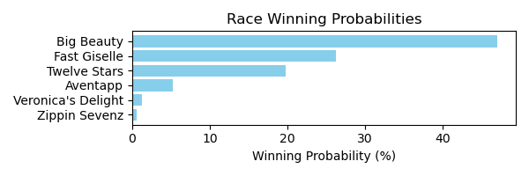

Figure: Winning Probability Distribution

NOTE: THIS RACE HAS HORSES THAT ARE MISSING CRITICAL DATA ELEMENTS

# Race: TUP | 2025-02-24 | Race #5 | Track: TURF PARADISE

Track: TURF PARADISE

|  |  |  |  |  |
| --- | --- | --- | --- | --- |
| Saddle Cloth # | Horse Name | Global Speed | Composite | Win Prob (%) |
| ['', 1, ''] | Winsitwell * | 103.8 | 5.70 | 66.29 |
| ['', 2, ''] | Hollywood Hero * | 103.8 | 3.33 | 9.93 |
| ['', 3, ''] | Muay Thai (IRE) * | 103.8 | 3.55 | 11.83 |
| ['', 4, ''] | Dr Vinnie Boombatz * | 103.8 | -3.04 | 0.06 |
| ['', 5, ''] | Thompson * | 103.8 | -7.25 | 0.00 |
| ['', 6, ''] | Blues Rapper * | 103.8 | 2.59 | 5.52 |
| ['', 7, ''] | Fayruz Tribute * | 103.8 | 2.77 | 6.37 |

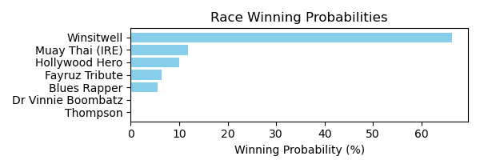

Figure: Winning Probability Distribution

NOTE: THIS RACE HAS HORSES THAT ARE MISSING CRITICAL DATA ELEMENTS

# Race: TUP | 2025-02-24 | Race #6 | Track: TURF PARADISE

Track: TURF PARADISE

|  |  |  |  |  |
| --- | --- | --- | --- | --- |
| Saddle Cloth # | Horse Name | Global Speed | Composite | Win Prob (%) |
| ['', 1, ''] | Forest Acclamation * | 103.8 | 6.33 | 9.27 |
| ['', 2, ''] | Charley Paints * | 103.8 | 1.70 | 0.23 |
| ['', 3, ''] | Shelby Shortstop * | 103.8 | -8.68 | 0.00 |
| ['', 4, ''] | Infinite Love * | 103.8 | 8.46 | 51.03 |
| ['', 5, ''] | Delusional Dream | 103.8 | 1.97 | 0.28 |
| ['', 6, ''] | Sky Sailing * | 103.8 | 6.52 | 10.73 |
| ['', 7, ''] | Above the Fold | 103.8 | 7.73 | 28.46 |
| ['', 8, ''] | Tia Suzi * | 103.8 | -2.67 | 0.01 |
| ['', 9, ''] | Leipzig * | 103.8 | -6.57 | 0.00 |

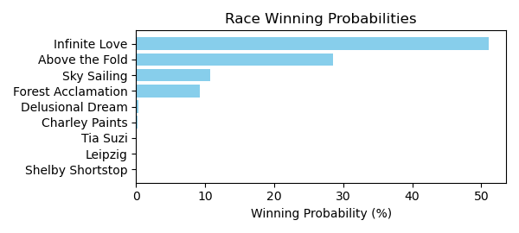

Figure: Winning Probability Distribution

NOTE: THIS RACE HAS HORSES THAT ARE MISSING CRITICAL DATA ELEMENTS

# Race: TUP | 2025-02-24 | Race #7 | Track: TURF PARADISE

Track: TURF PARADISE

|  |  |  |  |  |
| --- | --- | --- | --- | --- |
| Saddle Cloth # | Horse Name | Global Speed | Composite | Win Prob (%) |
| ['', 1, ''] | Railway | 104.2 | -3.71 | 0.04 |
| ['', 2, ''] | Ready to Storm * | 104.2 | 4.57 | 27.79 |
| ['', 3, ''] | I'm Noble * | 104.2 | 1.26 | 1.97 |
| ['', 4, ''] | Bodemonster | 104.2 | -2.47 | 0.10 |
| ['', 5, ''] | Keen Heir | 104.2 | 5.25 | 48.10 |
| ['', 6, ''] | Quarterback Dak * | 104.2 | -0.13 | 0.65 |
| ['', 7, ''] | Street Humor * | 104.2 | 4.24 | 21.36 |

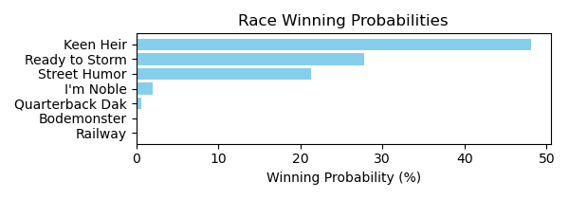

Figure: Winning Probability Distribution

NOTE: THIS RACE HAS HORSES THAT ARE MISSING CRITICAL DATA ELEMENTS

# Race: TUP | 2025-02-24 | Race #8 | Track: TURF PARADISE

Track: TURF PARADISE

|  |  |  |  |  |
| --- | --- | --- | --- | --- |
| Saddle Cloth # | Horse Name | Global Speed | Composite | Win Prob (%) |
| ['', 1, ''] | El Alto Hombre * | 82.7 | 6.65 | 2.11 |
| ['', 2, ''] | Mr. Who | 82.7 | 2.09 | 0.05 |
| ['', 3, ''] | Truth Seeker * | 82.7 | 7.55 | 4.36 |
| ['', 4, ''] | Diamond Rim * | 82.7 | 9.26 | 17.07 |
| ['', 5, ''] | Itsallgoodman | 82.7 | 5.30 | 0.72 |
| ['', 6, ''] | Tenth Street Don | 82.7 | 1.26 | 0.03 |
| ['', 7, ''] | Bearings * | 82.7 | 11.12 | 75.65 |

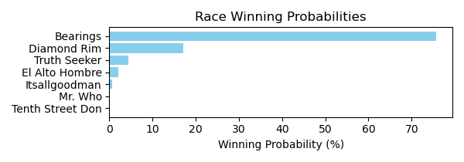

Figure: Winning Probability Distribution

NOTE: THIS RACE HAS HORSES THAT ARE MISSING CRITICAL DATA ELEMENTS

# Race: TUP | 2025-02-24 | Race #9 | Track: TURF PARADISE

Track: TURF PARADISE

|  |  |  |  |  |
| --- | --- | --- | --- | --- |
| Saddle Cloth # | Horse Name | Global Speed | Composite | Win Prob (%) |
| ['', 1, ''] | Coastal Fog | 71.1 | 5.40 | 24.60 |
| ['', 2, ''] | Stone Carver | 71.1 | -0.97 | 0.15 |
| ['', 3, ''] | Corn Pop * | 71.1 | 2.93 | 3.42 |
| ['', 4, ''] | Electrostatic * | 71.1 | -3.63 | 0.02 |
| ['', 5, ''] | Inch | 71.1 | -6.47 | 0.00 |
| ['', 6, ''] | Groovy Huey * | 71.1 | -5.61 | 0.00 |
| ['', 7, ''] | Our Bold Prince * | 71.1 | -2.91 | 0.03 |
| ['', 8, ''] | Star Entry * | 71.1 | 6.69 | 69.00 |
| ['', 9, ''] | Let's Rejoyce | 71.1 | 2.67 | 2.78 |
| ['', 10, ''] | Theuntouchableone * | 71.1 | -9.16 | 0.00 |

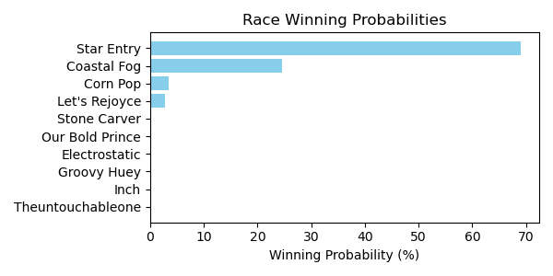

Figure: Winning Probability Distribution

NOTE: THIS RACE HAS HORSES THAT ARE MISSING CRITICAL DATA ELEMENTS

# Race: TUP | 2025-02-25 | Race #3 | Track: TURF PARADISE

Track: TURF PARADISE

|  |  |  |  |  |
| --- | --- | --- | --- | --- |
| Saddle Cloth # | Horse Name | Global Speed | Composite | Win Prob (%) |
| ['', 1, ''] | Unrivaled Queen * | 76.4 | 1.31 | 0.01 |
| ['', 2, ''] | Don't Tell Hydee * | 62.8 | 4.57 | 0.01 |
| ['', 3, ''] | Rubysa * | 76.4 | 5.18 | 0.20 |
| ['', 4, ''] | Diplomatica | 96.5 | 7.12 | 53.52 |
| ['', 5, ''] | High Gunner * | 76.4 | 5.61 | 0.28 |
| ['', 6, ''] | Drink and a Wink * | 104.0 | 4.99 | 43.78 |
| ['', 7, ''] | Miss Union * | 76.4 | 8.16 | 2.19 |

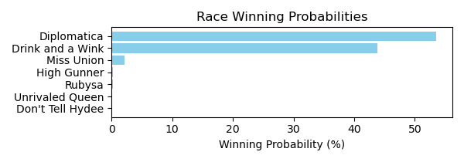

Figure: Winning Probability Distribution

NOTE: THIS RACE HAS HORSES THAT ARE MISSING CRITICAL DATA ELEMENTS

# Race: TUP | 2025-02-25 | Race #4 | Track: TURF PARADISE

Track: TURF PARADISE

|  |  |  |  |  |
| --- | --- | --- | --- | --- |
| Saddle Cloth # | Horse Name | Global Speed | Composite | Win Prob (%) |
| ['', 1, ''] | G G Gilley * | 71.1 | 8.01 | 25.53 |
| ['', 2, ''] | REGARDING HARRY * | 74.5 | 6.63 | 16.88 |
| ['', 3, ''] | Knockout Guy * | 96.5 | -6.79 | 0.03 |
| ['', 4, ''] | Firefight | 71.1 | -4.61 | 0.00 |
| ['', 5, ''] | Brownstone | 71.1 | 8.48 | 37.24 |
| ['', 6, ''] | Rebellious Red * | 71.1 | 5.49 | 3.41 |
| ['', 7, ''] | Gonzaga * | 71.1 | -2.30 | 0.01 |
| ['', 8, ''] | BIG STETSON * | 74.5 | 6.63 | 16.90 |

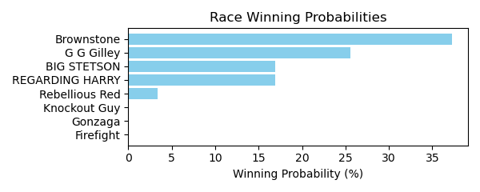

Figure: Winning Probability Distribution

NOTE: THIS RACE HAS HORSES THAT ARE MISSING CRITICAL DATA ELEMENTS

# Race: TUP | 2025-02-25 | Race #5 | Track: TURF PARADISE

Track: TURF PARADISE

|  |  |  |  |  |
| --- | --- | --- | --- | --- |
| Saddle Cloth # | Horse Name | Global Speed | Composite | Win Prob (%) |
| ['', 1, ''] | Aspirational | 82.4 | 2.94 | 0.29 |
| ['', 2, ''] | Little Bit Tipsy | 76.3 | 1.80 | 0.03 |
| ['', 3, ''] | Annie Fox * | 103.9 | 2.53 | 15.32 |
| ['', 4, ''] | Ropers N Wranglers * | 103.9 | 4.46 | 71.58 |
| ['', 5, ''] | Charybdis * | 71.0 | 2.53 | 0.02 |
| ['', 6, ''] | Minedandrefined * | 76.3 | 9.10 | 11.84 |
| ['', 7, ''] | Rockbar * | 76.3 | 5.80 | 0.84 |
| ['', 8, ''] | Love Alive | 71.0 | 4.06 | 0.07 |

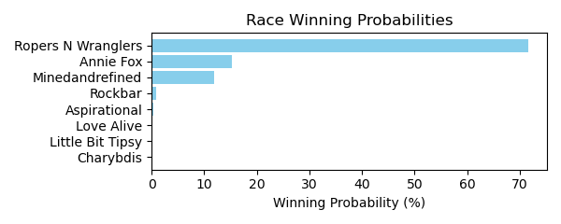

Figure: Winning Probability Distribution

NOTE: THIS RACE HAS HORSES THAT ARE MISSING CRITICAL DATA ELEMENTS

# Race: TUP | 2025-02-25 | Race #6 | Track: TURF PARADISE

Track: TURF PARADISE

|  |  |  |  |  |
| --- | --- | --- | --- | --- |
| Saddle Cloth # | Horse Name | Global Speed | Composite | Win Prob (%) |
| ['', 1, ''] | Sahara Sue | 71.0 | -4.33 | 0.01 |
| ['', 2, ''] | Bea Mischief * | 82.4 | -5.78 | 0.02 |
| ['', 3, ''] | Night Flyer | 82.4 | 2.01 | 8.47 |
| ['', 4, ''] | Em N Holl's Fiesta * | 76.3 | 5.95 | 58.88 |
| ['', 5, ''] | Vella | 76.3 | -2.95 | 0.05 |
| ['', 6, ''] | Deficit Maja * | 66.5 | 7.39 | 26.32 |
| ['', 7, ''] | Unified A. P. * | 76.3 | 2.56 | 3.92 |
| ['', 8, ''] | A Dime for Me * | 71.0 | 3.24 | 2.34 |
| ['', 9, ''] | Game to Play * | 66.5 | -10.17 | 0.00 |

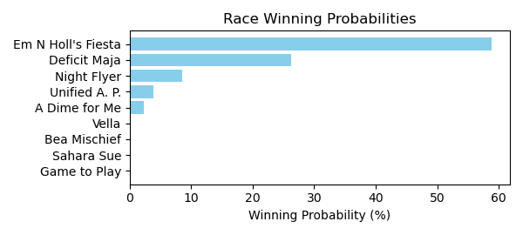

Figure: Winning Probability Distribution

NOTE: THIS RACE HAS HORSES THAT ARE MISSING CRITICAL DATA ELEMENTS

# Race: TUP | 2025-02-25 | Race #7 | Track: TURF PARADISE

Track: TURF PARADISE

|  |  |  |  |  |
| --- | --- | --- | --- | --- |
| Saddle Cloth # | Horse Name | Global Speed | Composite | Win Prob (%) |
| ['', 1, ''] | Happy Chappy | 76.2 | -1.60 | 0.13 |
| ['', 2, ''] | Maui Sunrise * | 66.4 | 3.64 | 1.21 |
| ['', 3, ''] | Jessica Blah Blah * | 82.2 | -7.23 | 0.00 |
| ['', 4, ''] | Diamond Dee * | 66.4 | 7.13 | 19.71 |
| ['', 5, ''] | Bango's Heat * | 66.4 | 5.18 | 4.15 |
| ['', 6, ''] | Sissue * | 66.4 | -6.54 | 0.00 |
| ['', 7, ''] | Fly South | 70.9 | -3.77 | 0.01 |
| ['', 8, ''] | Measureofdevotion | 53.7 | 4.72 | 0.22 |
| ['', 9, ''] | Queen Mystic * | 66.4 | -9.18 | 0.00 |
| ['', 10, ''] | Daddy Classy Dill * | 66.4 | 8.79 | 74.55 |
| ['', 11, ''] | Can't Want That * | 66.4 | -2.49 | 0.01 |
| ['', 12, ''] | Russian Tothe Wire * | 82.2 | -5.69 | 0.02 |

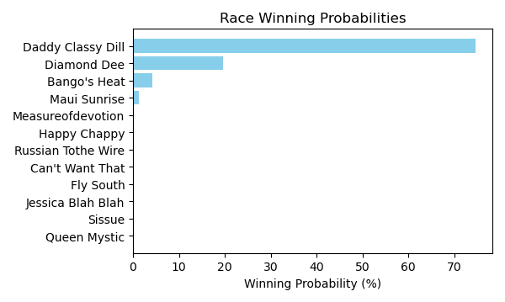

Figure: Winning Probability Distribution

NOTE: THIS RACE HAS HORSES THAT ARE MISSING CRITICAL DATA ELEMENTS

# Race: TUP | 2025-02-25 | Race #8 | Track: TURF PARADISE

Track: TURF PARADISE

|  |  |  |  |  |
| --- | --- | --- | --- | --- |
| Saddle Cloth # | Horse Name | Global Speed | Composite | Win Prob (%) |
| ['', 1, ''] | War Chest | 111.6 | 9.94 | 95.17 |
| ['', 2, ''] | Flint Stroll | 104.2 | 1.41 | 0.02 |
| ['', 3, ''] | Club Mesquite * | 111.6 | 5.82 | 3.52 |
| ['', 4, ''] | Aquacat * | 104.2 | 1.86 | 0.03 |
| ['', 5, ''] | Dos Vicios | 104.2 | -1.89 | 0.00 |
| ['', 6, ''] | Birth of Cool | 104.2 | 5.60 | 0.67 |
| ['', 7, ''] | You Kidding Me * | 76.5 | -1.51 | 0.00 |
| ['', 8, ''] | Sunny Spot * | 104.2 | 4.18 | 0.22 |
| ['', 9, ''] | Shut Up Michael (IRE) * | 104.2 | 4.06 | 0.20 |
| ['', 10, ''] | Thirty Seconds Out * | 104.2 | 3.82 | 0.16 |

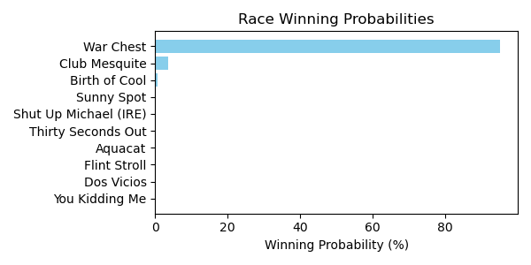

Figure: Winning Probability Distribution

NOTE: THIS RACE HAS HORSES THAT ARE MISSING CRITICAL DATA ELEMENTS

# Race: TUP | 2025-02-25 | Race #9 | Track: TURF PARADISE

Track: TURF PARADISE

|  |  |  |  |  |
| --- | --- | --- | --- | --- |
| Saddle Cloth # | Horse Name | Global Speed | Composite | Win Prob (%) |
| ['', 1, ''] | Mongolian Ninja * | 62.7 | 2.14 | 0.02 |
| ['', 2, ''] | Mr. Mustache | 82.2 | -9.74 | 0.00 |
| ['', 3, ''] | Ukraine Strong | 70.9 | 8.27 | 12.91 |
| ['', 4, ''] | Crown Prosecutor | 103.6 | 0.12 | 13.25 |
| ['', 5, ''] | Take My Allowance | 76.2 | 2.99 | 0.54 |
| ['', 6, ''] | Cruel Endeavor * | 82.2 | 1.15 | 0.41 |
| ['', 7, ''] | Crazy Storm * | 62.7 | 2.43 | 0.02 |
| ['', 8, ''] | Royal Curlin * | 76.2 | 7.67 | 22.74 |
| ['', 9, ''] | Drive for Show * | 82.2 | 4.95 | 8.63 |
| ['', 10, ''] | Son o' Sanpete * | 82.2 | -0.33 | 0.13 |
| ['', 11, ''] | Yankee Tea Party * | 82.2 | 6.90 | 41.31 |
| ['', 12, ''] | Tempting Prospect * | 70.9 | 1.08 | 0.04 |

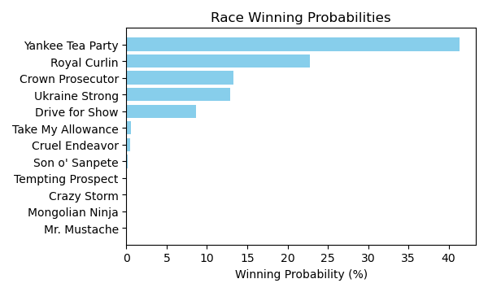

Figure: Winning Probability Distribution

NOTE: THIS RACE HAS HORSES THAT ARE MISSING CRITICAL DATA ELEMENTS

# Race: TTP | 2025-02-21 | Race #1 | Track: TURFWAY PARK

Track: TURFWAY PARK

|  |  |  |  |  |
| --- | --- | --- | --- | --- |
| Saddle Cloth # | Horse Name | Global Speed | Composite | Win Prob (%) |
| ['', 1, ''] | El Franco | 104.2 | -2.02 | 0.01 |
| ['', 2, ''] | Hard Mission | 104.2 | 7.27 | 21.48 |
| ['', 3, ''] | Golden Reign | 76.5 | -4.72 | 0.00 |
| ['', 4, ''] | Maynard | 104.2 | 4.26 | 1.93 |
| ['', 5, ''] | Commando Joe | 76.5 | -1.79 | 0.00 |
| ['', 6, ''] | Moonstrike (GB) | 82.6 | -4.60 | 0.00 |
| ['', 7, ''] | Dontkissdaminister | 76.5 | -5.27 | 0.00 |
| ['', 8, ''] | Temper Tantrum | 104.2 | -2.41 | 0.01 |
| ['', 9, ''] | dh-Category Ten | 104.2 | 8.86 | 76.57 |

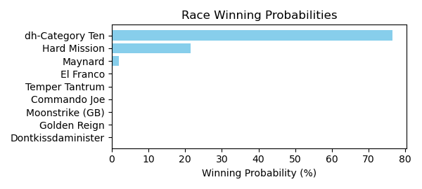

Figure: Winning Probability Distribution

NOTE: THIS RACE HAS HORSES THAT ARE MISSING CRITICAL DATA ELEMENTS

# Race: TTP | 2025-02-21 | Race #2 | Track: TURFWAY PARK

Track: TURFWAY PARK

|  |  |  |  |  |
| --- | --- | --- | --- | --- |
| Saddle Cloth # | Horse Name | Global Speed | Composite | Win Prob (%) |
| ['', 1, ''] | Mariposa de Pista | 103.7 | -2.07 | 0.15 |
| ['', 2, ''] | Glorious Musings | 103.7 | -4.17 | 0.03 |
| ['', 3, ''] | Indy's Universe | 103.7 | 5.64 | 69.76 |
| ['', 4, ''] | Protonica | 76.2 | -4.79 | 0.00 |
| ['', 5, ''] | Holy Belle * | 76.2 | -9.00 | 0.00 |
| ['', 6, ''] | Are You a Spy | 103.7 | -4.98 | 0.01 |
| ['', 7, ''] | Tuenda | 103.7 | 4.48 | 27.62 |
| ['', 8, ''] | LATE FOR MASS * | 93.5 | 3.96 | 2.39 |
| ['', 9, ''] | Florina | 103.7 | -4.07 | 0.03 |
| ['', 10, ''] | Baytown Storm | 103.7 | -4.70 | 0.02 |
| ['', 11, ''] | Get It Together * | 82.3 | -9.52 | 0.00 |
| ['', 12, ''] | Rabble | 76.2 | -4.35 | 0.00 |

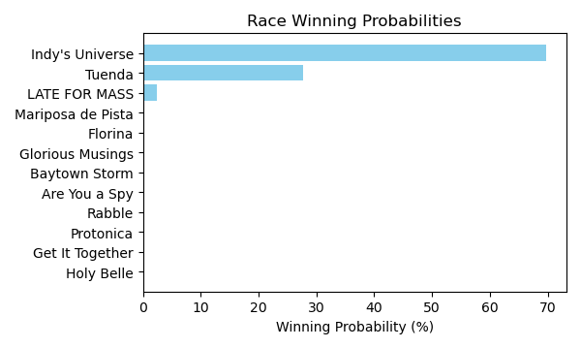

Figure: Winning Probability Distribution

NOTE: THIS RACE HAS HORSES THAT ARE MISSING CRITICAL DATA ELEMENTS

# Race: TTP | 2025-02-21 | Race #3 | Track: TURFWAY PARK

Track: TURFWAY PARK

|  |  |  |  |  |
| --- | --- | --- | --- | --- |
| Saddle Cloth # | Horse Name | Global Speed | Composite | Win Prob (%) |
| ['', 1, ''] | Embrace Me | 129.2 | -0.94 | 9.58 |
| ['', 2, ''] | Quarrel | 129.2 | -3.23 | 1.53 |
| ['', 3, ''] | Breezing Along | 82.7 | 3.90 | 0.04 |
| ['', 4, ''] | Under the Bed | 104.3 | 7.36 | 50.61 |
| ['', 5, ''] | Starship Belmont | 104.3 | 3.38 | 2.08 |
| ['', 6, ''] | Indy's Star | 104.3 | 6.94 | 35.93 |
| ['', 7, ''] | Wonka | 104.3 | 0.57 | 0.22 |
| ['', 8, ''] | Cat Attack * | 76.5 | -6.84 | 0.00 |

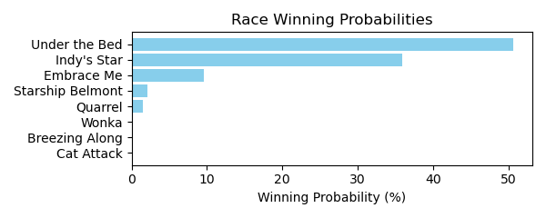

Figure: Winning Probability Distribution

NOTE: THIS RACE HAS HORSES THAT ARE MISSING CRITICAL DATA ELEMENTS

# Race: TTP | 2025-02-21 | Race #4 | Track: TURFWAY PARK

Track: TURFWAY PARK

|  |  |  |  |  |
| --- | --- | --- | --- | --- |
| Saddle Cloth # | Horse Name | Global Speed | Composite | Win Prob (%) |
| ['', 1, ''] | Queen of the Dance | 103.9 | 3.47 | 41.57 |
| ['', 2, ''] | Frosty Tale | 103.9 | 1.90 | 11.77 |
| ['', 3, ''] | Laughing Out Loud | 108.6 | -9.25 | 0.00 |
| ['', 4, ''] | Camp Akeela | 82.4 | -2.80 | 0.00 |
| ['', 5, ''] | Halcyon Days | 103.9 | -3.18 | 0.20 |
| ['', 6, ''] | Serene Waters | 82.4 | 6.36 | 5.68 |
| ['', 7, ''] | I Gotta Bolt | 82.4 | -3.59 | 0.00 |
| ['', 8, ''] | Callas | 103.9 | 3.13 | 31.61 |
| ['', 9, ''] | Ms Ks Dynasty | 103.9 | 0.72 | 4.60 |
| ['', 10, ''] | No Trust | 82.4 | -5.87 | 0.00 |
| ['', 11, ''] | Bump in the Night | 82.4 | -5.89 | 0.00 |
| ['', 12, ''] | dh-Abstract Moment | 103.9 | 0.57 | 4.07 |
| ['', 13, ''] | Stay Faithful | 82.4 | 3.29 | 0.49 |

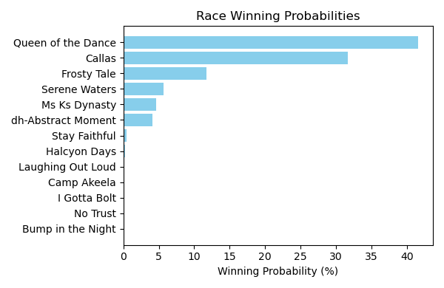

Figure: Winning Probability Distribution

NOTE: THIS RACE HAS HORSES THAT ARE MISSING CRITICAL DATA ELEMENTS

# Race: TTP | 2025-02-21 | Race #5 | Track: TURFWAY PARK

Track: TURFWAY PARK

|  |  |  |  |  |
| --- | --- | --- | --- | --- |
| Saddle Cloth # | Horse Name | Global Speed | Composite | Win Prob (%) |
| ['', 1, ''] | My Friend Louie | 104.3 | 3.21 | 0.72 |
| ['', 2, ''] | Cabernaydo | 104.3 | 2.72 | 0.49 |
| ['', 3, ''] | On My Honor | 82.6 | -1.84 | 0.00 |
| ['', 4, ''] | Top Secret | 76.5 | 2.71 | 0.00 |
| ['', 5, ''] | Hope Joe's Right | 111.6 | 7.44 | 93.06 |
| ['', 6, ''] | Right On Right On | 82.6 | -8.20 | 0.00 |
| ['', 7, ''] | First of His Name | 104.3 | -0.97 | 0.03 |
| ['', 8, ''] | Boone's Path | 104.3 | -1.28 | 0.02 |
| ['', 9, ''] | Speed Institute | 104.3 | -4.70 | 0.00 |
| ['', 10, ''] | Cruisin and Boozin | 104.3 | 4.33 | 1.77 |
| ['', 11, ''] | Coach Campbell | 104.3 | 4.31 | 1.75 |
| ['', 12, ''] | Kentucky Go Go | 104.3 | -1.30 | 0.02 |
| ['', 13, ''] | Atlantic Dancer | 104.3 | 3.03 | 0.63 |
| ['', 14, ''] | Friar Newton | 104.3 | 4.14 | 1.52 |

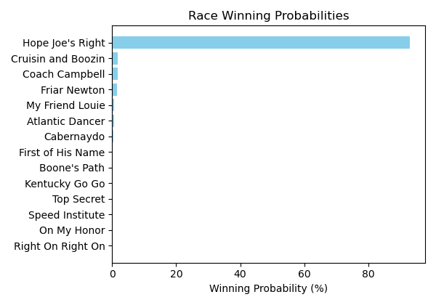

Figure: Winning Probability Distribution

NOTE: THIS RACE HAS HORSES THAT ARE MISSING CRITICAL DATA ELEMENTS

# Race: TTP | 2025-02-21 | Race #6 | Track: TURFWAY PARK

Track: TURFWAY PARK

|  |  |  |  |  |
| --- | --- | --- | --- | --- |
| Saddle Cloth # | Horse Name | Global Speed | Composite | Win Prob (%) |
| ['', 1, ''] | Starship Beauty * | 76.3 | 7.39 | 10.84 |
| ['', 2, ''] | Mink Stole | 103.9 | 0.37 | 9.83 |
| ['', 3, ''] | Moringa | 76.3 | -6.30 | 0.00 |
| ['', 4, ''] | Tiz Silver * | 103.9 | -7.48 | 0.02 |
| ['', 5, ''] | Adalene | 76.3 | -0.60 | 0.02 |
| ['', 6, ''] | Turino | 111.3 | -8.29 | 0.04 |
| ['', 7, ''] | Rockaway Reef | 82.4 | 8.30 | 75.76 |
| ['', 8, ''] | Strife | 76.3 | 4.83 | 1.40 |
| ['', 9, ''] | Evermore | 82.4 | 3.39 | 1.49 |
| ['', 10, ''] | Miss Susan B | 76.3 | 3.67 | 0.55 |
| ['', 11, ''] | Cloud Rider | 82.4 | -0.85 | 0.05 |

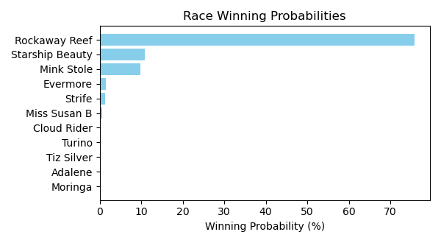

Figure: Winning Probability Distribution

NOTE: THIS RACE HAS HORSES THAT ARE MISSING CRITICAL DATA ELEMENTS

# Race: TTP | 2025-02-21 | Race #7 | Track: TURFWAY PARK

Track: TURFWAY PARK

|  |  |  |  |  |
| --- | --- | --- | --- | --- |
| Saddle Cloth # | Horse Name | Global Speed | Composite | Win Prob (%) |
| ['', 1, ''] | Tiger Division | 104.1 | 1.03 | 0.02 |
| ['', 2, ''] | Just Ruthless | 104.1 | 8.76 | 9.59 |
| ['', 3, ''] | Bracelet | 104.1 | 7.63 | 3.87 |
| ['', 4, ''] | White Rocks | 104.1 | 9.75 | 21.04 |
| ['', 5, ''] | She's All Charm | 76.4 | -1.16 | 0.00 |
| ['', 6, ''] | Somethinabouther | 111.5 | 9.14 | 56.37 |
| ['', 7, ''] | Pure Majestic | 104.1 | -7.74 | 0.00 |
| ['', 8, ''] | Girl Math | 104.1 | 7.68 | 4.03 |
| ['', 9, ''] | Salt | 108.9 | 4.55 | 0.85 |
| ['', 10, ''] | Admit | 104.1 | 7.59 | 3.76 |
| ['', 11, ''] | Presha | 104.1 | 3.88 | 0.19 |
| ['', 12, ''] | Foxtastic | 111.5 | 2.40 | 0.26 |
| ['', 13, ''] | Wondrous * | 76.4 | 7.94 | 0.02 |

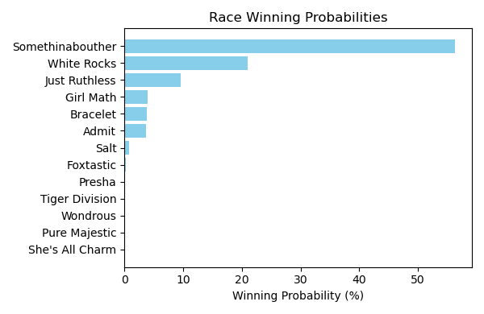

Figure: Winning Probability Distribution

NOTE: THIS RACE HAS HORSES THAT ARE MISSING CRITICAL DATA ELEMENTS

# Race: TTP | 2025-02-21 | Race #8 | Track: TURFWAY PARK

Track: TURFWAY PARK

|  |  |  |  |  |
| --- | --- | --- | --- | --- |
| Saddle Cloth # | Horse Name | Global Speed | Composite | Win Prob (%) |
| ['', 1, ''] | Special Creed | 82.5 | -5.97 | 0.00 |
| ['', 2, ''] | Countthebrave | 76.4 | -7.51 | 0.00 |
| ['', 3, ''] | Blue Coast | 104.0 | 6.67 | 99.07 |
| ['', 4, ''] | Mo Hair Sam | 76.4 | 1.07 | 0.00 |
| ['', 5, ''] | Graydaria | 76.4 | 6.95 | 0.49 |
| ['', 6, ''] | Flat to Da Mat | 76.4 | 6.77 | 0.43 |
| ['', 7, ''] | Killjoy | 82.5 | -1.55 | 0.00 |
| ['', 8, ''] | El Cordobes | 104.0 | -6.10 | 0.00 |
| ['', 9, ''] | Baytown Baracus | 76.4 | -3.92 | 0.00 |

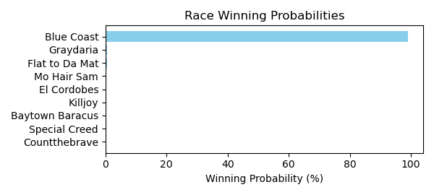

Figure: Winning Probability Distribution

NOTE: THIS RACE HAS HORSES THAT ARE MISSING CRITICAL DATA ELEMENTS

# Race: TTP | 2025-02-21 | Race #9 | Track: TURFWAY PARK

Track: TURFWAY PARK

|  |  |  |  |  |
| --- | --- | --- | --- | --- |
| Saddle Cloth # | Horse Name | Global Speed | Composite | Win Prob (%) |
| ['', 1, ''] | Dyno War * | 103.8 | -6.18 | 0.02 |
| ['', 2, ''] | Son of a Gray | 103.8 | 4.15 | 60.32 |
| ['', 3, ''] | Cue Country Roads * | 111.1 | -3.31 | 0.67 |
| ['', 4, ''] | Cade's Goal | 103.8 | -4.63 | 0.05 |
| ['', 5, ''] | Willingness | 103.8 | -6.76 | 0.01 |
| ['', 6, ''] | Adios Kid | 103.8 | -4.23 | 0.07 |
| ['', 7, ''] | Utopian Treasure * | 103.8 | -4.00 | 0.09 |
| ['', 8, ''] | Tie Breaker Lennie | 103.8 | 0.47 | 3.18 |
| ['', 9, ''] | Photo Op | 103.8 | -2.51 | 0.29 |
| ['', 10, ''] | Decatur Street | 103.8 | 3.47 | 34.92 |
| ['', 11, ''] | Egyptian Quest | 103.8 | -2.27 | 0.35 |
| ['', 12, ''] | Daguerre | 103.8 | -6.78 | 0.01 |
| ['', 13, ''] | Papa D L | 76.2 | 0.69 | 0.02 |
| ['', 14, ''] | Odorico * | 76.2 | -5.62 | 0.00 |

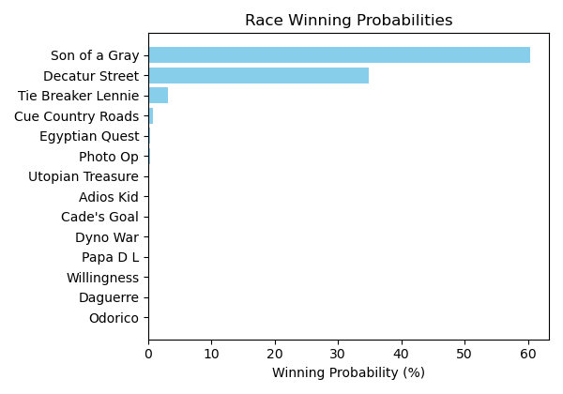

Figure: Winning Probability Distribution

NOTE: THIS RACE HAS HORSES THAT ARE MISSING CRITICAL DATA ELEMENTS

# Race: TTP | 2025-02-21 | Race #10 | Track: TURFWAY PARK

Track: TURFWAY PARK

|  |  |  |  |  |
| --- | --- | --- | --- | --- |
| Saddle Cloth # | Horse Name | Global Speed | Composite | Win Prob (%) |
| ['', 1, ''] | Or Magique * | 76.3 | -5.26 | 0.00 |
| ['', 2, ''] | EQUAL FORCE * | 91.1 | 4.52 | 21.15 |
| ['', 3, ''] | Ace On the Turn | 82.4 | -9.04 | 0.00 |
| ['', 4, ''] | Catalina Cat * | 82.4 | 5.93 | 11.52 |
| ['', 5, ''] | Super Snoop | 103.9 | -5.82 | 0.07 |
| ['', 6, ''] | SUITED AND BOOTED * | 91.1 | 4.33 | 18.17 |
| ['', 7, ''] | Missed Option * | 82.4 | -5.20 | 0.00 |
| ['', 8, ''] | Cold Front * | 76.3 | 4.58 | 1.16 |
| ['', 9, ''] | Hasten | 111.3 | 0.43 | 45.79 |
| ['', 10, ''] | Kye | 103.9 | -3.34 | 0.51 |
| ['', 11, ''] | To Monarch | 82.4 | 2.67 | 0.85 |
| ['', 12, ''] | Tkac | 103.9 | -5.28 | 0.11 |
| ['', 13, ''] | Blakely's Boy | 103.9 | -3.01 | 0.67 |

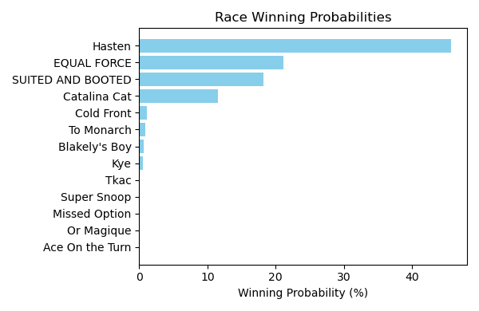

Figure: Winning Probability Distribution

NOTE: THIS RACE HAS HORSES THAT ARE MISSING CRITICAL DATA ELEMENTS

# Race: TTP | 2025-02-23 | Race #1 | Track: TURFWAY PARK

Track: TURFWAY PARK

|  |  |  |  |  |
| --- | --- | --- | --- | --- |
| Saddle Cloth # | Horse Name | Global Speed | Composite | Win Prob (%) |
| ['', 1, ''] | Miss Moon Pie | 104.0 | -8.04 | 0.00 |
| ['', 2, ''] | Isa Lei | 104.0 | 5.92 | 5.91 |
| ['', 3, ''] | Endless | 104.0 | -4.09 | 0.00 |
| ['', 4, ''] | Lucky Ana | 104.0 | 5.71 | 5.00 |
| ['', 5, ''] | Gogo Chanel | 104.0 | 9.25 | 84.89 |
| ['', 6, ''] | Cant Keep Me Down | 104.0 | -0.11 | 0.05 |
| ['', 7, ''] | Councilwoman Jilly | 104.0 | 5.34 | 3.72 |
| ['', 8, ''] | Megan's Noel | 104.0 | 2.65 | 0.43 |

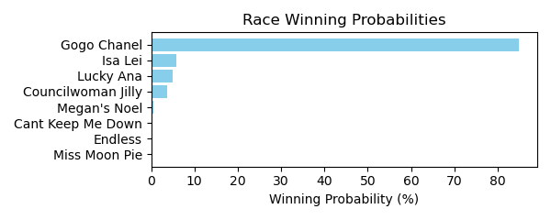

Figure: Winning Probability Distribution

NOTE: THIS RACE HAS HORSES THAT ARE MISSING CRITICAL DATA ELEMENTS

# Race: TTP | 2025-02-23 | Race #2 | Track: TURFWAY PARK

Track: TURFWAY PARK

|  |  |  |  |  |
| --- | --- | --- | --- | --- |
| Saddle Cloth # | Horse Name | Global Speed | Composite | Win Prob (%) |
| ['', 1, ''] | J W Ruckus | 82.5 | 4.53 | 12.49 |
| ['', 2, ''] | Cog | 82.5 | 6.28 | 50.57 |
| ['', 3, ''] | Violin Maker | 82.5 | -3.38 | 0.02 |
| ['', 4, ''] | Buzzer | 82.5 | -9.66 | 0.00 |
| ['', 5, ''] | Dragon Drew | 82.5 | 3.09 | 3.94 |
| ['', 6, ''] | Ready Pursuit | 82.5 | -0.86 | 0.17 |
| ['', 7, ''] | All in Sync | 82.5 | 4.49 | 12.15 |
| ['', 8, ''] | One for Richie | 82.5 | 5.16 | 20.66 |

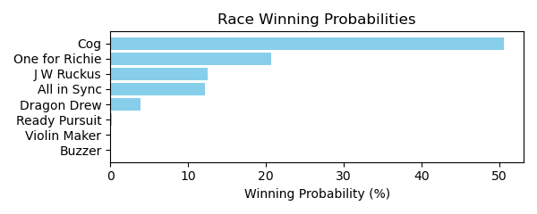

Figure: Winning Probability Distribution

NOTE: THIS RACE HAS HORSES THAT ARE MISSING CRITICAL DATA ELEMENTS

# Race: TTP | 2025-02-23 | Race #3 | Track: TURFWAY PARK

Track: TURFWAY PARK

|  |  |  |  |  |
| --- | --- | --- | --- | --- |
| Saddle Cloth # | Horse Name | Global Speed | Composite | Win Prob (%) |
| ['', 1, ''] | Tiger's Legacy | 82.9 | 7.49 | 21.20 |
| ['', 2, ''] | Script | 82.9 | 8.04 | 32.78 |
| ['', 3, ''] | Sigiloso | 82.9 | 2.85 | 0.52 |
| ['', 4, ''] | Big Hat Willie | 82.9 | -0.63 | 0.03 |
| ['', 5, ''] | Alder | 82.9 | -6.16 | 0.00 |
| ['', 6, ''] | Night Time | 82.9 | 6.98 | 14.02 |
| ['', 7, ''] | Lugan Knight | 82.9 | 1.37 | 0.16 |
| ['', 8, ''] | Simcoe | 82.9 | 7.98 | 31.30 |

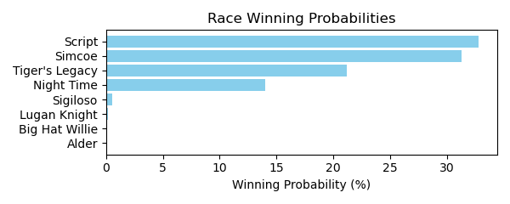

Figure: Winning Probability Distribution

NOTE: THIS RACE HAS HORSES THAT ARE MISSING CRITICAL DATA ELEMENTS

# Race: TTP | 2025-02-23 | Race #4 | Track: TURFWAY PARK

Track: TURFWAY PARK

|  |  |  |  |  |
| --- | --- | --- | --- | --- |
| Saddle Cloth # | Horse Name | Global Speed | Composite | Win Prob (%) |
| ['', 1, ''] | Dark Fury | 82.5 | -0.51 | 0.11 |
| ['', 2, ''] | Indescriptable | 82.5 | -3.02 | 0.02 |
| ['', 3, ''] | Tennesseehoneybee | 82.5 | -5.72 | 0.00 |
| ['', 4, ''] | Meet in Secret | 82.5 | -4.90 | 0.00 |
| ['', 5, ''] | Bellofthebluegrass | 82.5 | -7.39 | 0.00 |
| ['', 6, ''] | Sally's Gold | 82.5 | 7.14 | 51.19 |
| ['', 7, ''] | Yuma's Shadow | 82.5 | 6.97 | 44.54 |
| ['', 8, ''] | I'm a Cookie Lover | 82.5 | -0.22 | 0.14 |
| ['', 9, ''] | Red Hot Jeanie | 82.5 | -4.32 | 0.01 |
| ['', 10, ''] | Foolish | 82.5 | 3.68 | 3.21 |
| ['', 11, ''] | Elle's Dancer | 82.5 | 1.89 | 0.77 |
| ['', 12, ''] | Wanda Susie Doozy | 82.5 | -6.56 | 0.00 |
| ['', 13, ''] | Carolina Candy | 82.5 | -5.11 | 0.00 |

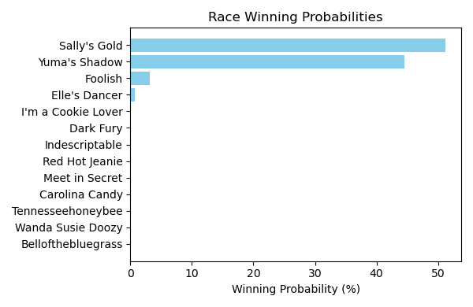

Figure: Winning Probability Distribution

NOTE: THIS RACE HAS HORSES THAT ARE MISSING CRITICAL DATA ELEMENTS

# Race: TTP | 2025-02-23 | Race #5 | Track: TURFWAY PARK

Track: TURFWAY PARK

|  |  |  |  |  |
| --- | --- | --- | --- | --- |
| Saddle Cloth # | Horse Name | Global Speed | Composite | Win Prob (%) |
| ['', 1, ''] | LA SCATTA * | 82.4 | 3.73 | 4.52 |
| ['', 2, ''] | Don't Cross Alexis * | 82.4 | 7.19 | 72.40 |
| ['', 3, ''] | LOW MOON * | 82.4 | 3.74 | 4.57 |
| ['', 4, ''] | Super Maxima | 82.4 | -2.87 | 0.02 |
| ['', 5, ''] | Bonita Vida * | 82.4 | -5.30 | 0.00 |
| ['', 6, ''] | Dang It Ophelia * | 82.4 | -0.57 | 0.15 |
| ['', 7, ''] | Sister Carlie * | 82.4 | -6.71 | 0.00 |
| ['', 8, ''] | M'Lady Sansa | 82.4 | -5.20 | 0.00 |
| ['', 9, ''] | Pretty in Pearls | 82.4 | -3.73 | 0.01 |
| ['', 10, ''] | People Get Ready * | 82.4 | 5.17 | 14.33 |
| ['', 11, ''] | BINDI * | 82.4 | 3.56 | 3.97 |
| ['', 12, ''] | Her Holy Name | 82.4 | -3.51 | 0.01 |
| ['', 13, ''] | Pearl Magic * | 82.4 | -4.19 | 0.01 |
| ['', 14, ''] | Stopsprettyplaces * | 82.4 | -9.51 | 0.00 |

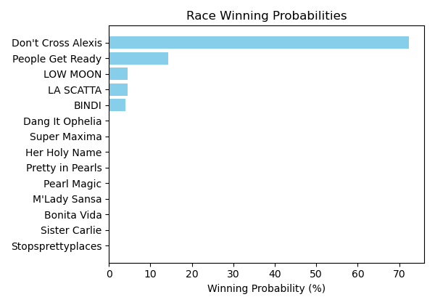

Figure: Winning Probability Distribution

NOTE: THIS RACE HAS HORSES THAT ARE MISSING CRITICAL DATA ELEMENTS

# Race: TTP | 2025-02-23 | Race #6 | Track: TURFWAY PARK

Track: TURFWAY PARK

|  |  |  |  |  |
| --- | --- | --- | --- | --- |
| Saddle Cloth # | Horse Name | Global Speed | Composite | Win Prob (%) |
| ['', 1, ''] | Match Five | 82.3 | -8.17 | 0.00 |
| ['', 2, ''] | Lalily | 82.3 | -8.50 | 0.00 |
| ['', 3, ''] | Waitinbythenile | 82.3 | -5.64 | 0.01 |
| ['', 4, ''] | Statler Inn | 82.3 | -0.79 | 0.38 |
| ['', 5, ''] | CRUISING GAL * | 82.3 | 5.14 | 43.02 |
| ['', 6, ''] | You Know Me | 82.3 | -1.65 | 0.19 |
| ['', 7, ''] | Make a Million | 82.3 | 3.74 | 14.01 |
| ['', 8, ''] | Warm Days | 82.3 | -7.73 | 0.00 |
| ['', 9, ''] | BOBBY'S WORKOUT * | 82.3 | 5.12 | 42.40 |

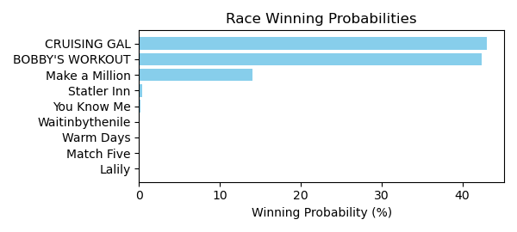

Figure: Winning Probability Distribution

NOTE: THIS RACE HAS HORSES THAT ARE MISSING CRITICAL DATA ELEMENTS

# Race: TTP | 2025-02-23 | Race #7 | Track: TURFWAY PARK

Track: TURFWAY PARK

|  |  |  |  |  |
| --- | --- | --- | --- | --- |
| Saddle Cloth # | Horse Name | Global Speed | Composite | Win Prob (%) |
| ['', 1, ''] | Epic Ride | 82.8 | 6.87 | 15.36 |
| ['', 2, ''] | B D Valeski | 82.8 | 1.11 | 0.15 |
| ['', 3, ''] | Hedwig | 82.8 | 1.99 | 0.31 |
| ['', 4, ''] | Mischievous Rogue | 82.8 | 6.42 | 10.69 |
| ['', 5, ''] | Clear the Air | 82.8 | -0.98 | 0.03 |
| ['', 6, ''] | Let My People Go | 82.8 | 0.36 | 0.08 |
| ['', 7, ''] | Transect | 82.8 | -6.19 | 0.00 |
| ['', 8, ''] | Okiro | 82.8 | 4.41 | 2.14 |
| ['', 9, ''] | Surly Furious | 82.8 | 8.79 | 71.24 |

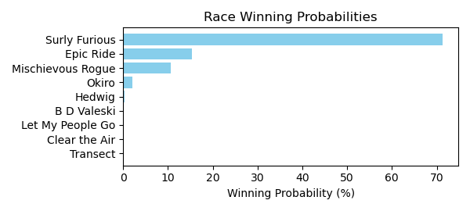

Figure: Winning Probability Distribution

NOTE: THIS RACE HAS HORSES THAT ARE MISSING CRITICAL DATA ELEMENTS

# Race: TTP | 2025-02-23 | Race #8 | Track: TURFWAY PARK

Track: TURFWAY PARK

|  |  |  |  |  |
| --- | --- | --- | --- | --- |
| Saddle Cloth # | Horse Name | Global Speed | Composite | Win Prob (%) |
| ['', 1, ''] | Berea | 82.4 | -6.54 | 0.00 |
| ['', 2, ''] | Cleomenes | 82.4 | -9.69 | 0.00 |
| ['', 3, ''] | Ligeia * | 82.4 | 0.73 | 0.47 |
| ['', 4, ''] | dh-Terpeye * | 82.4 | 1.85 | 1.14 |
| ['', 5, ''] | Sassy and Bold | 82.4 | 0.86 | 0.52 |
| ['', 6, ''] | Fireside Kitten | 82.4 | -3.68 | 0.01 |
| ['', 7, ''] | Bo Runkle * | 82.4 | 2.18 | 1.48 |
| ['', 8, ''] | Taking Charge Desi | 82.4 | -1.63 | 0.07 |
| ['', 9, ''] | Partake | 82.4 | 2.86 | 2.54 |
| ['', 10, ''] | Rock the Nile | 82.4 | 7.37 | 93.77 |

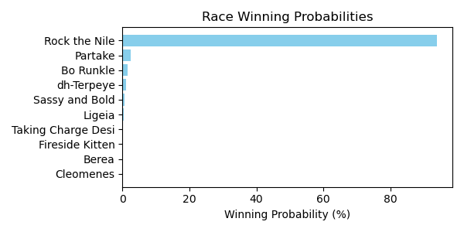

Figure: Winning Probability Distribution

NOTE: THIS RACE HAS HORSES THAT ARE MISSING CRITICAL DATA ELEMENTS

# Race: TTP | 2025-02-23 | Race #9 | Track: TURFWAY PARK

Track: TURFWAY PARK

|  |  |  |  |  |
| --- | --- | --- | --- | --- |
| Saddle Cloth # | Horse Name | Global Speed | Composite | Win Prob (%) |
| ['', 1, ''] | WAIT FOR ME * | 104.1 | 4.19 | 8.31 |
| ['', 2, ''] | Kicking Clear | 104.1 | -4.73 | 0.01 |
| ['', 3, ''] | Aqueous * | 104.1 | -6.41 | 0.00 |
| ['', 4, ''] | Midnight Vengeance | 104.1 | 2.01 | 1.45 |
| ['', 5, ''] | Stargell | 104.1 | 3.93 | 6.76 |
| ['', 6, ''] | MACH TWO BLUE * | 104.1 | 4.25 | 8.72 |
| ['', 7, ''] | Fletcher Bay * | 104.1 | -7.53 | 0.00 |
| ['', 8, ''] | Outofpi | 104.1 | -7.70 | 0.00 |
| ['', 9, ''] | Shinigami | 104.1 | -7.09 | 0.00 |
| ['', 10, ''] | Mubarez | 104.1 | -6.67 | 0.00 |
| ['', 11, ''] | Roc and Ready Jo * | 104.1 | -6.92 | 0.00 |
| ['', 12, ''] | Sinister Smile | 104.1 | 6.94 | 74.75 |

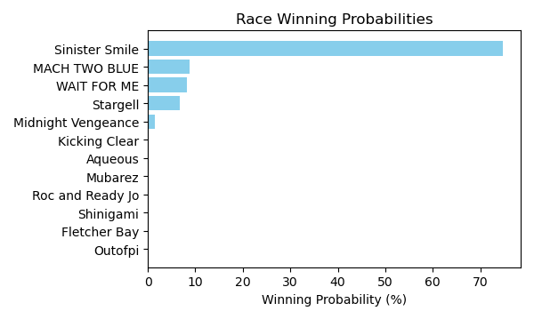

Figure: Winning Probability Distribution

NOTE: THIS RACE HAS HORSES THAT ARE MISSING CRITICAL DATA ELEMENTS

# Race: TTP | 2025-02-23 | Race #10 | Track: TURFWAY PARK

Track: TURFWAY PARK

|  |  |  |  |  |
| --- | --- | --- | --- | --- |
| Saddle Cloth # | Horse Name | Global Speed | Composite | Win Prob (%) |
| ['', 1, ''] | Egyptian King | 104.0 | 7.90 | 25.91 |
| ['', 2, ''] | Dancing Noah | 104.0 | -0.33 | 0.04 |
| ['', 3, ''] | Kykeon | 104.0 | -7.01 | 0.00 |
| ['', 4, ''] | Shiesty to Chase | 104.0 | 5.41 | 3.52 |
| ['', 5, ''] | Acting Debut | 104.0 | 3.08 | 0.55 |
| ['', 6, ''] | King Deivys | 104.0 | 7.45 | 18.06 |
| ['', 7, ''] | Righteous Star | 104.0 | -1.15 | 0.02 |
| ['', 8, ''] | Oathbreaker | 104.0 | 8.75 | 50.93 |
| ['', 9, ''] | Roundball Rock | 104.0 | 3.79 | 0.96 |
| ['', 10, ''] | Carlin Clan | 104.0 | -2.73 | 0.01 |
| ['', 11, ''] | Redhill | 104.0 | -3.99 | 0.00 |
| ['', 12, ''] | Strike Price | 104.0 | -6.37 | 0.00 |

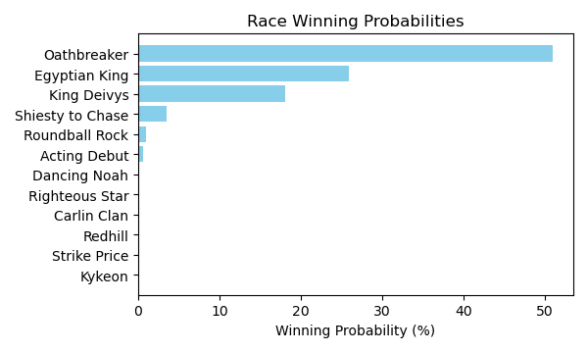

Figure: Winning Probability Distribution

NOTE: THIS RACE HAS HORSES THAT ARE MISSING CRITICAL DATA ELEMENTS